# FULLSTACKDEVELOPMENT

**(20A05703a )**



# LECTURE NOTES B.TECH VIIYEAR–ISEM(R20)

(2023-2024)

**DEPARTMENTOFCOMPUTATIONALINTELLIGENCE (CSE-AIML,AIML,AI&DS)**

**MADAKA SANJAY [M C A ]**

**( Deportment of CSE)**

#### SRI VENKATESWARA INSTITUTE OF SCIENCE AND TECHNOLOGY

**(AutonomousInstitution–UGC,Govt.of India)**

(AffiliatedtoJNTUA, Hyderabad, Approved byAICTE -Accredited byNBA&NAAC – ‘A’ Grade-ISO9001:2015 Certified) Krishnapuram, Kadapa , Andhra Predesh, 51600,3INDIA.

**(20A05703a )**

#### FULLSTACKDEVELOPMENT COURSE OBJECTIVES:

1. To become knowledge able about the most recent web development technologies.
2. Idea for creating two tier and three Tierra chitectural web applications.
3. Design and Analyze real-time web applications.
4. Constructing suitable client and server side applications.
5. To learn core concept of both front end and back end programming.

#### UNIT-I

Web Development Basics: Web development Basics - HTML & Web servers Shell - UNIX CLI Version control - Git &Github HTML, CSS

#### UNIT-II

Frontend Development: Javascript basics OOPS Aspects of JavaScript Memory usage and Functions in JS AJAX for data exchange with server jQuery Framework jQuery events, UI components etc. JSON data format.

#### UNIT-III

REACT JS: Introduction to React React Router and Single Page Applications React Forms, Flow Architecture and Introduction to Redux More Redux and Client-Server Communication

#### UNIT-IV

Java Web Development: JAVA PROGRAMMING BASICS, Model View Controller (MVC) Pattern MVC Architecture using Spring REST ful API using Spring Framework Building an application using Maven

#### UNIT-V

Databases & Deployment: Relational schemas and normalization Structured Query Language (SQL) Data persistence using Spring JDBC Agile development principles and deploying application in Cloud

#### TEXTBOOKS:

1. Web Design with HTML, CSS,JavaScript and JQuery Set Book by Jon Duckett Professional JavaScript for Web Developers Book by Nicholas C. Zakas
2. LearningPHP,MySQL,JavaScript,CSS&HTML5:AStep-by- Step Guide to Creating Dynamic Websites by Robin Nixon
3. Full Stack JavaScript: Learn Backbone.js, Node.jsand MongoDB. Copyright © 2015 BYAZAT MARDAN

#### REFERENCEBOOKS:

1. Full[-Stack JavaScript Development by](https://www.amazon.com/gp/product/0997196602/ref%3Das_li_qf_sp_asin_il_tl?ie=UTF8&tag=whatpixel-20&camp=1789&creative=9325&linkCode=as2&creativeASIN=0997196602&linkId=a85bff2175a83423faa25f4d049eace8) Eric Bush.
2. Mastering Full Stack React Web DevelopmentPaperback –April28, 2017 by To[maszDyl , Kamil Przeorski , M](https://www.amazon.com/s/ref%3Ddp_byline_sr_book_1?ie=UTF8&field-author=Tomasz%2BDyl&text=Tomasz%2BDyl&sort=relevancerank&search-alias=books)[aciej Czarnecki](https://www.amazon.com/s/ref%3Ddp_byline_sr_book_3?ie=UTF8&field-author=Maciej%2BCzarnecki&text=Maciej%2BCzarnecki&sort=relevancerank&search-alias=books)

#### COURSEOUTCOMES:

1. Develop a fully functioning web site and deployona webserver.
2. Gain Knowledge about the frontend and back end Tools
3. Find and usecode packages based on their documentation to produce working results ina project.
4. Create webpages that function using external data.
5. Implementation of web application employing efficient database access.

|  |  |  |
| --- | --- | --- |
| **UNIT** | **TOPIC** | **PAGE** |
| **UNIT -I** | Web development Basics- HTML | 6 |
|  | Web servers Shell-UNIXCLI | 90 |
|  | Version control-Git & Github HTML | 92 |
|  | CSS | 124 |
| **Unit-II** | Java script basics | 170 |
|  | OOPS Aspects of JavaScript | 179 |
|  | Memory usage and Functions in JS | 183 |
|  | AJAX ford at a exchange with server | 187 |
|  | JQuery Frame work | 191 |
|  | JQuery events | 193 |
|  | JSON data format. | 194 |
| **Unit-III** | REACTJS: Introduction to React | 195 |
|  | React Router and Single Page Applications | 198 |
|  | React Forms | 199 |
|  | Introduction to Redux | 211 |
|  | More Redux | 214 |
|  | Client-Server Communication | 215 |
| **UNIT-IV** | Java Web Development: | 221 |
|  | JAVAPROGRAMMING BASICS | 225 |
|  | Model View Controller(MVC) | 237 |
|  | MVC Architecture using Spring | 242 |
|  | REST ful API using Spring Framework | 244 |
|  | BuildinganapplicationusingMaven | 261 |
| **Unit-V** | Databases & Deployment | 266 |
|  | Relational schemas and normalization | 268 |
|  | Structured Query Language | 269 |
|  | Data persistence using Spring | 274 |
|  | JDBC Agile development | 276 |
|  | Principles and deploying application in Cloud | 281 |

# What isHTML

HTML is an acronym [**consisting of the first letters of each word in the name of something]**  which stands for **HyperTextMarkupLanguage** which is used for creating web pages and web applications. Let's see what is meant by Hypertext Markup Language, and Web page.

**HyperText:** HyperText simply means "Text within Text." A text has a link with init, is a hypertext. Whenever you click on a link which brings you to a new webpage, you have clicked on a hypertext. HyperText is a way to link two or more web pages (HTML documents) with each other.

**Markup language:** A markup language is a computer language that is used to apply layout andformattingconventionstoatextdocument.Markuplanguagemakestextmoreinteractive and dynamic. It can turn text into images, tables, links, etc.

**Web Page:** A webpage is a document which is commonly written in HTML and translated by a web browser. A web page can be identified by entering an URL. A Web page can be of the staticor dynamic type. **With the help of HTML only, we can create static web pages**.

Hence, HTML is a markup language which is used for creating attractive web pages with the help of styling, and which looks in a nice format on a web browser. An HTML document is made of many HTML tags and each HTML tag contains different content.

##### Let's see a simple example of HTML.

1. <!DOCTYPE>
2. <html>
3. <head>
4. <title>Web page title</title>
5. </head>
6. <body>
7. <h1>Write Your First Heading</h1>
8. <p>Write Your First Paragraph.</p>
9. </body>
10. </html>

### Description of HTML Example

**<!DOCTYPE>:** It defines the document type origin struct the browser about the version of HTML.

**<html>**:This tag informs the browser that it is an HTML document. Text between html tag describes the web document. It is a container for all other elements of HTML except

<!DOCTYPE>

**<head>:** It should be the first element inside the <html> element, which contains the metadata(information about the document).It must be closed before the body tag opens.

**<title>:** As its name suggested, it is used to add title of that HTML page which appears at the top of the browser window. It must be placed inside the head tag and should close immediately. (Optional)

**<body>**:Text betweenbodytagdescribesthebodycontentofthepagethatisvisibletothe end user. This tag contains the main content of the HTML document.

**<h1>**:Text between<h1>tag describes the first level heading of the webpage.

**<p>**:Text between<p>tag describes the paragraph of the web page.

### Brief History of HTML

In the late1980's, a physicist, Tim Berners – Lee who was a contractor at CERN, proposeda system for CERN researchers. In 1989, he wrote a memo proposing an internet based hypertext system.

**Tim Berners-Lee** is known as the father of HTML. The first available description of HTML was a document called "HTML Tags" proposed by Tim in late 1991. The latest version of HTML is HTML5, which we will learn later in this tutorial.

### HTML Versions

Since the time HTML was in vented the reare lots of HTML versions in market, the brief introduction about the HTML version is given below:

**HTML1.0:**The first versionofHTMLwas1.0, which was the barebones version of HTML language, and it was released in1991.

**HTML 2.0:** This was the next version which was released in 1995, and it was standard language versionforwebsitedesign.HTML2.0wasableto support extra features such as form-based file upload, form elements such as text box, option button, etc.

**HTML 3.2:** HTML 3.2 version was published by W3C in early 1997. This version was capable of creating tables and providing support for extra options for form elements. It can also support a web page with complex mathematicalequations. It be camean official standard for any browser till January1997. Today it is practically supported by most of the browsers.

**HTML4.01:** HTML4.01versionwasreleased onDecember 1999, and it isa verystable version of HTML language. This version is the current official standard, and it provides addedsupportforstylesheets(CSS)andscriptingabilityforvariousmultimediaelements.

**HTML5 :** HTML5 is the newest version of HyperText Markup language. The first draft of this version was announced in January2008. There are two major organizations one is W3C (World Wide WebConsortium), and another one is WHATWG( WebHypertext Application TechnologyWorkingGroup)whichareinvolved inthedevelopment ofHTML5version, and still, it is under development.

### FeaturesofHTML

1. Itisavery**easy andsimplelanguage**.Itcanbeeasilyunderstoodandmodified.
2. Itisveryeasytomakean**effectivepresentation** withHTML because it hasa lotof formatting tags.
3. Itisa**markuplanguage**, so it providesaflexiblewayto designwebpagesalongwiththe text.
4. Itfacilitatesprogrammerstoadda **link**onthewebpages(byhtmlanchortag), soit enhances the interest of browsing of the user.
5. Itis**platform-independent** because it canbedisplayedonanyplatformlike Windows, Linux, and Macintosh, etc.
6. Itfacilitatestheprogrammerto add**Graphics,Videos, andSound**tothewebpageswhich makes it more attractive and interactive.
7. HTMLisacase-insensitive language, whichmeanswecanusetagseither inlower-caseor upper-case.

# HTMLtextEditors

* + AnHTMLfileisatextfile,so tocreateanHTMLfilewecanuseanytexteditors.
  + Text editorsaretheprogramswhichallowediting inawrittentext,henceto createa web page we need to write our code in some text editor.
  + Therearevarioustypesoftext editorsavailablewhichyoucandirectlydownload,but for a beginner, the best text editor is Notepad (Windows) or TextEdit (Mac).
  + Afterlearningthebasics,youcaneasilyuseotherprofessionaltexteditorswhichare,

##### Notepad++,SublimeText,Vim,etc.

* + Inourtutorial,wewilluseNotepadandsublimetext editor. Followingaresomeeasy ways to create your first web page with Notepad, and sublime text.

### HTMLcodewithNotepad.(Recommendedfor Beginners)

Notepadisasimpletext editorandsuitable forbeginnerstolearnHTML.Itisavailable inall versions of Windows, from where you easily access it.

**Step1:OpenNotepad (Windows)**

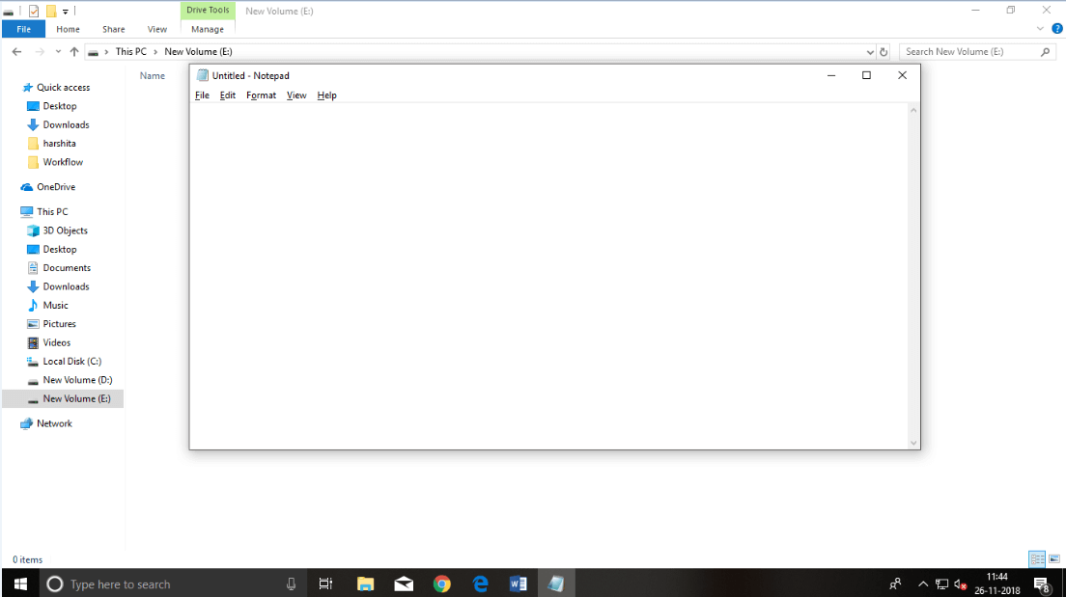

**Step 2:Write code inHTML**

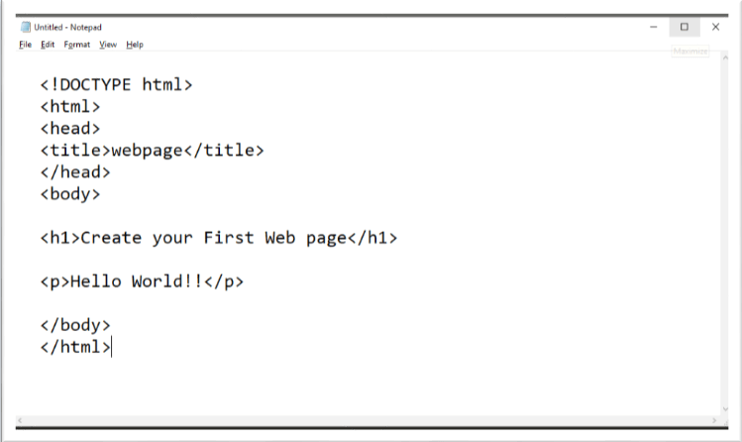

**Step3:Savethe HTMLfile with.htmor.htmlextension.**

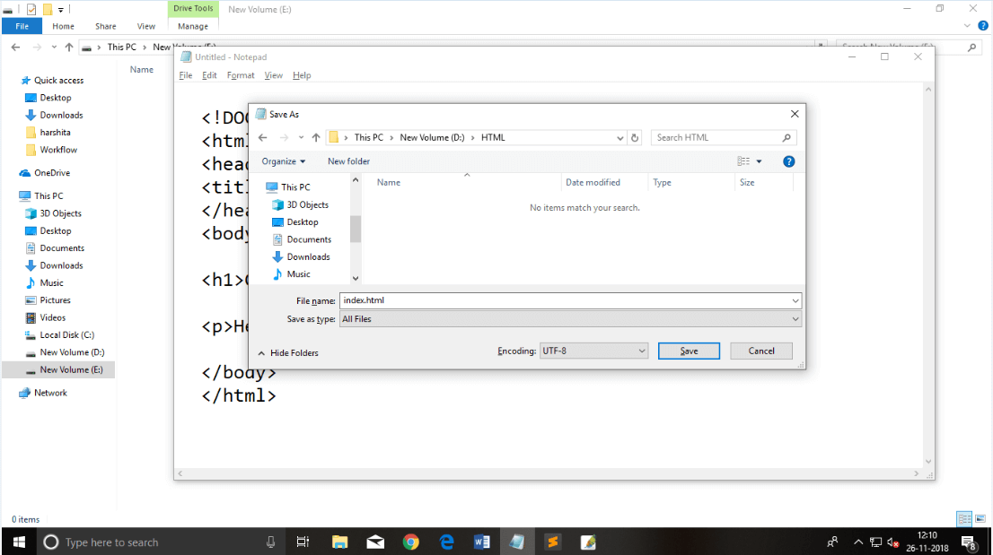

**Step4:OpentheHTMLpageinyourwebbrowser.**

ToruntheHTMLpage,youneedtoopenthe file location,where youhavesavedthe fileand then either double-click on file or click on open with option

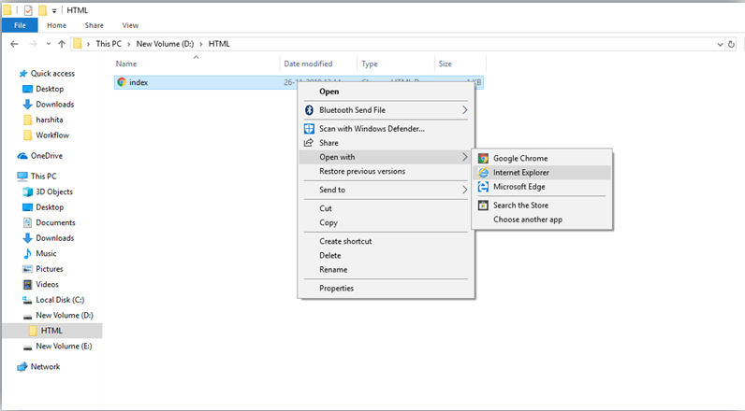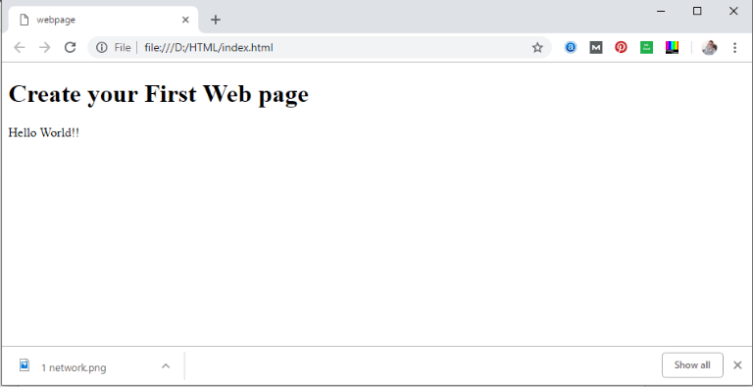

### HTMLcodewithSublimeText-editor.(Recommended after learning basics of HTML)

When you will learn the basics of HTML, then you can use some professional text editors, whichwillhelp youtowriteanefficient and fast code.Soto useSublimeText editors,first it needs to download and install from internet. You can easily download it from this <https://www.sublimetext.com/download>linkandcaninstallin your PC. Wheninstallationof Sublime text editor done then you can follow the simple steps to use it:

##### Step1:OpenSublimeText editor(Windows8):

ToopenSublimeText editorgoto **Startscreen**⤏ **typeSublimeText**⤏ **Open**it. Toopena new page press **CTRL+N.**

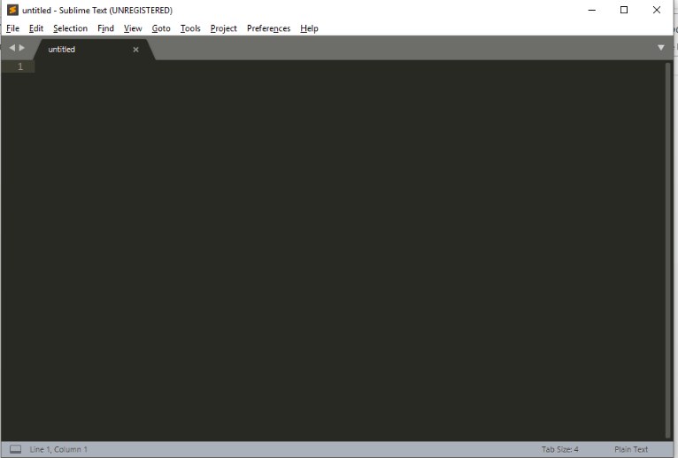

##### Step 2:Savethepagebeforewriting anycode.

Tosave yourpageinSublimeText pressCtrl+SorgotoFileoption ⤏ save,to saveafileuse extension.htmor .html. Werecommendto savethefile first thenwritethecodebecauseafter saving the page sublime text editor will give you suggestions to write code.

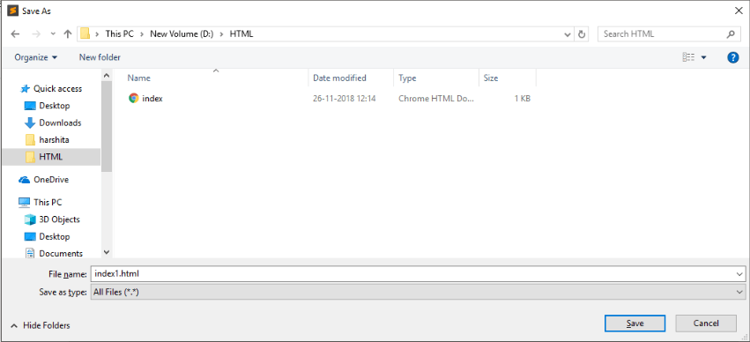

##### Step3:WritethecodeinSublimeTexteditor

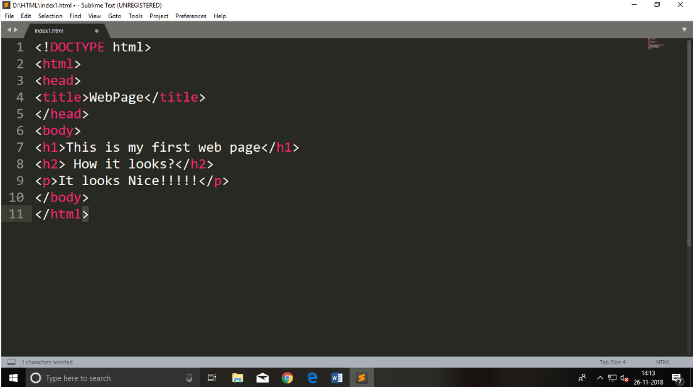

**Step4:OpentheHTMLpageinyourBrowser**

Toexecuteoropenthispage inWebbrowserjust **rightclick**bymouseonsublimetext page and click on **Open in Browser**.

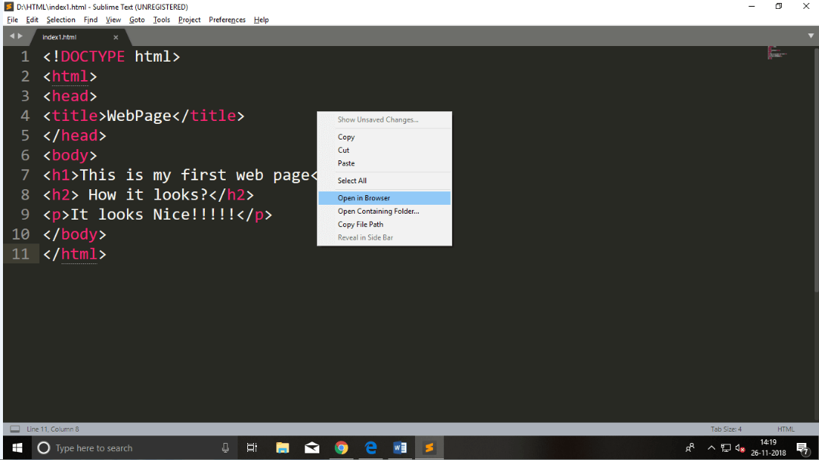

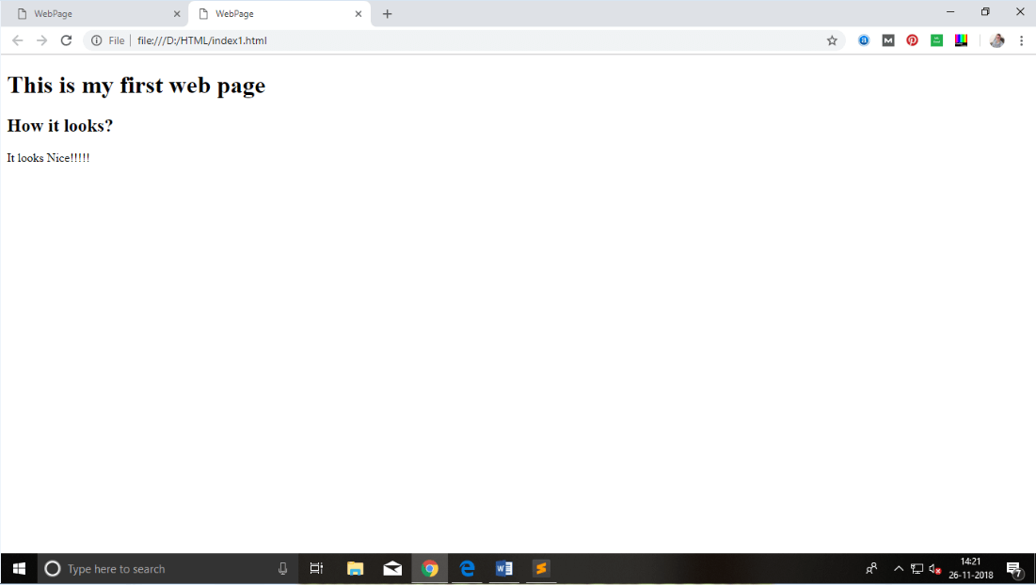

# BuildingblocksofHTML

AnHTMLdocumentconsistofitsbasicbuildingblockswhichare:

* **Tags:** AnHTMLtagsurroundsthe contentandapplymeaningtoit. Itiswritten between < and > brackets.
* **Attribute:** Anattribute inHTMLprovidesextrainformationabouttheelement,and it is applied within the start tag. AnHTML attribute contains two fields: name &value.

### Syntax

* 1. <tagnameattribute_name= "attr_value"> content</tag name>
     + **Elements:** AnHTMLelement isanindividualcomponentofanHTML file. Inan HTML file, everything written within tags are termed as HTML elements.

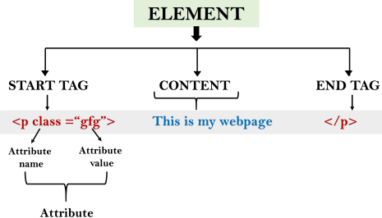

### Example:

1. <!DOCTYPE html>
2. <html>
3. <head>
4. <title>ThebasicbuildingblocksofHTML</title>
5. </head>
6. <body>
7. <h2>Thebuildingblocks</h2>
8. <p>Thisisaparagraphtag</p>
9. <pstyle="color:red">Thestyleisattributeofparagraphtag</p>
10. <span>Theelementcontainstag,attributeandcontent</span>
11. </body>
12. </html>

**Output:**

### Thebuilding blocks

Thisisaparagraph tag

# HTMLTags

HTML tags are like keywords whichdefines that how webbrowser will format and display thecontent. Withthehelpoftags, awebbrowsercandistinguishbetweenanHTMLcontent and a simplecontent.HTMLtagscontainthree mainparts:opening tag, content and closing tag. But some HTML tags are unclosed tags.

Whenawebbrowser readsanHTMLdocument, browserreadsit fromtoptobottomand left to right. HTML tags are used to create HTML documents and render their properties. Each HTML tags have different properties.

AnHTML file must havesomeessentialtagssothat webbrowsercandifferentiatebetweena simple text and HTML text. You can use as manytags you want as per your code requirement.

* AllHTMLtagsmustenclosedwithin<>thesebrackets.
* EverytaginHTMLperformdifferent tasks.
* Ifyouhaveusedanopentag<tag>, thenyoumust useaclosetag</tag>(except sometags)

### Syntax

<tag>content</tag>

### HTML TagExamples

*Note:HTMLTagsarealwayswritteninlowercaseletters.ThebasicHTMLtagsaregivenbelow:*

<p>ParagraphTag</p>

### <h2>HeadingTag</h2>

<b>**BoldTag**</b>

<i>*ItalicTag*</i>

<u>Underline Tag</u>

### UnclosedHTMLTags

SomeHTMLtagsarenotclosed,forexamplebrandhr.

**<br>Tag**:brstandsforbreakline,itbreaksthelineofthecode.

**<hr>Tag**:hrstandsfor HorizontalRule.Thistagisusedto putalineacrossthewebpage.

### HTMLMetaTags

DOCTYPE,title,link,metaand style

### HTMLTextTags

<p>,<h1>,<h2>,<h3>,<h4>,<h5>,<h6>,<strong>,<em>,<abbr>,<acronym>,

<address>,<bdo>,<blockquote>,<cite>, <q>,<code>,<ins>,<del>, <dfn>,<kbd>, <pre>,

<samp>,<var>and<br>

### HTML LinkTags

<a>and<base>

### HTMLImageandObjectTags

<img>,<area>,<map>,<param>and<object>

### HTMLListTags

<ul>,<ol>,<li>,<dl>,<dt>and<dd>

### HTMLTableTags

table,tr,td,th,tbody, thead,tfoot,col, colgroupandcaption

### HTMLFormTags

form,input,textarea,select,option,optgroup,button,label,fieldsetand legend

### HTMLScriptingTags

scriptandnoscript

*Note:Wewill seeexamples usingthesetagsinlater charters.*

### HTMLTagsList

Following isthecompletelist ofHTMLtagswiththedescriptionwhicharearranged alphabetically.

# HTMLAttribute

* HTMLattributesarespecialwordswhichprovideadditionalinformationabout theelements or attributes are the modifier of the HTML element.
* Each element or tag can have attributes, which defines the behavior of that element.
* Attributes should always be applied with start tag.
* The Attribute should always be applied with its name and value pair.
* The Attributes name and values are case sensitive, and it isrecommendedbyW3C that it should be written in Lowercase only.
* You can add multiple attributes in one HTML element, but need to gives pace between two attributes.

### Syntax

1. <element attribute_name="value">content</element>

### Example

1. <!DOCTYPE html>
2. <html>
3. <head>
4. </head>
5. <body>
6. <h1>This is Style attribute</h1>
7. <pstyle="height:50px;color: blue">It will add style property in element</p>
8. <pstyle="color:red">It will change the color of content</p>
9. </body>
10. </html>

##### Output:

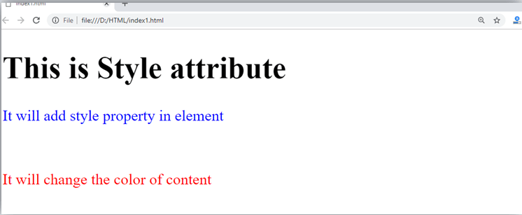

**Explanation ofaboveexample:**

1.<pstyle="height:50px;color:blue">Itwilladdstylepropertyinelement</p>

Intheabovestatement, wehaveusedparagraphtags inwhichwe haveappliedstyleattribute. This attribute is used for applying CSS propertyonanyHTMLelement.It provides height to paragraph element of 50px and turns it colour to blue.

1.<pstyle="color:red">Itwillchangethecolorofcontent</p>

Intheabovestatement wehaveagainusedstyleattributeinparagraphtag, whichturns its colour red.

*Note:Therearesomecommonlyusedattributesaregivenbelow, andthecompletelistand explanation of all attributes are given in HTML attributes List.*

### ThetitleattributeinHTML

**Description:** The title attribute is used as text tooltip in most ofthe browsers. It display its text whenuser move the cursor over a link or anytext. You canuse it withanytext or link to showthedescriptionaboutthatlinkortext.Inourexample, wearetaking thiswithparagraph tag and heading tag.

### Example

##### With<h1>tag:

1.<h1 title="Thisisheading tag">Exampleoftitle attribute</h1>

##### With<p>tag:

1. <ptitle="This isparagraphtag">Movethecursorovertheheadingandparagraph, and you will see a description as a tooltip</p>

##### Code:

1. <!DOCTYPE html>
2. <html>
3. <head>
4. </head>
5. <body>
6. ​
7. <h1title="This isheadingtag">Exampleoftitle attribute</h1>
8. <ptitle="Thisisparagraphtag">Movethecursor over theheadingandparagraph,andyou will see a description as a tooltip</p>
9. ​
10. </body>
11. </html>

**Output:**

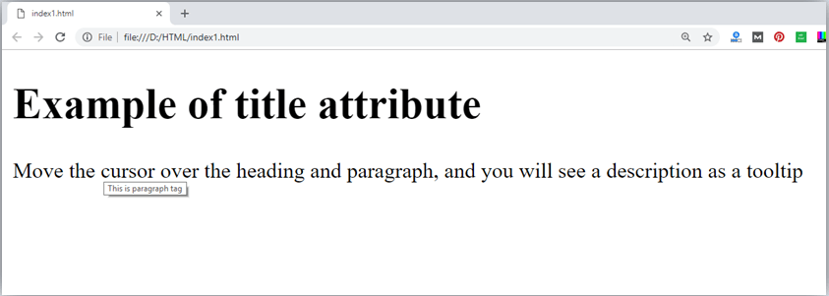

### Thehrefattributein HTML

**Description:** The hrefattribute is the main attribute of<a> anchor tag. This attribute gives thelinkaddresswhichisspecified inthat link. **Thehrefattributeprovidesthehyperlink, and if it is blank, then it will remain in same page**.

### Example

##### With linkaddress:

1. <ahref="https:/[/www](http://www.javatpoint.com/html-anchor).[javatpoint.com/html-anchor](http://www.javatpoint.com/html-anchor)">Thisisalink</a>

##### Withoutlinkaddress:

1. <ahref="">Thisisalink</a>

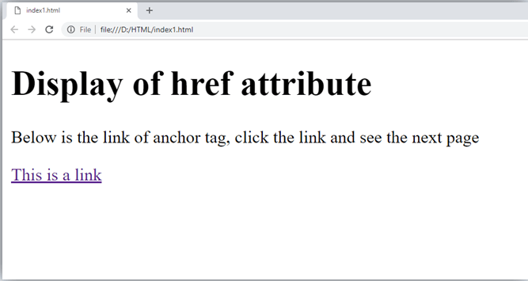

### Thesrc Attribute

The**src**attribute isoneofthe important andrequiredattributeof**<img>**element. Itissource for the image which is required to display on browser. This attribute can contain image in same directoryor another directory. The image name or source should be correct else browser will not display the image.

### Example

1. <imgsrc="whitepeacock.jpg"height="400"width="600">

*Note:Theaboveexamplealsohaveheight andwidth attribute,which definetheheight andwidth of image on web page.*

**Output:**

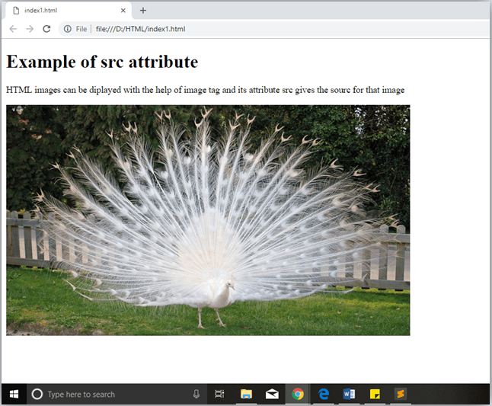

### Quotes:singlequotesordoublequotes?

In this chapter you have seen that, we have used attribute with double quotes, but some people might usesinglequotesinHTML. SouseofsinglequoteswithHTMLattribute,is also allowed. The following both statements are absolutely fine.

1. <ahref="https:/[/www](http://www.javatpoint.com/).[javatpoint.com](http://www.javatpoint.com/)">AlinktoHTML.</a>
2. <ahref='https://www.javatpoint.com'>AlinktoHTML.</a>

INHTML5,youcanalsoomituseofquotesaroundattributevalues.

1.<a href=https:/[/www](http://www.javatpoint.com/).[javatpoint.com](http://www.javatpoint.com/)>Alink to HTML.</a>

# HTMLElements

AnHTML file is made ofelements. These elements are responsible for creating webpages and definecontent inthat webpage. Anelement in HTMLusuallyconsist ofastart tag<tag name>,closetag</tagname>andcontent insertedbetweenthem. **Technically,anelement is a collection of start tag, attributes, end tag, content between them**.

*Note:Someelementsdoesnothaveendtagandcontent, theseelementsaretermedasemptyelements or self-closing element or void elements.*

Suchas:

1. <p>Helloworld!!!</p>

### Example

1. <!DOCTYPE html>
2. <html>
3. <head>
4. <title>WebPage</title>
5. </head>
6. <body>
7. <h1>This is myfirstwebpage</h1>
8. <h2>Howit looks?</h2>
9. <p>Itlooks Nice!!!!!</p>
10. </body>
11. </html>

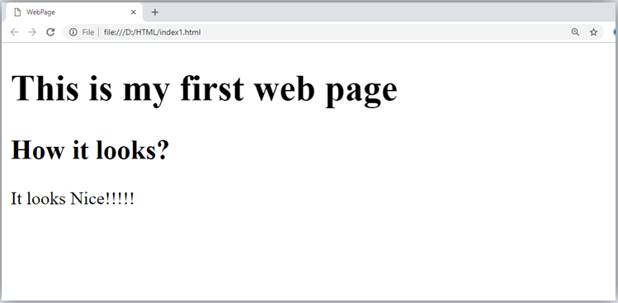

* + Allthecontentwrittenbetweenbodyelementsarevisibleonwebpage.

**Voidelement:** Alltheelements inHTMLdo notrequireto havestarttagandendtag,some elements does not have content and end tag such elements are known as Void elements or empty elements. **These elements are also called as unpaired tag**.

##### SomeVoidelementsare<br>(representsalinebreak),<hr>(representsahorizontal line), etc.

**NestedHTMLElements:** HTMLcanbenested,whichmeansanelement cancontain another element.

### Block-levelandInlineHTML elements

Forthedefault displayandstylingpurposeinHTML, alltheelementsaredivided intotwo categories:

* + Block-levelelement
  + Inlineelement

### Block-levelelement:

* + Thesearetheelements, whichstructuremainpart ofweb page, bydividinga pageinto coherent blocks.
  + Ablock-level element alwaysstart withnewlineandtakesthefullwidthof webpage, from left to right.
  + Theseelementscancontainblock-levelaswellasinlineelements.

Followingaretheblock-levelelementsinHTML.

<address>,<article>,<aside>,<blockquote>,<canvas>,<dd>,<div>,<dl>,<dt>,<fieldset>,

<figcaption>,<figure>,<footer>,<form>,<h1>-<h6>,<header>,<hr>,<li>,<main>,

<nav>,<noscript>,<ol>,<output>,<p>,<pre>,<section>,<table>,<tfoot>,<ul>and

<video>.

*Note:Alltheseelementsaredescribedinlater chapters.*

### Example:

1. <!DOCTYPE html>
2. <html>
3. <head>
4. </head>
5. <body>
6. <divstyle="background-color:lightblue">Thisisfirstdiv</div>
7. <divstyle="background-color:lightgreen">Thisisseconddiv</div>
8. <pstyle="background-color:pink">Thisisablocklevelelement</p>
9. </body>
10. </html>

##### Output:

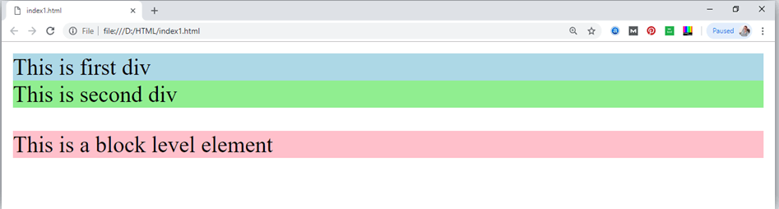

Intheaboveexamplewehaveused

tag,whichdefinesa sectioninawebpage,andtakesfullwidthofpage.

We haveusedstyleattributewhichisusedto stylingtheHTMLcontent,andthebackground color are showing that it's a block level element.

### Inlineelements:

* + Inlineelementsarethoseelements, whichdifferentiatethepartofa giventext andprovideit a particular function.
  + Theseelementsdoesnot startwithnewlineandtakewidthasper requirement.
  + TheInlineelementsaremostlyusedwithotherelements.

<a>,<abbr>,<acronym>,<b>,<bdo>,<big>,<br>,<button>,<cite>,<code>,<dfn>,<em>,

<i>,<img>,<input>,<kbd>,<label>,<map>,<object>,<q>,<samp>,<script>,<select>,

<small>,<span>,<strong>,<sub>,<sup>,<textarea>,<time>,<tt>,<var>.

### Example:

1. <!DOCTYPE html>
2. <html>
3. <head>
4. </head>
5. <body>
6. <ahref="https://[www.javatpoint.com/html-tutorial](http://www.javatpoint.com/html-tutorial)">Clickonlink</a>
7. <spanstyle="background-color:lightblue">thisisinlineelement</span>
8. <p>Thiswilltakewidthoftextonly</p>
9. </body>
10. </html>

##### Output:

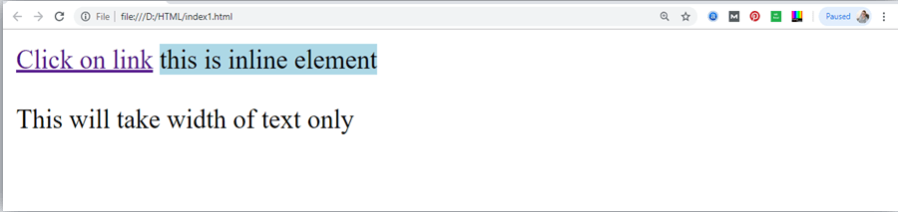

FollowingisthelistofthesomemainelementsusedinHTML:

# HTMLFormatting

**HTML Formatting** is a process of formatting text for better look and feel. HTML provides usabilityto formattext withoutusingCSS.TherearemanyformattingtagsinHTML.These tags are used to make text bold, italicized, or underlined. There are almost 14 options available that how text appears in HTML and XHTML.

InHTMLtheformattingtagsaredividedintotwocategories:

* + Physicaltag:Thesetagsareusedtoprovidethevisualappearancetothetext.
  + Logicaltag:Thesetags areusedtoaddsomelogicalorsemanticvaluetothetext.

*NOTE:Therearesomephysicalandlogicaltagswhich maygivesamevisual appearance, but they will be different in semantics.*

Here,wearegoingtolearn14HTMLformattingtags. Following isthe list ofHTML formatting text.

|  |  |
| --- | --- |
| **Element name** | **Description** |
| <b> | Thisisaphysicaltag, whichisusedtoboldthetextwrittenbetweenit. |
| <strong> | Thisisalogicaltag, whichtellsthebrowserthatthetextis important. |
| <i> | Thisisaphysicaltagwhichisusedtomaketext italic. |
| <em> | Thisisalogicaltagwhichisusedtodisplaycontentinitalic. |
| <mark> | Thistagisusedtohighlighttext. |
| <u> | Thistagisusedtounderlinetextwrittenbetweenit. |
| <tt> | Thistagisusedtoappearatextinteletype. (notsupportedinHTML5) |
| <strike> | Thistagisusedtodrawa strikethroughona sectionof text. (Notsupportedin HTML5) |
| <sup> | Itdisplaysthecontentslightlyabovethenormalline. |

|  |  |
| --- | --- |
| <sub> | Itdisplaysthecontent slightlybelowthenormalline. |
| <del> | Thistagisusedtodisplaythedeletedcontent. |
| <ins> | Thistagdisplaysthecontentwhichisadded |
| <big> | Thistagis usedto increasethefontsizebyoneconventionalunit. |
| <small> | Thistagisusedtodecreasethefontsizeby oneunitfrombasefontsize. |

### BoldText

HTML<b>and<strong>formattingelements

TheHTML<b>element isaphysicaltagwhichdisplaytext inbold font,withoutanylogical importance. If you write anything within <b> </b> element, is shown in bold letters.

Seethis example:

* 1. <p><b>WriteYourFirstParagraphinboldtext.</b></p>

##### Output:

**WriteYourFirstParagraphinboldtext.**

TheHTML<strong>tagisa logicaltag,whichdisplaysthecontent inbold font and informs the browser about its logical importance. If you write anything between

<strong>???????.</strong>,isshownimportanttext. See this example:

1. <p><strong>Thisisanimportantcontent</strong>,andthisisnormalcontent</p>

##### Output:

**Thisisanimportant content, andthisisnormalcontent**

Example

1. <!DOCTYPE html>
2. <html>
3. <head>
4. <title>formattingelements</title>
5. </head>
6. <body>
7. <h1>Explanationofformatting element</h1>
8. <p><strong>Thisisanimportantcontent</strong>,andthisisnormalcontent</p>
9. </body>
10. </html>

### Italic Text

##### HTML<i>and<em>formatting elements

TheHTML<i>element isphysicalelement,whichdisplaytheenclosedcontent initalic font, without any added importance. If you write anything within <i> </i> element, is

showninitalicletters. See this example:

* 1. <p><i>WriteYourFirstParagraphinitalictext.</i></p>

##### Output:

*WriteYourFirstParagraphinitalictext.*

TheHTML<em>tagisa logicalelement, whichwilldisplaytheenclosedcontent initalic font, with added semantics importance.

##### Seethis example:

1. <p><em>Thisisanimportantcontent</em>,whichdisplayedinitalic font.</p>

##### Output:

*Thisisanimportantcontent*, whichdisplayedinitalicfont.

1. <!DOCTYPE html>
2. <html>
3. <head>
4. <title>formattingelements</title>
5. </head>
6. <body>
7. <h1>Explanationofitalicformattingelement</h1>
8. <p><em>Thisisanimportantcontent</em>,whichdisplayedinitalicfont.</p>
9. </body>
10. </html>

### HTMLMarkedformatting

Ifyouwanttomarkorhighlightatext,youshouldwritethecontentwithin

<mark> </mark>.

Seethis example:

* 1. <h2>Iwant toputa<mark>Mark</mark>onyourface</h2>

**Output:**

### IwanttoputaMarkonyour face

1. **UnderlinedText**

Ifyouwriteanythingwithin<u> </u>element, isshowninunderlined text.

Seethis example:

* 1. <p><u>WriteYour FirstParagraphinunderlinedtext.</u></p>

##### Output:

WriteYourFirstParagraphinunderlinedtext.

### StrikeText

Anythingwrittenwithin<strike> </strike>elementisdisplayedwith

strikethrough.It isathinlinewhichcrossthestatement. See this example:

* 1. <p><strike>WriteYour FirstParagraphwithstrikethrough</strike>.</p>

##### Output:

~~WriteYourFirstParagraphwithstrikethrough.~~

### MonospacedFont

Ifyouwantthateachletterhasthesamewidththenyoushouldwritethecontent within

<tt> </tt>element.

Note:Weknowthatmostofthe fontsareknownasvariable-widthfontsbecausedifferent lettershavedifferent width.(forexample:'w'iswiderthan'i').MonospacedFont provides similar space among every letter.

Seethis example:

* 1. <p>Hello<tt>WriteYourFirstParagraphinmonospacedfont.</tt></p>

##### Output:

HelloWriteYourFirstParagraphinmonospacedfont.

### SuperscriptText

Ifyouputthecontentwithin<sup> </sup>element,isshowninsuperscript;meansit

isdisplayedhalfacharacter'sheight abovetheothercharacters. See this example:

* 1. <p>Hello<sup>WriteYourFirstParagraphinsuperscript.</sup></p>

##### Output:

Hello WriteYourFirstParagraphin superscript.

### SubscriptText

Ifyouputthecontentwithin<sub> </sub>element,isshowninsubscript;meansit

isdisplayedhalfacharacter'sheight belowtheothercharacters. See this example:

* 1. <p>Hello<sub>WriteYourFirstParagraphinsubscript.</sub></p>

##### Output:

Hello WriteYourFirstParagraphin subscript.

# HTMLHeading

A HTML heading or HTML h tag can be defined as a title or a subtitle which you want to display on the webpage. When you place the text within the heading tags <h1> </h1>,it

isdisplayedonthebrowserinthebold format andsizeofthetextdependsonthenumberof heading.

Therearesixdifferent HTMLheadingswhichare definedwiththe<h1>to <h6>tags, from highest level h1 (main heading) to the least level h6 (least important heading).

h1 isthe largest headingtagandh6 isthesmallestone.Soh1 isused for mostimportant heading and h6 is used for least important.

##### HeadingsinHTMLhelpsthesearchenginetounderstandandindexthestructureof web page.

*Note:Themainkeywordof thewholecontent ofawebpageshouldbedisplaybyh1headingtag.*

Seethis example:

1. <h1>Headingno.1</h1>
2. <h2>Headingno.2</h2>
3. <h3>Headingno.3</h3>
4. <h4>Headingno.4</h4>
5. <h5>Headingno.5</h5>
6. <h6>Headingno.6</h6>

**Output:**

# Headingno.1

### Headingno.2

Heading no. 3

*Headingno.4*

Headingno.5

Headingno.6

*Headingelements(h1. h6)shouldbeusedforheadingsonly.Theyshouldnotbeusedjustto make*

*textboldorbig.*

* **HTMLheadingscanalsobe usedwithnestedelements. Followingaredifferentcodesto display the way to use heading elements.**

##### Example:

1. <!DOCTYPE html>
2. <html>
3. <head>
4. <title>Headingelements</title>
5. </head>
6. <body>
7. <h1>Thisis mainheadingofpage.</h1>
8. <p>h1isthemost important heading, whichisusedtodisplaythekeywordofpage</p>
9. <h2>Thisisfirstsub-heading</h2>
10. <p>h2describesthefirst subheadingofpage. </p>
11. <h3>ThisisSecondsub-heading</h3>
12. <p>h3describesthesecondsubheadingof page.</p>
13. <p>Wecanuseh1toh6tagto usethedifferentsub- heading with their paragraphs if
14. required.
15. </p>
16. </body>
17. </html>

**Output:**

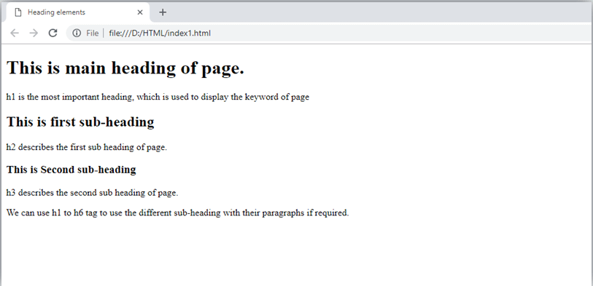

# HTMLParagraph

HTMLparagraphor HTMLptag is used to define a paragraphina webpage. Let's take a simpleexampletoseehowit work.Itisa notablepointthat abrowseritselfaddanempty line before and after a paragraph. AnHTML<p> tag indicates starting ofnew paragraph.

*Note:If weareusingvarious<p>tagsinoneHTML filethen browser automaticallyaddsasingle blank line between the two paragraphs.*

Seethis example:

1. <p>Thisisfirst paragraph.</p>
2. <p>Thisissecondparagraph.</p>
3. <p>Thisisthirdparagraph.</p>Output:

This is first paragraph. Thisissecondparagraph. This is third paragraph.

### SpaceinsideHTMLParagraph

Ifyouput alotofspaces insidetheHTMLptag, browserremovesextraspacesandextraline while displaying the page. The browser counts number of spaces and lines as a single one.

1. <p>
2. Iam
3. goingtoprovide
4. youatutorialonHTML
5. and hopethatitwill
6. beverybeneficialforyou.
7. </p>
8. <p>
9. Look,Iputherea lot
10. ofspaces but Iknow,Browser willignoreit.
11. </p>
12. <p>
13. You cannotdetermine thedisplayofHTML</p>
14. <p>becauseresizedwindowsmaycreatedifferentresult.
15. </p>

Output:

Iamgoingtoprovide youatutorialonHTMLand hopethat it willbe verybeneficialfor you.

Look,I putherealotofspacesbutIknow,Browser will ignoreit.

Youcannotdeterminethe displayofHTML

becauseresizedwindowsmaycreatedifferentresult.

Asyoucansee,alltheextralinesandunnecessaryspacesareremovedbythebrowser.

### HowtoUse<br>and<hr>tagwithparagraph?

AnHTML<br>tagisused forline breakand it canbeusedwithparagraphelements. Following is the example to show how to use <br> with <p> element.

##### Example:

1. <!DOCTYPE html>
2. <html>
3. <head>
4. </head>
5. <body>
6. <h2>Useoflinebreakwithpragraphtag</h2>
7. <p><br>Papaandmama, andbabyandDot,
8. <br>Willieandme?thewholeofthelot
9. <br>OfusallwentoverinBimberlie's sleigh,
10. <br>Tograndmama'shouseonChristmasday.
11. </p>
12. </body>
13. </html>

##### Output:

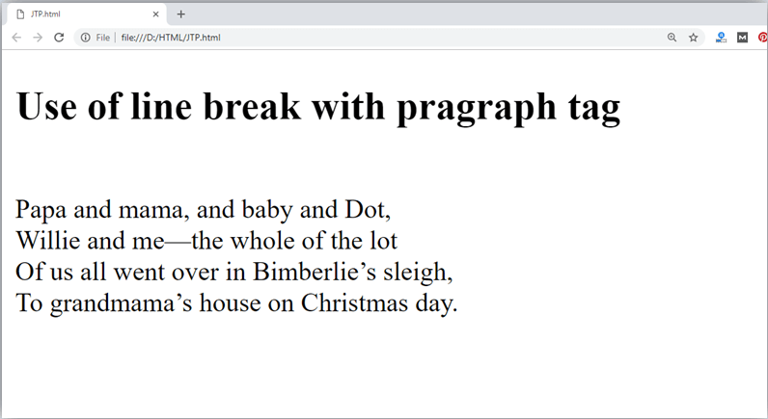

An HTML <hr> tag is used to apply a horizontal line between two statements or two paragraphs.Following istheexamplewhichisshowinguseof<hr>tagwithparagraph.

##### Example:

1. <!DOCTYPE html>
2. <html>
3. <head>
4. </head>
5. <body>
6. <h2>Exampletoshowahorizontallinewithparagraphs</h2>
7. <p>AnHTMLhr tagdrawahorizontallineandseparatetwoparagraphswiththat line.<hr> it will start a new paragraph.
8. </p>
9. </body>
10. </html>

**Output:**

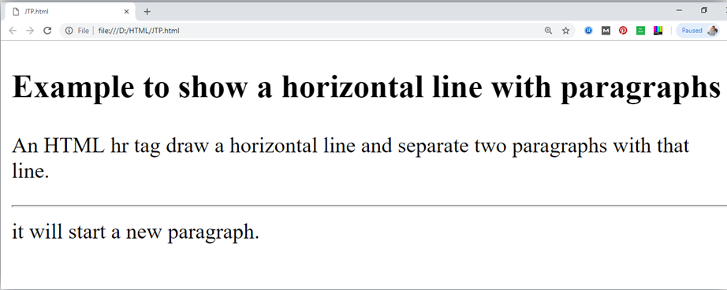

# HTMLAnchor

The**HTMLanchortag** defines*ahyperlinkthatlinksonepagetoanotherpage*.Itcancreate hyperlink to other web page as wellas files, location, or anyURL. The "href" attribute is the most important attribute of the HTML a tag. and which links to destination page or URL.

### hrefattributeofHTMLanchor tag

Thehrefattributeisusedto definetheaddressofthe filetobe linked. Inotherwords,it points out the destination page.

The syntaxofHTMLanchortagisgivenbelow.

<ahref=" ">LinkText</a>

Let'ssee anexample ofHTMLanchortag.

1. <ahref="second.html">ClickforSecondPage</a>

### SpecifyalocationforLinkusing target attribute

Ifwewanttoopenthat linktoanother pagethenwecanusetarget attributeof<a>tag.With the help of this link will be open in next page.

### Example:

1. <!DOCTYPE html>
2. <html>
3. <head>
4. <title></title>
5. </head>
6. <body>
7. <p>Clickon<ahref="https:/[/www](http://www.javatpoint.com/).[javatpoint.com/"](http://www.javatpoint.com/)target="_blank">this- link </a>to go on home page of JavaTpoint.</p>
8. </body>
9. </html>

##### Output:

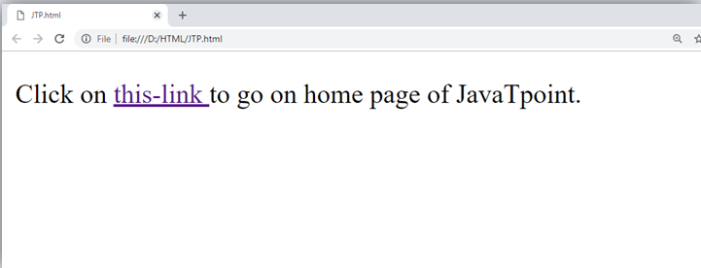

**Note:**

* + The**target**attributecanonlyuse withhrefattributeinanchortag.
  + Ifwewillnot usetargetattributethen linkwillopen insamepage.

### AppearanceofHTMLanchor tag

An**unvisitedlink**isdisplayedunderlinedandblue. A **visited link** displayed underlined and purple.

An**activelink**isunderlinedandred.

# HTMLImage

**HTMLimgtag**isusedto displayimageonthewebpage. HTML imgtagisanemptytag that contains attributes only, closing tags are not used in HTML image element.

Let'ssee anexampleofHTMLimage.

1. <h2>HTMLImageExample</h2>
2. <imgsrc="good_morning.jpg"alt="GoodMorningFriends"/>

Output:



### AttributesofHTMLimgtag

Thesrcandalt are important attributesofHTML imgtag.AllattributesofHTML imagetag are given below.

1. *src*

Itisa necessaryattributethat describesthesourceorpathoftheimage. It instructsthe browser where to look for the image on the server.

Thelocationofimagemaybeonthesamedirectoryoranotherserver.

1. *alt*

Thealt attributedefinesanalternatetextforthe image,ifit can't bedisplayed.Thevalueof the alt attribute describe the image in words. The alt attribute is considered good for SEO prospective.

1. *width*

It isanoptionalattributewhichisusedtospecifythewidthtodisplaythe image. Itis not recommended now. You should apply CSS in place of width attribute.

1. *height*

Ith3theheight oftheimage.TheHTMLheight attributealso supportsiframe, imageand object elements. It is not recommended now. You should apply CSS in place of height attribute.

### Useof height andwidthattributewithimgtag

Youhave learnt abouthowtoinsert animage inyourwebpage,nowifwewantto givesome height and width to display image according to our requirement, then we can set it with height and width attributes of image.

### Example:

* 1. <imgsrc="animal.jpg" height="180"width="300"alt="animalimage">

##### Output:

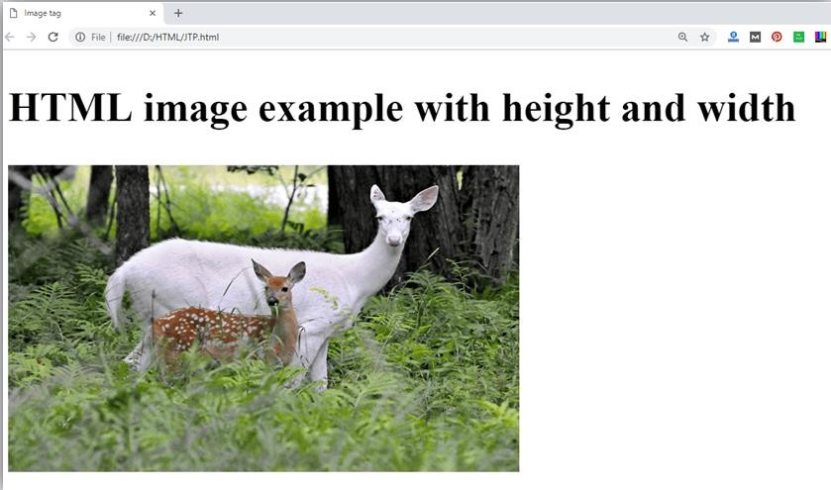

*Note:Alwaystrytoinserttheimagewithheight andwidth, elseitmayflickerwhiledisplayingon webpage.*

### Useofaltattribute

We can use alt attribute with tag.Itwilldisplayanalternativetext incase ifimage cannot be displayed on browser. Following is the example for alt attribute:

1. <imgsrc="animal.png"height="180"width="300"alt="animalimage">

**Output:**

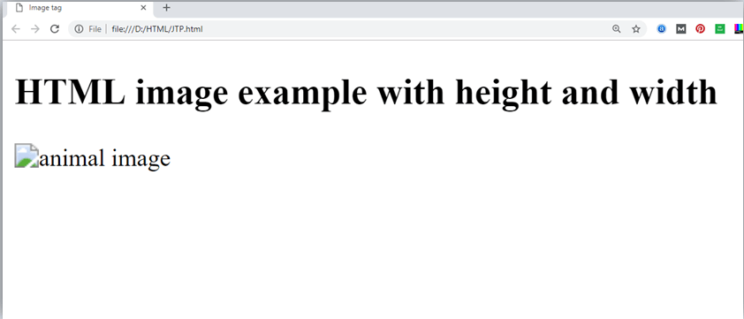

### Howtogetimagefromanother directory/folder?

To insert animage in your web, that image must be present in your same folder where you haveputtheHTMLfile.But ifinsomecase image isavailable insomeotherdirectorythen you can access the image like this:

1. <img src="E:/images/animal.png" height="180" width="300" alt="animal image"> InabovestatementwehaveputimageinlocaldiskE------>images folder >animal.png.

*Note:If srcURLwill beincorrectormisspellthenit will not displayyourimageonwebpage, sotry to put correct URL.*

### Use<img>tag asa link

Wecanalsolinkanimagewithother pageor wecanuseanimageasalink.Todothis,put

<img>taginsidethe<a>tag.

### Example:

1. <ahref="https:/[/www](http://www.javatpoint.com/what-is-).[javatpoint.com/what-is-](http://www.javatpoint.com/what-is-)

robotics"><imgsrc="robot.jpg"height="100"width="100"></a>

**Output:**



# HTMLTable

**HTMLtabletag**isusedto displaydataintabularform(row*column). Therecanbe many columns in a row.

Wecancreateatableto displaydataintabularform,using<table>element,withthehelp of

<tr>,<td>,and<th>elements.

InEachtable, tablerowisdefined by<tr>tag,tableheader isdefined by<th>, andtabledata is defined by <td> tags.

HTMLtablesareusedtomanagethe layoutofthepagee.g.headersection,navigationbar, bodycontent, footersectionetc. But it isrecommendedtousedivtagovertableto manage the layout of the page .

### HTMLTableTags

|  |  |
| --- | --- |
| **Tag** | **Description** |
| <table> | Itdefinesa table. |
| <tr> | It definesarow ina table. |
| <th> | Itdefinesaheader cellina table. |
| <td> | Itdefinesacellin atable. |
| <caption> | Itdefinesthetablecaption. |
| <colgroup> | Itspecifiesagroupofoneormorecolumnsinatableforformatting. |
| <col> | Itisusedwith<colgroup>elementtospecifycolumnpropertiesforeachcolumn. |
| <tbody> | It isused togroupthebodycontentina table. |
| <thead> | Itisusedtogrouptheheadercontentinatable. |
| <tfooter> | Itisusedtogroupthefooter contentina table. |

**HTMLTable Example**

Let'ssee theexample ofHTMLtable tag.Itoutput isshownabove.

1. <table>
2. <tr><th>First_Name</th><th>Last_Name</th><th>Marks</th></tr>
3. <tr><td>Sonoo</td><td>Jaiswal</td><td>60</td></tr>
4. <tr><td>James</td><td>William</td><td>80</td></tr>
5. <tr><td>Swati</td><td>Sironi</td><td>82</td></tr>
6. <tr><td>Chetna</td><td>Singh</td><td>72</td></tr>
7. </table>

**Output:**

|  |  |  |
| --- | --- | --- |
| **First_Name** | **Last_Name** | **Marks** |
| Sonoo | Jaiswal | 60 |

# HTMLLists

HTMLListsareusedto specifylistsofinformation. Alllists maycontainoneormore list elements. There are three different types of HTML lists:

1. OrderedList orNumberedList(ol)
2. UnorderedListorBulletedList(ul)
3. DescriptionListorDefinitionList(dl)

*Note:Wecancreatealistinsideanotherlist, whichwillbetermedasnestedList.*

### HTMLOrderedListorNumberedList

IntheorderedHTMLlists, allthe list itemsaremarkedwithnumbersbydefault. It isknown as numbered list also. The ordered list starts with <ol> tag and the list items start with <li>tag.

1. <ol>
2. <li>Aries</li>
3. <li>Bingo</li>
4. <li>Leo</li>
5. <li>Oracle</li>
6. </ol>

Output:

1. Aries
2. Bingo
3. Leo
4. Oracle

Clickherefor fulldetailsofHTMLorderedlist.[HTMLOrdered List](https://www.javatpoint.com/html-ordered-list)

### HTMLUnorderedListorBulletedList

In HTML Unordered list, allthe list items are marked with bullets. It is also known as bulletedlist also.TheUnorderedlist startswith<ul>tagand list itemsstart withthe<li>tag.

1. <ul>
2. <li>Aries</li>
3. <li>Bingo</li>
4. <li>Leo</li>
5. <li>Oracle</li>
6. </ul>

Output:

* + Aries
  + Bingo
  + Leo
  + Oracle

### HTML DescriptionListorDefinition List

HTMLDescriptionlist isalso alist stylewhichissupportedbyHTMLandXHTML.It is also known as definition list where entries are listed like a dictionaryor encyclopedia.

Thedefinitionlist isveryappropriatewhenyouwantto present glossary, list oftermsor other name-value list.

TheHTMLdefinitionlistcontainsfollowingthreetags:

1. **<dl>tag**definesthestartofthelist.
2. **<dt>tag**definesa term.
3. **<dd>tag**definesthetermdefinition(description).
4. <dl>
5. <dt>Aries</dt>
6. <dd>-Oneofthe12 horoscopesign.</dd>
7. <dt>Bingo</dt>
8. <dd>-Oneofmyevening snacks</dd>
9. <dt>Leo</dt>
10. <dd>-Itisalsoanoneofthe12horoscope sign.</dd>
11. <dt>Oracle</dt>
12. <dd>-Itisamultinationaltechnologycorporation.</dd>
13. </dl>

Output:

Aries

Bingo

Leo

Oracle

-Oneofthe12horoscopesign.

-Oneofmyeveningsnacks

-Itis alsoanoneofthe12horoscopesign.

-Itisamultinationaltechnologycorporation.

ClickhereforfulldetailsofHTMLdescriptionlist.[HTMLDescriptionList](https://www.javatpoint.com/html-description-list)

### HTMLNested List

Alist withinanotherlist istermedasnestedlist.Ifyouwant abullet list insideanumbered list then such type of list will called as nested list.

##### Code:

1. <!DOCTYPE html>
2. <html>
3. <head>
4. <title>Nestedlist</title>
5. </head>
6. <body>
7. <p>ListofIndianStateswiththiercapital</p>
8. <ol>
9. <li>Delhi
10. <ul>
11. <li>NewDelhi</li>
12. </ul>
13. </li>
14. <li>Haryana
15. <ul>
16. <li>Chandigarh</li>
17. </ul>
18. </li>
19. <li>Gujarat
20. <ul>
21. <li>Gandhinagar</li>
22. </ul>
23. </li>
24. <li>Rajasthan
25. <ul>
26. <li>Jaipur</li>
27. </ul>
28. </li>
29. <li>Maharashtra
30. <ul>
31. <li>Mumbai</li>
32. </ul>
33. </li>
34. <li>Uttarpradesh
35. <ul>
36. <li>Lucknow</li></ul>
37. </li>
38. </ol>
39. </body>
40. </html>

**Output:**

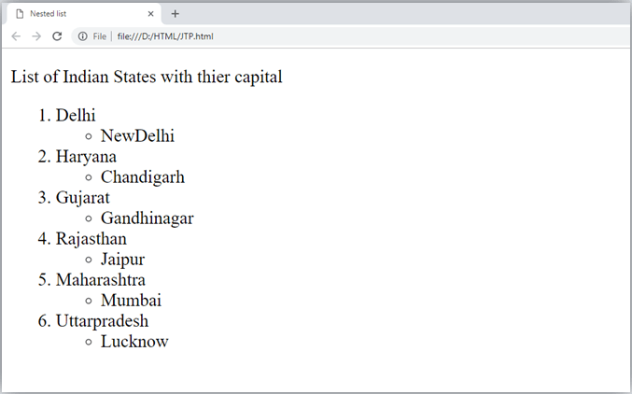

# HTMLOrderedList|HTMLNumbered List

**HTML Ordered List** or Numbered List displays elements innumbered format. The HTML oltag is used for ordered list. We can use ordered list to represent items either in numerical orderformat oralphabeticalorderformat,oranyformat whereanorderisemphasized.There can be different types of numbered list:

* + NumericNumber(1,2,3)
  + CapitalRomanNumber(IIIIII)
  + SmallRomalNumber(iiiiii)
  + CapitalAlphabet(ABC)
  + SmallAlphabet(abc)

Torepresentdifferentorderedlists, thereare5typesofattributesin<ol>tag.

|  |  |
| --- | --- |
| **Type** | **Description** |
| Type"1" | Thisisthedefaulttype.Inthistype, thelistitemsarenumberedwithnumbers. |
| Type"I" | Inthistype, thelistitemsarenumberedwithuppercaseromannumbers. |
| Type"i" | Inthistype,thelistitemsarenumberedwithlowercaseromannumbers. |
| Type"A" | Inthistype,thelistitemsarenumberedwithuppercaseletters. |
| Type"a" | Inthistype, thelistitemsarenumberedwithlowercaseletters. |

### HTMLOrderedList Example

Let'sseetheexampleofHTMLorderedlistthat displays4topicsinnumbered list.Herewe are not defining type="1" because it is the default type.

1. <ol>
2. <li>HTML</li>
3. <li>Java</li>
4. <li>JavaScript</li>
5. <li>SQL</li>
6. </ol> Output:
   1. HTML
   2. Java
   3. JavaScript
   4. SQL

### ol type="I"

Let'sseetheexampletodisplaylistinromannumber uppercase.

1. <oltype="I">
2. <li>HTML</li>
3. <li>Java</li>
4. <li>JavaScript</li>
5. <li>SQL</li>
6. </ol> Output:
7. HTML
8. Java
9. JavaScript
10. SQL

### ol type="i"

Let'sseetheexampletodisplaylistinromannumberlowercase.

* 1. <oltype="i">
  2. <li>HTML</li>
  3. <li>Java</li>
  4. <li>JavaScript</li>
  5. <li>SQL</li>
  6. </ol> Output:

1. HTML
2. Java
3. JavaScript
4. SQL

### ol type="A"

Let'sseetheexampletodisplaylistinalphabetuppercase.

* 1. <oltype="A">
  2. <li>HTML</li>
  3. <li>Java</li>
  4. <li>JavaScript</li>
  5. <li>SQL</li>
  6. </ol> Output:
     1. HTML
     2. Java
     3. JavaScript
     4. SQL

### ol type="a"

Let'sseetheexampletodisplaylistinalphabetlowercase.

1. <oltype="a">
2. <li>HTML</li>
3. <li>Java</li>
4. <li>JavaScript</li>
5. <li>SQL</li>
6. </ol> Output:
   1. HTML
   2. Java
   3. JavaScript
   4. SQL

### startattribute

Thestartattributeisused witholtagtospecifyfromwheretostartthelistitems.

**<oltype="1" start="5">**:Itwillshownumericvaluesstartingwith"5".

**<oltype="A" start="5">**: It willshow capitalalphabetsstarting with"E".

**<oltype="a"start="5">**:Itwillshowlowercasealphabetsstartingwith"e".

**<oltype="I" start="5">**:ItwillshowRomanuppercasevaluestartingwith"V".

**<oltype="i"start="5">**:ItwillshowRomanlowercasevaluestartingwith"v".

1. <oltype="i"start="5">
2. <li>HTML</li>
3. <li>Java</li>
4. <li>JavaScript</li>
5. <li>SQL</li>
6. </ol> Output:
7. HTML
8. Java
9. JavaScript
10. SQL

# HTMLForm

An**HTMLform** is*asectionof adocument* whichcontainscontrolssuchastext fields, password fields, checkboxes, radio buttons, submit button, menus etc.

AnHTMLformfacilitatestheuserto enterdatathat isto besenttotheserver forprocessing such as name, email address, password, phone number, etc. .

### Why useHTMLForm

HTMLformsarerequiredif youwanttocollectsomedatafromofthesitevisitor.

Forexample:Ifauserwantto purchasesome itemsoninternet,he/she must fillthe formsuch as shipping address and credit/debit card details so that itemcanbe sent to the givenaddress.

### HTMLFormSyntax

* 1. <formaction="server url"method="get|post">
  2. //inputcontrolse.g.textfield,textarea,radiobutton,button
  3. </form>

### HTMLFormTags

Let'sseethelistofHTML5formtags.

|  |  |
| --- | --- |
| **Tag** | **Description** |
| <form> | It definesanHTMLformtoenterinputsbytheusedside. |
| <input> | Itdefinesaninputcontrol. |
| <textarea> | Itdefinesamulti-lineinput control. |
| <label> | Itdefinesa labelfor aninputelement. |
| <fieldset> | Itgroupstherelatedelementinaform. |

|  |  |
| --- | --- |
| <legend> | Itdefinesacaptionfora<fieldset>element. |
| <select> | Itdefinesa drop-downlist. |
| <optgroup> | Itdefinesagroupofrelatedoptionsinadrop-downlist. |
| <option> | It definesanoptioninadrop-downlist. |
| <button> | Itdefinesaclickablebutton. |

### HTML5FormTags

Let'sseethelistofHTML5formtags.

|  |  |
| --- | --- |
| **Tag** | **Description** |
| <datalist> | Itspecifiesalistofpre-definedoptionsforinputcontrol. |
| <keygen> | Itdefinesakey-pairgeneratorfieldforforms. |
| <output> | Itdefines theresult ofacalculation. |

### HTML<form>element

TheHTML<form>element provideadocument sectiontotakeinput fromuser.Itprovides various interactive controls for submitting informationto webserver suchas text field, text area, password field, etc.

*Note:The<form>element does notitselfcreateaformbutitiscontainerto containallrequiredform elements, such as <input>, <label>, etc.*

##### Syntax:

1. <form>
2. //Form elements
3. </form>

### HTML<input> element

TheHTML<input>element is fundamentalformelement.Itisusedto createformfields,to takeinput fromuser. Wecanapplydifferent input filed to gather different information form user. Following is the example to show the simple text input.

### Example:

1. <body>
2. <form>
3. Enteryourname<br>
4. <inputtype="text"name="username">
5. </form>
6. </body>

**Output:**

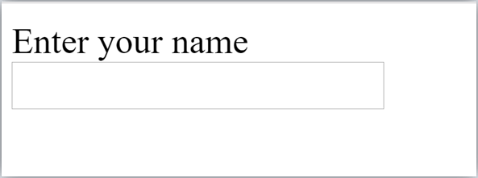

### HTMLTextFieldControl

Thetype="text"attributeofinputtagcreatestextfieldcontrolalso knownassingle line textfield control. The name attribute is optional, but it is required for the server side component such as JSP, ASP, PHP etc.

1. <form>
2. FirstName:<inputtype="text"name="firstname"/><br/>
3. Last Name:<inputtype="text"name="lastname"/><br/>
4. </form>

##### Output:

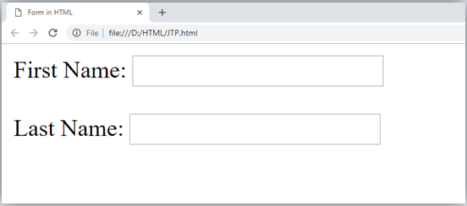

*Note:If youwill omit'name'attributethenthetextfiledinputwill notbesubmittedtoserver.*

### HTML<textarea>taginform

The<textarea>taginHTML isusedtoinsertmultiple-linetextinaform. Thesizeof

<textarea>canbespecifyeitherusing "rows"or"cols"attributeorbyCSS.

##### Example:

1. <!DOCTYPE html>
2. <html>
3. <head>
4. <title>ForminHTML</title>
5. </head>
6. <body>
7. <form>
8. Enteryouraddress:<br>
9. <textarearows="2"cols="20"></textarea>
10. </form>
11. </body>
12. </html>

**Output:**

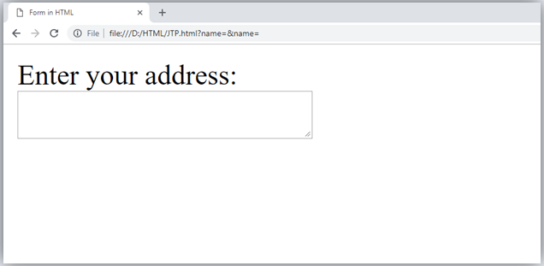

### LabelTagin Form

Itisconsideredbetterto have labelin form.Asit makesthecodeparser/browser/user friendly.

Ifyouclickonthe labeltag,it willfocusonthetextcontrol.Todo so,youneedto have for attribute in label tag that must be same as id attribute of input tag.

*NOTE:Itisgoodtouse<label>tagwith form, although itisoptionalbutifyou will useit,thenit will provide a focus when you tap or click on label tag. It is more worthy with touchscreens.*

1. <form>
2. <labelfor="firstname">FirstName:</label><br/>
3. <inputtype="text"id="firstname"name="firstname"/><br/>
4. <labelfor="lastname">LastName:</label>
5. <inputtype="text"id="lastname"name="lastname"/><br/>
6. </form>

**Output:**

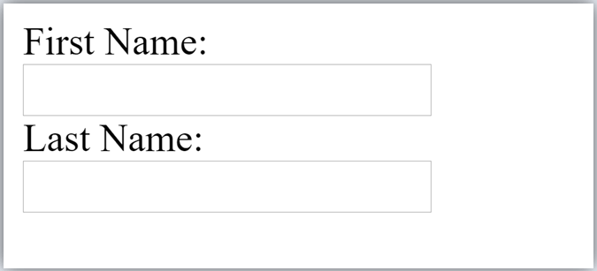

### HTMLPasswordFieldControl

Thepasswordisnotvisibletotheuserinpasswordfieldcontrol.

1. <form>
2. <labelfor="password">Password:</label>
3. <inputtype="password"id="password"name="password"/><br/>
4. </form>

**Output:**

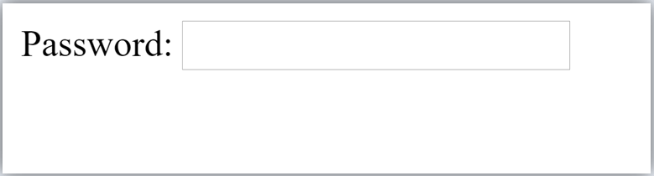

### HTML5 EmailFieldControl

Theemailfield innew inHTML5. It validatesthetext forcorrect emailaddress.Youmust use @ and . in this field.

1. <form>
2. <labelfor="email">Email:</label>
3. <inputtype="email"id="email"name="email"/><br/>
4. </form>

Itwilldisplayinbrowserlikebelow:



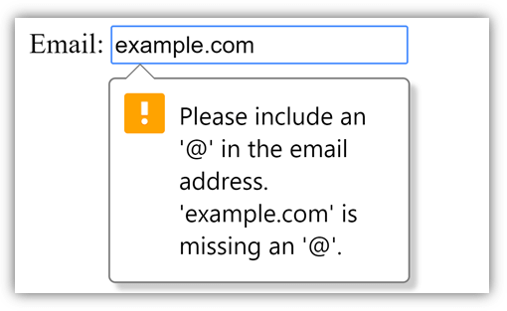*Note:Ifwe willnotenterthecorrectemail,itwilldisplayerror like:*

### RadioButtonControl

Theradio buttonisusedtoselectoneoptionfrommultipleoptions.Itisused forselectionof gender, quiz questions etc.

Ifyouuseonename forallthe radio buttons,onlyoneradio buttoncanbeselectedat atime. Using radio buttons for multiple options, you can only choose a single option at a time.

1. <form>
2. <labelfor="gender">Gender:</label>
3. <inputtype="radio"id="gender"name="gender" value="male"/>Male
4. <inputtype="radio"id="gender"name="gender"value="female"/>Female<br/>
5. </form>

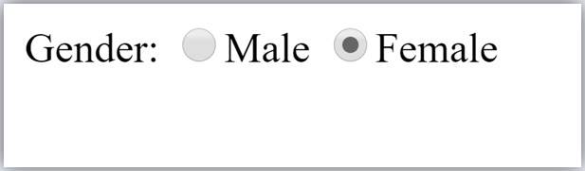

### CheckboxControl

Thecheckboxcontrolisusedtocheckmultipleoptionsfromgivencheckboxes.

1. <form>
2. Hobby:<br>
3. <inputtype="checkbox"id="cricket"name="cricket"value="cricket"/>
4. <labelfor="cricket">Cricket</label><br>
5. <inputtype="checkbox"id="football"name="football"value="football"/>
6. <labelfor="football">Football</label><br>
7. <inputtype="checkbox"id="hockey"name="hockey"value="hockey"/>
8. <labelfor="hockey">Hockey</label>
9. </form>

*Note:Thesearesimilartoradiobutton except itcan choose multipleoptionsat atimeandradio button can select one button at a time, and its display.*

**Output:**

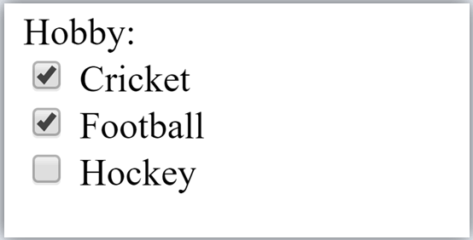

### Submit buttoncontrol

HTML**<inputtype="submit">**areusedto addasubmit buttononwebpage. Whenuser clicks on submit button, then form get submit to the server.

Syntax:

1. <inputtype="submit"value="submit">

Thetype=submit,specifyingthatitisasubmitbutton

Thevalueattributecanbeanythingwhichwewriteonbuttononwebpage. The name attribute can be omit here.

##### Example:

1. <form>
2. <labelfor="name">Entername</label><br>
3. <inputtype="text"id="name" name="name"><br>
4. <labelfor="pass">EnterPassword</label><br>
5. <inputtype="Password"id="pass"name="pass"><br>
6. <inputtype="submit"value="submit">
7. </form>

**Output:**

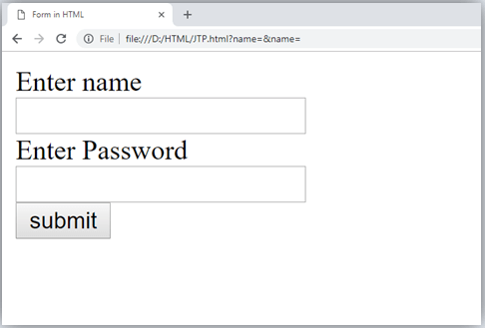

### HTML<fieldset>element:

The<fieldset>element inHTMLisusedto grouptherelated informationofa form.This element is used with<legend> element whichprovide caption for the grouped elements.

##### Example:

1. <form>
2. <fieldset>
3. <legend>UserInformation:</legend>
4. <labelfor="name">Entername</label><br>
5. <inputtype="text"id="name"name="name"><br>
6. <labelfor="pass">EnterPassword</label><br>
7. <inputtype="Password"id="pass"name="pass"><br>
8. <inputtype="submit"value="submit">
9. </fieldset>
10. lt;/form>

**Output:**

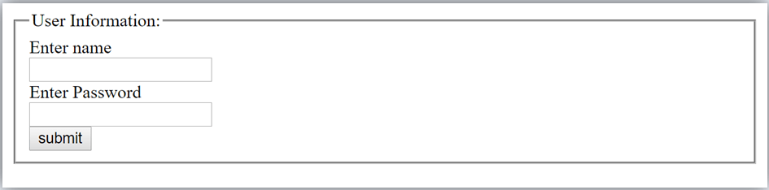

### HTMLFormExample

Followingistheexampleforasimpleformofregistration.

1. <!DOCTYPE html>
2. <html>
3. <head>
4. <title>ForminHTML</title>
5. </head>
6. <body>
7. <h2>Registrationform</h2>
8. <form>
9. <fieldset>
10. <legend>Userpersonalinformation</legend>
11. <label>Enteryourfullname</label><br>
12. <inputtype="text"name="name"><br>
13. <label>Enteryour email</label><br>
14. <inputtype="email"name="email"><br>
15. <label>Enteryour password</label><br>
16. <inputtype="password"name="pass"><br>
17. <label>confirmyourpassword</label><br>
18. <inputtype="password"name="pass"><br>
19. <br><label>Enteryourgender</label><br>
20. <inputtype="radio"id="gender"name="gender"value="male"/>Male<br>
21. <inputtype="radio"id="gender"name="gender"value="female"/>Female<br/

>

1. <inputtype="radio"id="gender"name="gender"value="others"/>others<br/>
2. <br>Enteryour Address:<br>
3. <textarea></textarea><br>
4. <inputtype="submit"value="sign-up">
5. </fieldset>
6. </form>
7. </body>
8. </html>

**Output:**

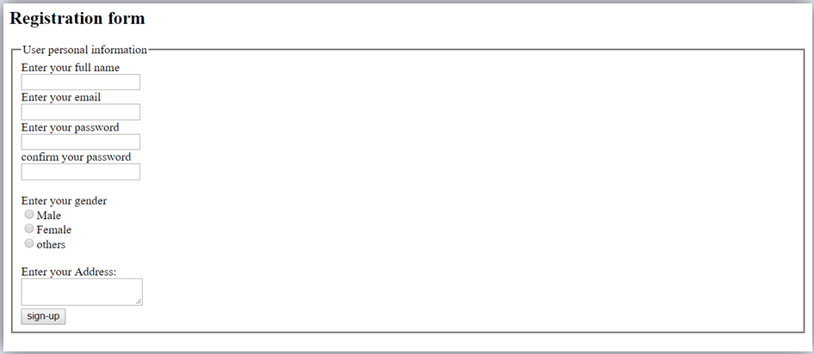

# HTMLFormInputTypes

InHTML<input type=""> isanimportantelementofHTML form. The"type"attributeof input element can be various types, which defines information field. Such as <input type="text" name="name"> gives a text box.

### Followingisalistofalltypesof<input>elementof HTML.

|  |  |
| --- | --- |
| **type=""** | **Description** |
| text | Definesaone-linetextinputfield |
| password | Definesaone-linepasswordinputfield |
| submit | Definesasubmit buttontosubmittheformtoserver |
| reset | Definesaresetbuttontoresetallvaluesintheform. |
| radio | Definesaradiobuttonwhichallowsselectoneoption. |
| checkbox | Definescheckboxeswhichallowselect multipleoptionsform. |
| button | Definesasimplepushbutton,whichcanbeprogrammedtoperformataskonan event. |
| file | Definestoselectthefilefromdevicestorage. |
| image | Definesagraphicalsubmitbutton. |

##### HTML5addednewtypeson<input>element. Followingisthelistoftypesofelements of HTML5

|  |  |
| --- | --- |
| **type=""** | **Description** |
| color | Definesaninputfieldwithaspecificcolor. |
| date | Definesaninputfieldfor selectionofdate. |
| datetime-local | Definesaninputfieldfor enteringa datewithouttimezone. |
| email | Definesaninputfieldforenteringanemailaddress. |
| month | Definesacontrolwithmonthandyear,withouttimezone. |
| number | Definesaninputfieldtoenteranumber. |
| url | DefinesafieldforenteringURL |
| week | Definesa fieldtoenterthedatewithweek-year,withouttimezone. |
| search | Definesasinglelinetextfieldforenteringasearchstring. |
| tel | Definesaninputfieldforenteringthetelephonenumber. |

**Followingisthedescription abouttypesof<input>element withexamples.**

1. <inputtype="text">:

<input>elementoftype"text"areusedtodefinea single-line inputtext field. Example:

* 1. <form>
  2. <label>Enterfirstname</label><br>
  3. <inputtype="text"name="firstname"><br>
  4. <label>Enterlastname</label><br>
  5. <inputtype="text"name="lastname"><br>
  6. <p><strong>Note:</strong>Thedefaultmaximumcahracterlenghtis20.</p>
  7. </form>

##### Output:

Input"text"type:

The**"text"**fielddefinesasinlgeline inputtextfield.

Enterfirstname

Enterlastname

**Note:**Thedefaultmaximumcahracterlenghtis20.

1. <inputtype="password">:

The <input> element oftype "password" allow a user to enterthe passwordsecurely ina webpage.Theenteredtext inpasswordfiledconvertedinto"*"or".",sothat it cannot be read by another user.

Example:

* 1. <form>
  2. <label>EnterUsername</label><br>
  3. <inputtype="text"name="firstname"><br>
  4. <label>EnterPassword</label><br>
  5. <inputtype="Password"name="password"><br>
  6. <br><inputtype="submit"value="submit">
  7. </form>

##### Output:

Input "password"type:

The**"password"**fielddefinesasinlge line input passwordfieldto enterthepassword securely.

EnterUsername

EnterPassword

1. <inputtype="submit">:

The<input>element oftype"submit"definesasubmit buttonto submit the formtothe server when the "click" event occurs.

Example:

* 1. <formaction="https:/[/www](http://www.javatpoint.com/html-tutorial).[javatpoint.com/html-tutorial](http://www.javatpoint.com/html-tutorial)">
  2. <label>EnterUsername</label><br>
  3. <inputtype="text"name="firstname"><br>
  4. <label>EnterPassword</label><br>
  5. <inputtype="Password"name="password"><br>
  6. <br><inputtype="submit"value="submit">
  7. </form>

##### Output:

Input"submit"type:

EnterUsername

EnterPassword

Afterclickingonsubmit button,thiswillsubmit theformto serverandwillredirectthepage to **action** value.We will learn about "action" attribute in later chapters

1. <inputtype="reset">:

The<input>type"reset" isalso definedasabuttonbut whentheuserperformsaclickevent, it by default reset the all inputted values.

Example:

* 1. <form>
  2. <label>Userid:</label>
  3. <inputtype="text"name="user-id"value="user">
  4. <label>Password:</label>
  5. <inputtype="password"name="pass"value="pass"><br><br>
  6. <inputtype="submit"value="login">
  7. <inputtype="reset"value="Reset">
  8. </form>

##### Output:

Input"reset"type:

user

Userid:

Password:

****

Trytochangethe input valuesofuser idandpassword,thenwhenyouclickonreset,it will reset input fields with default values.

1. <inputtype="radio">:

The<input>type"radio"definestheradio buttons,whichallowchoosinganoptionbetween a set of related options. At a time onlyone radio buttonoption can be selected at a time.

Example:

* 1. <form>
  2. <p>KindlySelectyourfavoritecolor</p>
  3. <inputtype="radio"name="color"value="red">Red<br>
  4. <inputtype="radio"name="color"value="blue">blue<br>
  5. <inputtype="radio"name="color"value="green">green<br>
  6. <inputtype="radio"name="color"value="pink">pink<br>
  7. <inputtype="submit"value="submit">
  8. </form>

##### Output:

Input"radio"type

KindlySelectyourfavoritecolor

Red blue green pink

1. <inputtype="checkbox">:

The<input>type"checkbox"aredisplayedassquareboxeswhichcanbecheckedor unchecked to select the choices from the given options.

*Note: The "radio" buttons are similar to checkboxes, but there is an important difference between both types:radiobuttonsallowtheuser toselect onlyoneoptionatatime, whereas checkboxallows a user to select zero to multiple options at a time.*

Example:

* 1. <form>
  2. <label>EnteryourName:</label>
  3. <inputtype="text"name="name">
  4. <p>KindlySelectyourfavouritesports</p>
  5. <inputtype="checkbox"name="sport1"value="cricket">Cricket<br>
  6. <inputtype="checkbox"name="sport2"value="tennis">Tennis<br>
  7. <inputtype="checkbox"name="sport3"value="football">Football<br>
  8. <inputtype="checkbox"name="sport4"value="baseball">Baseball<br>
  9. <inputtype="checkbox"name="sport5"value="badminton">Badminton<br><br>
  10. <inputtype="submit"value="submit">
  11. </form>

**Output:**

### Input"checkbox"type

RegistrationForm

EnteryourName:

KindlySelectyour favorite sports

Cricket Tennis Football Baseball Badminton

1. <inputtype="button">:

The<input>type"button"definesasimplepushbutton, whichcanbeprogrammedtocontrol a functionally on any event such as, click event.

*Note:ItmainlyworkswithJavaScript.*

Example:

* 1. <form>
  2. <inputtype="button"value="Clcikme"onclick="alert('youarelearningHTML')">
  3. </form>

**Output:**

### Input"button"type.

Click the buttontoseethe result:

*Note:Intheaboveexamplewehaveusedthe"alert"ofJS, whichyouwill learninourJStutorial.It is used to show a pop window.*

1. <inputtype="file">:

The <input> element with type "file" is used to select one or more files fromuser device storage.Once youselectthefile,andaftersubmission,thisfilecanbeuploadedtotheserver with the help of JS code and file API.

Example:

* 1. <form>
  2. <label>Selectfiletoupload:</label>
  3. <inputtype="file"name="newfile">
  4. <inputtype="submit"value="submit">
  5. </form>

**Output:**

### Input"file"type.

Wecanchooseanytypeoffileuntilwedo notspecify it!Theselectedfilewillappear at next to "choose file" option

Select filetoupload:

1. <inputtype="image">:

The<input>type"image" isusedtorepresent asubmit buttoninthe formofimage. Example:

* 1. <!DOCTYPE html>
  2. <html>
  3. <body>
  4. <h2>Input"image"type.</h2>
  5. <p>Wecancreate animageassubmitbutton</p>
  6. <form>
  7. <label>Userid:</label><br>
  8. <inputtype="text"name="name"><br><br>
  9. <inputtype="image"alt="Submit"src="login.png"width="100px">
  10. </form>
  11. ​
  12. </body>
  13. </html>

### HTML5newlyadded<input>typeselement

1. <inputtype="color">:

The<input>type"color"isusedto defineaninput fieldwhichcontainsacolour.It allowsa user to specify the colour by the visual colour interface on a browser.

*Note:The"color"typeonlysupportscolorvalueinhexadecimal format,andthedefault valueis #000000 (black).*

Example:

* 1. <form>
  2. Pickyour Favoritecolor:<br><br>
  3. <inputtype="color"name="upclick"value="#a52a2a">Upclick<br><br>
  4. <inputtype="color"name="downclick"value="#f5f5dc">Downclick
  5. </form>

##### Output:

Input"color"types:

Pickyour Favoritecolor:

Up-click Down-click

**Note:**Thedefault valueof"color"type is#000000(black).Itonlysupportscolorvalue in hexadecimal format.

1. <inputtype="date">:

The<input>element oftype"date"generatesaninputfield,whichallowsauserto input the date in a given format. A user can enter the date bytext field or bydate picker interface.

Example:

* 1. <form>
  2. SelectStartandEndDate:<br><br>
  3. <inputtype="date"name="Startdate">Startdate:<br><br>
  4. <inputtype="date"name="Enddate">Enddate:<br><br>
  5. <inputtype="submit">
  6. </form>

##### Output:

Input"date"type

SelectStartandEndDate: Start date:

Enddate:

1. <inputtype="datetime-local">:

The<input>element oftype"datetime-local"createsinput filedwhichallowauserto select the date as wellas localtime in the hour and minute without time zone information.

Example:

* 1. <form>
  2. <label>
  3. Select themeetingschedule:<br><br>
  4. Selectdate&time:<inputtype="datetime-local"name="meetingdate"><br><br>
  5. </label>
  6. <inputtype="submit">
  7. </form>

##### Output:

Input"datetime-local"type

Selectthemeetingschedule: Select date & time:

1. <inputtype="email">:

The<input>type"email"createsaninput filedwhichallowauserto enterthee-mailaddress with pattern validation. The multiple attributes allow a user to enter more than one email address.

Example:

* 1. <form>
  2. <label><b>EnteryourEmail-address</b></label>
  3. <inputtype="email"name="email"required>
  4. <inputtype="submit">
  5. <p><strong>Note:</strong>Usercanalso entermultipleemailaddressesseparat ing by comma or whitespace as following: </p>
  6. <label><b>EntermultipleEmail-addresses</b></label>
  7. <inputtype="email"name="email"multiple>
  8. <inputtype="submit">
  9. </form>

##### Output:

Input"email"type

**EnteryourEmail-address**

**Note:**Usercanalso entermultipleemailaddressesseparating bycommaorwhitespaceas following:

**EntermultipleEmail-addresses**

1. <inputtype="month">:

The <input> type "month" creates an input field which allows a user to easily enter month and year inthe formatof"MM,YYYY"whereMMdefinesmonthvalue,andYYYYdefines the year value. New

Example:

* 1. <form>
  2. <label>EnteryourBirthMonth-year:</label>
  3. <inputtype="month" name="newMonth">
  4. <inputtype="submit">
  5. </form>

##### Output:

Input"month"type:

EnteryourBirthMonth-year:

# HTMLformAttribute

### HTML<form>elementattributes

InHTMLtherearevariousattributesavailablefor<form>elementwhicharegivenbelow:

### HTMLactionattribute

Theactionattributeof<form>element definesthe processtobeperformedonformwhen form is submitted, or it is a URI to process the form information.

Theactionattributevaluedefinesthewebpagewhereinformationproceed.It canbe.php,

.jsp,.asp,etc.oranyURLwhereyouwanttoprocessyour form.

*Note:If actionattributevalueis blankthenformwill beprocessedtothesamepage.*

Example:

1. <formaction="action.html"method="post">
2. <label>UserName:</label><br>
3. <inputtype="text"name="name"><br><br>
4. <label>UserPassword</label><br>
5. <inputtype="password"name="pass"><br><br>
6. <inputtype="submit">
7. </form>

**Output:**

### Demoofactionattributeofformelement

UserName:

UserPassword

##### Itwillredirecttoanewpage"action.html"whenyouclickonsubmitbutton

HTMLmethod attribute

ThemethodattributedefinestheHTTPmethodwhichbrowserusedto submit theform.The possible values of method attribute can be:

* **post:**Wecanusethepost valueof methodattributewhen wewant toprocess thesensitive data as it does not display the submitted data in URL.

Example:

1. <formaction="action.html"method="post">
   * **get:**Thegetvalueof methodattributeisdefaultvaluewhilesubmittingtheform. Butthisis not secure as it displays data in URL after submitting the form.

Example:

1.<formaction="action.html"method="get">

Whensubmitting the data,itwilldisplaytheentered dataintheformof:

1.file:///D:/HTML/action.html?name=JavaTPoint&pass=123

### HTMLtarget attribute

Thetarget attributedefineswheretoopentheresponseaftersubmittingthe form.The following are the keywords used with the target attribute.

* **_self:**Ifweuse_selfas anattributevalue,thentheresponsewilldisplayincurrentpageonly.

Example:

1. <formaction="action.html"method="get"target="_self">
   * **_blank:**Ifweuse_blankasanattributeitwillloadtheresponseinanewpage.

Example:

1. <formaction="action.html"method="get"target="_blank">

### HTMLautocompleteattribute

TheHTMLautocompleteattributeisanewlyaddedattributeofHTML5whichenablesan input fieldto completeautomatically.It canhavetwo values"on"and"off"which enables autocomplete either ON or OFF. The default value of autocomplete attribute is "on".

Example:

1. <formaction="action.html"method="get"autocomplete="on">Example:
   1. <formaction="action.html"method="get"autocomplete="off">

*Note:itcanbeusedwith<form>element and<input>element both.*

### HTMLenctypeattribute

TheHTMLenctypeattributedefinestheencoding typeofform-content whilesubmittingthe form to the server. The possible values of enctype can be:

* + - **application/x-www-form-urlencoded:**Itisdefault encodingtypeiftheenctypeattributeis not included in the form. All characters are encoded before submitting the form.

Example:

1. <formaction="action.html"method="post"enctype="application/x-www-form- urlencoded">
   * **multipart/form-data:**Itdoesnot encodeanycharacter. Itisusedwhenour formcontains file-upload controls.

Example:

1. <formaction="action.html"method="post"enctype="multipart/form-data">
   * **text/plain(HTML5):** Inthis encodingtypeonlyspaceareencodedinto+ symboland noany other special character encoded.

Example:

1.<formaction="action.html"method="post"enctype="text/plain">

### HTMLnovalidateattributeHTML5

Thenovalidateattribute is newlyaddedBooleanattributeofHTML5. Ifweapplythis attribute in formthen it does not performanytype ofvalidationand submit the form.

Example:

1. <formaction="action.html"method="get"novalidate>

**Output:**

### Filltheform

Entername:

Enterage:

Enteremail:

**Trytochangetheformdetialswith novalidateatttributeandwithoutnovalidate attribute and see the difference.**

### HTML<input>elementattribute HTML name attribute

TheHTMLnameattributedefinesthenameofaninput element.Thenameandvalue attribute are included in HTTP request when we submit the form.

*Note:Oneshouldnot omitthenameattributeaswhen wesubmit theformtheHTTPrequest includes both name-value pair and if name is not available it will not process that input field.*

Example:

1. <formaction="action.html"method= "get">
2. Entername:<br><inputtype="name"name="uname"><br>
3. Enterage:<br><inputtype="number"name="age"><br>
4. Enteremail:<br><inputtype="email"><br>
5. <inputtype="submit"value="Submit">
6. </form>

**Output:**

### Filltheform

Entername:

Enterage:

Enteremail:

##### Note:Ifyouwillnotusenameattributeinanyinputfield, thenthatinputfieldwillnot be submitted, when submit the form.

Clickonsubmit andseetheURLwhereemailis notincluded inHTTPrequest aswehave not used name attribute in the email input field

### HTMLvalueattribute

TheHTMLvalueattributedefinestheinitialvalueordefault valueofaninput field. Example:

1. <form>
2. <label>EnteryourName</label><br>
3. <inputtype="text"name="uname"value="EnterName"><br><br>
4. <label>EnteryourEmail-address</label><br>
5. <inputtype="text"name="uname"value="Enteremail"><br><br>
6. <label>Enteryourpassword</label><br>
7. <inputtype="password"name="pass" value=""><br><br>
8. <inputtype="submit"value="login">
9. </form>

**Output:**

### Filltheform

EnteryourName

Enter Name

EnteryourEmail-address

Enter email

Enteryourpassword

**Note:In passwordinputfiledthevalueattributewillalwaysunclear**

### HTMLrequiredattributeHTML5

HTMLrequired isaBooleanattributewhichspecifiesthat usermust fillthat filedbefore submitting the form.

Example:

1. <form>
2. <label>EnteryourEmail-address</label><br>
3. <inputtype="text"name="uname"required><br><br>
4. <label>Enteryourpassword</label><br>
5. <inputtype="password"name="pass"><br><br>
6. <inputtype="submit"value="login">
7. </form>

**Output:**

### Filltheform

EnteryourEmail-address

Enteryourpassword

**Ifyouwilltrytosubmit theformwithoutcompletingemailfieldthenitwillgivean error pop up.**

### HTMLautofocusattributeHTML5

TheautofocusisaBooleanattributewhichenablesafieldautomaticallyfocusedwhena webpage loads.

Example:

1. <form>
2. <label>EnteryourEmail-address</label><br>
3. <inputtype="text"name="uname"autofocus><br><br>
4. <label>Enteryourpassword</label><br>
5. <inputtype="password"name="pass"><br><br>
6. <inputtype="submit"value="login">
7. </form>

### HTMLplaceholderattributeHTML5

Theplaceholderattributespecifiesatext withinaninput fieldwhichinformstheuserabout the expected input of that filed.

Theplaceholderattributecanbeusedwithtext,password,email,andURLvalues. When the user enters the value, the placeholder will be automatically removed.

Example:

1. <form>
2. <label>Enteryourname</label><br>
3. <inputtype="text"name="uname"placeholder="Yourname"><br><br>
4. <label>EnteryourEmailaddress</label><br>
5. <inputtype="email"name="email"placeholder="[example@gmail.com](mailto:example@gmail.com)"><br><br>
6. <label>Enteryourpassword</label><br>
7. <inputtype="password"name="pass"placeholder="yourpassword"><br><br>
8. <inputtype="submit"value="login">
9. </form>

##### Output:

Registrationform

Enteryourname

EnteryourEmailaddress

Enteryourpassword

### HTMLdisabledattribute

TheHTMLdisabledattributewhenappliedthenit disablethat input field.Thedisabledfield does not allow the user to interact with that field.

Thedisabledinput fileddoesnotreceiveclickevents,andtheseinput valuewillnot besent to the server when submitting the form.

Example:

1. <inputtype="text"name="uname"disabled><br><br>

##### Output:

Registrationform

EnterUsername

USER

EnteryourEmailaddress

Enteryourpassword

### HTML size attribute

Thesizeattributecontrolsthesizeoftheinput fieldintypedcharacters. Example:

1. <label>Accountholder name</label><br>
2. <inputtype="text"name="uname"size="40"required><br><br>
3. <label>Accountnumber</label><br>
4. <inputtype="text"name="an"size="30"required><br><br>
5. <label>CVV</label><br>
6. <inputtype="text"name="cvv"size="1"required><br><br>

##### Output:

Registrationformwithdisbaled attribute

Accountholdername

Accountnumber

CVV

### HTMLformattribute

HTMLformattributeallowsauserto specifyaninputfiledoutsidethe formbut remainsthe part of the parent form.

Example:

1. Useremail:<br><inputtype="email"name="email"form="fcontrol"required><br>
2. <inputtype="submit"form="fcontrol">

##### Output:

UserName:

Userpassword:

Theemailfieldisoutsidetheformbutstillitwillremainpartoftheform

Useremail:

# HTMLstyleusingCSS

Let's suppose we have created our web page using a simple HTML code, and we want somethingwhichcanpresentourpageinacorrectformat, andvisiblyattractive. Sotodo this, we can style our web page with CSS (Cascading Stylesheet) properties.

CSSisusedto applythestyle inthewebpagewhichis madeupofHTMLelements. It describes the look of the webpage.

CSSprovidesvariousstylepropertiessuchasbackgroundcolor,padding, margin,border- color, and many more, to style a webpage.

EachpropertyinCSShasaname-valuepair, andeachpropertyisseparatedbyasemicolon (;).

*Note:Inthischapter,wehavegivenasmalloverviewofCSS.Youwilllearneverythingindepth about CSS in our CSS tutorial.*

Example:

1. <bodystyle="text-align:center;">
2. <h2style="color:red;">WelcometojavaTpoint</h2>
3. <pstyle="color:blue;font-size:25px;font-

style: italic;">This isagreatwebsitetolearntechnologiesinverysimpleway. </p>

1. </body>

Intheaboveexample, wehaveusedastyleattributetoprovidesomestyling format toour code.

##### Output:

**WelcometojavaTpoint**

*Thisisagreatwebsitetolearntechnologiesinverysimpleway.*

### ThreewaystoapplyCSS

To useCSS withHTMLdocument,there arethree ways:

* **InlineCSS:**DefineCSSpropertiesusingstyleattributeintheHTMLelements.
* **InternalorEmbeddedCSS:** DefineCSSusing<style>tagin<head>section.
* **ExternalCSS:** DefineallCSSpropertyina separate.css file, andthen includethefilewith HTML file using tag in section.

### Inline CSS:

InlineCSS isusedto applyCSS inasingleelement. Itcanapplystyleuniquelyineach element.

ToapplyinlineCSS, youneedto usestyleattributewithinHTMLelement.Wecanuseas many properties as we want, but each property should be separated by a semicolon (;).

Example:

1. <h3style="color: red;
2. font-style:italic;
3. text-align:center;
4. font-size:50px;
5. padding-top:25px;">LearningHTMLusingInlineCSS</h3>

##### Output:

LearningHTMLusingInlineCSS

### InternalCSS:

AnInternalstylesheetscontainstheCSSproperties forawebpage in<head>sectionof HTML document. To use Internal CSS, we can use class and id attributes.

Wecanuse internalCSSto applyastyle fora singleHTMLpage. Example:

1. <!DOCTYPE html>
2. <html>
3. <head>
4. <style>
5. /*InternalCSSusingelementname*/
6. body{background-color:lavender;
7. text-align:center;}
8. h2{font-style:italic;
9. font-size:30px;
10. color:#f08080;}
11. p{font-size:20px;}
12. /*InternalCSSusingclassname*/
13. .blue{color:blue;}
14. .red{color:red;}
15. .green{color:green;}
16. </style>
17. </head>
18. <body>
19. <h2>LearningHTMLwithinternalCSS</h2>
20. <pclass="blue">Thisisabluecolor paragraph</p>
21. <pclass="red">This isaredcolorparagraph</p>
22. <pclass="green">Thisisagreencolor paragraph</p>
23. </body>
24. </html>

*Note:Intheaboveexample, wehaveusedaclassattributewhichyouwilllearninthenext chapter.*

### ExternalCSS:

AnexternalCSScontainsaseparateCSSfilewhichonlycontainsstylecodeusingtheclass name, id name, tagname, etc. WecanusethisCSSfile inanyHTML file byincluding it in HTML file using <link> tag.

Ifwe have multipleHTMLpages for anapplicationandwhichusesimilar CSS,thenwecan use external CSS.

Therearetwofilesneed tocreatetoapplyexternal CSS

* + First,createtheHTMLfile
  + CreateaCSS fileandsaveit usingthe.css extension(This fileonlywillonlycontainthe styling code.)
  + LinktheCSSfileinyourHTMLfileusingtaginheadersectionofHTML document.

Example:

1. <!DOCTYPE html>
2. <html>
3. <head>
4. <linkrel="stylesheet"type="text/css"href="style.css">
5. </head>
6. <body>
7. <h2>LearningHTMLwithExternalCSS</h2>
8. <pclass="blue">Thisisabluecolor paragraph</p>
9. <pclass="red">This isaredcolorparagraph</p>
10. <pclass="green">Thisisagreencolor paragraph</p>
11. </body>
12. </html>

##### CSSfile:

body{

background-color:lavender; text-align: center;

}

h2{

font-style:italic; size: 30px; color: #f08080;

}

p{

font-size:20px;

}

.blue{ color:blue;

}

.red{ color:red;

}

.green{ color:green;

}

**CommonlyusedCSSproperties:**

|  |  |  |
| --- | --- | --- |
| **Properties-name** | **Syntax** | **Description** |
| background-color | background-color:red; | Itdefinesthebackgroundcolor ofthatelement. |
| color | color:lightgreen; | Itdefinesthecoloroftextofanelement |
| padding | padding:20px; | It definesthespacebetweencontent andtheborder. |
| margin | margin:30px;margin-left: | It creates spacearoundanelement. |
| font-family | font-family:cursive; | Font-familydefinesafontforaparticularelement. |
| Font-size | font-size:50px; | Font-sizedefinesa fontsizefor aparticularelement. |
| text-align | text-align:left; | It isusedtoalignthetextinaselectedposition. |

# HTMLClasses

### ClassAttributeinHTML

TheHTMLclassattributeisusedtospecifyasingleormultipleclassnamesforanHTML element. The class name can be used byCSS and JavaScript to do some tasks for HTML elements. You can use this class in CSS with a specific class, write a period (.) character, followed by the name of the class for selecting elements.

Aclassattributecanbedefinedwithin<style>tagorinseparatefileusingthe(.) character. In an HTML document, we can use the same class attribute name with different elements.

### Defining anHTMLclass

TocreateanHTMLclass, firstlydefinestyleforHTMLclassusing<style>tagwithin

<head>sectionasfollowing example:

Example:

1. <head>
2. <style>
3. .headings{
4. color:lightgreen;
5. font-family:cursive;
6. background-color:black;}
7. </style>
8. </head>

We havedefine style foraclassname"headings",andwecanusethisclassnamewithanyof HTML element in which we want to provide such styling. We just need to follow the following syntax to use it.

1. <tagclass="ghf">content</tag>Example 1:
   1. <!DOCTYPE html>
   2. <html>
   3. <head>
   4. <style>
   5. .headings{
   6. color:lightgreen;
   7. font-family:cursive;
   8. background-color:black;}
   9. </style>
   10. </head>
   11. <body>
   12. <h1class="headings">Thisisfirstheading</h1>
   13. <h2class="headings">ThisisSecondheading</h2>
   14. <h3class="headings">Thisisthirdheading</h3>
   15. <h4class="headings">This is fourthheading</h4>
   16. </body>
   17. </html>

### AnotherExamplewithdifferentclass name

Example:

Let'suseaclassname"Fruit"withCSStostyleallelements.

1. <style>
2. .fruit{
3. background-color:orange;
4. color:white;
5. padding:10px;

6.}

7.</style>

8.

1. <h2class="fruit">Mango</h2>
2. <p>Mangoiskingofallfruits.</p>
3. ​
4. <h2class="fruit">Orange</h2>
5. <p>OrangesarefullofVitaminC.</p>
6. ​
7. <h2class="fruit">Apple</h2>
8. <p>Anappleaday,keeps theDoctoraway.</p>

Here youcanseethatwehaveusedtheclass name"fruit"with(.)touseallitselements.

*Note:YoucanuseclassattributeonanyHTMLelement.Theclassnameiscase-sensitive.*

### ClassAttributeinJavaScript

YoucanuseJavaScript accesselementswithaspecifiedclassname byusingthe getElementsByClassName() method.

Example:

Let'shidealltheelementswithclassname"fruit"whentheuser click onthebutton.

1. <!DOCTYPE html>
2. <html>
3. <body>
4. ​
5. <h2>ClassAttributewithJavaScript</h2>
6. <p>Clickthebutton,tohideall elementswiththeclass name"fruit",withJavaScript:</p>
7. ​
8. <buttononclick="myFunction()">Hideelements</button>
9. ​
10. ​
11. <h2class="fruit">Mango</h2>
12. <p>Mangoiskingofallfruits.</p>
13. ​
14. <h2class="fruit">Orange</h2>
15. <p>OrangesarefullofVitaminC.</p>
16. ​
17. <h2class="fruit">Apple</h2>
18. <p>Anappleaday,keeps theDoctoraway.</p>
19. ​
20. <script>
21. functionmyFunction(){
22. varx= document.getElementsByClassName("fruit");
23. for(vari=0; i<x.length; i++){
24. x[i].style.display="none";

25.}

26.}

27.</script>

28.

29.</body>

30.</html>

*Note:Youwilllearnmoreabout JavaScriptinourJavaScript tutorial.*

### MultipleClasses

Youcanusemultipleclassnames(morethanone)withHTMLelements. Theseclass names must be separated by a space.

Example:

Let'sstyleelementswithclass name"fruit"andalsowithaclassname"center".

1. <!DOCTYPE html>
2. <html>
3. <style>
4. .fruit{
5. background-color:orange;
6. color:white;
7. padding:10px;

8.}

9.

1. .center{
2. text-align:center;

12.}

1. </style>
2. <body>
3. ​
4. <h2>MultipleClasses</h2>
5. <p>Allthreeelementshavetheclassname"fruit". Inaddition, Mango also havethecl ass name "center", which center-aligns the text.</p>
6. ​
7. <h2class="fruit center">Mango</h2>
8. <h2class="fruit">Orange</h2>
9. <h2class="fruit">Apple</h2>
10. ​
11. </body>
12. </html>

Youcanseethatthefirst element <h2>belongstoboththe"fruit"classandthe"center"class.

### SameclasswithDifferentTag

Youcanusethesameclassnamewithdifferent tags like<h2>and<p>etc.tosharethesame style.

Example:

1. <!DOCTYPE html>
2. <html>
3. <style>
4. .fruit{
5. background-color:orange;
6. color:white;
7. padding:10px;

8.}

1. </style>
2. <body>
3. <h2>SameClasswithDifferentTag</h2>
4. <h2class="fruit">Mango</h2>
5. <pclass="fruit">Mangoisthekingofall fruits.</p>
6. </body>
7. </html>

[TestitNow](https://www.javatpoint.com/oprweb/test.jsp?filename=htmlclasses4)**HTMLIdAttribute**

The**id attribute** isusedtospecifytheuniqueIDforanelement oftheHTMLdocument.It allocatestheunique identifierwhichisused bythe **CSS**andthe**JavaScript** forperforming certain tasks.

*Note:In theCascading Stylesheet (CSS), wecan easilyselect an elementwith thespecificid byusing the # symbol followed by id.*

*Note:JavaScriptcanaccessanelementwiththegivenIDbyusingthegetElementById()method.*

Syntax

1. <tagid="value">

**Example1:**Thefollowingexampledescribes howtousetheidattributeinCSSdocument:

1. <!DOCTYPE html>
2. <html>
3. <head>
4. <title>
5. ExampleofIdattributein CSS
6. </title>
7. <style>
8. #Cars {
9. padding:40px;
10. background-color:lightblue;
11. color:black;
12. text-align:center;
13. }
14. ​
15. #Bikes
16. {
17. padding:50px;
18. background-color:lightGreen;
19. text-align:center;
20. }
21. </style>
22. </head>
23. <body>
24. <p>UseCSStostylean elementwiththeid:</p>
25. <h1id="Cars">Cars</h1>
26. <h1id="Bikes">Bikes</h1>
27. </body>
28. </html>

##### Output:

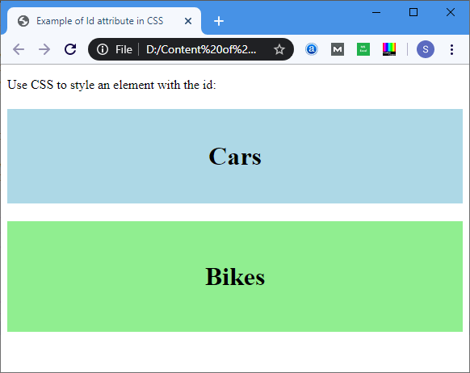

**Example2:**Thefollowingexampledescribes howtousetheIDattributeinJavaScript.

1. <!DOCTYPE html>
2. <html>
3. <head>
4. <title>DateAttribute</title>
5. <script>
6. functionviewdate(){
7. varx=document.getElementById("dob").value;
8. document.getElementById("demo").innerHTML=x;
9. </script>
10. </head>
11. <body>
12. EmployeeName:<inputtype="text"placeholder="YourGoodname"/>
13. <br>
14. <br>
15. Dateof Joining:
16. <inputtype="date"id="dob">
17. <br>
18. <buttononclick="viewdate()">Submit
19. </button>
20. <br>
21. <h2id="demo"></h2>
22. </body>
23. </html>

**Output:**

# HTML Id AttributeHTML

**List Box**

The**listbox**isagraphicalcontrolelement intheHTMLdocument thatallowsausertoselect one or more options from the list of options.

Syntax

Tocreatealist box,usethe [HTMLelement](https://www.javatpoint.com/html-elements)**<select>**whichcontainstwoattributes**Name**and **Size**. The**Name**attribute isusedtodefinethenamefor callingthelist box, and **size**attribute is used to specifythe numerical value that shows the how many options it contains.

1. <selectName="Name_of_list_box"Size="Number_of_options">
2. <option>Listitem1</option>
3. <option>Listitem2</option>
4. <option>Listitem3</option>
5. <option>ListitemN</option>
6. </select>

Examples:

**Example1:**Considerthebelowexamplethatcreatesasimplelistbox.

1. <!DOCTYPE html>
2. <html>
3. <title>
4. ExampleofListBox
5. </title>
6. <body>
7. CustomerName:<inputtype="text"Placeholder="EntertheCustomer Name"/>
8. <br>
9. <br>
10. <selectname="Cars"size="5">
11. <optionvalue="Merceders">Merceders</option>
12. <optionvalue="BMW">BMW</option>
13. <optionvalue="Jaguar">Jaguar</option>
14. <optionvalue="Lamborghini">Lamborghini</option>
15. <optionvalue="Ferrari">Ferrari</option>
16. <optionvalue="Ford">Ford</option>
17. </select>
18. </body>
19. </html>

##### Output:

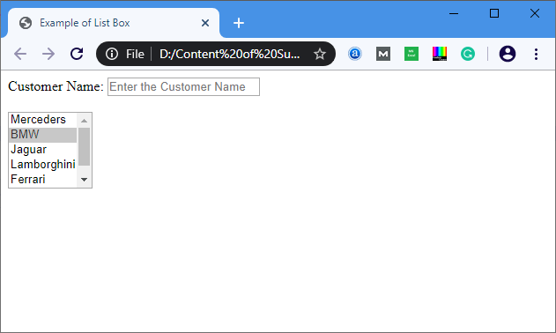

**Example2:**Belowexampleusesthe**multiple**attributeforselectingthe multipleoptionsina list. We can select multiple options from list box by holding the ctrl key.

1. <!DOCTYPE html>
2. <html>
3. <title>
4. ExampleofListBoxwithmultipleattribute
5. </title>
6. <body>
7. CustomerName:<inputtype="text"Placeholder="EntertheCustomer Name"/>
8. <br>
9. <br>
10. <selectname="Cars"size="5"multiple="multiple">
11. <optionvalue="Merceders">Merceders</option>
12. <optionvalue="BMW">BMW</option>
13. <optionvalue="Jaguar">Jaguar</option>
14. <optionvalue="Lamborghini">Lamborghini</option>
15. <optionvalue="Ferrari">Ferrari</option>
16. <optionvalue="Ford">Ford</option>
17. </select>
18. </body>
19. </html>

**Output:**

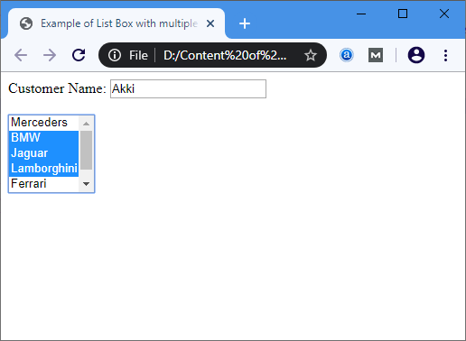

# Unixcommandslist

This guide has been prepared by me to help myself with the list of frequentlyused ***basic commandsinUNIX/LINUX***tobeonmyfingertip.Thoughtofsharing it withtheothers,in case, it might turnout helpfulto other readers as well. This is ***Unix/Linux basic commands - 1***,for 2nd part follow the link given at the end of this article.

## WebserversShell

**Unix/Linuxfilecommandsguide**

This article willserve as a 5 minute guide or tutorialto learn/revisit basic unix or linux commandsfrequentlyusedwhileworkingwithfiles.Unix/Linuxcommand isgivenalong with their *usage or description*.

* **ls**►usethis*commandinunix/linux*to seeallthedirectorylisting. However, any hidden files will not be listed.
* **ls-al**► usethis*commandinunix/linux*to seeformatteddirectorylistingalongwith the hidden files.
* **ls-lt** ► usethis*commandinunix/linux*tosortthedirectorylistingbytheir timeof modification.
* **pwd**►usethis*commandinunix/linux*toshowyour currentworkingdirectory.
* **touchfileName**►usethis*commandinunix/linux*to createnewfilewithitsnameas filename.
* **cd**►usethis*command in unix/linux*to moveto homedirectory.
* **cddirName**► usethis*commandinunix/linux*tochangecurrent directoryto dirName directory.
* **mkdirdirName**►usethis*commandinunix/linux*to makeorcreatedirectoryhaving name as dirName.
* **rmfileName**► usethis*commandinunix/linux*toremoveordeletefilehavingname as fileName.
* **rm-rdirName**► usethis*commandinunix/linux*toremoveordeletedirectory dirName.
* **rm-ffilename** ►usethis*commandinunix/linux*toforceremovethefilefilename.
* **morefileName**► usethis*commandinunix/linux*togetthecontentoffilehaving name as filename
* **headfileName**► usethis*commandinunix/linux*togetoutputoffirst 10linesofthe file fileName.
* **tailfileName**► usethis*commandinunix/linux*togetoutputoflast 10linesofthe file filename.
* **cpfileAfileB**►usethis *command inunix/linux*tocopythe content offileAtofileB.
* **cp -rdirAdirB** ►usethis*command in unix/linux*to copydirectorydirAto directory dirB and create dirB if not already created.
* **mvfileAfileB**►usethis*commandin unix/linux* torenameormovefileAto fileB.
* **cat>file**►usethis*commandinunix/linux*toplacestandardinputintothe file.

##### UnixorLinuxprocessmanagementcommandsguide

This section will serve as a 5 minute guide or tutorialto learn/revisit basic unix or linux commandsfrequentlyusedwhileworkingwithprocessmanagement. Unix/Linuxcommand is given along with their *usage or description*.

* **ps**►usethiscommandinunix/linuxtoseecurrentlyworking processes.
* **top**►usethiscommandinunix/linuxtodisplayalltherunning processes.
* **killpid**►usethiscommandinunix/linuxtokillthe processwithgiven pid.
* **killallprocessA**► usethiscommand inunix/linuxto killalltheprocessnamedas processA
* **pkillpattern** ► usethiscommand inunix/linuxtokillallprocesses matchingthe given pattern.
* **bg**►usethiscommandinunix/linuxto listallthebackgroundjobs.
* **fg**►usethiscommandinunix/linuxtobringthemostrecentjobtoforeground.
* **fgn1**►usethiscommandinunix/linuxtobringjobn1totheforeground.

##### Unix/Linuxsysteminfocommandsguide

This section will serve as a 5 minute guide or tutorialto learn/revisit basic unix or linux commandsfrequentlyusedwhileworkingwithsystem. Unix/Linuxcommand isgivenalong with their *usage or description*.

* **cal**►usethiscommandinunix/linuxtoshowcurrentmonthscalendar.
* **date**►usethiscommandinunix/linuxtoshowcurrentdateandtime.
* **w**►usethiscommand inunix/linuxto seewho allarecurrentlylogged intothe system.
* **whoami**► usethiscommand inunix/linuxtoseewho youarecurrentlylogged inas in the system.
* **uname-a**►usethiscommandinunix/linuxto seekernelinformation.
* **fingeruser**►usethiscommandinunix/linuxto displayinformationabout user.
* **mancommand** ►usethiscommandinunix/linuxtoshowthemanualfor command.
* **free**►usethiscommandinunix/linuxtoshowmemoryand swapusage.
* **df**►usethiscommandinunix/linuxto seethediskusage.
* **du**►usethiscommandinunix/linuxtoseethe directoryspace usage.
* **whereisapp**►usethiscommandinunix/linuxtoshowpossiblelocationofapp.
* **whichapp**►usethiscommand inunix/linuxtoshowwhichapplicationwillberun by default.

Versioncontrol

## GitGitHubPages

### Create aNewRepository

Startbysigning into GitHub. GitHubpages need aspecialnameandsetupto work, so we start by creating a new repository:

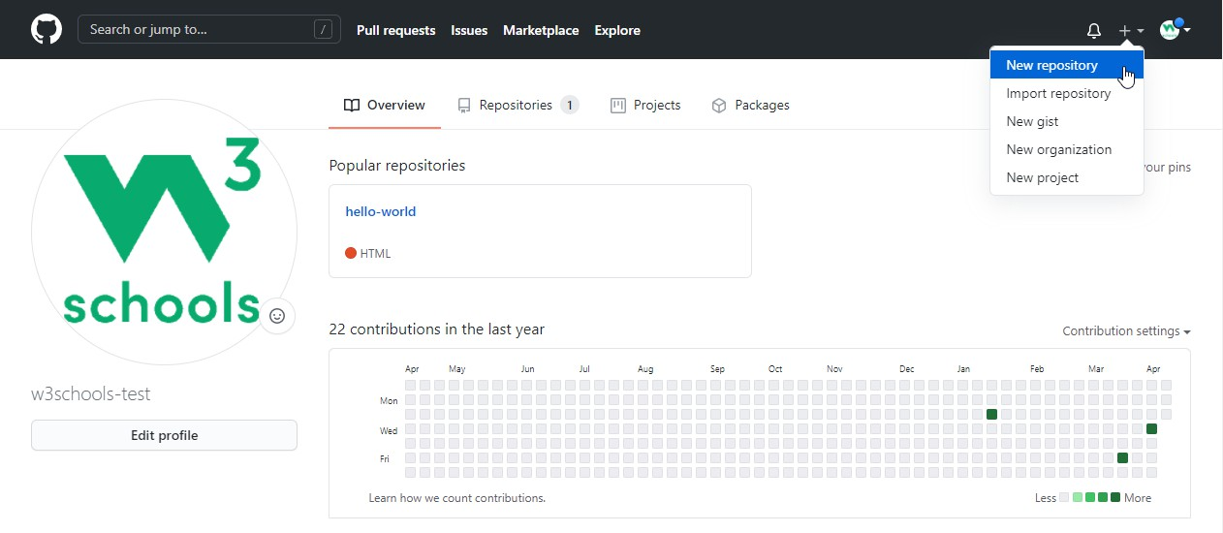

Thisrepositoryneedsaspecialnametofunctionas aGitHubpage. Itneedsto beyour GitHub username, followed by .github.io:

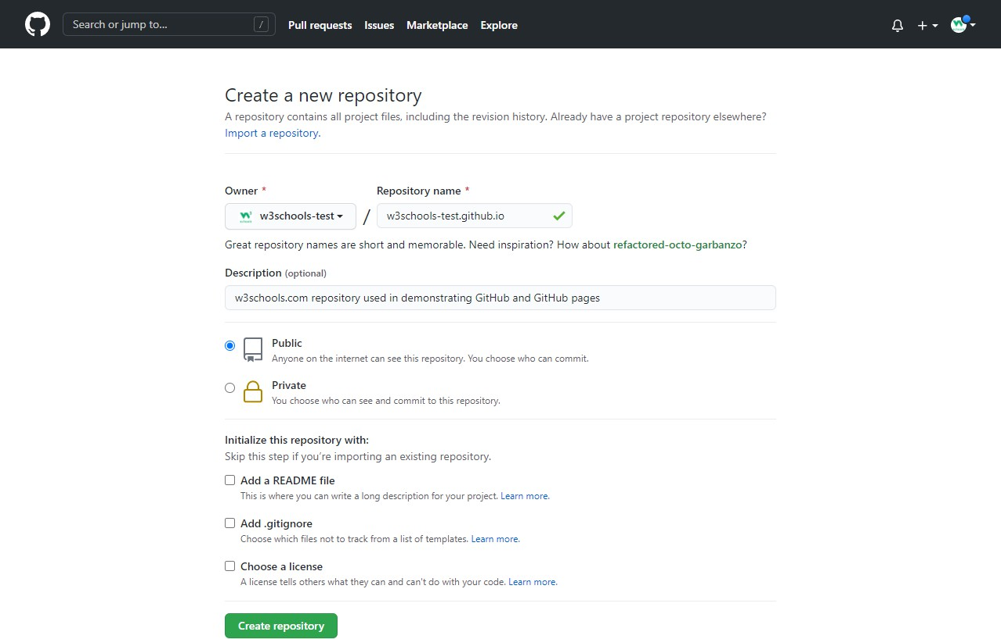

### PushLocalRepositorytoGitHubPages

Weaddthisnewrepositoryasaremoteforourlocalrepository, wearecalling it gh-page (for GitHub Pages).

CopytheURLfromhere:

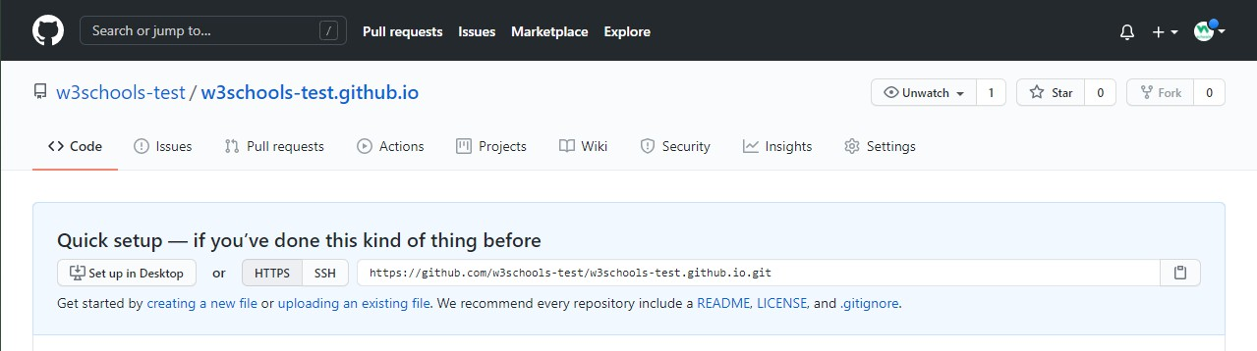

Andadditasanew remote:

Example

gitremoteaddgh-pagehttps://github.com/w3schools-test/w3schools-test.github.io.git

Makesureyouareonthemasterbranch,thenpushthemasterbranchtothenew remote:

Example

git push gh-page master Enumeratingobjects:33,done.

Counting objects: 100% (33/33), done. Delta compression using up to 16 threads Compressingobjects:100%(33/33),done.

Writingobjects: 100%(33/33),94.79KiB|15.80MiB/s, done.

Total33(delta18),reused 0(delta0),pack-reused 0 remote: Resolving deltas: 100% (18/18), done.

Tohttps://github.com/w3schools-test/w3schools-test.github.io.git

*[newbranch] master->master

**Note:**Ifthisisthe firsttime youareconnectingtoGitHub, youwillget somekindof notification to authenticate this connection.

Checkthat thenewrepositoryhasreceivedallthefiles:

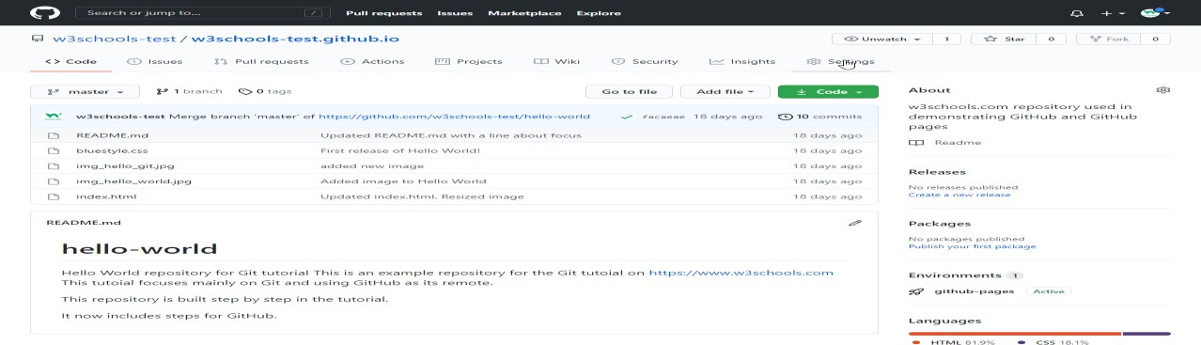

### CheckOut YourOwnGitHubPage

Thatlooksgood,nowclicktheSettings menuandnavigatetothePagestab:

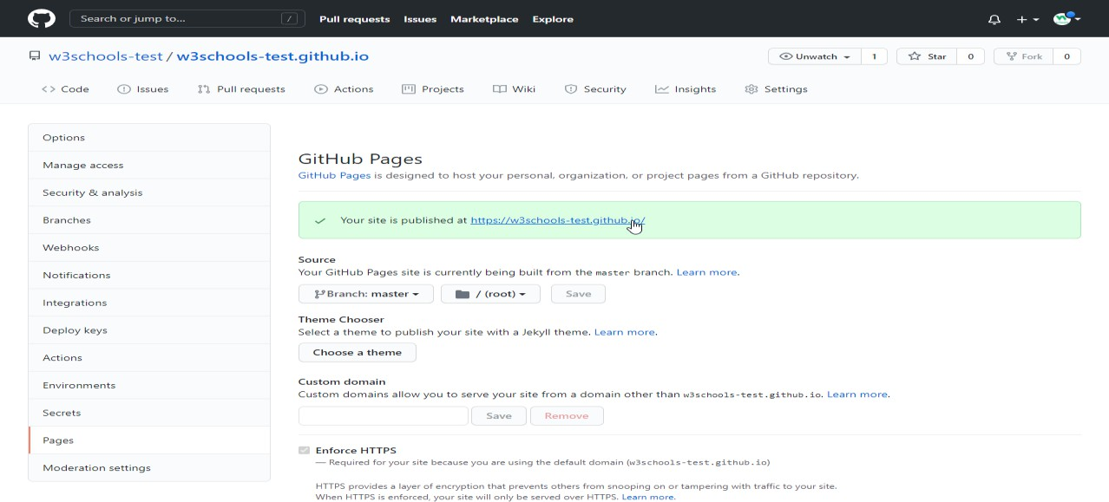

TheGitHubpageiscreated,andyoucanclick theURLtoviewtheresult!

# GitTutorial

### LearningbyExamples

Inthistutorial,wewillshowyouGitcommands like this:

Example

git--version

gitversion2.30.2.windows.1

Fornewusers,usingtheterminalviewcanseemabit complicated.Don't worry!Wewill keep it really simple, and learning this waygives you a good grasp of how Git works.

Inthecodeabove,youcanseecommands(input)andoutput. Lines like this are commands we input:

Example

git--version

Lineslikethisaretheoutput/responsetoourcommands:

Example

gitversion2.30.2.windows.1

Ingeneral, lineswith$ infrontofit is input.These arethecommands youcancopyandrun in your terminal.

### GitandRemote Repositories

GitandGitHubaredifferentthings.

Inthistutorialyouwillunderstandwhat Git isand howto useitontheremoterepository platforms, like GitHub.

Youcanchoose,andchange,whichplatformtofocusonbyclickinginthemenuonthe right:

### GitExercises

**TestYourselfWithExercises** **Exercise:**

InsertthemissingpartofthecommandtocheckwhichversionofGit(ifany)isinstalled.

git

### WhatisGit?

Git isapopularversioncontrolsystem.It wascreatedbyLinusTorvalds in2005,and has been maintained by Junio Hamano since then.

Itisusedfor:

* Trackingcodechanges
* Trackingwhomadechanges
* Codingcollaboration

WhatdoesGitdo?

* Manageprojectswith**Repositories**
* **Clone**aprojecttoworkonalocalcopy
* Controlandtrackchangeswith**Staging**and**Committing**
* **Branch**and**Merge**toallowforworkondifferent partsandversionsofaproject
* **Pull**thelatest versionoftheproject toalocalcopy
* **Push**localupdatestothemainproject

WorkingwithGit

* InitializeGitonafolder, makingita**Repository**
* Gitnowcreatesahiddenfoldertokeeptrackofchangesinthat folder
* Whenafileischanged,addedor deleted,itisconsidered**modified**
* Youselectthemodifiedfilesyouwantto**Stage**
* The**Staged**filesare**Committed**, whichpromptsGit tostorea **permanent**snapshot ofthe files
* Gitallowsyoutoseethefullhistoryofeverycommit.
* Youcanrevert backtoanypreviouscommit.
* Gitdoesnotstorea separatecopyof everyfileineverycommit, butkeepstrackofchanges made in each commit!

WhyGit?

* Over 70%ofdevelopersuseGit!
* Developerscanworktogetherfromanywhereinthe world.
* Developerscanseethefullhistoryoftheproject.
* Developerscanreverttoearlier versionsofa project.

WhatisGitHub?

* Git is notthesameas GitHub.
* GitHub makestoolsthatuseGit.
* GitHubisthelargest host ofsourcecodeintheworld, andhasbeenownedbyMicrosoft since 2018.
* Inthistutorial, wewillfocusonusingGitwithGitHub.

### GitInstall

YoucandownloadGitfor freefromthefollowingwebsite:[https://www.git-scm.com/](https://git-scm.com/)

### Using GitwithCommand Line

TostartusingGit, wearefirstgoingtoopenupourCommand shell.

ForWindows, youcanuseGit bash,whichcomesincluded inGit forWindows.ForMacand Linux you can use the built-in terminal.

Thefirstthingweneedtodo,istocheckifGitisproperly installed:

Example

git--version

gitversion2.30.2.windows.1

IfGitisinstalled,it shouldshowsomethinglikegitversionX.Y

### ConfigureGit

Nowlet Git knowwho youare.Thisisimportantforversioncontrolsystems,aseachGit commit uses this information:

Example

gitconfig--globaluser.name"w3schools-test"

gitconfig--globaluser.email"[test@w3schools.com](mailto:test@w3schools.com)"

Changetheusernameande-mailaddresstoyourown. Youwillprobablyalso want touse this when registering to GitHub later on.

**Note:**Useglobal tosettheusernameande-mailfor **every repository**onyourcomputer. If you want to set the username/e-mail for just the current repo, you can remove global

### CreatingGitFolder

Now,let'screateanewfolderforour project:

Example mkdirmyproject cdmyproject

mkdir**make**sa**newdirectory**.

##### cdchangesthecurrentworkingdirectory.

Nowthatweareinthecorrectdirectory.Wecanstartbyinitializing Git!

**Note:** Ifyoualreadyhaveafolder/directoryyouwouldliketousefor Git:

Navigatetoit incommand line,oropenit inyourfileexplorer,right-clickandselect "Git Bash here"

### InitializeGit

Onceyouhavenavigatedtothecorrectfolder,youcaninitializeGitonthatfolder:

Example

gitinit

InitializedemptyGitrepositoryin/Users/user/myproject/.git/

Youjustcreatedyourfirst GitRepository!

**Note:**Git nowknowsthat it shouldwatchthefolderyouinitiatediton. Git creates a hidden folder to keep track of changes.

### GitAddingNewFiles

YoujustcreatedyourfirstlocalGitrepo.Butitisempty.

Solet'saddsome files, orcreateanewfileusing yourfavouritetext editor.Thensaveor move it to the folder you just created.

Ifyouwanttolearnhowto createanew fileusing atexteditor,youcanvisit ourHTML tutorial:

[HTMLEditors](https://www.w3schools.com/html/html_editors.asp)

Forthisexample, IamgoingtouseasimpleHTMLfile likethis: Example

<!DOCTYPEhtml>

<html>

<head>

<title>HelloWorld!</title>

</head>

<body>

<h1>Helloworld!</h1>

<p>ThisisthefirstfileinmynewGit Repo.</p>

</body>

</html>

Andsaveittoournewfolderasindex.html.

Let'sgobacktotheterminalandlistthefilesinour currentworkingdirectory:

Example ls index.html

lswill**list** thefiles inthedirectory.Wecanseethatindex.htmlisthere.

Thenwecheck theGitstatusandseeifitisapartofourrepo:

Example

git status

Onbranchmaster No commits yet

Untrackedfiles:

(use"gitadd..."toincludeinwhatwill becommitted) index.html

nothingaddedtocommitbutuntrackedfilespresent(use"gitadd"totrack)

NowGit is**aware**ofthefile,but hasnot **added**ittoourrepository! Files in your Git repository folder can be in one of 2 states:

* Tracked-filesthat Git knowsabout andareaddedtotherepository
* Untracked-filesthatareinyourworkingdirectory,butnotaddedtotherepository

Whenyoufirst addfilesto anemptyrepository, theyarealluntracked.To getGit totrack them, you need to stage them, or add them to the staging environment.

### GitStaging Environment

OneofthecorefunctionsofGitistheconceptsoftheStaging Environment,andtheCommit.

Asyouareworking, youmaybeadding,editingandremovingfiles.Butwhenever youhit a milestone or finish a part of the work, you should add the files to a Staging Environment.

**Staged** filesare filesthat arereadytobe **committed**totherepositoryyouareworkingon. You will learn more about commit shortly.

Fornow,wearedoneworkingwithindex.html.SowecanaddittotheStagingEnvironment:

Example

gitaddindex.html

Thefileshouldbe **Staged**. Let'scheckthestatus::

Example

git status

Onbranchmaster No commits yet

Changestobecommitted:

(use"gitrm --cached..."tounstage) new file: index.html

Nowthefilehasbeenaddedto theStaging Environment.

### Git AddMorethanOneFile

Youcanalso stagemorethanone fileat atime. Let'sadd2morefilestoourworking folder. Use the text editor again.

AREADME.mdfilethatdescribestherepository(recommendedforallrepositories):

Example

#hello-world

HelloWorldrepositoryfor Gittutorial

Thisisanexamplerepositoryfor theGittutoialonhttps://[www.w3schools.com](http://www.w3schools.com/) This repository is built step by step in the tutorial.

Abasicexternalstylesheet(bluestyle.css):

Example

body{

background-color:lightblue;

}

h1{

color: navy; margin-left:20px;

}

Andupdateindex.htmltoincludethestylesheet:

Example

<!DOCTYPEhtml>

<html>

<head>

<title>HelloWorld!</title>

<linkrel="stylesheet"href="bluestyle.css">

</head>

<body>

<h1>Helloworld!</h1>

<p>Thisisthefirstfile inmynewGit Repo.</p>

</body>

</html>

NowaddallfilesinthecurrentdirectorytotheStaging Environment:

Example

gitadd--all

Using--all insteadofindividualfilenameswillstage allchanges(new, modified, anddeleted) files.

Example

git status

Onbranchmaster No commits yet

Changestobecommitted:

(use"gitrm --cached..."tounstage) new file:README.md

newfile:bluestyle.css new file:index.html

Nowall3filesareaddedtotheStagingEnvironment,and wearereadytodoour firstcommit.

### GitCommit

Since we have finished our work, we are ready move from stage to commit for our repo. Addingcommitskeeptrackofourprogressandchangesaswework. Git considerseach

commitchangepointor"savepoint". Itisapointintheprojectyoucangobacktoifyoufind

abug,or wanttomakea change.

Whenwecommit, weshould **always**includea**message**.

Byaddingclear messagesto eachcommit,it iseasyforyourself(andothers)to seewhat has changed and when.

Example

gitcommit-m"FirstreleaseofHelloWorld!"

[master(root-commit)221ec6e]FirstreleaseofHelloWorld! 3 files changed, 26 insertions(+)

createmode100644README.md create mode 100644 bluestyle.css create mode 100644 index.html

Thecommitcommandperformsacommit, andthe-m "*message*"addsamessage.

TheStagingEnvironment hasbeencommittedtoourrepo,withthe message: "First release of Hello World!"

### GitCommitwithoutStage

Sometimes,whenyou makesmallchanges,usingthestaging environment seemslikeawaste oftime. It is possible to commit changes directly, skipping the staging environment. The -a option will automatically stage every changed, already tracked file.

Let'saddasmallupdatetoindex.html: Example

<!DOCTYPEhtml>

<html>

<head>

<title>HelloWorld!</title>

<linkrel="stylesheet"href="bluestyle.css">

</head>

<body>

<h1>Helloworld!</h1>

<p>ThisisthefirstfileinmynewGit Repo.</p>

<p>Anewlineinourfile!</p>

</body>

</html>

Andcheckthestatusofour repository. Butthistime, wewillusethe --shortoptiontoseethe changes in a more compact way:

Example

gitstatus--short M index.html

### GitHelp

Ifyouarehavingtroublerememberingcommands oroptions forcommands,youcanuseGit

help.

Thereareacoupleofdifferentways youcanusethehelpcommandincommandline:

* git*command*-help-Seealltheavailableoptionsforthespecificcommand
* githelp--all-Seeallpossiblecommands

Let'sgooverthedifferentcommands.

### Git-helpSeeOptionsforaSpecific Command

Anytimeyouneedsomehelprememberingthespecificoptionforacommand,youcanuse

git*command*-help:

Example

gitcommit-help

usage:gitcommit[][--]...

-q,--quiet suppresssummaryaftersuccessfulcommit

-v,--verbose showdiffincommitmessagetemplate

Commitmessageoptions

-F,--file readmessagefrom file

--author overrideauthorforcommit

--date overridedateforcommit

-m,--message

commitmessage

-c,--reedit-message

reuseandeditmessagefromspecifiedcommit

-C,--reuse-message

reusemessagefromspecifiedcommit

--fixup useautosquashformattedmessagetofixupspecifiedcommit

--squash useautosquashformattedmessagetosquashspecifiedcommit

--reset-author thecommitisauthoredbymenow(usedwith-C/-c/--amend)

-s,--signoff addaSigned-off-bytrailer

-t,--template

usespecifiedtemplatefile

-e,--edit forceeditofcommit

--cleanup howtostripspacesand#commentsfrommessage

--status includestatusincommitmessagetemplate

-S,--gpg-sign[=]

GPGsigncommit

Commitcontentsoptions

-a,--all commitallchangedfiles

-i,--include addspecifiedfilestoindexfor commit

--interactive interactivelyaddfiles

-p,--patch interactivelyaddchanges

-o,--only commitonlyspecifiedfiles

-n,--no-verify bypasspre-commitandcommit-msghooks

--dry-run showwhatwouldbecommitted

--short showstatus concisely

--branch showbranchinformation

--ahead-behind computefullahead/behindvalues

--porcelain machine-readableoutput

--long showstatusinlongformat(default)

-z,--null terminateentrieswithNUL

--amend amendpreviouscommit

--no-post-rewrite bypasspost-rewritehook

-u,--untracked-files[=]

showuntrackedfiles,optionalmodes:all,normal,no.(Default:all)

--pathspec-from-file

readpathspecfromfile

--pathspec-file-nulwith--pathspec-from-file,pathspecelementsareseparatedwithNULcharacter

**Note:** Youcanalsouse--helpinsteadof-help toopentherelevantGitmanualpage

### Githelp--allSeeAllPossible Commands

Tolistallpossiblecommands, usethehelp--allcommand:

**Warning:** Thiswilldisplayaverylong listofcommands Example

$githelp--all

See'githelp'toreadaboutaspecificsubcommand

MainPorcelainCommands

add Addfilecontentstotheindex

am Apply a series of patches from a mailbox archive Createanarchiveoffiles fromanamedtree

bisect Usebinarysearchtofindthecommitthatintroduceda bug branch List, create, or delete branches

bundle Moveobjectsandrefsbyarchive

checkout Switchbranchesorrestoreworkingtreefiles

cherry-pick Applythechangesintroduced bysomeexistingcommits citool Graphical alternative to git-commit

clean Removeuntrackedfilesfromtheworkingtree clone Clone a repository into a new directory commit Record changes to the repository

describe Givean object ahumanreadablenamebasedonanavailableref diff Show changes between commits, commit and working tree, etc fetch Download objects and refs from another repository

format-patch Prepare patches for e-mail submission gcCleanupunnecessaryfilesandoptimizethelocalrepository gitk The Git repository browser

grep Printlinesmatchingapattern

gui AportablegraphicalinterfacetoGit

init Createan emptyGitrepositoryor reinitializean existing one log Show commit logs

maintenance Run tasks to optimize Git repository data merge Jointwoormoredevelopmenthistoriestogether mv Move or rename a file, a directory, or a symlink notes Add or inspect object notes

pull Fetchfromandintegratewithanotherrepositoryor alocal branch push Update remote refs along with associated objects

range-diff Comparetwocommitranges(e.g.twoversionsofa branch) rebase Reapply commits on top of another base tip

reset ResetcurrentHEADtothespecifiedstate restore Restore working tree files

revert Revertsomeexistingcommits

rm Removefilesfromtheworkingtreeandfromtheindex shortlog Summarize 'git log' output

show Showvarioustypesofobjects

sparse-checkout Initializeandmodifythesparse-checkout

stash Stashthechangesinadirtyworkingdirectoryaway status Show the working tree status

submodule Initialize,updateorinspectsubmodules switch Switch branches

tag Create,list,deleteor verifyatagobjectsignedwithGPG worktree Manage multiple working trees

AncillaryCommands/Manipulators

config Getandsetrepositoryor globaloptions fast-export Git data exporter

fast-import BackendforfastGitdataimporters filter-branch Rewrite branches

mergetool Runmergeconflictresolutiontoolstoresolvemergeconflicts pack-refs Pack heads and tags for efficient repository access

prune Pruneallunreachableobjectsfromtheobjectdatabase reflog Manage reflog information

remote Manage set of tracked repositories repack Pack unpacked objects in a repository replace Create,list,deleterefstoreplaceobjects

AncillaryCommands/Interrogators

annotate Annotatefilelineswithcommitinformation

blame Showwhatrevision andauthorlastmodifiedeachlineofa file bugreport Collect information for user to file a bug report

count-objects Countunpackednumber ofobjectsandtheirdiskconsumption difftool Show changes using common diff tools

fsck Verifiestheconnectivityandvalidityoftheobjectsinthedatabase gitweb Git web interface (web frontend to Git repositories)

help DisplayhelpinformationaboutGit

instaweb Instantlybrowseyourworkingrepositoryingitweb

merge-tree Showthree-waymergewithouttouchingindex rerere Reuse recorded resolution of conflicted merges

show-branch Show branches and their commits verify-commit ChecktheGPGsignatureofcommits verify-tag Check the GPG signature of tags

whatchanged Showlogswithdifferenceeachcommitintroduces

InteractingwithOthers

archimport Import a GNU Arch repository into Git cvsexportcommit ExportasinglecommittoaCVScheckout

cvsimport Salvageyour dataoutofanother SCMpeoplelovetohate cvsserver A CVS server emulator for Git

imap-send Sendacollection ofpatchesfromstdintoanIMAPfolder p4 Import from and submit to Perforce repositories

quiltimport Appliesaquiltpatchsetontothecurrent branch request-pull Generates a summary of pending changes send-email Send a collection of patches as emails

svn BidirectionaloperationbetweenaSubversionrepositoryandGit

Low-levelCommands/Manipulators

apply Apply a patch to files and/or to the index checkout-index Copyfilesfrom theindextotheworkingtree commit-graph Write and verify Git commit-graph files commit-tree Create a new commit object

hash-object Computeobject IDandoptionallycreatesablobfrom afile index-pack Build pack index file for an existing packed archive

merge-file Runathree-wayfile merge

merge-index Runamergefor filesneedingmerging mktag Creates a tag object

mktree Buildatree-objectfromls-treeformattedtext multi-pack-index Write and verify multi-pack-indexes pack-objects Create a packed archive of objects

prune-packed Removeextraobjectsthatarealreadyinpackfiles read-tree Reads tree information into the index

symbolic-ref Read, modify and delete symbolic refs unpack-objects Unpackobjectsfromapackedarchive

update-index Register filecontentsintheworkingtreetotheindex update-ref Update the object name stored in a ref safely

write-tree Createatreeobjectfromthecurrentindex

Low-levelCommands/Interrogators

cat-file Providecontentortypeandsizeinformationforrepositoryobjects cherry Find commits yet to be applied to upstream

diff-files Comparesfilesintheworkingtreeandtheindex diff-index Compare a tree to the working tree or index

diff-tree Comparesthecontentandmodeofblobs foundviatwotreeobjects for-each-ref Output information on each ref

for-each-repo RunaGitcommandonalistofrepositories

get-tar-commit-idExtract commitIDfromanarchivecreatedusinggit-archive ls-files Show information about files in the index and the working tree

ls-remote Listreferencesinaremoterepository ls-tree List the contents of a tree object

merge-base Findasgoodcommonancestorsaspossiblefor amerge name-rev Find symbolic names for given revs

pack-redundant Findredundantpackfiles

rev-list Listscommitobjectsinreversechronologicalorder rev-parse Pick out and massage parameters

show-index Showpackedarchiveindex

show-ref Listreferencesinalocalrepository

unpack-file Createsatemporaryfilewithablob'scontents

var ShowaGitlogicalvariable

verify-pack ValidatepackedGitarchivefiles

Low-levelCommands/SyncingRepositories

daemon Areallysimpleserver forGitrepositories

fetch-pack Receive missing objects from another repository http-backend Server side implementation of Git over HTTP send-pack Pushobjectsover Gitprotocoltoanotherrepository update-server-infoUpdate auxiliary info file to help dumb servers

Low-levelCommands/InternalHelpers

check-attr Displaygitattributesinformation check-ignore Debuggitignore/excludefiles

check-mailmap Showcanonicalnamesandemailaddressesofcontacts check-ref-format Ensures that a reference name is well formed

column Display data in columnscredential Retrieveandstoreusercredentials

credential-cache Helper totemporarilystorepasswordsinmemory credential-store Helper to store credentials on disk

fmt-merge-msg Produceamergecommitmessage

interpret-trailersAddorparsestructuredinformationin commitmessages mailinfo Extractspatch and authorship from a singlee-mail message mailsplit Simple UNIX mbox splitter program

merge-one-fileThestandardhelper programtousewith git-merge-index patch-id Compute unique ID for a patch

sh-i18n Git'si18nsetupcodefor shellscripts sh-setup Common Git shell script setup code stripspace Remove unnecessary whitespace

Externalcommands askyesno

credential-helper-selector flow

lfs

**Note:**Ifyoufindyourselfstuckinthelistview,SHIFT+Gtojumptheendofthelist,thenq

toexitthe view.

# GitGitHubGettingStarted

### EditCodeinGitHub

Inadditionto beingahost forGit content,GitHubhasaverygoodcodeeditor. Let's tryto edit the README.md file in GitHub. Just click the edit button:

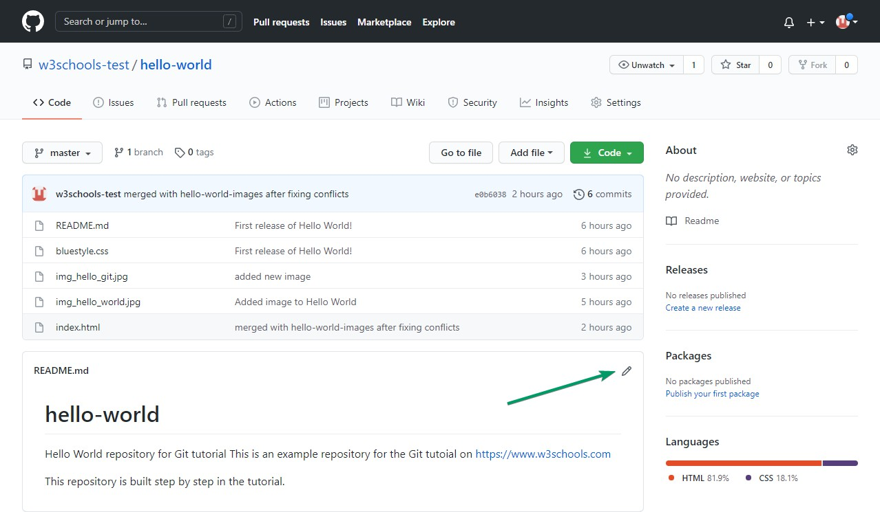

Addsomechangestothecode,andthencommit the changes. Fornow,wewill"Commit directly to the master branch".

Remembertoaddadescriptionforthecommit:

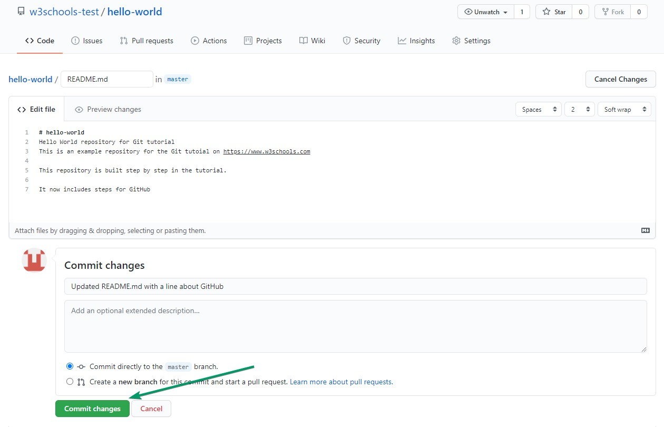

Thatishow youeditcodedirectlyinGitHub!

### PullingtoKeepup-to-datewithChanges

Whenworkingasateamonaproject,itisimportantthateveryonestaysuptodate.

Anytime youstartworkingonaproject,youshouldgetthe mostrecent changesto yourlocal copy.

WithGit,you cando thatwithpull.

pullisacombinationof2 differentcommands:

* fetch
* merge

Let'stakeacloserlookintohowfetch,merge,andpullworks.

### GitFetch

fetchgetsallthe changehistoryofa trackedbranch/repo.

So,onyour localGit,fetchupdatesto seewhathaschangedonGitHub:

Example

gitfetchorigin

remote: Enumerating objects: 5, done. remote:Countingobjects:100%(5/5),done.

remote:Compressingobjects:100%(3/3),done.

remote: Total 3 (delta 2), reused 0 (delta 0), pack-reused 0 Unpackingobjects:100%(3/3),733bytes|3.00KiB/s,done.

Fromhttps://github.com/w3schools-test/hello-world e0b6038..d29d69fmaster -> origin/master

Nowthatwehavetherecentchanges,wecancheck ourstatus:

Example

git status

Onbranchmaster

Your branchisbehind'origin/master'by1commit,andcan befast-forwarded. (use "git pull" to update your local branch)

nothingtocommit,workingtreeclean

Wearebehindthe origin/master by1commit.That shouldbetheupdatedREADME.md, butlets double check by viewing the log:

Example

gitlogorigin/master

commitd29d69ffe2ee9e6df6fa0d313bb0592b50f3b853(origin/master)

Author:w3schools-test<[77673807+w3schools-test@users.noreply.github.com](mailto:77673807%2Bw3schools-test@users.noreply.github.com)> Date:Fri Mar 26 14:59:14 2021 +0100

UpdatedREADME.mdwithalineaboutGitHub

commite0b6038b1345e50aca8885d8fd322fc0e5765c3b(HEAD->master) Merge: dfa79db 1f1584e

Author:w3schools-test

Date:FriMar 2612:42:562021+0100

mergedwithhello-world-imagesafterfixingconflicts

...

...

Thatlooksasexpected,butwecanalsoverifybyshowingthedifferencesbetweenour local

masterandorigin/master:

Example

gitdifforigin/master

diff--gita/README.mdb/README.md index 23a0122..a980c39 100644

---a/README.md

+++ b/README.md

@@-2,6+2,4@@

HelloWorldrepositoryforGittutorial

ThisisanexamplerepositoryfortheGittutoialonhttps://[www.w3schools.com](http://www.w3schools.com/)

-Thisrepositoryisbuilt stepbystepinthetutorial.

-

-ItnowincludesstepsforGitHub

+Thisrepositoryisbuiltstepbystepinthetutorial.

\Nonewlineatend of file

Thatlookspreciselyasexpected!Nowwecansafelymerge.

### GitMerge

mergecombinesthecurrentbranch, withaspecified branch.

We haveconfirmedthattheupdatesareasexpected,andwecan mergeourcurrent branch (master) with origin/master:

Example

git merge origin/master Updatinge0b6038..d29d69f Fast-forward

README.md|4+++-

1filechanged,3insertions(+),1deletion(-)

Checkourstatusagaintoconfirmweareuptodate:

Example

git status

Onbranchmaster

Your branchisuptodatewith'origin/master'. nothing to commit, working tree clean

There!Your localgitisuptodate!

### GitPull

But whatifyou just wantto updateyourlocalrepository,withoutgoingthroughallthose steps?

pull isacombinationoffetch and merge. It isused to pullallchanges fromaremoterepository into the branch you are working on.

MakeanotherchangetotheReadme.mdfileonGitHub.

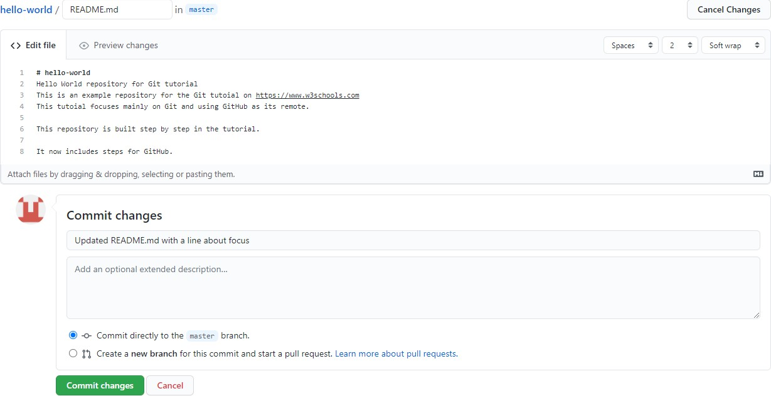

Usepullto updateourlocalGit:

Example

gitpullorigin

remote: Enumerating objects: 5, done. remote:Countingobjects:100%(5/5),done.

remote:Compressingobjects:100%(3/3),done.

remote: Total 3 (delta 1), reused 0 (delta 0), pack-reused 0 Unpackingobjects:100%(3/3),794bytes|1024bytes/s,done.

Fromhttps://github.com/w3schools-test/hello-world a7cdd4b..ab6b4edmaster -> origin/master

Updatinga7cdd4b..ab6b4ed Fast-forward

README.md|2++

1filechanged,2insertions(+)

That is how youkeepyourlocalGit upto datefromaremoterepository. Inthenext chapter, we will look closer at how push works on GitHub.

# GitPushto GitHub

### PushChangestoGitHub

Let'strymakingsomechangestoourlocalgit and pushingthemto GitHub. Example

<!DOCTYPEhtml>

<html>

<head>

<title>HelloWorld!</title>

<linkrel="stylesheet"href="bluestyle.css">

</head>

<body>

<h1>Helloworld!</h1>

<div><imgsrc="img_hello_world.jpg"alt="HelloWorldfromSpace"style="width:100%;max- width:640px"></div>

<p>Thisisthefirst fileinmynewGit Repo.</p>

<p>Thislineisheretoshowhowmerging works.</p>

<div><imgsrc="img_hello_git.jpg"alt="HelloGit"style="width:100%;max-width:640px"></div>

</body>

</html>

Commit thechanges:

Example

gitcommit-a-m"Updatedindex.html.Resizedimage" [master e7de78f] Updated index.html. Resized image1 file changed, 1 insertion(+), 1 deletion(-)

Andcheckthe status:

Example

git status

Onbranchmaster

Your branchisaheadof'origin/master'by1commit. (use "git push" to publish your local commits)

nothingtocommit,workingtreeclean

Nowpushourchangestoourremoteorigin:

Example

gitpushorigin

Enumerating objects: 9, done. Countingobjects:100%(8/8),done.

Deltacompressionusingupto16threads Compressing objects: 100% (5/5), done.

Writingobjects:100%(5/5),578bytes|578.00KiB/s, done.

Total5(delta3),reused0(delta0),pack-reused0

remote:Resolvingdeltas:100%(3/3),completedwith3localobjects. To https://github.com/w3schools-test/hello-world.git5a04b6f..facaeaemaster -> master

GotoGitHub,andconfirmthattherepositoryhas anew commit:

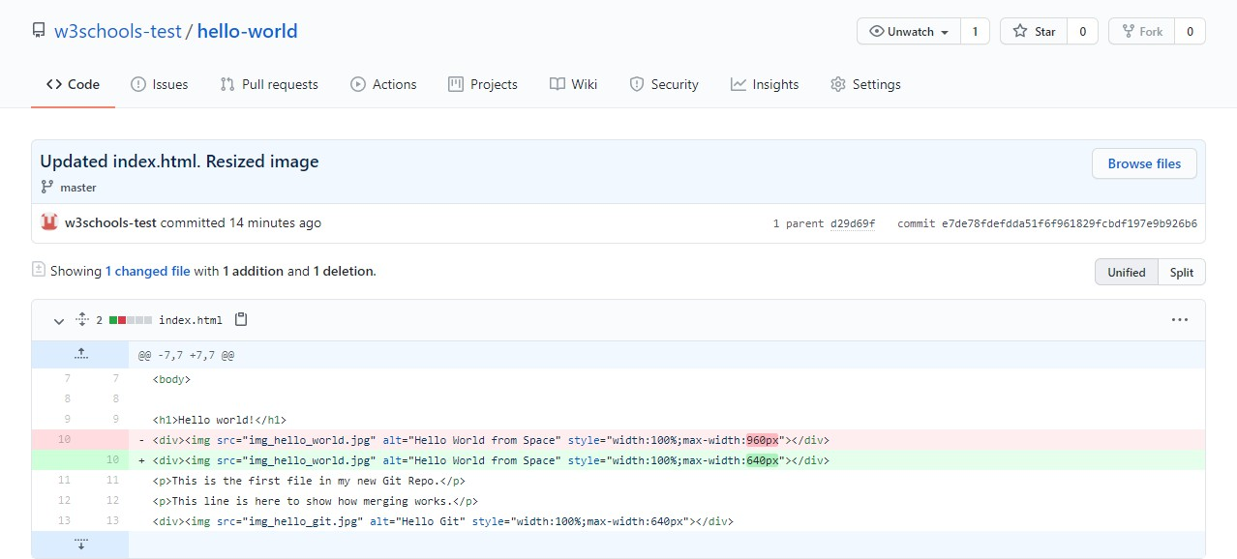

Now,wearegoingtostartworkingonbranchesonGitHub.

# GitGitHubBranch

### CreateaNewBranchonGitHub

OnGitHub, accessyour repositoryandclickthe"master"branchbutton.

There youcancreateanewBranch. Typeinadescriptivename, andclickCreate branch:

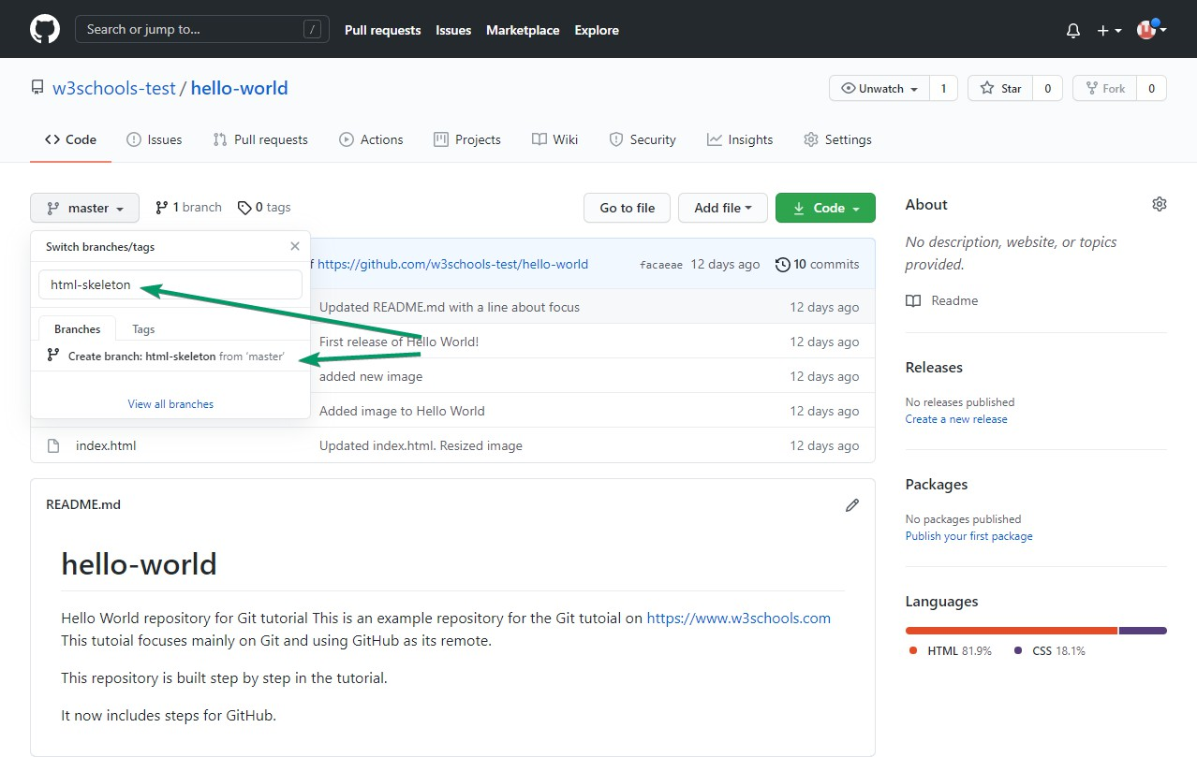

Thebranch should nowbecreatedandactive.Youcanconfirmwhichbranchyouareworking on by looking at the branch button. See that it now says "html-skeleton" instead of "main"?

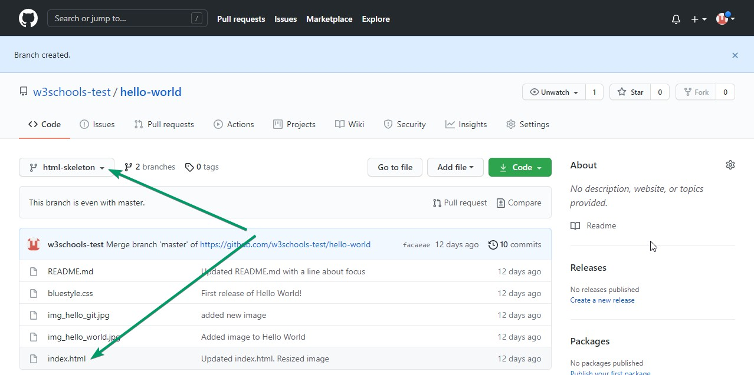

Startworkingonanexistingfileinthisbranch.Clickthe"index.html"fileandstart editing:

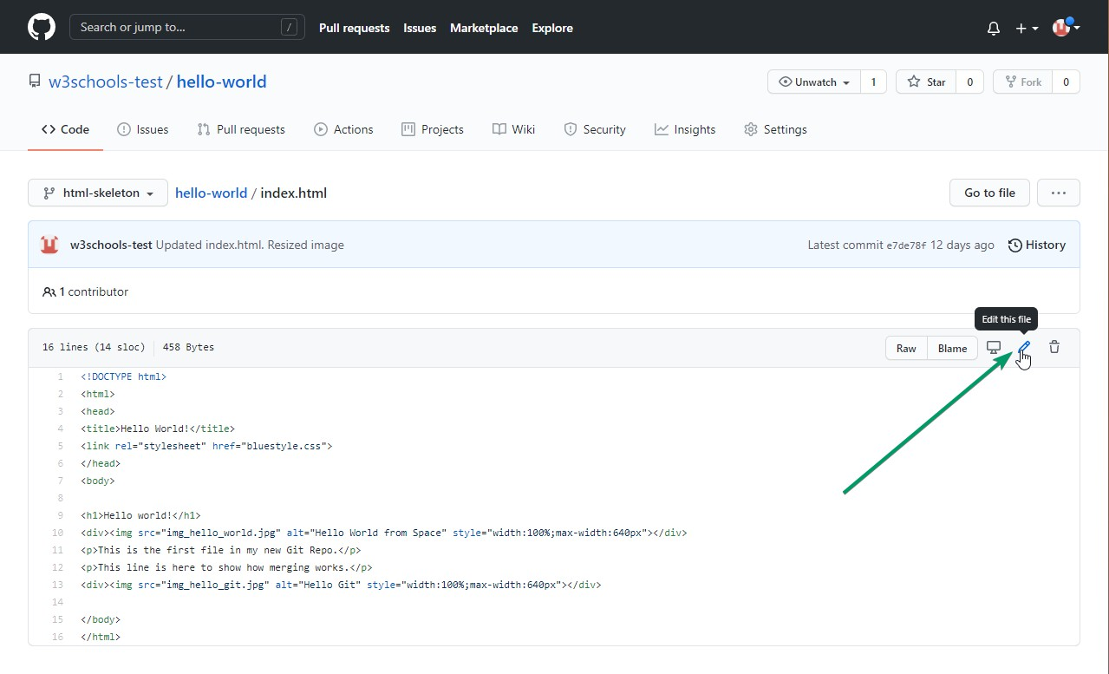

After youhave finishededitingthefile, youcanclickthe"Previewchanges"tabto seethe changes you made highlighted:

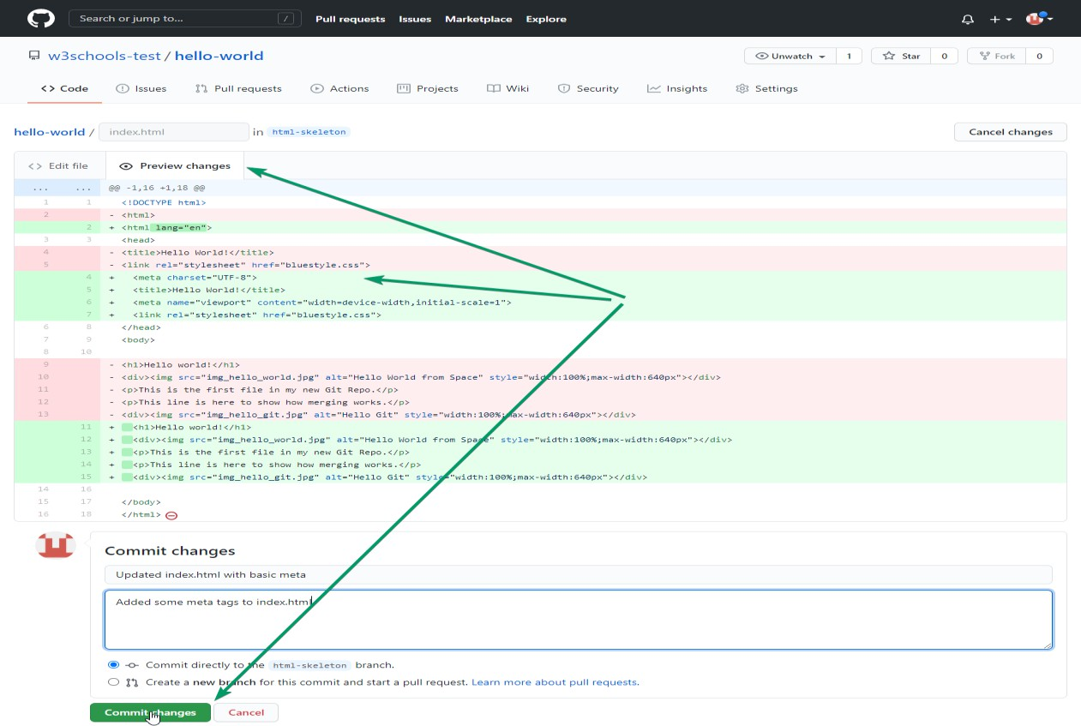

Ifyouarehappywiththechange,addacomment that explainswhat youdid,andclick Commit changes.

# GitPullBranchfromGitHub

### Pulling aBranchfromGitHub

Nowcontinueworking onournewbranchinourlocalGit.

LetspullfromourGitHubrepositoryagainsothatourcodeis up-to-date:

Example

gitpull

remote: Enumerating objects: 5, done. remote:Countingobjects:100%(5/5),done.

remote:Compressingobjects:100%(3/3),done.

remote: Total 3 (delta 2), reused 0 (delta 0), pack-reused 0 Unpackingobjects:100%(3/3),851bytes|9.00KiB/s,done. From https://github.com/w3schools-test/hello-world

* [new branch] html-skeleton->origin/html-skeleton Already up to date.

Nowourmain branch isuptodate. Andwecanseethatthere isanew branch availableon GitHub.

Doaquick statuscheck:

Example

git status

Onbranchmaster

Your branchisuptodatewith'origin/master'. nothing to commit, working tree clean

Andconfirmwhichbrancheswehave,andwhereweareworkingatthemoment:

Example

git branch

*master

So, wedonothavethenew branch onourlocalGit. Butweknowit isavailableonGitHub. So we can use the -a option to see all local and remote branches:

Example

gitbranch-a

*master

remotes/origin/html-skeleton remotes/origin/master

**Note:**branch-risforremotebranchesonly.

Weseethatthebranchhtml-skeleton isavailableremotely, but notonourlocalgit. Letscheck it out:

Example

gitcheckouthtml-skeleton

Switchedtoanewbranch'html-skeleton'

Branch'html-skeleton'setuptotrackremotebranch'html-skeleton'from'origin'.

Andcheckifitisalluptodate:

Example

gitpull

Alreadyupto date.

Whichbranchesdowehavenow,andwhereareweworkingfrom?

Example

git branch

*html-skeleton master

Now,openyour favouriteeditorand confirmthatthechanges fromtheGitHubbranch carried over.

ThatishowyoupullaGitHubbranchtoyour localGit.

# GitPushBranchto GitHub

### PushaBranchtoGitHub

Let'stryto createanew localbranch,andpushthatto GitHub. Start by creating a branch, like we did earlier:

Example

gitcheckout-bupdate-readme

Switchedtoanewbranch'update-readme'

AndwemakesomechangestotheREADME.mdfile.Just addanewline. So now we check the status of the current branch.

Example

git status

On branch update-readme Changesnotstagedforcommit:

(use"gitadd..."toupdatewhatwillbecommitted)

(use"gitrestore..."todiscardchangesinworkingdirectory) modified:README.md

nochangesaddedtocommit(use"gitadd"and/or"gitcommit-a")

WeseethatREADME.mdismodifiedbutnotaddedtotheStagingEnvironment:

Example

gitaddREADME.md

Checkthestatusofthebranch:

Example

git status

Onbranchupdate-readme Changestobecommitted:

(use"gitrestore--staged..."tounstage) modified:README.md

Wearehappywithourchanges.Sowewillcommitthemto thebranch:

Example

gitcommit-m"UpdatedreadmeforGitHubBranches"

[update-readme836e5bf] Updatedreadmefor GitHubBranches 1 file changed, 1 insertion(+)

Nowpush thebranch fromourlocalGit repository, toGitHub, whereeveryonecanseethe changes:

Example

git push origin update-readme Enumerating objects: 5, done. Countingobjects:100%(5/5),done.

Deltacompressionusingupto16threads Compressing objects: 100% (3/3), done.

Writingobjects:100%(3/3),366bytes|366.00KiB/s, done.

Total3(delta2),reused0(delta0),pack-reused0

remote:Resolvingdeltas:100%(2/2),completedwith2localobjects. remote:

remote:Createapullrequestfor'update-readme'onGitHubbyvisiting:

remote: https://github.com/w3schools-test/hello-world/pull/new/update-readme remote:

Tohttps://github.com/w3schools-test/hello-world.git

*[newbranch] update-readme->update-readme

GotoGitHub, andconfirmthattherepositoryhasanewbranch:

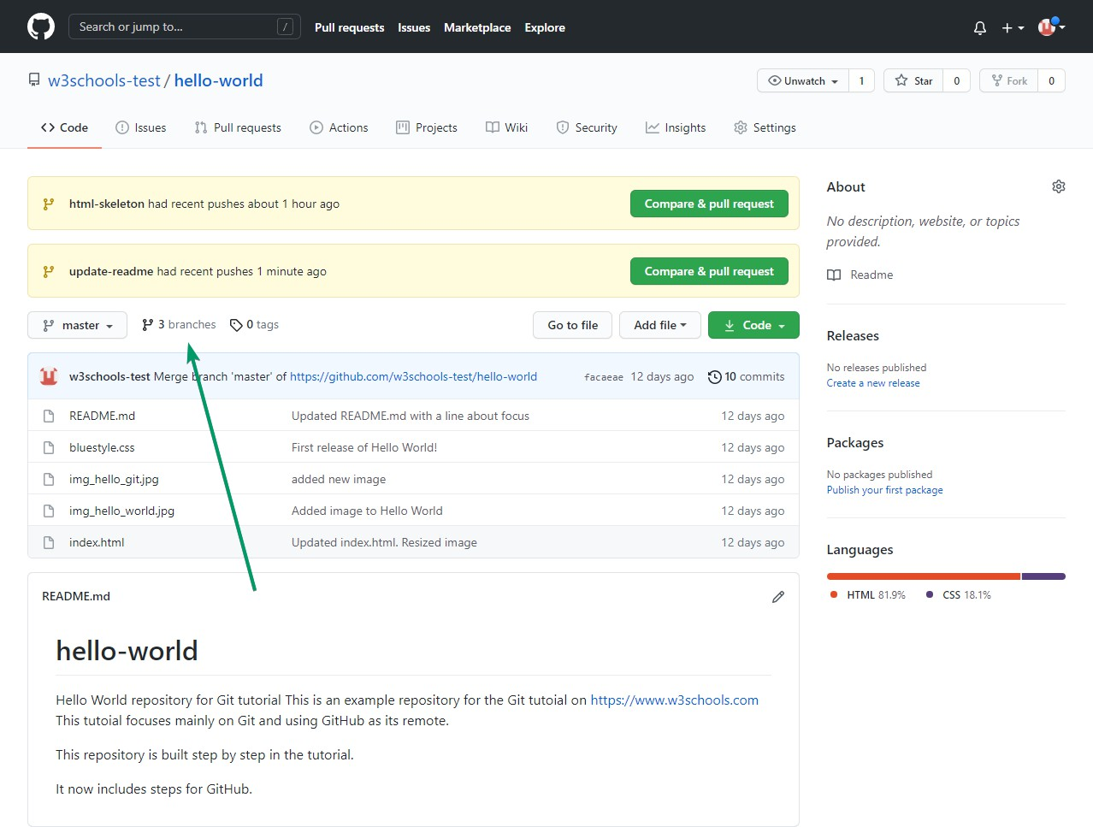

InGitHub, wecannowseethechangesand merge themintothemaster branch ifweapprove it.

Ifyouclickthe"Compare &pullrequest", youcangothroughthechanges madeand new files added:

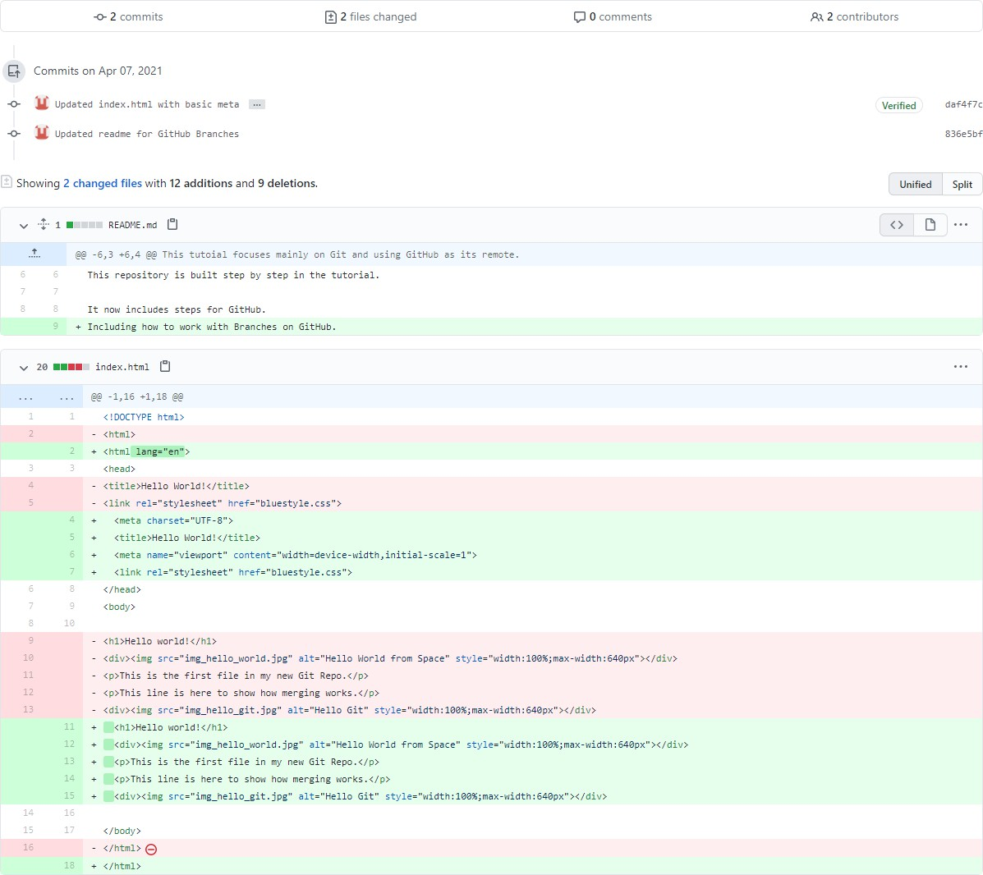

**Note:** Thiscomparisonshowsboththechanges fromupdate-readme andhtml-skeleton because we created the new branch FROM html-skeleton.

Ifthechangeslook good,you cangoforward,creatingapullrequest:

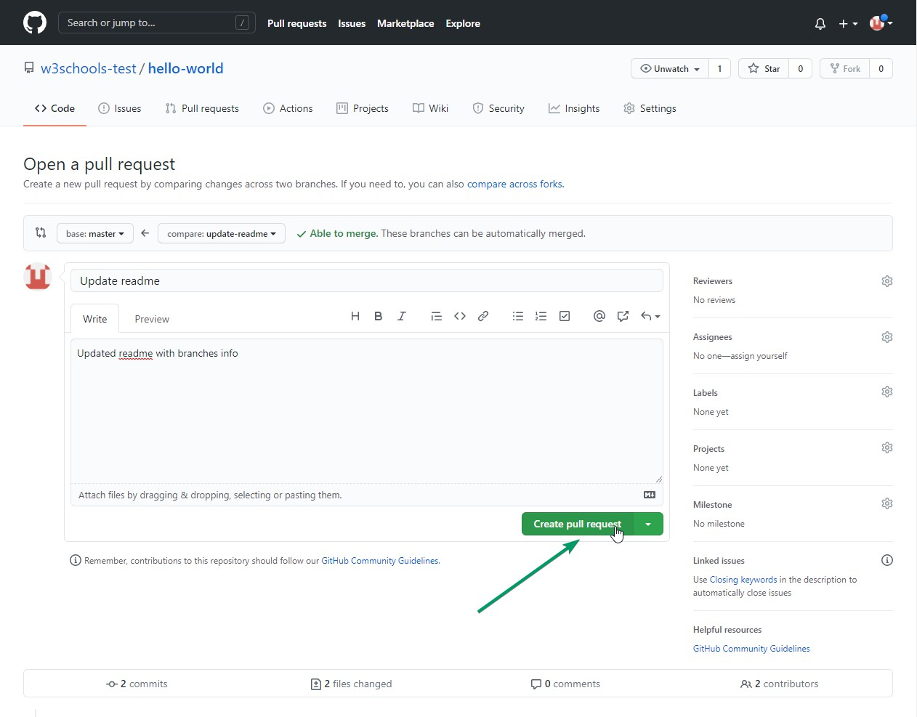

Apullrequest ishowyouproposechanges.Youcanasksometoreview yourchangesorpull your contribution and merge it into their branch.

Sincethis isyourownrepository,youcanmergeyourpullrequestyourself:

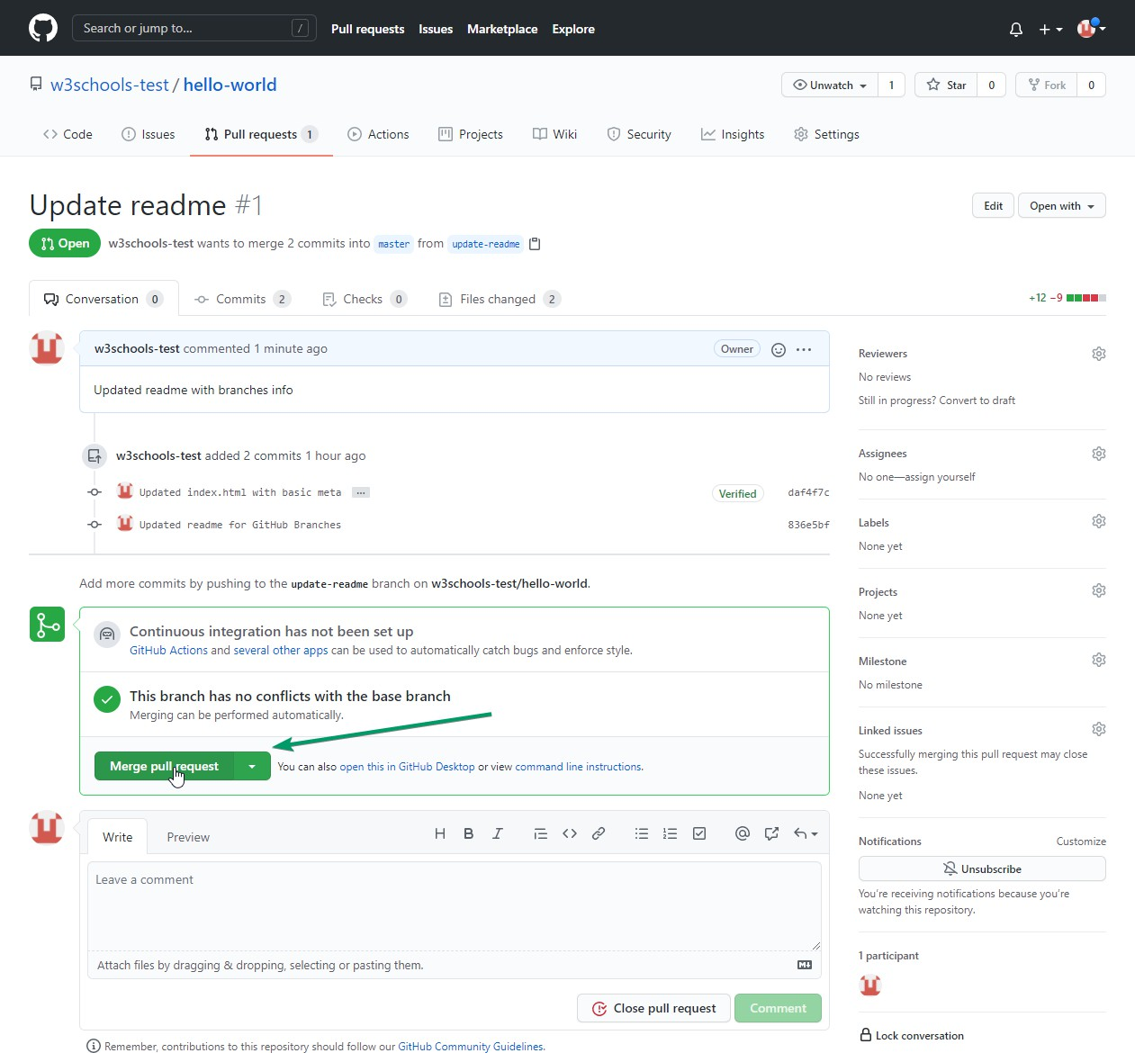

Thepullrequest willrecordthechanges, which means you cango throughthemlaterto figure out the changes made.

Theresultshouldbesomethinglikethis:

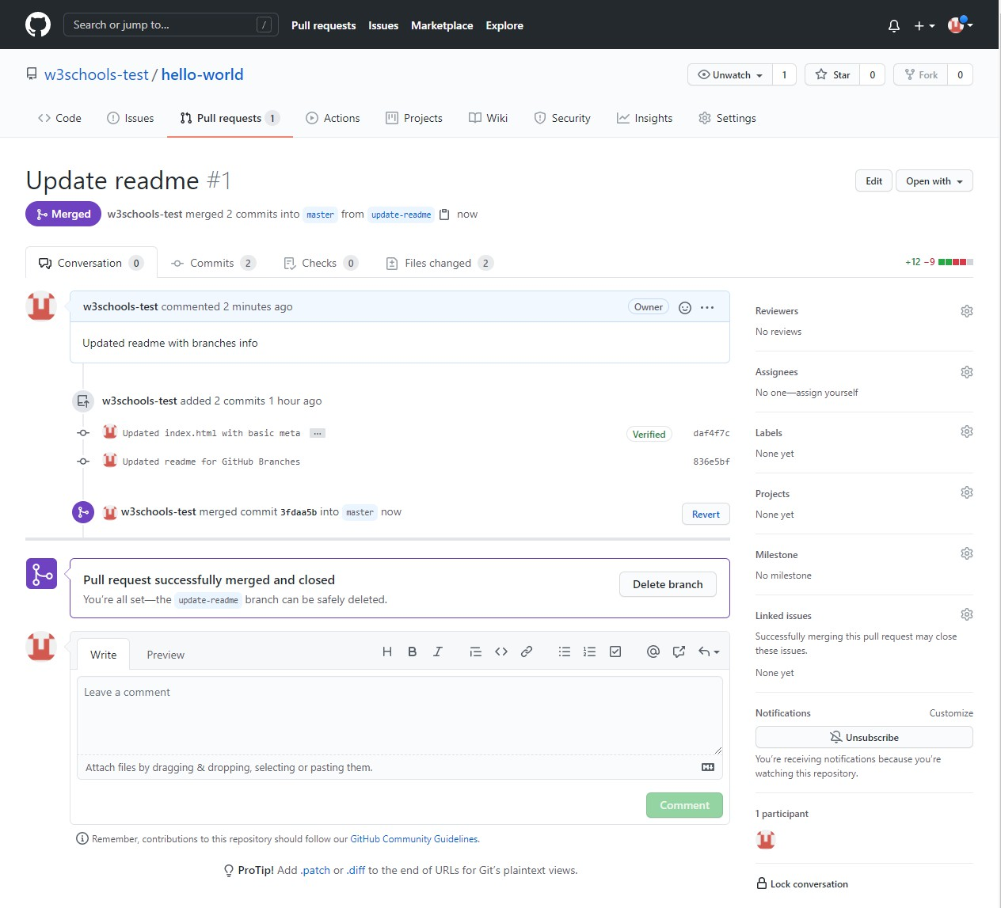

Tokeeptherepo fromgettingoverlycomplicated,youcandeletethenowunusedbranchby clicking "Delete branch".



Anafter youconfirmthatthechanges fromtheprevious branchwere included, deletethatas well:

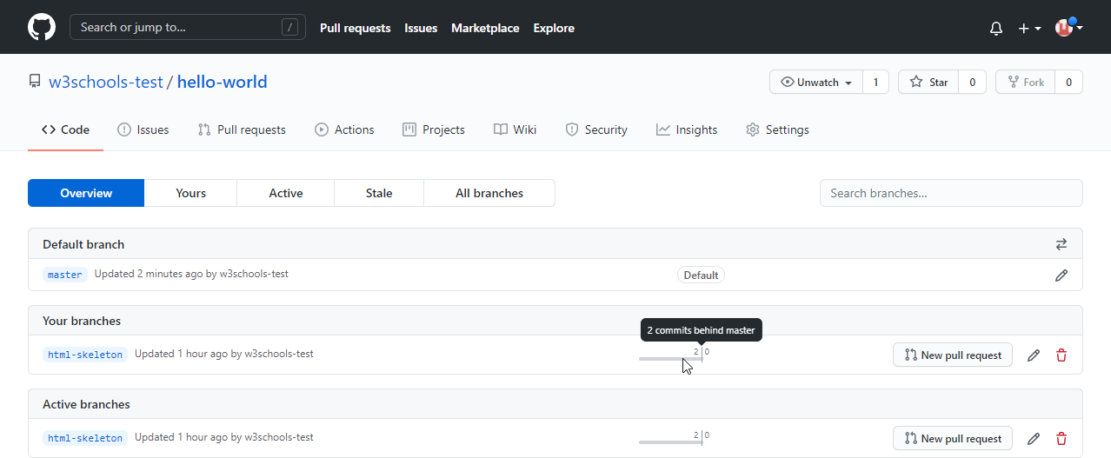

# CSSTutorial

**CSS tutorial** or CSS 3 tutorial provides basic and advanced concepts of CSS technology. OurCSStutorialisdeveloped forbeginnersandprofessionals.The majorpointsofCSSare given below:

* CSSstandsforCascadingStyleSheet.
* CSSisusedtodesignHTML tags.
* CSSisawidelyusedlanguageontheweb.
* HTML,CSSandJavaScript areusedforwebdesigning.It helpsthewebdesignersto apply style on HTML tags.

### CSS ExamplewithCSSEditor

Inthistutorial, youwillget alotofCSSexamples, youcanedit andruntheseexampleswith our online CSS editor tool.

1. <!DOCTYPE>
2. <html>
3. <head>
4. <style>
5. h1{
6. color:white;
7. background-color:red;
8. padding:5px;
9. }
10. p{
11. color:blue;
12. }
13. </style>
14. </head>
15. <body>
16. <h1>WriteYour FirstCSSExample</h1>
17. <p>ThisisParagraph.</p>
18. </body>
19. </html>[Test it Now](https://www.javatpoint.com/oprweb/test.jsp?filename=csscss1)

Output:

**WriteYourFirstCSS Example**

This isParagraph.

# What isCSS

CSSstandsforCascadingStyleSheets.Itisastyle sheet languagewhichisusedto describe thelookandformattingofadocument writteninmarkup language.It providesanadditional featureto HTML. ItisgenerallyusedwithHTMLtochangethestyleofwebpagesanduser interfaces. Itcanalso beusedwithanykindofXMLdocuments includingplainXML, SVG and XUL.

CSSisusedalongwithHTMLandJavaScript inmost websitesto createuserinterfacesfor web applications and user interfaces for many mobile applications.

### What doesCSSdo

* Youcanadd newlookstoyourold HTMLdocuments.
* Youcancompletelychangethe lookofyourwebsitewithonlya fewchanges inCSS code.

### Whyuse CSS

ThesearethethreemajorbenefitsofCSS:

### Solvesabig problem

Before CSS,tags like font, color, background style, element alignments, border and size had to be repeated on everyweb page. This was a very long process. For example: If you are developinga largewebsitewhere fontsandcolorinformationareaddedoneverysinglepage, it will be become a long and expensive process. CSS was created to solve this problem. Itwas a W3C recommendation.

### Savesalotoftime

CSSstyledefinitionsaresaved inexternalCSS filesso it ispossibleto changetheentire website by changing just one file.

### Providemoreattributes

CSSprovides moredetailedattributesthanplainHTMLtodefinethe lookandfeelofthe website.

# CSSSyntax

ACSSrulesetcontainsaselectorandadeclarationblock.

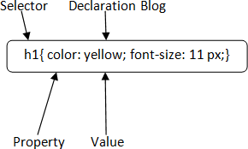

**Selector:** SelectorindicatestheHTMLelementyouwanttostyle. Itcouldbeanytaglike

<h1>,<title> etc.

**DeclarationBlock:** Thedeclarationblockcancontainoneormoredeclarationsseparatedby a semicolon. For the above example, there are two declarations:

* 1. color:yellow;
  2. font-size:11px;

Eachdeclarationcontainsapropertynameandvalue,separatedbya colon.

**Property:** APropertyisatypeofattributeofHTMLelement.Itcould becolor,borderetc.

**Value:**ValuesareassignedtoCSSproperties.Intheaboveexample,value"yellow" is assigned to color property.

# Selector{Property1:value1;Property2:val ue2; ..........;}CSS Selector

**CSS selectors**areused*to selectthecontent you want to style*.SelectorsarethepartofCSS

ruleset.CSSselectorsselect HTMLelementsaccordingtoitsid,class,type,attributeetc. There are several different types of selectors in CSS.

1. CSSElement Selector
2. CSSIdSelector
3. CSSClassSelector
4. CSSUniversalSelector
5. CSSGroupSelector

### CSSElementSelector

TheelementselectorselectstheHTMLelementbyname.

* 1. <!DOCTYPE html>
  2. <html>
  3. <head>
  4. <style>
  5. p{
  6. text-align:center;
  7. color:blue;

8.}

1. </style>
2. </head>
3. <body>
4. <p>Thisstylewillbeappliedoneveryparagraph.</p>
5. <pid="para1">Metoo!</p>
6. <p>And me!</p>
7. </body>
8. </html>[Test it Now](https://www.javatpoint.com/oprweb/test.jsp?filename=cssselector1)

Output:

Thisstylewillbeappliedoneveryparagraph.

Me too! And me!

### CSSIdSelector

The idselectorselectsthe idattributeofanHTMLelementto select aspecificelement.Anid is always unique within the page so it is chosen to select a single, unique element.

Itiswrittenwiththehashcharacter(#),followed bytheidofthe element.

Let?stakeanexamplewiththeid "para1".

* 1. <!DOCTYPE html>
  2. <html>
  3. <head>
  4. <style>
  5. #para1{
  6. text-align:center;
  7. color:blue;

8.}

1. </style>
2. </head>
3. <body>
4. <pid="para1">HelloJavatpoint.com</p>
5. <p>Thisparagraphwillnotbeaffected.</p>
6. </body>
7. </html>

[TestitNow](https://www.javatpoint.com/oprweb/test.jsp?filename=cssselector2)

Output:

HelloJavatpoint.com

Thisparagraphwill not beaffected.

### CSS Class Selector

TheclassselectorselectsHTMLelementswithaspecificclassattribute.It isusedwitha period character . (full stop symbol) followed by the class name.

*Note:Aclassnameshouldnotbestartedwith anumber.*

Let'stake anexample witha class"center".

* 1. <!DOCTYPE html>
  2. <html>
  3. <head>
  4. <style>
  5. .center{
  6. text-align:center;
  7. color:blue;

8.}

1. </style>
2. </head>
3. <body>
4. <h1class="center">Thisheadingisblueandcenter-aligned.</h1>
5. <pclass="center">Thisparagraphisblueandcenter-aligned.</p>
6. </body>
7. </html>

[TestitNow](https://www.javatpoint.com/oprweb/test.jsp?filename=cssselector3)

Output:

**Thisheading isblueandcenter-aligned.**

Thisparagraphis blueandcenter-aligned.

### CSSClassSelectorforspecificelement

Ifyouwanttospecifythat onlyonespecificHTMLelement should beaffectedthenyou should use the element name with class selector.

Let'sseeanexample.

1. <!DOCTYPE html>
2. <html>
3. <head>
4. <style>
5. p.center{
6. text-align:center;
7. color:blue;

8.}

1. </style>
2. </head>
3. <body>
4. <h1class="center">Thisheadingisnot affected</h1>
5. <pclass="center">Thisparagraphisblueandcenter-aligned.</p>
6. </body>
7. </html>

[TestitNow](https://www.javatpoint.com/oprweb/test.jsp?filename=cssselector32)

Output:

### Thisheadingisnotaffected

Thisparagraphisblueand center-aligned.

### CSSUniversalSelector

Theuniversalselectorisused asawildcard character.Itselectsalltheelementsonthe pages.

* 1. <!DOCTYPE html>
  2. <html>
  3. <head>
  4. <style>
  5. *{
  6. color:green;
  7. font-size:20px;

8.}

1. </style>
2. </head>
3. <body>
4. <h2>Thisisheading</h2>
5. <p>Thisstylewillbeappliedoneveryparagraph.</p>
6. <pid="para1">Metoo!</p>
7. <p>Andme!</p>
8. </body>
9. </html>

[TestitNow](https://www.javatpoint.com/oprweb/test.jsp?filename=cssselector4)

Output:

**Thisis heading**

Thisstylewillbeappliedoneveryparagraph. Me too!

Andme!

### CSSGroupSelector

Thegroupingselectorisusedtoselectalltheelementswiththesamestyle definitions.

Groupingselectorisusedtominimizethecode. Commasareusedto separateeachselectorin grouping.

Let'sseetheCSS codewithout groupselector.

* 1. h1{
  2. text-align:center;
  3. color:blue;

4.}

1. h2{
2. text-align:center;
3. color:blue;

8.}

1. p{
2. text-align:center;
3. color:blue;

12.}

Asyoucansee, you needto defineCSSpropertiesforalltheelements.It canbegroupedin following ways:

1. h1,h2,p{
2. text-align:center;
3. color:blue;

4.}

Let'sseethefullexampleofCSS groupselector.

1. <!DOCTYPE html>
2. <html>
3. <head>
4. <style>
5. h1, h2,p{
6. text-align:center;
7. color:blue;

8.}

1. </style>
2. </head>
3. <body>
4. <h1>HelloJavatpoint.com</h1>
5. <h2>HelloJavatpoint.com(Insmallerfont)</h2>
6. <p>Thisis aparagraph.</p>
7. </body>
8. </html>

Output:

**HelloJavatpoint.com**

HelloJavatpoint.com(Insmallerfont)

# Howtoadd CSS

This isaparagraph.

CSSisaddedto HTMLpagestoformatthedocument accordingto informationinthestyle sheet. There are three ways to insert CSS in HTML documents.

1. InlineCSS
2. InternalCSS
3. ExternalCSS

### InlineCSS

InlineCSS isusedto applyCSSonasingle lineorelement. For example:

* 1. <pstyle="color:blue">HelloCSS</p> For more visit here: [Inline CSS](https://www.javatpoint.com/inline-css)

### InternalCSS

InternalCSS isusedto applyCSSonasingledocumentorpage. Itcanaffect alltheelements of the page. It is written inside the style tag within head section of html.

Forexample:

* 1. <style>
  2. p{color:blue}
  3. </style>

Formorevisithere:[InternalCSS](https://www.javatpoint.com/internal-css)

### ExternalCSS

ExternalCSS isusedto applyCSSonmultiplepagesorallpages. Here, wewritealltheCSS code in a css file. Its extension must be .css for example style.css.

Forexample:

* 1. p{color:blue}

Youneedtolinkthisstyle.css filetoyourhtmlpages like this:

1. <linkrel="stylesheet"type="text/css"href="style.css"> The link tag must be used inside head section of html.

# InlineCSS

WecanapplyCSSinasingleelementbyinlineCSStechnique.

The inlineCSS isalso amethodtoinsert stylesheetsinHTMLdocument.Thismethod mitigates some advantages ofstyle sheets so it is advised to usethis method sparingly.

IfyouwanttouseinlineCSS, youshouldusethestyleattributetotherelevant tag. Syntax:

1. <htmltagstyle="cssproperty1:value;cssproperty2:value;"></htmltag>Example:
   1. <h2style="color:red;margin-left:40px;">InlineCSS isappliedonthisheading.</h2>
   2. <p>Thisparagraphisnotaffected.</p>Output:

**InlineCSS isappliedon thisheading.**

Thisparagraphis notaffected.

### DisadvantagesofInline CSS

* + - Youcannotusequotationswithin inlineCSS.Ifyouusequotationsthebrowserwill interpret this as an end of your style value.
    - Thesestylescannotbereusedanywhereelse.
    - Thesestylesaretoughtobeedited becausetheyarenot storedat asingleplace.
    - Itis notpossibletostylepseudo-codesandpseudo-classeswithinlineCSS.
    - InlineCSSdoesnotprovidebrowsercache advantages.

# InternalCSS

Theinternalstylesheetis usedtoaddauniquestyleforasingledocument. Itisdefinedin

<head>sectionoftheHTMLpage insidethe<style>tag. Example:

1. <!DOCTYPE html>
2. <html>
3. <head>
4. <style>
5. body{
6. background-color:linen;

7.}

1. h1{
2. color: red;
3. margin-left:80px;

11. }

1. </style>
2. </head>
3. <body>
4. <h1>Theinternalstylesheetisappliedonthisheading.</h1>
5. <p>Thisparagraphwillnotbeaffected.</p>
6. </body>
7. </html>

# External CSS

Theexternalstylesheet isgenerallyusedwhenyouwantto makechangesonmultiplepages. Itis idealforthisconditionbecause it facilitates youto changethe lookoftheentirewebsite by changing just one file.

Itusesthe<link>tagoneverypagesandthe<link>tagshouldbeput insidetheheadsection. Example:

1. <head>
2. <linkrel="stylesheet"type="text/css"href="mystyle.css">
3. </head>

Theexternalstylesheet maybewritteninanytext editorbutmust besavedwitha.css extension. This file should not contain HTML elements.

Let'stakeanexampleofastylesheet file named"mystyle.css". File: mystyle.css

1. body{
2. background-color:lightblue;

3.}

1. h1{
2. color:navy;
3. margin-left:20px;

7.}

Note:Youshould notusea spacebetweenthepropertyvalueandtheunit. Forexample:It should be margin-left:20px not margin-left:20 px.

# CSS Comments

CSScommentsaregenerallywrittento explain yourcode.It isveryhelpfulfortheuserswho reads your code so that they can easily understand the code.

Commentsareignoredbybrowsers.

Commentsaresingleormultiplelinesstatementandwrittenwithin/*. */.

1. <!DOCTYPE html>
2. <html>
3. <head>
4. <style>
5. p{
6. color:blue;
7. /*Thisisasingle-linecomment*/
8. text-align:center;

9.}

1. /*Thisis
2. amulti-line
3. comment*/
4. </style>
5. </head>
6. <body>
7. <p>HelloJavatpoint.com</p>
8. <p>ThisstatementisstyledwithCSS.</p>
9. <p>CSScommentsareignoredbythebrowsersandnotshown intheoutput.</p>
10. </body>
11. </html> Output:

HelloJavatpoint.com

ThisstatementisstyledwithCSS.

CSScommentsareignored bythebrowsersandnotshownintheoutput.

# CSSBackground

CSSbackgroundpropertyisusedtodefinethe backgroundeffectsonelement.Thereare5 CSS background properties that affects the HTML elements:

1. background-color
2. background-image
3. background-repeat
4. background-attachment
5. background-position

### CSSbackground-color

Thebackground-colorpropertyisusedtospecifythe backgroundcoloroftheelement. You can set the background color like this:

* 1. <!DOCTYPE html>
  2. <html>
  3. <head>
  4. <style>
  5. h2,p{
  6. background-color:#b0d4de;

7.}

1. </style>
2. </head>
3. <body>
4. <h2>MyfirstCSS page.</h2>
5. <p>HelloJavatpoint.ThisisanexampleofCSS background-color.</p>
6. </body>
7. </html> Output:

**Myfirst CSS page.**

HelloJavatpoint.ThisisanexampleofCSS background-color.

### CSSbackground-image

The background-image property is used to set an image as a background of an element. By default the imagecoverstheentireelement.Youcanset thebackground image forapagelike this.

* 1. <!DOCTYPE html>
  2. <html>
  3. <head>
  4. <style>
  5. body{
  6. background-image:url("paper1.gif");
  7. margin-left:100px;
  8. }
  9. </style>
  10. </head>
  11. <body>
  12. <h1>HelloJavatpoint.com</h1>
  13. </body>
  14. </html>

Note:Thebackground imageshould bechosenaccordingtotext color.Thebadcombination of text and background image may be a cause of poor designed and not readable webpage.

### CSSbackground-repeat

Bydefault, thebackground-imagepropertyrepeatsthebackground imagehorizontallyand vertically. Some images are repeated only horizontally or vertically.

Thebackgroundlooksbetter iftheimagerepeatedhorizontallyonly.

##### background-repeat:repeat-x;

* 1. <!DOCTYPE html>
  2. <html>
  3. <head>
  4. <style>
  5. body{
  6. background-image:url("gradient_bg.png");
  7. background-repeat:repeat-x;

8.}

1. </style>
2. </head>
3. <body>
4. <h1>HelloJavatpoint.com</h1>
5. </body>
6. </html>

##### background-repeat:repeat-y;

1. <!DOCTYPE html>
2. <html>
3. <head>
4. <style>
5. body{
6. background-image:url("gradient_bg.png");
7. background-repeat:repeat-y;

8.}

1. </style>
2. </head>
3. <body>
4. <h1>HelloJavatpoint.com</h1>
5. </body>
6. </html>

### CSSbackground-attachment

Thebackground-attachment propertyisusedto specifyifthebackground image isfixedor scroll with the rest ofthe page in browser window. If you set fixed the background image then the image will not move during scrolling in the browser. Let?s take an example with fixed background image.

* 1. background:whiteurl('bbb.gif');
  2. background-repeat:no-repeat;
  3. background-attachment: fixed;

### CSSbackground-position

Thebackground-positionpropertyisusedto definetheinitialpositionofthebackground image. By default, the background image is placed on the top-left of the webpage.

Youcansetthefollowingpositions:

* 1. center
  2. top
  3. bottom
  4. left
  5. right

1. background: whiteurl('good-morning.jpg');
2. background-repeat:no-repeat;
3. background-attachment: fixed;
4. background-position:center;

# CSSBorder

TheCSS borderisashorthandpropertyusedto settheborderonanelement.

The[CSS](https://www.javatpoint.com/css-tutorial)borderpropertiesareusetospecifythestyle, colorandsizeoftheborderofan element. The CSS border properties are given below

* + border-style
  + border-color
  + border-width
  + border-radius

### CSSborder-style

TheBorderstylepropertyisusedto specifythebordertypewhichyouwantto displayonthe web page.

Therearesome borderstylevalueswhichareusedwithborder-stylepropertyto definea border.

|  |  |
| --- | --- |
| **Value** | **Description** |
| none | Itdoesn't defineanyborder. |
| dotted | It isusedtodefineadottedborder. |
| dashed | It isusedtodefineadashedborder. |
| solid | It isusedtodefineasolidborder. |
| double | It definestwoborderswIththesameborder-widthvalue. |
| groove | Itdefinesa 3dgroovedborder. effectisgeneratedaccordingtoborder-colorvalue. |
| ridge | Itdefinesa3dridgedborder. effectisgeneratedaccordingtoborder-colorvalue. |
| inset | Itdefinesa 3dinsetborder.effectisgeneratedaccordingtoborder-color value. |
| outset | Itdefinesa 3doutsetborder.effectisgeneratedaccordingtoborder-colorvalue. |

* 1. <!DOCTYPE html>
  2. <html>
  3. <head>
  4. <style>
  5. p.none{border-style: none;}
  6. p.dotted{border-style:dotted;}
  7. p.dashed{border-style:dashed;}
  8. p.solid{border-style:solid;}
  9. p.double{border-style: double;}
  10. p.groove{border-style: groove;}
  11. p.ridge{border-style:ridge;}
  12. p.inset{border-style:inset;}
  13. p.outset{border-style:outset;}
  14. p.hidden{border-style:hidden;}
  15. </style>
  16. </head>
  17. <body>
  18. <pclass="none">Noborder.</p>
  19. <pclass="dotted">Adottedborder.</p>
  20. <pclass="dashed">Adashedborder.</p>
  21. <pclass="solid">Asolidborder.</p>
  22. <pclass="double">Adoubleborder.</p>
  23. <pclass="groove">Agroove border.</p>
  24. <pclass="ridge">Aridgeborder.</p>
  25. <pclass="inset">Aninsetborder.</p>
  26. <pclass="outset">Anoutsetborder.</p>
  27. <pclass="hidden">Ahiddenborder.</p>
  28. </body>
  29. </html> Output:

Noborder.

Adottedborder.

Adashedborder.

Asolid border.

Adoubleborder.

Agrooveborder.

Aridgeborder.

Aninsetborder.

Anoutsetborder.

Ahiddenborder.

### CSSborder-width

Theborder-widthpropertyisusedto settheborder'swidth.It isset inpixels.Youcanalso use the one of the three pre-defined values, thin, medium or thick to set the width of the border.

*Note:Theborder-width propertyisnotusedalone.Itisalways used with other borderpropertieslike "border-style" property to set the border first otherwise it will not work.*

* 1. <!DOCTYPE html>
  2. <html>
  3. <head>
  4. <style>
  5. p.one{
  6. border-style:solid;
  7. border-width:5px;

8.}

1. p.two{
2. border-style:solid;
3. border-width:medium;

12.}

1. p.three{
2. border-style:solid;
3. border-width:1px;

16.}

1. </style>
2. </head>
3. <body>
4. <pclass="one">Writeyourtext here.</p>
5. <pclass="two">Writeyourtexthere.</p>
6. <pclass="three">Writeyourtexthere.</p>
7. </body>
8. </html>

### CSSborder-color

Therearethreemethodsto setthe colorofthe border.

* Name:Itspecifiesthecolorname.Forexample:"red".
* RGB:ItspecifiestheRGBvalueofthecolor. For example:"rgb(255,0,0)".
* Hex:Itspecifiesthehexvalueofthecolor.For example:"#ff0000".

Thereisalsoabordercolornamed"transparent".Ifthebordercolorisnotsetit isinherited from the color property of the element.

*Note:Theborder-color propertyis notusedalone.Itisalways used with other borderpropertieslike "border-style" property to set the border first otherwise it will not work.*

* 1. <!DOCTYPE html>
  2. <html>
  3. <head>
  4. <style>
  5. p.one{
  6. border-style:solid;
  7. border-color:red;

8.}

1. p.two{
2. border-style:solid;
3. border-color:#98bf21;

12.}

1. </style>
2. </head>
3. <body>
4. <pclass="one">Thisisa solidredborder</p>
5. <pclass="two">Thisisasolidgreenborder</p>
6. </body>
7. </html>

# CSSborder-collapseproperty

ThisCSSpropertyisusedtosettheborderofthetablecellsandspecifieswhether thetable cells share the separate or common border.

Thispropertyhastwo mainvaluesthat are **separate**and**collapse**.Whenit isset tothevalue **separate**, the distance between the cells can be defined using the **border-spacing** property. When the **border-collapse** is set to the value **collapse**, then the **inset** value of **border-style** property behaves like **groove**, and the **outset** value behaves like **ridge**.

Syntax

1. border-collapse:separate|collapse|initial|inherit; The values of this CSS property are defined as follows.

PropertyValues

**separate:** It isthedefault valuethat separatestheborderofthetablecell.Usingthisvalue, each cell will display its own border.

**collapse:**Thisvalue isusedtocollapsethebordersinto asingleborder.Usingthis,two adjacenttablecellswillshareaborder.Whenthis value isapplied, the **border-spacing** property does not affect.

**initial:**Itsetsthepropertytoitsdefaultvalue.

**inherit:**Itinheritsthepropertyfromitsparentelement.

Now,let'sunderstandthis[CSS](https://www.javatpoint.com/css-tutorial)propertybyusingsomeexamples. Inthe first example, weare using the **separate** value of the **border-collapse** property. In the second example, we are using the **collapse** value of the **border-collapse** property.

Example-Usingseparatevalue

Withthisvalue, wecanusethe **border-spacing**propertyto setthedistancebetweenthe adjacent table cells.

1. <!DOCTYPE html>
2. <html>
3. ​
4. <head>
5. <title>border-collapseproperty</title>
6. <style>
7. table{
8. border:2pxsolidblue;
9. text-align:center;
10. font-size:20px;
11. width:80%;
12. height:50%;
13. }
14. th{
15. border:5pxsolidred;
16. background-color:yellow;
17. }
18. td{
19. border:5pxsolidviolet;
20. background-color:cyan;
21. }
22. #t1{
23. border-collapse:separate;
24. }
25. </style>
26. </head>
27. ​
28. <body>
29. ​
30. <h1>Theborder-collapseProperty</h1>
31. <h2>border-collapse:separate;</h2>
32. <tableid="t1">
33. <tr>
34. <th>First_Name</th>
35. <th>Last_Name</th>
36. <th>Subject</th>
37. <th>Marks</th>
38. </tr>
39. <tr>
40. <td>James</td>
41. <td>Gosling</td>
42. <td>Maths </td>
43. <td>92</td>
44. </tr>
45. <tr>
46. <td>Alan</td>
47. <td>Rickman</td>
48. <td>Maths </td>
49. <td>89</td>
50. </tr>
51. <tr>
52. <td>Sam</td>
53. <td>Mendes</td>
54. <td>Maths </td>
55. <td>82</td>
56. </tr>
57. </table>
58. </body>
59. ​
60. </html>[Test it Now](https://www.javatpoint.com/oprweb/test.jsp?filename=css-border-collapse-property1)

##### Output

Example-Usingcollapseproperty

The**border-spacing**and[**border-radius**properties](https://www.javatpoint.com/css-border-radius-property)cannotbeusedwiththis value.

1. <!DOCTYPE html>
2. <html>
3. ​
4. <head>
5. <title>border-collapseproperty</title>
6. <style>
7. table{
8. border:2pxsolidblue;
9. text-align:center;
10. font-size:20px;
11. width:80%;
12. height:50%;
13. }
14. th{
15. border:5pxsolidred;
16. background-color:yellow;
17. }
18. td{
19. border:5pxsolidviolet;
20. background-color:cyan;
21. }
22. #t1{
23. border-collapse:collapse;
24. }
25. </style>
26. </head>
27. ​
28. <body>
29. ​
30. <h1>Theborder-collapseProperty</h1>
31. <h2>border-collapse:collapse;</h2>
32. <tableid="t1">
33. <tr>
34. <th>First_Name</th>
35. <th>Last_Name</th>
36. <th>Subject</th>
37. <th>Marks</th>
38. </tr>
39. <tr>
40. <td>James</td>
41. <td>Gosling</td>
42. <td>Maths </td>
43. <td>92</td>
44. </tr>
45. <tr>
46. <td>Alan</td>
47. <td>Rickman</td>
48. <td>Maths </td>
49. <td>89</td>
50. </tr>
51. <tr>
52. <td>Sam</td>
53. <td>Mendes</td>
54. <td>Maths </td>
55. <td>82</td>
56. </tr>
57. </table>
58. </body>
59. </html>

[TestitNow](https://www.javatpoint.com/oprweb/test.jsp?filename=css-border-collapse-property2)

**Output**

# CSSborder-spacingproperty

This CSS propertyis used to setthe distance betweenthe borders ofthe adjacent cells inthe table. Itappliesonlywhenthe **border-collapse**propertyissetto **separate**. Therewillnot be any space between the borders if the [**border-collapse**](https://www.javatpoint.com/css-border-collapse-property)is set to **collapse**.

Itcanbedefined asoneortwo valuesfor determiningtheverticalandhorizontalspacing.

* + Whenonlyonevalueisspecified,thenitsetsbothhorizontalandverticalspacing.
  + When weusethetwo-valuesyntax, thenthefirst oneis usedtoset thehorizontalspacing(i.e., the space between the adjacent columns), and the second value sets the vertical spacing (i.e., the space between the adjacent rows).

Syntax

1. border-spacing:length|initial|inherit; Property Values

Thevaluesofthis[CSS](https://www.javatpoint.com/css-tutorial)propertyare defined asfollows.

**length:** This valuesetsthedistance betweenthebordersoftheadjacenttablecells inpx, cm, pt, etc. Negative values are not allowed.

**initial:**Itsetsthepropertytoitsdefaultvalue.

**inherit:**Itinheritsthepropertyfromitsparentelement.

Let's understand this CSS propertyby using some examples. In the first example, we are usingthesinglevalueofthe **border-spacing**property,and inthesecondexample,weare

usingtwovaluesofthe**border-spacing**property. Example

Here,weareusingthesinglevalueofthe**border-spacing**property. The**border-collapse**

propertyissetto**separate**,andthevalueofthe**border-spacing**issetto**45px**.

1. <!DOCTYPEhtml>
2. <html>
3. ​
4. <head>
5. <title> border-spacingproperty</title>
6. <style>
7. table{
8. border:2pxsolidblue;
9. text-align:center;
10. font-size:20px;
11. background-color: lightgreen;
12. }
13. th{
14. border:5pxsolidred;
15. background-color: yellow;
16. }
17. td{
18. border:5pxsolidviolet;
19. background-color:cyan;
20. }
21. #space{
22. border-collapse:separate;
23. border-spacing:45px;
24. }
25. </style>
26. </head>
27. ​
28. <body>
29. ​
30. <h1>Theborder-spacingProperty</h1>
31. <h2> border-spacing:45px;</h2>
32. <tableid="space">
33. <tr>
34. <th>First_Name</th>
35. <th>Last_Name</th>
36. <th>Subject</th>
37. <th>Marks</th>
38. </tr>
39. <tr>
40. <td>James</td>
41. <td>Gosling</td>
42. <td>Maths </td>
43. <td>92</td>
44. </tr>
45. <tr>
46. <td>Alan</td>
47. <td>Rickman</td>
48. <td>Maths </td>
49. <td>89</td>
50. </tr>
51. <tr>
52. <td>Sam</td>
53. <td>Mendes</td>
54. <td>Maths </td>
55. <td>82</td>
56. </tr>
57. </table>
58. </body>
59. ​
60. </html>

##### Output

Example

Here, weareusingtwo valuesofthe **border-spacing**property. The**border-collapse**property is set to **separate**, and the value ofthe **border-spacing** is set to **20pt 1em**. The first value,i.e., **20pt** setsthe horizontal spacing, and the value **1em** set the vertical spacing.

1. <!DOCTYPE html>
2. <html>
3. ​
4. <head>
5. <title> border-spacingproperty</title>
6. <style>
7. table{
8. border:2pxsolidblue;
9. text-align:center;
10. font-size:20px;
11. background-color: lightgreen;
12. }
13. th{
14. border:5pxsolidred;
15. background-color: yellow;
16. }
17. td{
18. border:5pxsolidviolet;
19. background-color:cyan;
20. }
21. #space{
22. border-collapse:separate;
23. border-spacing:20pt1em;
24. }
25. </style>
26. </head>
27. ​
28. <body>
29. ​
30. <h1>Theborder-spacingProperty</h1>
31. <h2> border-spacing:20pt1em;</h2>
32. <tableid="space">
33. <tr>
34. <th>First_Name</th>
35. <th>Last_Name</th>
36. <th>Subject</th>
37. <th>Marks</th>
38. </tr>
39. <tr>
40. <td>James</td>
41. <td>Gosling</td>
42. <td>Maths </td>
43. <td>92</td>
44. </tr>
45. <tr>
46. <td>Alan</td>
47. <td>Rickman</td>
48. <td>Maths </td>
49. <td>89</td>
50. </tr>
51. <tr>
52. <td>Sam</td>
53. <td>Mendes</td>
54. <td>Maths </td>
55. <td>82</td>
56. </tr>
57. </table>
58. </body>
59. ​
60. </html>

# CSSDisplay

CSSdisplayisthe most importantpropertyofCSSwhichisusedto controlthe layout ofthe element. It specifies how the element is displayed.

Everyelement has a default display value according to its nature. Everyelement onthe webpage isarectangularboxandthe [CSS](https://www.javatpoint.com/css-tutorial)propertydefinesthebehaviorofthat rectangular box.

### CSSDisplaydefaultproperties

|  |  |
| --- | --- |
| defaultvalue | inline |
| inherited | no |
| animationsupporting | no |

|  |  |
| --- | --- |
| version | css1 |
| javascriptsyntax | object.style.display="none" |

**Syntax**

1. display:value;

### CSSdisplayvalues

TherearefollowingCSSdisplayvalueswhicharecommonlyused.

1. display:inline;
2. display:inline-block;
3. display:block;
4. display:run-in;
5. display:none;

### CSSdisplayinline

The inlineelementtakestherequiredwidthonly. Itdoesn't forcethe line breaksotheflowof text doesn't break in inline example.

Theinlineelements are:

* + <span>
  + <a>
  + <em>
  + <b>etc.

Let'sseeanexampleofCSS display inline.

1. <!DOCTYPE html>
2. <html>
3. <head>
4. <style>
5. p{
6. display:inline;
7. }
8. </style>
9. </head>
10. <body>
11. <p>HelloJavatpoint.com</p>
12. <p>JavaTutorial.</p>
13. <p>SQLTutorial.</p>
14. <p>HTMLTutorial.</p>
15. <p>CSSTutorial.</p>
16. </body>
17. </html>

##### Output:

HelloJavatpoint.comJavaTutorial.SQLTutorial.HTMLTutorial.CSSTutorial.

### CSSdisplayinline-block

TheCSSdisplayinline-blockelement isverysimilarto inlineelement butthedifference is that you are able to set the width and height.

1. <!DOCTYPE html>
2. <html>
3. <head>
4. <style>
5. p{
6. display:inline-block;
7. }
8. </style>
9. </head>
10. <body>
11. <p>HelloJavatpoint.com</p>
12. <p>JavaTutorial.</p>
13. <p>SQLTutorial.</p>
14. <p>HTMLTutorial.</p>
15. <p>CSSTutorial.</p>
16. </body>
17. </html>

##### Output:

HelloJavatpoint.com[JavaTutorial.](https://www.javatpoint.com/java-tutorial)[SQLTutorial.](https://www.javatpoint.com/sql-tutorial)[HTMLTutorial.](https://www.javatpoint.com/html-tutorial)CSS Tutorial.

### CSSdisplayblock

The CSS display block element takes as much as horizontalspace as they can. Means the blockelementtakesthe fullavailablewidth.Theymakea line breakbeforeandafterthem.

1. <!DOCTYPE html>
2. <html>
3. <head>
4. <style>
5. p{
6. display:block;
7. }
8. </style>
9. </head>
10. <body>
11. <p>HelloJavatpoint.com</p>
12. <p>JavaTutorial.</p>
13. <p>SQLTutorial.</p>
14. <p>HTMLTutorial.</p>
15. <p>CSSTutorial.</p>
16. </body>
17. </html>

##### Output:

HelloJavatpoint.com Java Tutorial.

SQL Tutorial. HTMLTutorial. CSS Tutorial.

### CSSdisplayrun-in

Thispropertydoesn't workin[Mozilla Firefox.](https://www.javatpoint.com/mozilla-firefox)Theseelementsdon't produceaspecific box by themselves.

* + Iftherun-inboxcontainsabock box,itwill besameasblock.
  + Iftheblock boxfollowstherun-inbox, therun-inboxbecomesthe first inline boxof the block box.
  + Iftheinlinebox followstherun-inbox,therun-inboxbecomesablock box.

1. <!DOCTYPE html>
2. <html>
3. <head>
4. <style>
5. p{
6. display:run-in;
7. }
8. </style>
9. </head>
10. <body>
11. <p>HelloJavatpoint.com</p>
12. <p>JavaTutorial.</p>
13. <p>SQLTutorial.</p>
14. <p>HTMLTutorial.</p>
15. <p>CSSTutorial.</p>
16. </body>
17. </html>

##### Output:

HelloJavatpoint.com Java Tutorial.

SQL Tutorial. HTMLTutorial. CSS Tutorial.

### CSSdisplaynone

The"none"valuetotallyremovestheelementfromthepage.Itwill nottakeanyspace.

1. <!DOCTYPE html>
2. <html>
3. <head>
4. <style>
5. h1.hidden{
6. display:none;

7.}

1. </style>
2. </head>
3. <body>
4. <h1>Thisheading isvisible.</h1>
5. <h1class="hidden">Thisisnotvisible.</h1>
6. <p>Youcanseethatthe hidden headingdoesnot containanyspace.</p>
7. </body>
8. </html>

**Output:**

### Thisheadingisvisible.

Youcanseethatthe hiddenheadingdoesnotcontainanyspace.

**OtherCSSdisplay values**

|  |  |
| --- | --- |
| **Property-value** | **Description** |
| flex | Itisusedtodisplayanelement asanblock-levelflexcontainer.It isnew in css3. |
| inline-flex | Itisusedtodisplayanelement asaninline-levelflexcontainer.It isnew in css3. |
| inline-table | Itdisplays anelementasaninline-leveltable. |
| list-Item | Itmakestheelementbehavelikea<li>element. |
| table | Itmakestheelementbehavelikea<table>element. |
| table-caption | Itmakestheelementbehavelikea<caption>element. |
| table-column- group | Itmakestheelementbehavelikea<colgroup>element. |
| table-header- group | Itmakestheelementbehavelikea<thead>element. |
| table-footer-group | Itmakestheelementbehavelikea<tfoot> element. |
| table-row-group | Itmakestheelementbehavelikea<tbody>element. |
| table-cell | Itmakestheelementbehavelikea<td> element. |
| table-row | Itmakestheelementbehavelikea<tr>element. |
| table-column | Itmakestheelementbehavelikea<col>element. |

# CSSCursor

It is used to define the type of mouse cursor when the mouse pointer is on the element. It allowsustospecifythecursortype, whichwillbe displayedtotheuser. Whenauserhovers on the link, then by default, the cursor transforms into the hand from a pointer.

Let'sunderstandthe propertyvaluesofthe cursor.

|  |  |
| --- | --- |
| **Values** | **Usage** |
| **alias** | Itisusedtodisplaythe indicationofthecursorofsomethingthat istobe created. |
| **auto** | Itisthedefaultpropertyinwhichthebrowsersetsthecursor. |
| **all-scroll** | Itindicatesthescrolling. |
| **col-resize** | Usingit, thecursorwillrepresentthatthecolumncanbehorizontallyresized. |
| **cell** | Thecursorwillrepresentthatacellorthecollectionofcellsis selected. |
| **context- menu** | Itindicatesthe availabilityofthe contextmenu. |
| **default** | Itindicatesanarrow,whichisthedefaultcursor. |
| **copy** | Itisusedtoindicatethatsomethingiscopied. |
| **crosshair** | Init,thecursor changestothecrosshair ortheplussign. |
| **e-resize** | Itrepresentstheeast directionand indicatesthattheedgeofthe boxisto be shifted towards right. |
| **ew-resize** | Itrepresentstheeast/westdirectionandindicatesabidirectionalresizecursor. |
| **n-resize** | It representsthenorthdirectionthatindicatesthat theedgeofthebox istobe |

|  |  |
| --- | --- |
|  | shiftedtoup. |
| **ne-resize** | Itrepresentsthenorth/east directionand indicatesthattheedgeoftheboxisto be shifted towards up and right. |
| **move** | Itindicatesthatsomethingistobeshifted. |
| **help** | Itisinthe formofaquestionmarkorballon,whichrepresentsthathelp is available. |
| **None** | Itisusedtoindicatethatnocursorisrenderedforthe element. |
| **No-drop** | Itisused to represent that thedragged itemcannot bedropped here. |
| **s-resize** | Itindicatesanedgeboxistobemoveddown.Itindicatesthesouthdirection. |
| **Row-resize** | Itisused to indicatethattherowcanbeverticallyresized. |
| **Se-resize** | Itrepresentsthesouth/east direction,whichindicatesthat anedgeboxisto be moved down and right. |
| **Sw-resize** | Itrepresentssouth/west directionand indicatesthat anedgeoftheboxistobe shifted towards down and left. |
| **Wait** | It representsanhourglass. |
| **<url>** | Itindicatesthesourceofthecursorimagefile. |
| **w-resize** | Itindicatesthewest directionandrepresentsthattheedgeoftheboxisto be shifted left. |
| **Zoom-in** | Itisusedtoindicatethatsomethingcanbezoomedin. |
| **Zoom-out** | Itisusedtoindicatethatsomethingcanbezoomedout. |

Theillustrationofusing theabovevaluesofcursorpropertyisgiven below:

##### Example

1. <html>
2. <head>
3. </head>
4. <style>
5. body{
6. background-color:lightblue;
7. color:green;
8. text-align:center;
9. font-size:20px;

10. }

11.

12. </style>

13.

1. <body>
2. <p>Moveyourmouseoverthebelowwordsforthecursor change.</p>
3. <divstyle="cursor:alias">aliasValue</div>
4. <divstyle="cursor:auto">autoValue</div>
5. <divstyle="cursor:all-scroll">all-scroll value</div>
6. <divstyle="cursor:col-resize">col-resizevalue</div>
7. <divstyle="cursor:crosshair">Crosshair</div>
8. <divstyle="cursor:default">Defaultvalue</div>
9. <divstyle="cursor:copy">copyvalue</div>
10. <divstyle="cursor:pointer">Pointer</div>
11. <divstyle="cursor:move">Move</div>
12. <divstyle="cursor:e-resize">e-resize</div>
13. <divstyle="cursor:ew-resize">ew-resize</div>
14. <divstyle="cursor:ne-resize">ne-resize</div>
15. <divstyle="cursor:nw-resize">nw-resize</div>
16. <divstyle="cursor:n-resize">n-resize</div>
17. <divstyle="cursor:se-resize">se-resize</div>
18. <divstyle="cursor:sw-resize">sw-resize</div>
19. <divstyle="cursor:s-resize">s-resize</div>
20. <divstyle="cursor:w-resize">w-resize</div>
21. <divstyle="cursor:text">text</div>
22. <divstyle="cursor:wait">wait</div>
23. <divstyle="cursor:help">help</div>
24. <divstyle="cursor:progress">Progress</div>
25. <divstyle="cursor:no-drop">no-drop</div>
26. <divstyle="cursor:not-allowed">not-allowed</div>
27. <divstyle="cursor:vertical-text">vertical-text</div>
28. <divstyle="cursor:zoom-in">Zoom-in</div>
29. <divstyle="cursor:zoom-out">Zoom-out</div>
30. </body>
31. </html>

# CSSButtons

InHTML, weusethebuttontagtocreateabutton,but byusingCSSproperties, wecanstyle the buttons. Buttons help us to create user interaction and event processing. Theyare one of the widely used elements of web pages.

Duringtheformsubmission,to viewortoget some information,wegenerallyusebuttons. Let's see the basic styling in buttons.

### BasicstylinginButtons

Therearemultiplepropertiesavailablethat areusedto stylethe buttonelement.Let'sdiscuss them one by one.

### background-color

Aswehavediscussedearlier,thispropertyisusedfor settingthe [backgroundcolor](https://www.javatpoint.com/css-background-color)ofthe button element.

##### Syntax

1. element{
2. //background-color style

3.}

##### Example

1. <!DOCTYPE html>
2. <html>
3. ​
4. <head>
5. <title>
6. buttonbackgroundColor
7. </title>
8. ​
9. <style>
10. body{
11. text-align:center;

12. }

1. button{
2. color:lightgoldenrodyellow;
3. font-size:30px;

16. }

1. .b1{
2. background-color:red;

19. }

1. .b2{
2. background-color:blue;

22. }

1. .b3{
2. background-color:violet;

25. }

1. </style>
2. </head>
3. ​
4. <body>
5. <h1>Thebackground-color property.</h1>
6. <buttonclass="b1">Redcolorbutton</button>
7. <buttonclass="b2">Bluecolorbutton</button>
8. <buttonclass="b3">Violetcolorbutton</button>
9. </body>
10. </html>

### border

Itisusedtosetthe [border](https://www.javatpoint.com/css-border)ofthebutton. Itistheshorthandpropertyfor **border-width, border-color,** and **border-style**.

##### Syntax

1. element{
2. //border style

3.}

##### Example

1. <!DOCTYPE html>
2. <html>
3. ​
4. <head>
5. <title>
6. buttonbackgroundColor
7. </title>
8. ​
9. <style>
10. body{
11. text-align:center;

12. }

1. button{
2. color:lightgoldenrodyellow;
3. font-size:30px;

16. }

1. .b1{
2. background-color:red;
3. border:none;

20. }

1. .b2{
2. background-color:blue;
3. border:5pxbrownsolid;

24. }

1. .b3{
2. background-color:yellow;
3. color:black;
4. border:5pxred groove;

29. }

1. .b4{
2. background-color:orange;
3. border:5pxreddashed;

33. }

1. .b5{
2. background-color:gray;
3. border:5pxblackdotted;

37. }

1. .b6{
2. background-color:lightblue;
3. border:5pxbluedouble;

41. }

1. </style>
2. </head>
3. ​
4. <body>
5. <h1>Theborderproperty</h1>
6. <buttonclass="b1">none</button>
7. <buttonclass="b2">solid</button>
8. <buttonclass="b3">groove</button>
9. <buttonclass="b4">dashed</button>
10. <buttonclass="b5">dotted</button>
11. <buttonclass="b6">double</button>
12. ​
13. </body>
14. </html>

### border-radius

Itisused to maketherounded cornersofthebutton.It setstheborderradiusofthe button.

##### Syntax

1. element{
2. //border-radiusproperty

3.}

##### Example

1. <!DOCTYPE html>
2. <html>
3. ​
4. <head>
5. <title>
6. buttonbackgroundColor
7. </title>
8. ​
9. <style>
10. body{
11. text-align:center;

12. }

1. button{
2. color:lightgoldenrodyellow;
3. font-size:30px;

16. }

1. .b1{
2. background-color:red;
3. border:none;

20. }

1. .b2{
2. background-color:blue;
3. border:5pxbrownsolid;
4. border-radius:7px;

25. }

1. .b3{
2. background-color:yellow;
3. color:black;
4. border:5pxred groove;
5. border-radius:10px;

31. }

1. .b4{
2. background-color:orange;
3. border:5pxreddashed;
4. border-radius:20px;

36. }

1. .b5{
2. background-color:gray;
3. border:5pxblackdotted;
4. border-radius:30px;

41. }

1. .b6{
2. background-color:lightblue;
3. border:5pxbluedouble;
4. border-radius:25px;

46. }

1. </style>
2. </head>
3. ​
4. <body>
5. <h1>Theborder-radiusproperty</h1>
6. <h2>Belowthere isthebordernameandborder-radius</h2>
7. <buttonclass="b1">none</button>
8. <buttonclass="b2">solid7px</button>
9. <buttonclass="b3">groove10px</button>
10. <buttonclass="b4">dashed20px</button>
11. <buttonclass="b5">dotted30px</button>
12. <buttonclass="b6">double25px</button>59.
13. </body>
14. </html>

### box-shadow

As itsname implies, it isusedtocreatetheshadowofthebuttonbox. Itisusedto addthe shadow to the button. We can also create a shadow during the hover on the button.

##### Syntax

1. box-shadow:[horizontaloffset][verticaloffset][blurradius]
2. [optionalspreadradius][color];

##### Example

1. <!DOCTYPE html>
2. <html>
3. ​
4. <head>
5. <title>
6. buttonbackgroundColor
7. </title>
8. ​
9. <style>
10. body{
11. text-align:center;

12. }

1. button{
2. color:lightgoldenrodyellow;
3. font-size:30px;

16. }

1. .b1{
2. background-color:lightblue;
3. border:5pxreddouble;
4. border-radius:25px;
5. color:black;
6. box-shadow:08px16px0black,
7. 06px20px0 rgba(0,0,0,0.19);

24. }

1. .b2{
2. background-color:lightblue;
3. border:5pxreddotted;
4. color:black;
5. border-radius:25px;

30. }

1. .b2:hover{
2. box-shadow:08px16px0black,
3. 06px20px0 rgba(0,0,0,0.19);

34. }

1. </style>
2. </head>
3. ​
4. <body>
5. <buttonclass="b1">Shadowonbutton</button>
6. <buttonclass="b2">Box-shadowonhover</button>
7. </body>
8. </html>

### padding

It isusedtosetthe buttonpadding.

##### Syntax

1. element{
2. //paddingstyle

3.}

Let'sunderstanditusingan illustration.

##### Example

1. <!DOCTYPE html>
2. <html>
3. ​
4. <head>
5. <title>
6. buttonbackgroundColor
7. </title>
8. ​
9. <style>
10. body{
11. text-align:center;

12. }

1. button{
2. color:lightgoldenrodyellow;
3. font-size:30px;

16. }

1. .b1{
2. background-color:red;
3. border:none;
4. padding:16px;

21. }

1. .b2{
2. background-color:blue;
3. border:5pxbrownsolid;
4. padding:15px30px25px40px;

26. }

1. .b3{
2. background-color:yellow;
3. color:black;
4. border:5pxred groove;
5. padding-top:30px;

32. }

1. .b4{
2. background-color:orange;
3. border:5pxreddashed;
4. padding-bottom:40px;

37. }

1. .b5{
2. background-color:gray;
3. border:5pxblackdotted;
4. padding-left:40px;

42. }

1. .b6{
2. background-color:lightblue;
3. border:5pxbluedouble;
4. padding-right:40px;;

47. }

1. </style>
2. </head>
3. ​
4. <body>
5. <h1>Thepaddingproperty</h1>
6. <buttonclass="b1">none</button>
7. <buttonclass="b2">solid</button>
8. <buttonclass="b3">groove</button>
9. <buttonclass="b4">dashed</button>
10. <buttonclass="b5">dotted</button>
11. <buttonclass="b6">double</button>
12. ​
13. </body>
14. </html>

# CSS LineHeight

The**CSSlineheightproperty** isused*todefinetheminimalheightoflineboxeswithinthe element*. It sets the differences between two lines of your content.

Itdefinestheamountofspaceaboveandbelow inlineelements.Itallowsyoutosetthe height of a line of independently from the font size.

### CSSline-heightvalues

Therearesomepropertyvalueswhichareusedwith[CSS](https://www.javatpoint.com/css-tutorial)line-heightproperty.

|  |  |
| --- | --- |
| **value** | **description** |
| normal | Thisisadefaultvalue.itspecifiesanormallineheight. |
| number | Itspecifiesanumberthat is multipliedwiththecurrent font sizeto settheline height. |
| length | Itisusedtosetthelineheightinpx,pt,cm,etc. |
| % | Itspecifiesthelineheightinpercentofthecurrentfont. |
| initial | Itsetsthispropertyto itsdefaultvalue. |
| inherit | It inheritsthispropertyfromitsparentelement. |

### CSSline-heightexample

1. <!DOCTYPE html>
2. <html>
3. <head>
4. <style>
5. h3.small{
6. line-height: 70%;

7.}

1. h3.big{
2. line-height:200%;

10. }

1. </style>
2. </head>
3. <body>
4. <h3>
5. Thisisaheadingwithastandardline-height.<br>
6. Thisisaheadingwithastandardline-height.<br>
7. Thedefaultlineheightinmostbrowsersisabout110%to120%.<br>
8. </h3>
9. <h3class="small">
10. This isaheadingwithasmallerline-height.<br>
11. This isaheadingwithasmallerline-height.<br>
12. This isaheadingwithasmallerline-height.<br>
13. This isaheadingwithasmallerline-height.<br>
14. </h3>
15. <h3class="big">
16. Thisisaheadingwithabiggerline-height.<br>
17. Thisisaheadingwithabiggerline-height.<br>
18. Thisisaheadingwithabiggerline-height.<br>
19. Thisisaheadingwithabiggerline-height.<br>
20. </h3>
21. </body>
22. </html>

# CSSMargin

CSSMarginpropertyisusedtodefinethespacearoundelements. Itiscompletelytransparent and doesn't have any background color. It clears an area around the element.

Top,bottom,left andright margincanbechangedindependentlyusingseparateproperties. You can also change all properties at once by using shorthand margin property.

Therearefollowing[CSS](https://www.javatpoint.com/css-tutorial)marginproperties:

### CSSMarginProperties

|  |  |
| --- | --- |
| **Property** | **Description** |
| margin | Thispropertyisusedtoset allthepropertiesinone declaration. |
| margin-left | itisusedtosetleftmarginofanelement. |
| margin-right | Itisusedtosetrightmarginofanelement. |

|  |  |
| --- | --- |
| margin-top | Itisusedtosettopmarginofanelement. |
| margin-bottom | Itis usedtoset bottommarginofan element. |

**CSSMarginValues**

Thesearesomepossible valuesformarginproperty.

|  |  |
| --- | --- |
| **Value** | **Description** |
| auto | Thisisusedtolet thebrowsercalculateamargin. |
| length | Itisusedtospecifyamarginpt, px,cm,etc. itsdefaultvalueis0px. |
| % | Itisusedtodefineamargininpercentofthewidthofcontainingelement. |
| inherit | Itisusedtoinheritmarginfromparent element. |

*Note:You canalsousenegativevaluestooverlap content.*

### CSSmarginExample

Youcandefinedifferentmarginfordifferentsidesforanelement.

1. <!DOCTYPE html>
2. <html>
3. <head>
4. <style>
5. p{
6. background-color:pink;

7.}

1. p.ex{
2. margin-top:50px;
3. margin-bottom:50px;
4. margin-right:100px;
5. margin-left:100px;

13. }

1. </style>
2. </head>
3. <body>
4. <p>Thisparagraphisnotdisplayedwithspecifiedmargin. </p>
5. <pclass="ex">Thisparagraphisdisplayedwithspecified margin.</p>
6. </body>
7. </html>

##### Output:

Thisparagraphisnotdisplayedwithspecifiedmargin.

Thisparagraphisdisplayedwithspecifiedmargin.

### Margin:ShorthandProperty

CSSshorthandpropertyisusedtoshortenthecode.Itspecifiesallthe marginpropertiesin one property.

Therearefourtypestospecifythemarginproperty.You canuseoneofthem.

1. margin:50px 100px150px200px;
2. margin:50px100px150px;
3. margin:50px 100px;
4. margin50px;

### margin:50px100px150px200px;

Itidentifiesthat:

**top** margin value is 50px**right** margin value is 100px **bottom**marginvalueis150px **left** margin value is 200px

* 1. <!DOCTYPE html>
  2. <html>
  3. <head>
  4. <style>
  5. p{
  6. background-color:pink;

7.}

1. p.ex{
2. margin:50px100px150px200px;

10.}

1. </style>
2. </head>
3. <body>
4. <p>Thisparagraphisnotdisplayedwithspecifiedmargin.</p>
5. <pclass="ex">Thisparagraphisdisplayedwithspecifiedmargin.</p>
6. </body>
7. </html>

##### Output:

Thisparagraphisnotdisplayedwithspecifiedmargin.

Thisparagraphisdisplayedwithspecified margin.

### margin:50px100px150px;

Itidentifiesthat:

**top**marginvalue is50px

**leftandright**marginvaluesare100px

**bottom**marginvalue is150px

* 1. <!DOCTYPE html>
  2. <html>
  3. <head>
  4. <style>
  5. p{
  6. background-color:pink;

7.}

1. p.ex{
2. margin:50px100px150px;

10.}

1. </style>
2. </head>
3. <body>
4. <p>Thisparagraphisnotdisplayedwithspecifiedmargin.</p>
5. <pclass="ex">Thisparagraphisdisplayedwithspecifiedmargin.</p>
6. </body>
7. </html>

##### Output:

Thisparagraphisnotdisplayedwithspecifiedmargin.

Thisparagraphisdisplayedwithspecifiedmargin.

### margin:50px 100px;

Itidentifiesthat:

**topandbottom**marginvaluesare50px

**leftandright**marginvaluesare100px

* 1. <!DOCTYPE html>
  2. <html>
  3. <head>
  4. <style>
  5. p{
  6. background-color:pink;

7.}

1. p.ex{
2. margin:50px100px;

10.}

1. </style>
2. </head>
3. <body>
4. <p>Thisparagraphisnotdisplayedwithspecifiedmargin.</p>
5. <pclass="ex">Thisparagraphisdisplayedwithspecifiedmargin.</p>
6. </body>
7. </html>

##### Output:

Thisparagraphisnotdisplayedwithspecifiedmargin.

Thisparagraphisdisplayedwithspecifiedmargin.

**UNIT-II**

## FrontendDevelopment

**Javascriptbasics**

# LearnJavaScriptTutorial



Our**JavaScriptTutorial**isdesignedforbeginnersandprofessionalsboth.JavaScriptisused to create client-side dynamic pages.

JavaScriptis*anobject-basedscriptinglanguage*whichislightweightandcross-platform.

JavaScript is not a compiled language, but it is a translated language. The JavaScript Translator(embedded inthebrowser) isresponsiblefortranslatingtheJavaScript codefor the web browser.

### WhatisJavaScript

JavaScript (js) is a light-weight object-oriented programming language which is used by severalwebsitesforscriptingthewebpages.It isaninterpreted,full-fledgedprogramming language that enables dynamic interactivity on websites when applied to an HTML document. It was introduced inthe year 1995 for adding programs tothe webpages inthe Netscape Navigator browser. Since then, it has been adopted by all other graphical web browsers. With JavaScript, users can build modern web applications to interact directly without reloading the page every time. The traditional website uses js to provide several forms of interactivity and simplicity.

Although, JavaScript has no connectivity with Java programming language. The name was suggested and provided in the times when Java was gaining popularity in the market. In additionto webbrowsers,databasessuchasCouchDBandMongoDBusesJavaScript astheir scripting and query language.

### FeaturesofJavaScript

TherearefollowingfeaturesofJavaScript:

1. AllpopularwebbrowserssupportJavaScriptastheyprovidebuilt-inexecution environments.
2. JavaScriptfollowsthesyntaxandstructureoftheC programminglanguage. Thus, it isa structured programming language.
3. JavaScriptisaweaklytypedlanguage, wherecertaintypesareimplicitlycast (dependingon the operation).
4. JavaScriptisanobject-orientedprogramminglanguagethatusesprototypesrather thanusing classes for inheritance.
5. Itisalight-weightedandinterpretedlanguage.
6. Itisacase-sensitivelanguage.
7. JavaScriptissupportableinseveraloperatingsystemsincluding,Windows,macOS,etc.
8. Itprovidesgoodcontroltotheusersovertheweb browsers.

### HistoryofJavaScript

In 1993, **Mosaic**, the first popular web browser, came into existence. In the **year 1994**, **Netscape** was founded by **Marc Andreessen**. He realized that the web needed to become more dynamic. Thus, a 'glue language' was believed to be provided to HTMLto make web designing easy for designers and part-time programmers. Consequently, in 1995, thecompany recruited **Brendan Eich** intending to implement and embed Scheme programming language to the browser. But, before Brendan could start, the company merged with **Sun Microsystems**foraddingJavaintoitsNavigatorsothat it couldcompetewithMicrosoftover the web technologies and platforms. Now, two languages were there: Java and the scripting language. Further, Netscape decided to give a similar name to the scripting languageas Java's. It led to 'Javascript'. Finally, in May1995, Marc Andreessen coined the first code of Javascript named '**Mocha**'. Later, the marketing team replaced the name with '**LiveScript**'.

But,duetotrademarkreasonsandcertainotherreasons, inDecember 1995,the languagewas finally renamed to 'JavaScript'. From then, JavaScript came into existence.

### ApplicationofJavaScript

JavaScriptisusedtocreateinteractivewebsites. Itismainlyusedfor:

* + Client-sidevalidation,
  + Dynamicdrop-down menus,
  + Displayingdateand time,
  + Displayingpop-upwindowsanddialogboxes(likeanalert dialogbox, confirmdialogbox and prompt dialog box),
  + Displayingclocksetc.

JavaScriptExample

1. <script>
2. document.write("HelloJavaScriptbyJavaScript");
3. </script>

# JavaScriptExample

Javascript example iseasyto code.JavaScript provides3placestoputtheJavaScript code: within body tag, within head tag and external JavaScript file.

Let’screatethefirstJavaScriptexample.

1. <scripttype="text/javascript">
2. document.write("JavaScriptisasimple language forjavatpointlearners");
3. </script>[Test it Now](https://www.javatpoint.com/oprweb/test.jsp?filename=example1js)

The**script** tagspecifiesthatweareusingJavaScript.

The**text/javascript** isthecontenttypethat providesinformationtothebrowseraboutthe data.

The**document.write()** functionisusedtodisplaydynamiccontentthroughJavaScript.We will learn about document object in detail later.

### 3PlacestoputJavaScriptcode

1. Betweenthebodytagof html
2. Betweentheheadtagofhtml
3. In.jsfile(externaljavaScript)

### JavaScriptExample:code betweenthebodytag

Intheaboveexample,wehavedisplayedthedynamiccontent usingJavaScript.Let’sseethe simple example of JavaScript that displays alert dialog box.

* 1. <scripttype="text/javascript">
  2. alert("HelloJavatpoint");
  3. </script>

### JavaScriptExample:codebetweentheheadtag

Let’sseethesameexampleofdisplayingalert dialogboxofJavaScript thatiscontained inside the head tag.

Inthisexample,wearecreatingafunctionmsg().TocreatefunctioninJavaScript,youneed to write function with function_name as given below.

Tocallfunction, youneedtoworkonevent.Hereweareusingonclickeventto callmsg() function.

* 1. <html>
  2. <head>
  3. <scripttype="text/javascript">
  4. function msg(){
  5. alert("HelloJavatpoint");
  6. }
  7. </script>
  8. </head>
  9. <body>
  10. <p>WelcometoJavaScript</p>
  11. <form>
  12. <inputtype="button"value="click"onclick="msg()"/>
  13. </form>
  14. </body>
  15. </html>

# ExternalJavaScriptfile

WecancreateexternalJavaScriptfileandembeditinmanyhtmlpage.

Itprovides**codereusability** becausesingleJavaScriptfilecanbeusedinseveralhtmlpages.

AnexternalJavaScript file must besaved by.jsextension.Itisrecommendedtoembedall JavaScript files into a single file. It increases the speed of the webpage.

Let'screateanexternal[JavaScript](https://www.javatpoint.com/javascript-tutorial)filethatprintsHelloJavatpointinaalertdialogbox.

##### message.js

1. function msg(){
2. alert("HelloJavatpoint");
3. }

Let'sincludetheJavaScript file into [html](https://www.javatpoint.com/html-tutorial)page.Itcallsthe[JavaScript function](https://www.javatpoint.com/javascript-function)onbutton click.

##### index.html

1. <html>
2. <head>
3. <script type="text/javascript"src="message.js"></script>
4. </head>
5. <body>
6. <p>WelcometoJavaScript</p>
7. <form>
8. <inputtype="button"value="click"onclick="msg()"/>
9. </form>
10. </body>
11. </html>

### AdvantagesofExternalJavaScript

Therewillbefollowingbenefitsifauser createsanexternaljavascript:

1. Ithelpsinthereusabilityofcodein morethanoneHTMLfile.
2. It allowseasycode readability.
3. Itistime-efficient aswebbrowserscachetheexternaljsfiles,whichfurtherreduces the page loading time.
4. Itenablesbothwebdesignersandcodersto workwithhtmland js filesparallellyand separately, i.e., without facing any code conflictions.
5. Thelengthofthecodereducesasonlyweneed to specifythelocationofthejsfile.

### DisadvantagesofExternalJavaScript

Therearethefollowingdisadvantagesofexternal files:

1. Thestealermaydownload thecoder'scodeusing theurlofthejsfile.
2. Iftwojs filesaredependentononeanother,thena failure inone file mayaffectthe execution of the other dependent file.
3. Thewebbrowserneedsto makeanadditionalhttprequest to get thejscode.
4. Atinytoalargechange inthe jscodemaycauseunexpectedresults inallits dependent files.
5. We needtocheckeachfilethat dependsonthecommonlycreatedexternaljavascript file.
6. Ifitisafewlinesofcode,thenbettertoimplementtheinternaljavascriptcode.

# JavaScriptComment

1. [JavaScriptcomments](https://www.javatpoint.com/javascript-comment)
2. [AdvantageofjavaScript comments](https://www.javatpoint.com/javascript-comment)
3. [Single-lineandMulti-linecomments](https://www.javatpoint.com/javascript-comment)

The **JavaScript comments** are meaningful way to deliver message. It is used to add informationaboutthecode,warningsorsuggestionsso thatendusercaneasilyinterpretthe code.

TheJavaScriptcommentisignoredbytheJavaScriptengine i.e.embedded inthebrowser.

*AdvantagesofJavaScript comments*

TherearemainlytwoadvantagesofJavaScriptcomments.

1. **To makecodeeasy to understand** It canbeusedto elaboratethecodesothat enduser can easily understand the code.
2. **To avoid the unnecessary code** It can also be used to avoid the code being executed. Sometimes, weaddthecodetoperformsomeaction. Butafter sometime, theremaybeneed to disable the code. In such case, it is better to use comments.

### TypesofJavaScriptComments

There aretwotypesofcommentsinJavaScript.

1. Single-lineComment
2. Multi-lineComment

### JavaScriptSinglelineComment

Itisrepresentedbydouble forwardslashes(//).It canbeusedbeforeandafterthestatement. Let’s see the example of single-line comment i.e. added before the statement.

1. <script>
2. //Itissinglelinecomment
3. document.write("hellojavascript");
4. </script>[Test it Now](https://www.javatpoint.com/oprweb/test.jsp?filename=comment1js)

Let’sseetheexampleofsingle-linecommenti.e.addedafterthestatement.

1. <script>
2. var a=10;
3. var b=20;
4. var c=a+b;//Itaddsvaluesofa andb variable
5. document.write(c);//prints sumof10 and20
6. </script>

### JavaScriptMultilineComment

Itcanbeusedtoaddsingleaswellas multilinecomments. So,itismore convenient.

Itisrepresentedbyforwardslashwithasterisk thenasteriskwith forwardslash.Forexample:

1. /* yourcodehere*/

Itcanbeusedbefore, after andmiddleofthe statement.

1. <script>
2. /*It is multilinecomment.
3. Itwillnotbedisplayed*/
4. document.write("exampleofjavascriptmultilinecomment");
5. </script>

# javaScriptVariable

A**JavaScriptvariable** issimplyanameofstorage location. Therearetwotypesofvariables in JavaScript : local variable and global variable.

TherearesomeruleswhiledeclaringaJavaScriptvariable(alsoknownasidentifiers).

1. Namemust startwithaletter(atozorAtoZ),underscore(_),ordollar($)sign.
2. After firstletterwecanusedigits(0to9),forexamplevalue1.
3. JavaScriptvariablesarecasesensitive, forexamplexandXaredifferent variables.

### CorrectJavaScriptvariables

1. varx=10;
2. var_value="sonoo";

### IncorrectJavaScriptvariables

1. var123=30;
2. var*aa=320;

### ExampleofJavaScriptvariable

Let’sseeasimpleexampleofJavaScriptvariable.

1. <script>
2. varx=10;
3. vary=20;
4. varz=x+y;
5. document.write(z);
6. </script>

*Output oftheabove example*

30

### JavaScriptlocalvariable

AJavaScript localvariable isdeclared insideblockorfunction.Itisaccessiblewithin the function or block only. For example:

|  |  |  |
| --- | --- | --- |
|  | 1. | <script> |
| 2. | functionabc(){ |
| 3. | varx=10;//localvariable |
| 4. | } |
| 5. | </script> |
| Or, |  |  |
|  | 1. | <script> |
|  | 2. | If(10<13){ |
|  | 3. | var y=20;//JavaScriptlocalvariable |
|  | 4. | } |
|  | 5. | </script> |

### JavaScriptglobalvariable

A**JavaScriptglobalvariable** isaccessible fromanyfunction.Avariable i.e.declared outside the function or declared with window object is known as global variable. For example:

1. <script>
2. vardata=200;//gloabalvariable
3. functiona(){
4. document.writeln(data);
5. }
6. functionb(){
7. document.writeln(data);
8. }
9. a();//callingJavaScriptfunction
10. b();
11. </script>

# JavaScriptGlobalVariable

A**JavaScriptglobalvariable** isdeclaredoutsidethe functionordeclaredwithwindow object. It can be accessed from any function.

Let’sseethesimpleexampleofglobalvariableinJavaScript.

1. <script>
2. varvalue=50;//globalvariable
3. functiona(){
4. alert(value);
5. }
6. functionb(){
7. alert(value);
8. }
9. </script>

*DeclaringJavaScriptglobalvariablewithinfunction*

TodeclareJavaScript globalvariablesinside function, youneedto use **windowobject**.For example:

1. window.value=90;

Nowit canbedeclared insideanyfunctionandcanbeaccessed fromanyfunction.For example:

1. function m(){
2. window.value=100;//declaringglobalvariablebywindowobject
3. }
4. functionn(){
5. alert(window.value);//accessingglobalvariablefromotherfunction
6. }

### InternalsofglobalvariableinJavaScript

Whenyoudeclareavariableoutsidethefunction, itisadded inthe windowobject internally. You can access it through window object also. For example:

1. var value=50;
2. functiona(){
3. alert(window.value);//accessingglobalvariable
4. }

### OOPS ASPECTS INJAVASCRIPT

**WhatIsObject-orientedProgramming?**

Object-oriented Programming treats data as a crucial element in program development and doesn't allow it to flow freely around the system. It ties data more securelyto the functionthatoperatesonit andprotectsit fromaccidentalmodificationfromanoutside function. OOP breaks down a problem into several entities called objects and builds data and functions around these objects.

### BasicconceptsofObject-orientedProgramming

Objects

[Objects](https://www.simplilearn.com/tutorials/javascript-tutorial/javascript-objects)arethebasicrun-timebodies inanobject-orientedframework.Theymayrepresent a place, a person, an account, atable of data, or anything that the program needs to handle.

Objectscanalsorepresentuser-defineddatasuchasvectors,time,andlists.

Considertwoobjects,“customer”and“account”inaprogram.Thecustomerobject maysend a message requesting the bank balance.

Classes

We knowthat objects hold the data andthe functions to manipulate the data. However, the twocanbeboundtogether inauser-defineddatatypewiththehelpofclasses. Anynumber ofobjects can be created in a class. Each object is associated with the dataoftype class. A class is therefore a collection of objects of similar types.

Forexample,considertheclass“Fruits”. Wecancreatemultipleobjectsforthisclass - Fruit Mango;

Thiswillcreateanobject mangobelongingtotheclassfruit. Encapsulation

Encapsulationisthewrappingup/bindingofdataand functioninto asingleunit calledclass. Dataencapsulationisthe mostprominent featureofaclasswhereinthedataisnot accessible to the outside world, and only those functions wrapped inside the class can access it. These functions serve as the interface between the object’s data and the program.

Inheritance

The phenomenonwhere objects ofone class acquire the properties ofobjects ofanother class iscalledInheritance.It supportstheconceptofhierarchicalclassification.Considertheobject “car” that falls in the class “Vehicles” and “Light Weight Vehicles”.

InOOP,theconceptofinheritanceensuresreusability. This meansthat additionalfeatures canbeaddedto anexistingclasswithoutmodifyingit.Thisismadepossible byderivinga new class from the existing one.

### OOPConceptsinJavaScript

NowthatyouarefamiliarwithOOPconcepts,thissectionwillshow youhowJavaScript implements them.

CreatingObjects inJavaScript

* WecancreateanobjectusingthestringliteralinJavaScript.

varstudent={

name:"pp", age: 21,

studies:"ComputerScience",

};

document.getElementById("demo").innerHTML=student.name+"oftheage"+ student.age + " studies " + student.studies;

* Creatingobjectsusingthenewkeyword.

varstudent=newObject(); student.name = "pp", student.age=21,

student.studies="Computer Science";

document.getElementById("demo").innerHTML=student.name+"oftheage"+ student.age + " studies " + student.studies;

* Creatinganobject usingtheobject constructor.

functionstud(name,age,studies){ this.name = name;

this.age = age; this.studies=studies;

}

var student = stud("Chris", 21, "Computer Science"); document.getElementById("demo").innerHTML= student.name+"oftheage"+

student.age+"studies"+ student.studies;

### ClassImplementationinJavaScript

JavaScript usestheES6standardto defineclasses.Considerthefollowingexample. class Cars {

constructor(name,maker,price){ this.name = name;

this.maker=maker; this.price = price;

}

getDetails(){

return(`Thenameofthecaris ${this.name}.`)

}

}

let car1 = new Cars('Rolls Royce Ghost', 'Rolls Royce', '$315K'); letcar2=newCars('MercedesAMGOne','Mercedes','$2700K'); console.log(car1.name);

console.log(car2.maker); console.log(car1.getDetails()); The outputofthe above code is

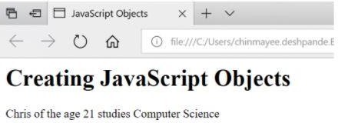

### EncapsulationinJavaScript

Encapsulationincludeswrappingthepropertyand thefunctionwithinasingleunit.Consider the following example:

class Emp_details{ constructor(name,id){

this.name=name; this.id = id;

}

add_Address(add){ this.add = add;

}

getDetails(){

console.log(`EmployeeName:${this.name},Address:${this.add}`);

}

}

letperson1=newEmp_details('Anand',27); person1.add_Address('Bangalore'); person1.getDetails();

Here,theclassholdsthedatavariablesnameand idalongwiththe functionsadd_Address and getDetails. All are encapsulated within the class Emp_details.

# MemoryManagementinJavaScript

Memorymanagement isanessentialtaskwhenwritingagoodandeffectiveprograminsome programming languages. This article will help you to understand different concepts of memory management in JavaScript. In low-level languages like C and C++, programmers should care about the usage of memory in some manual fashion. On the other hand, Javascript automaticallyallocatesmemorywhenobjectsarecreatedintotheenvironment and also it cleans the memorywhenanobject is destroyed. JavaScript can manage allofthese on its own but this does not implythat the developers do not need to worryabout the memory management in JavaScript.

Memorymanagementinanyprogramminglanguageinvolvesthreeimportantphases,termed as memory life-cycle −

* Allocatingthememorywhichisrequiredinour program.
* Utilizetheallocatedmemoryunit.
* Aftercompletion,clearthememoryblock.

### DifferentStrategiestoAllocate MemoryinJavaScript

Allocating byvalueinitialization

InJavaScript,wedo notneedtocareabout allocating memoryforsimplevariables.Wecan directlyassign values to some variables and it will allocate necessary memoryon its own.

*Syntax*

varvariable1=<value> varvariable2=<value>*Example*

Forsimpleallocationbyvalues,seethefollowing example.

*SourceCode*

<head>

<title>HTMLConsole</title>

</head>

<body>

<h3>OutputConsole</h3>

<p>Output:</p>

<divid="output">

</div>

<divid="opError"style="color:#ff0000">

</div>

<script>

varcontent='' var error =''

varopDiv=document.querySelector('#output') varopErrDiv=document.querySelector('#opError')

//actualjavascriptcode try{

var number =52; varst='my_string'; var student ={

name:'Smith', roll:5,age:23,

};

vararr=[15,null,'another_string'];

content+="Allocatedmemoryfornumber:"+JSON.stringify(number)+'<br>' content +="Allocated memory for string: "+JSON.stringify(st)+'<br>'content +="Allocated memoryfor student: "+JSON.stringify(student)+'<br>' content +="Allocated memory for array: "+JSON.stringify(arr)+'<br>'

}catch(err){

error+=err

}finally{

// display on output console opDiv.innerHTML= content opErrDiv.innerHTML=error

}

</script>

</body>

</html>

Fromtheaboveexample,it isclearthat numbersandstringsaresingle values,andallocation is also simple. But for objects and arrays, JavaScript can also easily allocate the memory based on their values.

AllocatingbyFunctionCall

Like variable value assignment, we can also create some memory blocks bycalling some functions.Forexample,whenafunctionreturnsaseparateobject it willautomaticallyassign a new memory block to the system.

*Syntax*

Memory_reference=<functioncallwhichreturnsanyvalue>

*Examples*

The followingexampleusesa functionthat worksonanHTMLdocument.Sothisprogram will run on a browser or HTML editor.

*SourceCode*

<!DOCTYPEhtml>

<htmllang="en">

<head>

<metacharset="UTF-8"/>

</head>

<body>

<script>

var e =document.createElement('div'); e.innerHTML="<h1>HeaderfromJavaScript</h1>"document.body.appendChild(e);

</script>

</body>

</html>

In this example, the JavaScript code is present inside the <script> tag in HTML. Please notice, inthiscase, initially,thedocument doesnothaveany<div>blockinside<body>.The JavaScript creates a new component bycalling createElement(), and then a new div block is created. This block allocates the memory but only when a function is called. After that, the new component is added as a child of the bodytag to use this inside the HTML document.

### UsingpreviouslyAllocatedMemoryinJavaScript

Using previously allocated memory is just reading or writing values from some variables whichareassignedpreviously. Wecanupdateitsexisting valuewithsomeothervalues.See the following example for a better understanding−

Example

Initiallyallocating memoryforavariable,thenreadingthevalue fromit.Writinganew value and again reading from it.

*SourceCode*

<!DOCTYPEhtml>

<html>

<head>

<title>HTMLConsole</title>

</head>

<body>

<h3>OutputConsole</h3>

<p>Output:</p>

<divid="output">

</div>

<divid="opError"style="color:#ff0000">

</div>

<script>

varcontent='' var error =''

opDiv=document.querySelector('#output') varopErrDiv=document.querySelector('#opError')

//actualjavascriptcode try{

vara=52;//allocatememory

content+="Readingvalueofvariablea:"+JSON.stringify(a)+'<br>' a =100

content+="Readingvalueofvariablea:"+JSON.stringify(a)+'<br>'

}

catch(err){

error+=err

}

finally{

// display on output console opDiv.innerHTML= content opErrDiv.innerHTML=error

}

</script>

</body>

</html>

### DeallocatingmemoryblocksinJavaScript

Whenour purposeisserved, wecanremovetheallocatedmemoryblock. Insome low-level languages, this is a necessarystep, otherwise, it mayoccupy memory spaces over time and the total system may crash. JavaScript also has native support of Garbage Collector, which cleans unnecessarymemoryblocks and cleans up the memory. But sometimes the compiler cannot understand whether a block will be used in later cases or not. In such cases, the GarbageCollectordoesnot cleanupthat memory. Tomanuallyremoveallocated locations, we can use the ‘delete’ keyword before the variable name.

Syntax

delete<variable_name>

Thevariable must beallocatedbeforehand,otherwise,it willraiseanerrorwhiletryingto delete that variable. Let us see one example to understand this concept clearly.

Example

*SourceCode*

<!DOCTYPEhtml>

<html>

<head>

<title>HTMLConsole</title>

</head>

<body>

<h3>OutputConsole</h3>

<p>Output:</p>

<divid="output">

</div>

<divid="opError"style="color:#ff0000">

</div>

<script>

varcontent='' var error =''

varopDiv=document.querySelector('#output') varopErrDiv=document.querySelector('#opError')

//actualjavascriptcode try{

a="asimplevariable";//allocatememory

content+="Readingvalueofvariablea:"+JSON.stringify(a)+'<br>' delete a

content+="Readingvalueofvariablea:"+JSON.stringify(a)+'<br>'

}

catch(err){

error+=err

}

finally{

// display on output console opDiv.innerHTML= content opErrDiv.innerHTML=error

}

</script>

</body>

</html>

**Note**−The‘delete’keywordwillonlyworkwhenthevariable isallocateddirectly(without using the var or let keyword).

### Conclusion

Working with any programming language, the programmer should know the overall concept in depth. Memory management is one of the concerning issues, in which developers should properlymanagethe memoryotherwise it willoccupyunnecessarymemoryblocksandcreate major problems in the environment. JavaScript provides an additional garbage collector tool that automatically cleans the unused memory blocks. However, we can also deallocate memory by using the ‘delete’ keyword just before the variable name

AJAXfordataexchangewithserverjQueryFramework

ShortDescriptionofAJAX

Ajaxisonlyanamegivento asetoftoolsthatwerepreviouslyexisting.

Themainpart isXMLHttpRequest,aserver-sideobject usableinJavaScript,that was implemented in Internet Explorer since the 4.0 version.

Togetdataontheserver,XMLHttpRequestprovidestwomethods:

1. open:Createsaconnection
2. send:Sendsarequesttotheserver

Datafurnished bytheserverwillbefoundintheattributesofthe XMLHttpRequestobject:

1. responseXmlforanXMLfile,or
2. responseTextforaplaintext

TakenotethatanewXMLHttpRequestobjecthastobecreatedfor eachnewdata request.

We havetowait forthedatatobeavailabletoprocess it, and inthispurpose, thestateof availability of data is given by the readyStateattribute of XMLHttpRequest.

AttributesofXMLHttpRequestClass

1. *readyState*:Thecodesuccessivelychanges valuefrom0 to4

0:Notinitialized

1:Connectionestablished

2: Request received 3:Answerinprocess 4: Finished

1. *status*:200isOK

404ifthepageisnot found

1. *responseText*:Holdsloadeddataasastringofcharacters.
2. *responseXml*:HoldsanXMLloadedfile,DOM'smethodallowstoextract data.
3. *onreadystatechange*:Propertythattakesa functionasvaluethatisinvokedwhenthe

readystatechangeeventisdispatched.

MethodsofXMLHttpRequestClass

1. *open(mode,url,boolean)*:*mode*:typeofrequest,GETor POST

*url*:thelocationofthefile,withapath

*boolean*:true(asynchronous)/false(synchronous)

optionally,aloginandapasswordmaybeaddedtoarguments

1. *send("string")*:string:POSTdata,nullforaGETcommand
2. *abort()*:Cancelsthecurrent HTTPrequest
3. *getAllResponseHeaders()*:RetrievesthevaluesofalltheHTTP headers
4. getResponseHeader(string):RetrievesthevalueofanHTTPheader fromtheresponsebody

*string*:nameofhttpheader

1. *setRequestHeader(name,value)*:Addsanewhttpheaderintherequest

*name*:name/identifieroftheheader

*value*:valueoftheheader

### Usingthe Code

Hereisasimplefunction'AjaxRequest'whichis implementedtoperformtheAJAXrequests.

JavaScript Shrink ▲

functionAjaxRequest(ReadyHandler,URL,Method,Params,QueryString,HttpHeaders){ if (URL == null) { alert("Request URL is Empty"); }

else{

if(window.XMLHttpRequest){//codefor IE7+,Firefox,Chrome,Opera,Safari xmlhttp = newXMLHttpRequest();

}

else{//codeforIE6,IE5

xmlhttp=newActiveXObject("Microsoft.XMLHTTP");

}

//Ananonymousfunctionisassignedtotheevent indicator. xmlhttp.onreadystatechange = function() {

//200statusmeansok,otherwisesomeerrorcodeisreturned,404forexample

//The4 statemeansfor theresponseisreadyandsent bytheserver. if (xmlhttp.readyState == 4&&xmlhttp.status == 200) {

ResponseText = xmlhttp.responseText;//get text data in theresponse ResponseXML=xmlhttp.responseXML; //getxmldataintheresponse ResponseHeaderJSON = xmlhttp.getResponseHeader

("CustomHeaderJSON");//ExtractDatainhttpheader ResponseHeaders = xmlhttp.getAllResponseHeaders();//Get a string

//containingallhttpheadersreturnedbyserver

// Make all the results available in the ReadyHandler via prototyping. ReadyHandler.prototype.ResponseText = ResponseText; ReadyHandler.prototype.ResponseHeaderJSON=ResponseHeaderJSON; ReadyHandler.prototype.ResponseXML = ResponseXML; ReadyHandler.prototype.ResponseHeaders = ResponseHeaders;

//ExecutefunctionpassedasReadyHandelr ReadyHandler();

}

}

//IfquerystringisprovidedAttachittotheurl

if(QueryString!=""){ varQueryStringData = "";

for (QueryStringAttributeinQueryString) { QueryStringData=QueryStringAttribute+ "="+

QueryString[QueryStringAttribute]+"&"+QueryStringData;

}

QueryStringData=QueryStringData.substring(0,

QueryStringData.lastIndexOf('&')); URL = URL + "?" + escape(QueryStringData); //Here is where the

//querystringiaattachedtotherequesturl.

}

//POSTorGETURLofthescripttoexecute.trueforasynchronous

//(false for synchronous). xmlhttp.open(Method,URL,true);

xmlhttp.setRequestHeader("Content-type","application/x-www-form-urlencoded"); if (HttpHeaders != "") {

varHttpHeadersData="";

for (HttpHeaderNameinHttpHeaders) { xmlhttp.setRequestHeader(HttpHeaderName,

HttpHeaders[HttpHeaderName]);//Herethecustomheadersareadded

}

}

//Post dataprovided thenassembleitintosinglestringtobepostedtoserver if (Params != "") {

varParamsData="";

for(ParamNameinParams){

ParamsData=ParamName+"="+Params[ParamName]+"&"+ParamsData;

}

ParamsData=ParamsData.substring(0,ParamsData.lastIndexOf('&'));

}

xmlhttp.send(ParamsData);//Sendtherequestwiththepost data

}

}

[Youcanfindthecompleteimplementationwithsufficientcommentsinthesource code.]

ItcangiveamoreclearideaofusingAJAXinyour applications.

Inthedemo application, youcantestthe'AjaxRequest'functionbychangingtheparameters that are passed to it.

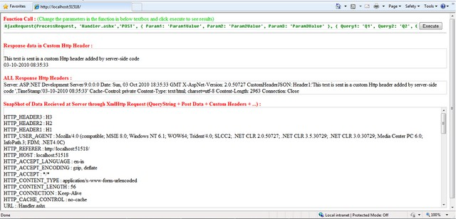

Actuallyallthecodethat istyped inthetext boxis executedasJavaScript codeonclickof 'Execute' button.This is done using the eval() function.

JavaScript

FunctionCall=document.getElementById('FunctionCode').value; eval(FunctionCall);

FunctionUsage JavaScript

functionAjaxRequest(ReadyHandler,URL,Method,Params,QueryString,HttpHeaders)

Description

*->ReadyHandler*:Functiontobecalledafter successfulcompletionoftheAJAXrequest

Note:Onsuccessfulcompletionoftherequest, theresult ofthe request willbeavailableinthe function passed as ReadyHandler.

Theresult ofrequestwillbein4variables,namely:

* ResponseText:Textresponsefromserver
* ResponseHeaderJSON:CustomHTTPHeaderStringvalue

Thisheaderstring maycontainasingle string valueorayoucanalso useaJSONformat for multiple values which then can be parsed in ReadyHandler(as shown in the example).

* ResponseHeaders:StringcontainingallResponseHTTPHeaders
* ResponseXML:XMLresponsefromserver (XMLobject availableonlywhentheResponse contains a proper XML)

->URL:ThisparametertakestheURLtowhichtherequest istobesent

->Method:Methodofrequest"GET"/"POST"

->Params:POSTdatatobesenttoserver. ExpectsaJSONformattednamevalue pairs

->QueryString:Datatobesenttotheserveras QueryString.ExpectsaJSONformattedname value pairs

->HttpHeaders:DatatobesentasHTTPHeaders.ExpectsJSONformattedname valuepairs

Note:Whilesendingthedata inheaders, you havetotakecareonlyASCIIcharacters wherecharCode ranging from 32 to 126 are sent or you may get unexpected results. See RFC documentation for HTTP.

The ReadyHandlercancontainthecodewhichwilldynamicallychangethecontentsofthe webpage based on the response data.

Forexample, inthedemo application,Ihaveused'ProcessRequest()'astheReadyhandler which sets the response in the respective <Div>.

JavaScript

functionProcessRequest(){

// // Assign the content to the form document.getElementById('ResponseTextDiv').innerHTML=ResponseText;

document.getElementById('ResponseXMLDiv').innerHTML=ResponseHeaders; eval("var CustomHeaders = { " + ResponseHeaderJSON + "};");

var header; varallHeaders="<br/>";

if(CustomHeaders!=""){

for(headerinCustomHeaders) {

allHeaders=allHeaders+CustomHeaders[header]+"<br/>"

}

}

document.getElementById('ResponseHeadersDiv').innerHTML=allHeaders;

}

Example:

JavaScript

AjaxRequest(ProcessRequest,'Handler.ashx','POST',

{Param1:'Param1Value',Param2:'Param2Value',Param3:'Param3Value'},

{Query1:'Q1',Query2:'Q2',Query3:'Q3'},

{Header1:'H1',Header2:'H2',Header3:'H3'}

);

Forhandlingtheclientrequest,Ihaveimplementedasimple**GenericHandler(.ashx).**

Youcanaccessallthedata(querystring+PostData+HTTPHeaders)thatissent bythe client browser in AJAX request.

IntheGenerichandler,thedataisaccessibleviathe context.Requestobject.

Thoughyoucanaccessallthedatatogether in context.Request.Params[],youcanaccessthedata separately as follows:

* QueryString:context.Request.QueryString[[index/string]]
* HttpHeaders:context.Request.Headers[[index/string]]

Intheexampleapplication,what Ihavedone isjustecho backthedatawhichisreceived in the request along with a custom HTTP header added.

JavaScript

foreach(stringParamincontext.Request.Params)

{

ParamsData ="<br/>" + Param + " : " + context.Request.Params[Param].ToString()+ParamsData;

}

context.Response.Write(ParamsData);

Theabove linescapturethedataintherequest andsend it back intheresponse. For adding an extra custom HTTP header in response:

C#

context.Response.AddHeader("CustomHeaderJSON",CustomHeaderJSON);

Asyousee,thecontext.Responseobject isusedto assembletheresponsewhichisto besent back to the browser.

Differentmethodsof*context.Response*canbeusedtodothis.

'*CustomHeaderJSON*'cancontainastring,butIhavecreatedaJSONformat stringfor supportingmultiplevalues.The valuesarethenparsedatclientsideusingJavaScript.

Ihave just usedstringconcatenateforcreating it,butyoucanalso usedifferent JSON parsers/Encoders available at <http://www.json.org/>.

Youcanalso useJSON stringsto exchangedatathroughAJAX.Itissometimesbettertouse JSON than XML. Using JSON results in less bytes transferred than XML.

### Pointsof Interest

Thisisabasic implementationofAJAXandthe functioncanbetunedand modified according to needs and reconfigurability.

Here ishowtherequestandresponselookslike[HTTPrequestinFiddler]:

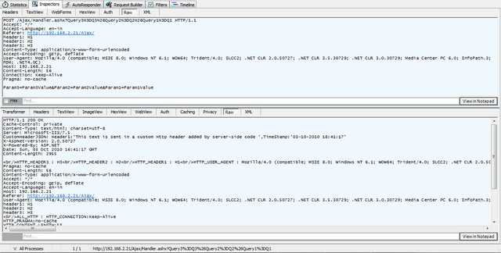

# jQueryEvents

jQueryeventsaretheactionsthat canbedetectedbyyour webapplication. Theyareusedto create dynamic web pages. An event shows the exact moment when something happens.

Thesearesomeexamplesofevents.

* Amouseclick
* AnHTML formsubmission
* Aweb pageloading
* Akeystrokeonthe keyboard
* Scrollingofthewebpageetc.

Theseeventscanbecategorizedonthebasistheir types:

### MouseEvents

* click
* dblclick
* mouseenter
* mouseleave

### KeyboardEvents

* keyup
* keydown
* keypress

### FormEvents

* submit
* change
* blur
* focus

### Document/WindowEvents

* load
* unload
* scroll
* resize

*Note:Aterm"fires"isgenerallyusedwithevents.Forexample:Theclickevent firesinthemoment you press a key.*

### Syntax foreventmethods

MostoftheDOMeventshaveanequivalent jQuerymethod. To assignaclickeventsto all paragraph on a page, do this:

1.$("p").click();

Thenext stepdefineswhat shouldhappenwhentheevent fires.Youmust passa functionto the event.

## UNIT–III

**REACTJS**

# ReactIntroduction

ReactJS is a declarative, efficient, and flexible JavaScript library for building reusable UI components.It isanopen-source,component-basedfront end libraryresponsibleonlyforthe view layer oftheapplication. It wascreatedby**Jordan Walke,** who wasasoftwareengineer at **Facebook.**Itwasinitiallydevelopedand maintained byFacebookandwaslaterusedinits products like **WhatsApp**&**Instagram.** Facebook developed ReactJS in **2011** in its newsfeed section, but it was released to the public in the month of **May 2013.**

Today, mostofthewebsitesarebuilt usingMVC(modelviewcontroller)architecture.In MVC architecture, React is the 'V' which stands for view, whereas the architecture is provided by the Redux or Flux.

AReactJS application is made up of multiple components, eachcomponent responsible for outputtingasmall, reusablepieceofHTMLcode.ThecomponentsaretheheartofallReact applications. These Components can be nested with other components to allow complex applications to be built of simple building blocks. ReactJS uses virtual DOM based mechanism to fill data in HTML DOM. The virtual DOM works fast as it only changes individual DOM elements instead of reloading complete DOM every time.

To create React app, we write React components that correspond to various elements. We organize these components inside higher level components which define the application structure. For example, we take a formthat consists of many elements like input fields, labels, orbuttons. Wecanwrite eachelement oftheformasReact components, andthenwe combine it into a higher-level component, i.e., the form component itself. The form components would specify the structure of the form along with elements inside of it.

### WhylearnReactJS?

Today, manyJavaScriptframeworksareavailableinthemarket(likeangular,node),butstill, React came into the market and gained popularity amongst them. The previous frameworks follow the traditional data flow structure, which uses the DOM (Document Object Model).

DOM is an object which is created bythe browser each time a web page is loaded. It dynamicallyaddsorremovesthedataatthebackendandwhenanymodificationsweredone, then each time a new DOM is created for the same page. This repeated creation of DOM makes unnecessary memory wastage and reduces the performance of the application.

Therefore, a new technology ReactJS framework invented which remove this drawback. ReactJS allows you to divide your entire application into various components. ReactJS still usedthesametraditionaldataflow,but it isnotdirectlyoperatingonthebrowser'sDocument Object Model (DOM) immediately; instead, it operates on a virtual DOM. It means rather thanmanipulatingthedocument inabrowserafterchangestoour data,it resolveschangeson a DOM built and run entirely in memory. After the virtualDOM has been updated, React determines what changes made to the actual browser's DOM. The React VirtualDOM exists entirely in memoryand is a representation ofthe web browser's DOM. Due to this, when we write a React component, we did not write directly to the DOM; instead, we are writing virtual components that react will turn into the DOM.

ReactRouterandSinglePageApplications

### PreparingtheReactApp

Installing thecreate-react-appPackage

Ifyou'veeverhadthechancetotryReact,you'veprobablyheardaboutthe**create-react-app**

package,whichmakesit supereasytostartwithaReact development environment. In this tutorial, we will use this package to initiate our React app.

So,firstofall,makesureyouhaveNode.jsinstalledonyourcomputer.Itwillalsoinstall

npmforyou.

Inyourterminal, runnpminstall-gcreate-react-app.Thiswillgloballyinstall**create-react-app**

onyourcomputer.

Once it isdone,youcanverifywhether it istherebytyping create-react-app-V. Creating the React Project

Nowit'stimetobuildourReact project.Just run create-react-appmulti-page-app.Youcan,of course, replace multi-page-app with anything you want.

Now,**create-react-app**willcreateafoldernamed**multi-page-app**.Justtypecdmulti-page-app

tochangedirectory,and nowrunnpmstart toinitializea localserver. That's all. You have a React app running on your local server.

Nowit'stimetocleanthedefaultfilesandprepareourapplication.

Inyour src folder,deleteeverything but App.js andindex.js.Thenopenindex.js andreplacethe content with the code below.

**import**React**from**'react';

**import**ReactDOM**from**'react-dom';

**import**App**from**'./App';

ReactDOM.render(<App/>,document.getElementById('root'));

Ibasicallydeletedthe registerServiceWorker related linesandalso the import'./index.css'; line. Also, replace your App.js file with the code below.

**import**React,{Component}**from**'react';

**class**App**extends**Component{

render(){

**return**(

<divclassName="App">

</div>

);

}

}

**exportdefault**App;

Nowwewillinstallthe requiredmodules.

Inyourterminal,typethe followingcommandstoinstallthe **react-router**and **react- transition-group** modules respectively.

npminstallreact-router-dom--save

npminstall[react-transition-group@1.x](mailto:react-transition-group@1.x)--save

After installingthepackages, youcancheckthepackage.json fileinsideyour mainproject directory to verify that the modules are included under **dependencies.**

### RouterComponents

Therearebasicallytwodifferentrouteroptions:**HashRouter**and**BrowserRouter**.

Asthename implies, **HashRouter**useshashestokeeptrackofyourlinks,and it issuitable for static servers. On the other hand, if you have a dynamic server, it is a better option to use **BrowserRouter**, considering the fact that your URLs will be prettier.

Once youdecidewhichone youshoulduse, just goaheadandaddthecomponentto your index.js file.

import{HashRouter}from'react-router-dom'

Thenextthingistowrapour<App>componentwiththerouter component.

Soyourfinalindex.jsfileshould looklike this:

**import**React**from**'react';

**import**ReactDOM**from**'react-dom';

**import**{HashRouter}**from**'react-router-dom'

**import**App**from**'./App';

ReactDOM.render(<HashRouter><App/></HashRouter>,document.getElementById('root'));

Ifyou'reusingadynamic serverandpreferto use**BrowserRouter**,theonlydifferencewould be importing the **BrowserRouter** and using it to wrap the <App>component.

Bywrappingour<App>component,weareservingthe **history**objecttoourapplication,and thus other react-router components can communicate with each other.

### Inside<App/> Component

Insideour<App>component,wewillhavetwo componentsnamed <Menu>and<Content>.As the names imply, theywill hold the navigation menu and displayed content respectively.

Createafoldernamed**"components"**inyoursrcdirectory, andthencreatetheMenu.js

andContent.jsfiles. Menu.js

Let's fillinourMenu.jscomponent.

Itwillbeastatelessfunctionalcomponentsincewedon'tneedstatesandlife-cycle hooks.

**import**React**from**'react'

**const** Menu=()=>{

**return**(

<ul>

<li>Home</li>

<li>Works</li>

<li>About</li>

</ul>

)

}

**exportdefault**Menu

Herewehavea<ul>tagwith<li>tags, whichwillbeourlinks. Now add the following line to your **Menu** component.

import{Link}from'react-router-dom'

Andthenwrapthecontentofthe<li>tagswiththe<Link>component.

The<Link>component isessentiallya **react-router**component acting likean<a>tag,but it does not reload your page with a new target link.

Also,ifyoustyle your a taginCSS, youwillnoticethatthe <Link>component getsthesame styling.

Notethatthereisa moreadvanced versionofthe <Link>component, whichis<NavLink>.This offers you extra features so that you can style the active links.

Nowweneedto definewhereeachlinkwillnavigate.Forthispurpose,the <Link>component has a to prop.

**import**React**from**'react'

**import**{Link}**from**'react-router-dom'

**const** Menu=()=>{

**return**(

<ul>

<li><Linkto="/">Home</Link></li>

<li><Linkto="/works">Works</Link></li>

<li><Linkto="/about">About</Link></li>

</ul>

)

}

**exportdefault**Menu

Content.js

Insideour<Content>component,wewilldefinethe**Routes**tomatchthe**Links.**

We needtheSwitch andRoute componentsfrom**react-router-dom.**So,firstofall, import them.

import{Switch,Route}from'react-router-dom'

Secondofall, importthecomponentsthat wewantto routeto. Thesearethe Home, Works and About components for our example. Assuming you have already created those components inside the **components** folder, we also need to import them.

import Home from './Home' importWorksfrom'./Works' import About from './About'

Thosecomponentscanbeanything.Ijust definedthemasstatelessfunctionalcomponents with minimum content. An example template is below. You can use this for all three components, but just don't forget to change the names accordingly.

**import**React**from**'react'

**const**Home= ()=>{

**return**(

<div>

Home

</div>

)

}

**exportdefault**Home

Switch

Weusethe<Switch>componentto groupour<Route>components. **Switch**looksforall the **Routes** and then returns the first matching one.

Route

Routesarecomponentscallingyourtargetcomponentifit matchesthe path prop. The final version of our Content.js file looks like this:

**import**React**from**'react'

**import**{Switch,Route}**from**'react-router-dom'

**import**Home**from**'./Home'

**import**Works**from**'./Works'

**import**About**from**'./About'

**const**Content=() =>{

**return**(

<Switch>

<Routeexactpath="/"component={Home}/>

<Routepath="/works"component={Works}/>

<Routepath="/about"component={About}/>

</Switch>

)

}

**exportdefault**Content

Notice that the extra exact prop is required for the **Home** component, which is the main directory. Using exactforces the **Route** to match the exact pathname. If it's not used, other pathnamesstartingwith/ wouldalso be matchedbythe **Home**component,and foreachlink, it would only display the **Home** component.

Nowwhenyouclickthemenulinks,yourappshouldbeswitchingthecontent.

### AnimatingtheRouteTransitions

Sofar, wehaveaworkingroutersystem. Nowwewillanimatetheroutetransitions. Inorder to achieve this, we will use the **react-transition-group** module.

We will be animating the *mounting* stateof each component. When you route different componentswiththe**Route**component inside**Switch**,youareessentially*mounting*and *unmounting* different components accordingly.

Wewilluse**react-transition-group** ineachcomponent wewanttoanimate.So youcanhave a different mounting animation for each component. I willonly use one animation for allof them.

As an example, let's use the <Home>component. First, we need to import **CSSTransitionGroup**. import{CSSTransitionGroup}from'react-transition-group'

Thenyouneedtowrapyour contentwithit.

Sincewearedealingwiththe mountingstateofthecomponent, weenable transitionAppear and set atimeout for it. Wealso disable transitionEnter andtransitionLeave, sincetheseareonlyvalid once the component is mounted. If you are planning to animate anychildren of the component, you have to use them.

Lastly,addthespecifictransitionNamesothatwecanrefertoitinsidetheCSSfile.

**import**React**from**'react'

**import**{CSSTransitionGroup}**from**'react-transition-group'

**import**'../styles/homeStyle.css'

**const**Home= ()=>{

**return**(

<CSSTransitionGroup

transitionName="homeTransition"

transitionAppear={**true**}

transitionAppearTimeout={**500**}

transitionEnter={**false**}

transitionLeave={**false**}>

<div>

Home

</div>

</CSSTransitionGroup>

)

}

**exportdefault**Home

WealsoimportedaCSSfile, wherewedefinetheCSStransitions.

**.homeTransition-appear**{

opacity:**0**;

}

**.homeTransition-appear.homeTransition-appear-active**{

opacity:**1**;

transition:all**.5s**ease-in-out;

}

Ifyourefreshthepage,you should seethefade-in effect ofthe**Home** component.

Ifyouapplythesameproceduretoalltheotherroutedcomponents, youwillseetheir individual animations when you change the content with your **Menu.**

### Conclusion

In this tutorial, we covered the **react-router-dom** and **react-transition-group** modules. However,there's moreto bothmodulesthanwecovered inthistutorial. Here isa [**workingdemo**](https://stackblitz.com/edit/react-49vg63)of what was covered.

So,tolearnmorefeatures, alwaysgo throughthedocumentationofthe modules youare using.

Over the last couple of years, React has grown in popularity. In fact, wehave a number of itemsinthemarketplacethat areavailableforpurchase,review, implementation,andsoon.If you’re looking for additional resources around React, don’t hesitate to [check them out](https://codecanyon.net/search?utf8=%E2%9C%93&term=React&as=0&referrer=homepage).

**ReactForms**

HTML formelementsworkabit differentlyfromotherDOMelementsinReact, because formelements naturallykeep some internalstate.For example, this forminplain HTML accepts a single name:

<form>

<label>

Name:

<inputtype="text"name="name"/>

</label>

<inputtype="submit"value="Submit"/>

</form>

This formhas the default HTML form behavior of browsing to a new page when the user submits the form. If you want this behavior in React, it just works. But in most cases, it’s convenient to have a JavaScript function that handles the submission of the formand has accesstothedatathattheuser enteredintotheform. Thestandardwaytoachievethis iswith a technique called “controlled components”.

### ControlledComponents

InHTML, formelementssuchas <input>,<textarea>, and<select>typicallymaintaintheirown state and update it based on user input. In React, mutable state is typicallykept in the state property of components, and only updated with [setState()](https://reactjs.org/docs/react-component.html#setstate).

WecancombinethetwobymakingtheReact statebethe“singlesourceoftruth”.Thenthe React componentthatrendersaformalso controls what happens inthat formonsubsequent user input.Aninput formelement whosevalue iscontrolled byReact in thiswayiscalleda “controlled component”.

Forexample, ifwewant tomakethepreviousexample logthenamewhenit issubmitted,we can write the form as a controlled component:

classNameFormextendsReact.Component{ constructor(props){

super(props); this.state={value:''};

this.handleChange=this.handleChange.bind(this); this.handleSubmit=this.handleSubmit.bind(this);

}

handleChange(event){this.setState({value:event.target.value});} handleSubmit(event){

alert('Anamewassubmitted:'+this.state.value); event.preventDefault();

}

render(){ return(

<formonSubmit={this.handleSubmit}><label>Name:

<inputtype="text"value={this.state.value}onChange={this.handleChange}/></label>

<inputtype="submit"value="Submit"/>

</form>

);

}

}

[**Try itonCodePen**](https://codepen.io/gaearon/pen/VmmPgp?editors=0010)

Since the value attribute is set onour form element, the displayed value will always be this.state.value, makingtheReact statethesourceoftruth.Since handleChange runsonevery keystroke to update the React state, the displayed value will update as the user types.

Withacontrolledcomponent,the input’svalue isalwaysdrivenbytheReact state.Whilethis means youhavetotypeabit morecode,youcannowpassthevaluetoother UIelementstoo, or reset it from other event handlers.

### Thetextarea Tag

InHTML,a<textarea>elementdefinesitstextbyitschildren:

<textarea>

Hellothere,thisissometextinatext area

</textarea>

InReact, a<textarea>usesavalue attribute instead. Thisway, a formusinga <textarea>canbe written very similarly to a form that uses a single-line input:

classEssayFormextendsReact.Component{ constructor(props){

super(props);

this.state={value:'Pleasewriteanessayabout your favoriteDOMelement.'}; this.handleChange=this.handleChange.bind(this); this.handleSubmit=this.handleSubmit.bind(this);

}

handleChange(event){this.setState({value:event.target.value});} handleSubmit(event){

alert('Anessaywassubmitted:'+this.state.value); event.preventDefault();

}

render(){ return(

<formonSubmit={this.handleSubmit}>

<label>

Essay:

<textareavalue={this.state.value}onChange={this.handleChange}/></label>

<inputtype="submit"value="Submit"/>

</form>

);

}

}

Noticethat this.state.value is initialized intheconstructor, sothatthetextareastartsoffwith some text in it.

### TheselectTag

InHTML, <select>createsadrop-downlist.Forexample,thisHTMLcreatesadrop-downlist of flavors:

<select>

<optionvalue="grapefruit">Grapefruit</option>

<optionvalue="lime">Lime</option>

<optionselectedvalue="coconut">Coconut</option>

<optionvalue="mango">Mango</option>

</select>

Note that the Coconut option is initially selected, because of the selected attribute. React, insteadofusingthis selected attribute, usesa value attributeontheroot select tag.This is more convenient in a controlled component because you only need to update it in one place. For example:

classFlavorFormextendsReact.Component{ constructor(props){

super(props); this.state={value:'coconut'};

this.handleChange=this.handleChange.bind(this); this.handleSubmit=this.handleSubmit.bind(this);

}

handleChange(event){this.setState({value:event.target.value});} handleSubmit(event){

alert('Yourfavoriteflavoris:'+this.state.value); event.preventDefault();

}

render(){ return(

<formonSubmit={this.handleSubmit}>

<label>

Pickyourfavoriteflavor:

<selectvalue={this.state.value}onChange={this.handleChange}><option value="grapefruit">Grapefruit</option>

<optionvalue="lime">Lime</option>

<optionvalue="coconut">Coconut</option>

<optionvalue="mango">Mango</option>

</select>

</label>

<inputtype="submit"value="Submit"/>

</form>

);

}

}

[**Try itonCodePen**](https://codepen.io/gaearon/pen/JbbEzX?editors=0010)

Overall, this makes it sothat <inputtype="text">,<textarea>,and<select>allworkverysimilarly- theyall accept a value attribute that you can use to implement a controlled component.

Note

Youcanpassanarrayintothevalueattribute, allowingyoutoselectmultipleoptions ina

selecttag:

<selectmultiple={true}value={['B','C']}>

### ThefileinputTag

InHTML, an<inputtype="file">letstheuserchooseoneormorefiles fromtheirdevicestorage to be uploaded to a server or manipulated byJavaScript via the [File API](https://developer.mozilla.org/en-US/docs/Web/API/File/Using_files_from_web_applications).

<inputtype="file"/>

Becauseitsvalueisread-only, it isan**uncontrolled**component inReact.Itisdiscussed together with other uncontrolled components [later in the documentation.](https://reactjs.org/docs/uncontrolled-components.html#the-file-input-tag)

### HandlingMultipleInputs

Whenyouneedto handle multiplecontrolled input elements, youcanaddaname attributeto each element and let the handler function choose what to do based onthe value of event.target.name.

Forexample:

classReservationextendsReact.Component{ constructor(props){

super(props); this.state={ isGoing:true, numberOfGuests:2

};

this.handleInputChange=this.handleInputChange.bind(this);

}

handleInputChange(event){ const target =event.target;

constvalue=target.type==='checkbox'?target.checked:target.value; const name = target.name;

this.setState({ [name]:value});

}

render(){ return(

<form>

<label>

Isgoing:

<input

name="isGoing" type="checkbox" checked={this.state.isGoing}

onChange={this.handleInputChange}/>

</label>

<br/>

<label>

Numberofguests:

<input

name="numberOfGuests" type="number" value={this.state.numberOfGuests}

onChange={this.handleInputChange}/>

</label>

</form>

);

}

}

[**Try itonCodePen**](https://codepen.io/gaearon/pen/wgedvV?editors=0010)

NotehowweusedtheES6 [computed propertyname](https://developer.mozilla.org/en/docs/Web/JavaScript/Reference/Operators/Object_initializer#Computed_property_names)syntaxto updatethestatekey corresponding to the given input name:

this.setState({ [name]:value});

ItisequivalenttothisES5code:

varpartialState={}; partialState[name]=value;this.setState(partialState);

Also, sincesetState() automatically[mergesapartialstateintothecurrent state](https://reactjs.org/docs/state-and-lifecycle.html#state-updates-are-merged), weonlyneeded to call it with the changed parts.

### ControlledInputNullValue

Specifying the value prop on a [controlled component](https://reactjs.org/docs/forms.html#controlled-components)prevents the user from changing the input unlessyoudesireso.Ifyou’vespecifieda value butthe input isstilleditable, youmay have accidentally set value to undefined or null.

Thefollowingcodedemonstratesthis.(Theinput islockedatfirst but becomeseditableafter a short delay.)

ReactDOM.createRoot(mountNode).render(<inputvalue="hi"/>);

setTimeout(function(){ ReactDOM.createRoot(mountNode).render(<inputvalue={null}/>);

},1000);

### AlternativestoControlledComponents

Itcansometimesbetedioustousecontrolledcomponents, because youneedto writeanevent handler for everyway your data can change and pipe all of the input statethrough a React component. This can become particularly annoying when you are converting a preexisting codebase to React, or integrating a React application with a non-React library. In these situations, youmight wanttocheckout [uncontrolledcomponents,](https://reactjs.org/docs/uncontrolled-components.html)analternativetechniquefor implementing input forms.

**IntroductiontoRedux**

Redux Toolkit

[**Redux Toolkit**](https://redux-toolkit.js.org/)is our official recommended approach for writing Redux logic. It wraps around the Redux core, and contains packages and functions that wethink are essential for buildingaReduxapp.ReduxToolkit buildsinoursuggestedbest practices,simplifiesmost Redux tasks, prevents common mistakes, and makes it easier to write Redux applications.

RTK includes utilities that help simplify many common use cases, including [store setup](https://redux-toolkit.js.org/api/configureStore), [creatingreducersandwriting immutableupdatelogic,](https://redux-toolkit.js.org/api/createreducer)andeven[creatingentire"slices"ofstate at once](https://redux-toolkit.js.org/api/createslice).

Whether you're a brand new Redux user setting up your first project, or an experienced user who wantstosimplifyanexistingapplication, [**ReduxToolkit**](https://redux-toolkit.js.org/)canhelp you make yourRedux code better.

ReduxToolkit isavailableasapackageonNPM forusewitha module bundlerorinaNode application:

#NPM

npminstall@reduxjs/toolkit

#Yarn

yarnadd@reduxjs/toolkit

CreateaReactRedux App

The recommended way to start new apps with React and Redux is by using the [officialRedux+JStemplate](https://github.com/reduxjs/cra-template-redux)or[Redux+TStemplate](https://github.com/reduxjs/cra-template-redux-typescript)for[CreateReactApp,](https://github.com/facebook/create-react-app)whichtakesadvantageof [**Redux Toolkit**](https://redux-toolkit.js.org/)and React Redux's integration with React components.

#Redux+PlainJS template

npxcreate-react-appmy-app--templateredux

#Redux+TypeScripttemplate

npxcreate-react-appmy-app--templateredux-typescript

Redux Core

TheReduxcorelibraryisavailableasapackageonNPM forusewitha module bundlerorin a Node application:

#NPM

npminstallredux

# Yarn yarnaddredux

Itisalso availableasaprecompiledUMDpackagethat definesa window.Redux global variable. The UMD package can be used as a [<script>tag](https://unpkg.com/redux/dist/redux.js)directly.

Formoredetails,seethe [Installation](https://redux.js.org/introduction/installation)page.

### Basic Example

The whole globalstateof your app is stored in an object tree inside a single *store*. The only wayto change the state tree is to create an *action*, an object describing what happened, and *dispatch* ittothestore.Tospecifyhowstategetsupdatedinresponseto anaction, youwrite pure *reducer* functions that calculate a new state based on the old state and the action.

import{createStore}from'redux'

/**

* Thisisareducer -a functionthattakesa currentstatevalueandan
* actionobjectdescribing"whathappened",andreturnsanewstatevalue.
* Areducer'sfunctionsignatureis:(state,action)=>newState
* TheReduxstateshouldcontainonlyplain JSobjects,arrays,andprimitives.
* Therootstatevalueisusuallyanobject.It'simportantthatyou should
* notmutatethestateobject, butreturnanewobject ifthestatechanges.
* Youcanuseanyconditionallogicyouwantinareducer.Inthisexample,
* weuseaswitchstatement,butit'snotrequired.

*/

functioncounterReducer(state={value: 0},action){ switch (action.type) {

case'counter/incremented': return{value:state.value+ 1} case'counter/decremented': return { value: state.value - 1 } default:

returnstate

}

}

//CreateaReduxstoreholdingthestateofyourapp.

//ItsAPIis{subscribe, dispatch,getState}. let store = createStore(counterReducer)

//Youcanusesubscribe()toupdatetheUIinresponsetostatechanges.

//Normallyyou'duseaviewbindinglibrary(e.g.ReactRedux)ratherthansubscribe()directly.

//Theremaybeadditionalusecaseswhereit'shelpful tosubscribeaswell. store.subscribe(() => console.log(store.getState()))

//Theonlywaytomutatetheinternalstateistodispatchanaction.

//Theactionscanbeserialized,loggedorstoredandlaterreplayed. store.dispatch({ type: 'counter/incremented'})

//{value:1}

store.dispatch({type:'counter/incremented'})

//{value:2}

store.dispatch({type:'counter/decremented'})

//{value:1}

Instead of mutating the state directly, you specify the mutations you want to happen with plainobjectscalled *actions*.Thenyouwriteaspecialfunctioncalleda *reducer*to decidehow every action transforms the entire application's state.

In a typical Redux app, there is just a single store with a single root reducing function. As yourappgrows,yousplit therootreducerintosmallerreducersindependentlyoperatingon thedifferent partsofthestatetree.This isexactlylike howthereis justoneroot component in a React app, but it is composed out of many small components.

Thisarchitecturemight seemlikea lot foracounterapp,butthebeautyofthispatternishow well it scales to large and complex apps. It also enables very powerful developer tools, because it ispossibletotraceeverymutationtotheactionthat causedit. Youcanrecorduser sessions and reproduce them just by replaying every action.

ReduxToolkitExample

ReduxToolkit simplifiestheprocessofwritingReduxlogicandsettingupthestore. With Redux Toolkit, that same logic looks like:

import{createSlice,configureStore}from'@reduxjs/toolkit'constcounterSlice = createSlice({

name:'counter', initialState: { value: 0

},

reducers: { incremented:state=>{

//ReduxToolkitallowsustowrite"mutating"logicinreducers.It

//doesn'tactuallymutatethestatebecauseitusestheImmerlibrary,

//which detectschangestoa"draftstate"andproducesabrandnew

//immutablestatebasedoffthosechanges state.value += 1

},

decremented:state=>{ state.value -= 1

}

}

})

exportconst{incremented,decremented}=counterSlice.actions const store = configureStore({

reducer:counterSlice.reducer

})

//Canstillsubscribetothe store

store.subscribe(()=>console.log(store.getState()))

//Stillpassaction objectsto`dispatch`,butthey'recreatedforus store.dispatch(incremented())

// {value: 1} store.dispatch(incremented())

// {value: 2} store.dispatch(decremented())

//{value:1}

ReduxToolkit allowsustowriteshorterlogicthat'seasiertoread,whilestillfollowingthe same Redux behavior and data flow.

### LearnRedux

We haveavarietyofresourcesavailabletohelp youlearnRedux. Redux Essentials Tutorial

The[**ReduxEssentialstutorial**](https://redux.js.org/tutorials/essentials/part-1-overview-concepts)isa"top-down"tutorialthatteaches"howto useReduxthe right way",usingourlatestrecommendedAPIsandbest practices.Werecommendstarting there.

ReduxFundamentalsTutorial

The [**Redux Fundamentals tutorial**](https://redux.js.org/tutorials/fundamentals/part-1-overview)is a "bottom-up" tutorial that teaches "how Redux works"fromfirst principlesandwithoutanyabstractions,andwhystandardReduxusage

patternsexist.

# Redux-DataFlow Redux-DataFlow

Reduxfollowstheunidirectionaldata flow.It meansthat yourapplicationdatawillfollow in one-way binding data flow. As the application grows & becomes complex, it is hard to reproduce issues and add new features if you have no controlover the state of your application.

Reduxreducesthe complexityofthe code,byenforcing the restrictiononhow and whenstate update can happen. This way, managing updated states is easy. We alreadyknow about the restrictions as the three principles of Redux. Following diagram will help you understand Redux data flow better −

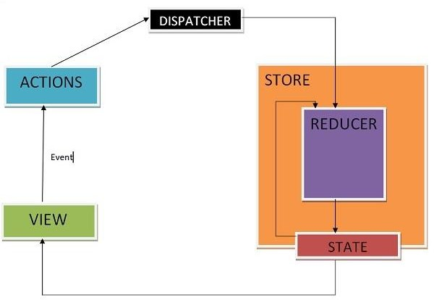

* + Anaction isdispatched whenauserinteractswith theapplication.
  + Therootreducerfunctioniscalledwiththecurrent stateandthedispatched action. The root reducer may divide the task among smaller reducer functions, which ultimately returns a new state.
  + Thestorenotifiestheviewbyexecutingtheircallbackfunctions.
  + Theviewcanretrieveupdated stateand re-render again.

#### Client-ServerCommunication

Let'sexpandtheapplicationsothatthenotesarestoredinthebackend. We'lluse [json-server,](https://fullstackopen.com/en/part2/getting_data_from_server) familiar from part 2.

The initialstateofthedatabase is storedinthe file *db.json*, whichisplaced intherootofthe project:

{

"notes":[

{

"content":"theappstateisinreduxstore", "important": true,

"id":1

},

{

"content":"statechangesaremadewithactions", "important": false,

"id":2

}

]

}

We'llinstalljson-serverforthe project...

npminstalljson-server--save-dev

andaddthefollowinglinetothe*scripts*partofthefile *package.json*

"scripts":{

"server":"json-server-p3001--watchdb.json",

// ...

}

Nowlet'slaunchjson-serverwiththecommand*npmrunserver*.

Next, we'llcreateamethod intothefile *services/notes.js*, whichuses*axios*tofetchdatafrom the backend

importaxiosfrom'axios'

constbaseUrl='http://localhost:3001/notes' constgetAll = async () => {

constresponse=awaitaxios.get(baseUrl) return response.data

}

exportdefault{getAll}

We'lladdaxiostothe project

npminstallaxios

We'llchangethe initializationofthestatein *noteReducer*, sothatbydefault thereareno notes:

constnoteSlice=createSlice({ name: 'notes',

initialState:[],//...

})

Let'salsoaddanewaction*appendNote*foraddinganoteobject:

constnoteSlice=createSlice({ name: 'notes',

initialState:[], reducers: {

createNote(state, action) { constcontent=action.payload

state.push({

content, important:false, id: generateId(),

})

},

toggleImportanceOf(state,action){ const id = action.payload

constnoteToChange=state.find(n=>n.id===id) constchangedNote = {

...noteToChange,

important:!noteToChange.important

}

return state.map(note =>note.id!==id?note:changedNote

)

},

appendNote(state,action){ state.push(action.payload) }},

})

exportconst{createNote,toggleImportanceOf,appendNote}=noteSlice.actions export default noteSlice.reducer

Aquickwaytoinitializethenotesstatebasedonthedatareceived fromtheserver istofetch the notes in the *index.js* file and dispatch an action using the *appendNote* action creator for each individual note object:

// ...

importnoteServicefrom'./services/notes'importnoteReducer,{appendNote}from'./reducers/noteReducer' const store = configureStore({

reducer:{

notes:noteReducer, filter:filterReducer,

}

})

noteService.getAll().then(notes=>notes.forEach(note=>{store.dispatch(appendNote(note))}))

// ...

Dispatchingmultipleactionsseemsabitimpractical.Let'saddanactioncreator*setNotes*

whichcanbeusedtodirectlyreplacethenotesarray.We'llget theactioncreator fromthe

*createSlice*functionbyimplementingthe *setNotes*action:

// ...

constnoteSlice=createSlice({ name: 'notes',

initialState:[], reducers: {

createNote(state, action) { constcontent=action.payload

state.push({

content, important:false, id: generateId(),

})

},

toggleImportanceOf(state,action){ const id = action.payload

constnoteToChange=state.find(n=>n.id===id) constchangedNote = {

...noteToChange,

important:!noteToChange.important

}

return state.map(note =>note.id!==id?note:changedNote

)

},

appendNote(state,action){ state.push(action.payload)

},

setNotes(state,action){ returnaction.payload }},

})

exportconst{createNote,toggleImportanceOf,appendNote,setNotes}= noteSlice.actions export default noteSlice.reducer

Now,the codeinthe*index.js*filelooksa lotbetter:

// ...

importnoteServicefrom'./services/notes'

importnoteReducer,{setNotes}from'./reducers/noteReducer' const store = configureStore({

reducer:{

notes:noteReducer, filter:filterReducer,

}

})

noteService.getAll().then(notes=>store.dispatch(setNotes(notes)))

**NB:** whydidn't weuseawait inplaceofpromises andevent handlers(registeredto *then*- methods)?

Await onlyworksinside*async* functions,andthecodein*index.js*isnot insidea function,so due to the simple nature of the operation, we'll abstain from using *async* this time.

Wedo,however,decidetomovethe initializationofthenotesintothe *App*component,and, as usual, when fetching data from a server, we'll use the *effect hook*.

import{useEffect}from'react'importNewNotefrom'./components/NewNote' import Notes from './components/Notes'

importVisibilityFilterfrom'./components/VisibilityFilter'

importnoteServicefrom'./services/notes'import{setNotes}from'./reducers/noteReducer'import{useDispatch

}from'react-redux' constApp=()=>{

const dispatch = useDispatch()useEffect(() => {noteService .getAll().then(notes=> dispatch(setNotes(notes)))}, [])

return(

<div>

<NewNote/>

<VisibilityFilter/>

<Notes/>

</div>

)

}

exportdefaultApp

UsingtheuseEffecthookcausesaneslintwarning:

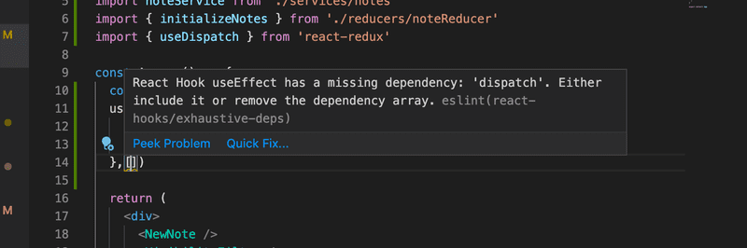

Wecangetrid ofitbydoing thefollowing:

constApp=()=>{

constdispatch=useDispatch() useEffect(() => {

noteService

.getAll().then(notes=>dispatch(setNotes(notes)))

},[dispatch])

// ...

}

Nowthevariable *dispatch* wedefine inthe *App* component, whichpracticallyisthedispatch function ofthe redux store, has been added to the arrayuseEffect receives as a parameter. **If** thevalueofthedispatchvariablewouldchangeduringruntime,theeffect would beexecuted again. This however cannot happen in our application, so the warning is unnecessary.

Another waytogetridofthewarningwouldbetodisableESlintonthatline:

constApp=()=>{

constdispatch=useDispatch() useEffect(() => {

noteService

.getAll().then(notes=>dispatch(setNotes(notes)))

},[])//eslint-disable-linereact-hooks/exhaustive-deps

// ...

}

GenerallydisablingESlint whenit throwsawarning isnot agoodidea.Eventhoughthe ESlint rule in question has caused some [arguments](https://github.com/facebook/create-react-app/issues/6880), we willuse the first solution.

Moreabouttheneed to definethehooksdependenciesin[thereactdocumentation.](https://reactjs.org/docs/hooks-faq.html#is-it-safe-to-omit-functions-from-the-list-of-dependencies)

Wecandothesamethingwhenit comesto creatinganewnote.Let'sexpandthecode communicating with the server as follows:

constbaseUrl='http://localhost:3001/notes' constgetAll = async () => {

constresponse=awaitaxios.get(baseUrl) return response.data

}

constcreateNew= async(content)=>{const object = {content,important: false}constresponse=await axios.post(baseUrl, object)return response.data}

exportdefault{ getAll, createNew,

}

Themethod *addNote*ofthecomponent*NewNote*changesslightly:

import{useDispatch}from'react-redux'

import{createNote}from'../reducers/noteReducer' import noteService from '../services/notes' constNewNote = (props) => {

constdispatch=useDispatch()

constaddNote=async(event)=>{event.preventDefault() const content = event.target.note.value event.target.note.value = ''

constnewNote=awaitnoteService.createNew(content)dispatch(createNote(newNote))}

return(

<formonSubmit={addNote}>

<inputname="note"/>

<buttontype="submit">add</button>

</form>

)

}

exportdefaultNewNote

Becausethebackendgeneratesidsforthenotes,we'llchangetheactioncreator*createNote*

accordingly:

createNote(state,action){ state.push(action.payload)

}

Changingthe importanceofnotescould be implementedusingthesame principle,bymaking an asynchronous method call to the server and then dispatching an appropriate action.

**UNIT–IV**

# JavaWebDevelopment

Web development is known as website development or web application development. The web development creates, maintains, and updates web development applications using a browser.Thiswebdevelopment requireswebdesigning,backendprogramming,anddatabase management. The development process requires software technology.

Web development creates web applications using servers. We can use a web server or machineserver likeaCPU.TheWebserverorvirtualserverrequireswebapplicationusing technology. Web development requires server-side programming language or technology. Mostly Java, PHP, and other server-side languages require for web development.

Java web development creates a server-side website and web application. The majority of Javawebappsdo notexecuteontheserverdirectly. Awebcontainerontheserver hostsJava web applications.

ForJavawebapplications,thecontaineractsasaruntimeenvironment.What theJavaVirtual Machine is for locally running Java applications, the container is for Java web applications.

JVMisusedtorunthecontaineritself.

Java distinguishes between two types of containers: web and Java EE. Additional functionality, such as server load distribution, can be supported bya container. A web containersupportsJavaservletsandJSP(JavaServerPages).InJavatechnology,Tomcat is a common web container.

A web container is usually a minimal need for web frameworks. GWT, Struts, JavaServer Faces,andtheSpring frameworkarecommonJavawebframeworks.Servletsareattheheart of most modern Java web frameworks.

### FunctionsofJavaWebDevelopment

Java webdevelopment creates applications and websites using static and dynamic resources. The static resource refers to HTML pages with images, and a dynamic resource refers to classes, jars,Servlet,andJSP.Javawebdevelopment usesseveralpackages, files,andonline links. Java web development requires web archive files known as a WAR files.

Javawebdevelopmentworksonthreemainfactors. Thesedevelopmentfactorsshow below.

* Front-endwebdevelopmentusingJava technology.
* BackendwebdevelopmentusingJavaservertechnology.
* DatabasemanagementusingJava databasedriver.

Theabovethreefactorscreate,update,remove,displayand operatedataorinformation.

**Front-end web development**: The front-end technology interacts with the user and Java interface.It helpstoinsert andsubmit data.Javawebdevelopment usesJavaServerPagesor JSP for the front-end form or table.

**Backendwebdevelopment**:Thebackendtechnologymaintainsandupdatesdataofthe database. Java uses Servlet, spring, and other advanced technology.

**Databasemanagement** handlesorfetchesdatafromthedatabaseusingtheJavadatabase driver. The Java technology uses JDBC, Hibernate to handle the database.

### TypesoftheJava WebTechnologies

* ServletAPI
* JSP(JavaServerpage)
* JDBCDriver
* JAVAPersistence
* JavaServerFaces(JSF)
* JSTL
* JAVAMessageServiceAPI

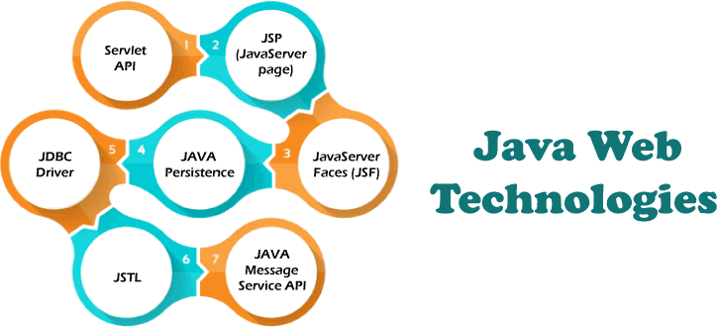

ServletAPI(JAVAWebapplicationprogramminginterface)

Servlet, filter, filter chain, servlet config, and other interfaces are available in the javax. Servlet package.Thecapabilitiesofserversthat host appsareincreased byusingServlet.

Therequest-response modelisused inwebdevelopment applicationswrittenwithJava servlets. From initialization to garbage collection, a servlet has a life cycle.

Servletsareusefulforvarioustasks,includingcollectingdataviawebpage forms,presenting data from a database or any other third-party source, etc.

ServletsareJavaprogramsthat runonawebapplicationandsendclient requeststo databases or servers. After talking with the database, the servlets help process the client's request and provide results.

JSP(JavaServerPageWebapplicationprogramming technology)

DevelopersemployJavaServer Pagesor JSPtechnologyto quicklyproduce platform- and server-independent online content. Normally, the developer works on separate Common GatewayInterface filestoembeddynamicelementsinHTMLpages.JavaJSPtechnology can be used, as it has access to the whole Java API family.

TheJSPtechnologypiecescodetocontrolwebinformationand movesdynamically. AJSP page comprises static data written in HTML, WML, XML, and other markup languages.

SpecialJSPtagssimplifyJavacodeinto HTMLpages, makingwebdevelopment user- friendly.

TheJSPtechnologyallowsembeddingbitsofservlet codeinatext-baseddocument.JSPisa popular Java EE technologythat allows programmers to create complex dynamic web pages quickly.

JDBCDriverorJavaDatabaseConnectivity

JDBCDriverisaconnectorbetweendatabaseandJavawebapplication.Java database

connectivity helps to update and modifydata using queries. The jdbc driver is an essential partofJavawebdevelopment.Thisdriver helpstosenddatatothedatabaseandretrievedata from the database.

WithinaJavaprogram,theJDBCdriver allowstoperformthefollowingtasks:

* Makeadatasourceconnection
* Tothedatasource,sendqueriesandupdatestatements
* Displaysrequiredatafromadatabase.
* Organizeapplicationinformation.

JDBC isasetofmethodsandqueries foraccessing databaseswritteninJava. Clientscanuse web applications using JDBC drivers to update any information in the database.

JDBCdriversconnecttodatabasesinfourways:JDBC-ODBCBridgeDriver,Network Protocol Driver, Native Driver, and Thin Driver.

PersistenceAPIforJava

For web development, the Java Persistence API employs object-relational mapping. This mappingconnectsadatabaseto anobject-orientedmodel.JavaPersistence makesit simpleto manage relational data in Java web applications. The Java Persistence API aids in database data management. This API sends data to a database and retrieves data from it regularly.

Largeamountsofcode,proprietaryframeworks, andotherfilesarenotrequired. JPAgivesa straightforward technique of database communication. A database is an object-relational approach for interacting with Java web development. JPA is a set of lightweight classes and methods for interacting with databases.

Technologyofthe JavaServerFaces

JavaServer Faces is called a JSF Technology. This technologyprovides a framework for developingweb-basedinterfaces.JSFprovidesasimplemodelforcomponentsinvarious scripting or markup languages.

Thedatasourcesandserver-sideevent handlersarecoupledtotheUserInterfacewidgets. JSF aids inthe creationand maintenance ofwebapplications byminimizing the time and effort required.

* ConstructJavawebdevelopmentpages.
* Dropcomponentsonawebpagebyaddingcomponenttagstoawebpage.
* ConnectJava webdevelopmentpagecomponentstoserver-sidedata.
* Connectcomponent-generatedeventstoapplicationcoderunningontheserver.
* Extendthelifeofserverrequestsbystoringandrestoringtheapplicationstate.

StandardTagLibraryfor JavaServerPages(JSTL)

TheJavaServer PagesStandardTagLibraryor JSTLabstractscommonfunctionalityofJSP- based applications. We use a single standard set of tags to incorporate tags from various vendors into web applications. This standardization enables the establishment of Java

applicationsonanyJSPcontainer. It supportsJSTLand increasesthetagstooptimizeduring implementation.

JSTL includes iterator and conditional tags for controlling flow. These tags work for manipulatingXMLdocumentsandtagsforinternationalization.ThisJSTLis also used for SQL database access and tags for frequently used functions.

APIforJavaMessageService

Messaging is a way for software components or apps to communicate with one another. A messagingsystemisatypeofpeer-to-peer network. Inother words, amessagingclient can communicate with and be communicated with by any other client.

Eachclient establishesaconnectionwitha messagingagent,facilitatingthecreation, transmission, receipt, and reading of messages.

TheJavaMessageService(JMS)APIprovidesastrongtoolforresolvingenterprise computing problems by integrating Java technology and enterprise messaging.

Enterprise messaging enablesthesecureand flexiblesharing ofbusinessdata.TheJMS API extendsthisbyprovidingauniformAPI andproviderframeworkthat facilitatesthebuilding of portable message-based Java applications.

### SpecialFeaturesoftheJavawebdevelopment

* Javaisamature,versatile,andpowerfulprogramminglanguage.
* Additionally,itispopular,whichmeansthat toolsandassistanceforJavawebdevelopment are readily available.
* Java's platform freedom is one of its strongest characteristics. Java code can be executed on anyplatform, includinga MacoraWindowscomputer. Onanyoperatingsystem, wecanrun a Java web application.
* Java isalsocapableofrunningmobileapplicationsonsmartphonesandtablets.
* Java web development doesnotrequireadditionalefforttodesignandrunwebappsacross several platforms.
* Java also includes an enormous standard library. This libraryreadily works with common taskssuchasinputandoutput,networking,andgraphicuserinterfaces.Itprovidestoolsto help web application developers.

### Conclusion

Javaprogramminglanguageiseasytohandleandprogrammer'sfirst choicefor web development. Java webdevelopment has basic rules apart fromoperating data. This technology does not need an extra operation or advanced programming.

Java web development creates multiple web applications using a single type of code on multiplepages. Ifweknowtheworking procedure,thenJAVAtechnologydevelopsany application.

**JAVAPROGRAMMINGBASICS**

# What isJava?

Javaisahigh-level,general-purpose,object-oriented,andsecureprogramminglanguage developed byJames Gosling at SunMicrosystems, Inc. in1991. It is formallyknownas OAK. In 1995, Sun Microsystemchanged the name to Java. In 2009, Sun Microsystem takeover by Oracle Corporation.

### EditionsofJava

EacheditionofJavahasdifferentcapabilities.TherearethreeeditionsofJava:

* **JavaStandardEditions(JSE):**Itisusedtocreateprograms for adesktopcomputer.
* **JavaEnterpriseEdition(JEE):**It isusedtocreate largeprogramsthat runonthe server and manages heavy traffic and complex transactions.
* **JavaMicroEdition(JME):**Itisusedto developapplicationsforsmalldevicessuch as set-top boxes, phone, and appliances.

### TypesofJavaApplications

TherearefourtypesofJavaapplicationsthatcanbecreatedusing Javaprogramming:

* **StandaloneApplications:** JavastandaloneapplicationsusesGUIcomponentssuch as AWT, Swing, and JavaFX. These components containbuttons, list, menu, scroll panel, etc. It is also known as desktop alienations.
* **EnterpriseApplications:** Anapplicationwhichisdistributedinnatureiscalled enterprise applications.
* **WebApplications:** Anapplicationsthat runontheserver iscalledwebapplications. We use JSP, Servlet, Spring, and Hibernate technologies for creating web applications.
* **Mobile Applications:** Java ME is a cross-platformto develop mobile applications whichrunacrosssmartphones.Java isaplatformforAppDevelopment inAndroid.

### JavaPlatform

JavaPlatformisacollectionofprograms. It helpstodevelopandrunaprogramwritteninthe Java programming language. Java Platform includes an execution engine, a compiler and set of libraries. Java is a platform-independent language.

### FeaturesofJava

* **Simple:** Java is a simple language because its syntax is simple, clean, and easyto understand. Complex and ambiguous concepts of C++ are either eliminated or re- implementedinJava.Forexample,pointerandoperatoroverloadingarenotusedin Java.
* **Object-Oriented:**InJava,everything isinthe formoftheobject.Itmeansit has some data and behavior. A program must have at least one class and object.
* **Robust:**Javamakesanefforttocheckerroratruntimeandcompiletime.Itusesa

strongmemorymanagement systemcalledgarbagecollector.Exceptionhandlingand garbage collection features make it strong.

* **Secure:**Javaisasecureprogramminglanguagebecause ithasnoexplicitpointerand programs runs in the virtual machine. Java contains a security manager that defines the access of Java classes.
* **Platform-Independent:** Java provides a guarantee that code writes once and run anywhere.Thisbytecodeisplatform-independent andcanberunonanymachine.

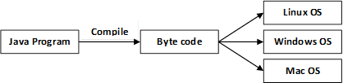

* **Portable:** Java Byte code can be carried to any platform. No implementation- dependentfeatures.Everythingrelatedtostorageispredefined,forexample,thesize of primitive data types.
* **HighPerformance:**Javaisaninterpretedlanguage.Javaenableshighperformance with the use of the Just-In-Time compiler.
* **Distributed:** Java also has networking facilities. It is designed for the distributed environmentofthe internet because it supportsTCP/IPprotocol.Itcanrunoverthe internet. EJB and RMI are used to create a distributed system.
* **Multi-threaded:**Javaalsosupportsmulti-threading.Itmeansto handlemorethan one job a time.

### OOPs(ObjectOrientedProgramming System)

Object-orientedprogramming isawayofsolvinga complexproblembybreakingtheminto a smallsub-problem. Anobject isareal-worldentity. Itiseasiertodevelopaprogrambyusing an object. In OOPs, we create programs using class and object in a structured manner.

**Class:**Aclassisatemplateorblueprint orprototypethatdefinesdatamembersand methods ofan object. An object is the instance ofthe class. We can define a class byusing the class keyword.

**Object:** Anobject isareal-worldentitythat canbe identifieddistinctly. Forexample,adesk, a circle can be considered as objects. An object has a unique behavior, identity, and state.

Datafieldswiththeircurrent valuesrepresent thestateofanobject (also knownasits properties or attributes).

**Abstraction:** An abstraction is a method of hiding irrelevant information fromthe user. For example, thedriveronlyknowshowtodriveacar;there is no needtoknowhowdoesthecar run. We can make a class abstract byusing the keyword abstract. In Java, we use abstract class and interface to achieve abstraction.

**Encapsulation:** An encapsulation is the process ofbinding data and functions into a single unit.Aclassisanexampleofencapsulation.InJava,Java beanisa fullyencapsulatedclass.

**Inheritance:** Inheritance is the mechanismin whichone class acquire allthe featuresof anotherclass.Wecanachieve inheritancebyusingtheextendskeyword.Itfacilitatesthe reusability of the code.

**Polymorphism:** The polymorphism is the ability to appear in many forms. In other words, singleactionindifferent ways.Forexample,aboyintheclassroombehaveslikeastudent,in house behaves like a son. There aretwotypes ofpolymorphism: runtime polymorphismand compile-time polymorphism.

# JavaVariables

Avariable isacontainerwhichholdsthevaluewhilethe [Javaprogram](https://www.javatpoint.com/simple-program-of-java)isexecuted. A variable is assigned with a data type.

Variable isanameofmemorylocation.Therearethreetypesofvariablesinjava: local, instance and static.

Therearetwotypesof[datatypesinJava](https://www.javatpoint.com/java-data-types):primitive andnon-primitive.

### Variable

Avariable isthename ofareservedareaallocatedinmemory. Inotherwords, it isanameof the memory location. It is a combination of "vary + able" which means its value can be changed.

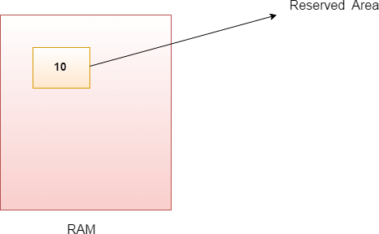

1. intdata=50;//Heredataisvariable Types of Variables

There arethree typesofvariablesin[Java](https://www.javatpoint.com/java-tutorial):

* + localvariable
  + instancevariable
  + staticvariable

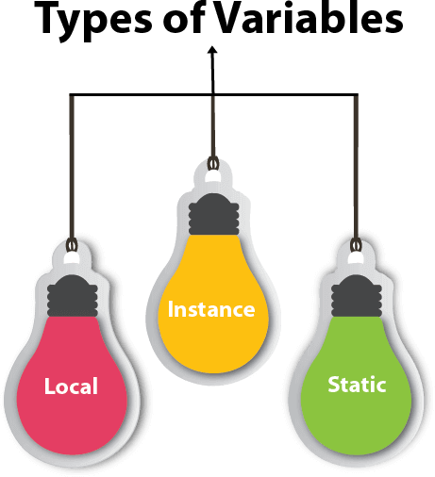

1. *LocalVariable*

A variable declared inside the bodyof the method is called local variable. You can use this variableonlywithinthat methodandtheothermethods intheclassaren't evenawarethatthe variable exists.

Alocalvariablecannotbedefinedwith"static"keyword.

1. *InstanceVariable*

Avariabledeclared insidetheclassbutoutsidethebodyofthe method,iscalledaninstance variable. It is not declared as [static.](https://www.javatpoint.com/static-keyword-in-java)

Itiscalledaninstancevariablebecauseitsvalue isinstance-specificand isnotsharedamong

instances.

1. *Staticvariable*

A variable that is declared as static is called a static variable. It cannot be local. You can createasinglecopyofthestatic variableandshareit amongallthe instancesoftheclass. Memoryallocation for static variables happens onlyonce when the class is loaded in the memory.

Exampletounderstandthetypesofvariablesin java

* 1. publicclassA
  2. {
  3. staticint m=100;//staticvariable
  4. voidmethod()
  5. {
  6. intn=90;//localvariable

7. }

1. publicstaticvoidmain(Stringargs[])
2. {
3. intdata=50;//instancevariable

11. }

12.}//endofclass

JavaVariableExample:AddTwoNumbers

1. publicclassSimple{
2. publicstaticvoidmain(String[]args){
3. inta=10;
4. int b=10;
5. intc=a+b;
6. System.out.println(c);
7. }
8. }

##### Output:

20

JavaVariableExample:Widening

1. publicclassSimple{
2. publicstaticvoidmain(String[]args){
3. inta=10;
4. floatf=a;
5. System.out.println(a);
6. System.out.println(f);
7. }}

##### Output:

10

10.0

JavaVariableExample:Narrowing(Typecasting)

1. publicclassSimple{
2. publicstaticvoidmain(String[]args){
3. float f=10.5f;
4. //inta=f;//Compiletimeerror
5. inta=(int)f;
6. System.out.println(f);
7. System.out.println(a);
8. }}

##### Output:

10.5

10

JavaVariableExample:Overflow

1. classSimple{
2. publicstaticvoidmain(String[]args){
3. //Overflow
4. int a=130;
5. byteb=(byte)a;
6. System.out.println(a);
7. System.out.println(b);
8. }}

##### Output:

130

-126

JavaVariableExample:AddingLowerType

1. classSimple{
2. publicstaticvoidmain(String[]args){
3. bytea=10;
4. byteb=10;
5. //bytec=a+b;//CompileTimeError:becausea+b=20willbeint
6. bytec=(byte)(a+b);
7. System.out.println(c);
8. }}

##### Output:

20

# JavaOOPs Concepts

1. [Object-OrientedProgramming](https://www.javatpoint.com/java-oops-concepts#oops)
2. [AdvantageofOOPsoverProcedure-orientedprogramminglanguage](https://www.javatpoint.com/java-oops-concepts#oopsadvantage)
3. [DifferencebetweenObject-orientedandObject-basedprogramminglanguage.](https://www.javatpoint.com/java-oops-concepts#oopsdifference)

In this page, we will learn about the basics of OOPs. Object-Oriented Programming is a paradigmthat providesmanyconcepts,suchas **inheritance**,**databinding**,**polymorphism**, etc.

**Simula** is considered the first object-oriented programming language. The programming paradigmwhereeverything isrepresentedasanobject isknownasatrulyobject-oriented programming language.

**Smalltalk**isconsideredthefirsttrulyobject-orientedprogramming language. The popular object-oriented languages are [Java,](https://www.javatpoint.com/java-tutorial)[C#](https://www.javatpoint.com/c-sharp-tutorial), [PHP](https://www.javatpoint.com/php-tutorial), [Python](https://www.javatpoint.com/python-tutorial), [C++](https://www.javatpoint.com/cpp-tutorial), etc.

The mainaimofobject-orientedprogramming istoimplement real-worldentities, for example, object, classes, abstraction, inheritance, polymorphism, etc.

### OOPs(Object-OrientedProgrammingSystem)

**Object** meansareal-worldentitysuchasapen,chair,table,computer,watch,etc. **Object- Oriented Programming** is a methodologyor paradigmto design a programusing classes and objects. It simplifies software development and maintenance by providing some concepts:

* [Object](https://www.javatpoint.com/object-and-class-in-java)
* Class
* [Inheritance](https://www.javatpoint.com/inheritance-in-java)
* [Polymorphism](https://www.javatpoint.com/runtime-polymorphism-in-java)
* [Abstraction](https://www.javatpoint.com/abstract-class-in-java)
* [Encapsulation](https://www.javatpoint.com/encapsulation)

Apart fromtheseconcepts,therearesomeothertermswhichareused inObject-Oriented design:

* Coupling
* Cohesion
* Association
* Aggregation
* Composition

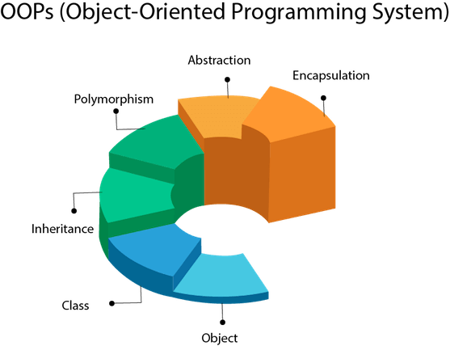

### Object

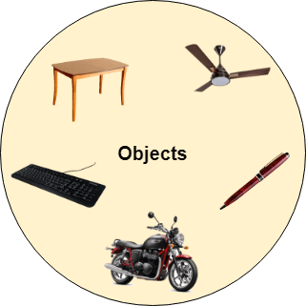

Anyentitythat hasstateandbehavior isknownasanobject.Forexample,achair,pen,table, keyboard, bike, etc. It can be physical or logical.

AnObjectcanbedefinedasaninstanceofaclass.Anobjectcontainsanaddressand takes

up some space in memory. Objects can communicate without knowing the details of each other'sdataor code.Theonlynecessarything isthetype ofmessageacceptedandthetypeof response returned by the objects.

**Example:** Adogisanobject because it hasstateslikecolor,name,breed,etc.aswellas behaviors like wagging the tail, barking, eating, etc.

### Class

*Collectionofobjects*iscalledclass. Itisalogicalentity.

Aclasscanalso bedefinedasablueprint fromwhichyoucancreateanindividualobject. Class doesn't consume any space.

Inheritance

*Whenoneobjectacquiresallthepropertiesandbehaviorsof aparentobject*, it isknownas inheritance. It provides code reusability. It is used to achieve runtime polymorphism.

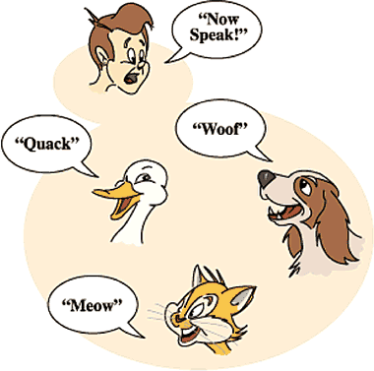

Polymorphism

If*one task is performed in different ways*, it is known as polymorphism. For example: to convincethecustomerdifferently,todrawsomething, forexample,shape,triangle,rectangle, etc.

InJava,weusemethodoverloadingandmethodoverridingtoachievepolymorphism.

Anotherexamplecanbetospeaksomething;forexample,acat speaksmeow,dogbarks woof, etc.

*Abstraction*

*Hidinginternaldetailsandshowingfunctionality* isknownasabstraction.Forexamplephone call, we don't know the internal processing.

InJava,weuseabstractclassandinterfacetoachieveabstraction.



Encapsulation

*Binding(or wrapping) codeanddatatogether intoasingleunitareknownasencapsulation*. For example, a capsule, it is wrapped with different medicines.

Ajavaclassistheexampleofencapsulation.Java beanisthe fullyencapsulatedclass because all the data members are private here.

Coupling

Coupling refers to the knowledge or information or dependencyof another class. It arises whenclassesareawareofeachother.Ifaclass hasthedetails informationofanother class, thereisstrong coupling. InJava, weuseprivate, protected,and public modifiersto display the visibility level of a class, method, and field. You can use interfaces for the weaker coupling because there is no concrete implementation.

Cohesion

Cohesion refers to the level of a component which performs a single well-defined task. A singlewell-definedtaskisdone bya highlycohesive method.Theweaklycohesive method will split the task into separate parts. The java.io package is a highlycohesive package because it has I/O related classes and interface. However, the java.utilpackage is a weakly cohesive package because it has unrelated classes and interfaces.

Association

Association represents the relationship between the objects. Here, one object can be associatedwithoneobject or manyobjects.Therecanbe fourtypesofassociationbetween the objects:

* OnetoOne
* Oneto Many
* ManytoOne,and
* Manyto Many

Let's understand the relationship with real-time examples. For example, One country can have one prime minister (one to one), and a prime minister can have many ministers (one to many).Also,manyMP'scanhaveoneprime minister(manytoone),andmanyministerscan have many departments (many to many).

Associationcanbeundirectionalorbidirectional.

Aggregation

Aggregation is a wayto achieve Association. Aggregation represents the relationship where one object contains other objects as a part of its state. It represents the weak relationship betweenobjects.It isalsotermedasa *has-a*relationship inJava.Like, inheritancerepresents the *is-a* relationship. It is another way to reuse objects.

Composition

The composition is also a wayto achieve Association. The composition represents the relationship where one object contains other objects as a part of its state. There is a strong relationship between the containing object and the dependent object. It is the state where containingobjectsdonothaveanindependent existence.Ifyoudeletetheparent object,all the child objects will be deleted automatically.

### AdvantageofOOPsoverProcedure-oriented programming language

1. OOPsmakesdevelopment and maintenanceeasier,whereas, inaprocedure-oriented programminglanguage, it isnot easytomanageifcodegrowsasproject sizeincreases.
2. OOPsprovidesdatahiding,whereas, inaprocedure-orientedprogramming language, global data can be accessed from anywhere.

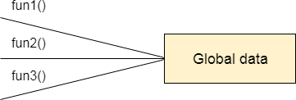

Figure:DataRepresentationinProcedure-OrientedProgramming

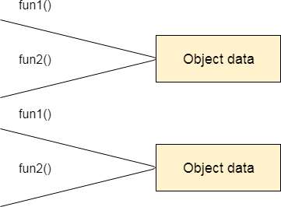

Figure:DataRepresentationinObject-OrientedProgramming

1. OOPs provides the ability to simulate real-world event much more effectively. We can providethesolutionofrealword problemifweareusing theObject-Oriented Programming language.

### What is the difference between an object-oriented programminglanguageandobject-basedprogramming language?

Object-basedprogramming language followsallthefeaturesofOOPsexcept Inheritance. JavaScript and VBScript are examples of object-based programming languages.

# MVCArchitectureinJava

The Model-View-Controller (MVC) is a well-known[designpattern](https://www.javatpoint.com/design-patterns-in-java)inthe webdevelopment field. It iswaytoorganizeourcode.It specifiesthat aprogramorapplicationshallconsist of data model, presentation information and control information. The MVC pattern needs all these components to be separated as different objects.

Inthissection,wewilldiscusstheMVCArchitectureinJava,alongwithitsadvantagesand disadvantages and examples to understand the implementation of MVC in Java.

WhatisMVCarchitectureinJava?

The model designs based on the MVC architecture follow MVC design pattern. The applicationlogic isseparatedfromtheuser interfacewhiledesigningthesoftwareusing model designs.

TheMVCpatternarchitectureconsistsofthreelayers:

* **Model:**It representsthebusiness layer ofapplication. It isanobject tocarrythedata thatcan also contain the logic to update controller if data is changed.
* **View:**It representsthepresentationlayer ofapplication. Itisusedtovisualizethedatathat the model contains.
* **Controller:** It works on both the model and view. It is used to manage the flow of application, i.e. data flowinthemodelobjectandtoupdatetheviewwhenever data is changed.

InJavaProgramming, theModelcontainsthesimple [Javaclasses,](https://www.javatpoint.com/object-and-class-in-java) theViewusedto display thedataandtheControllercontainsthe [servlets](https://www.javatpoint.com/servlet-tutorial). Duetothisseparationtheuserrequestsare processed as follows:

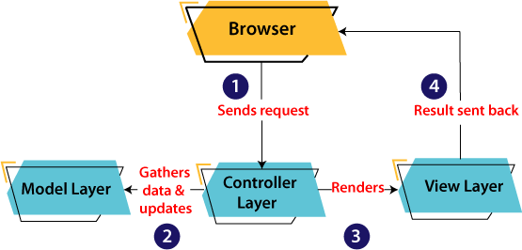

* 1. Aclient(browser)sendsarequesttothecontroller ontheserver side, forapage.
  2. Thecontrollerthencallsthemodel.Itgatherstherequesteddata.
  3. Thenthecontrollertransfersthedataretrievedtotheview layer.
  4. Nowtheresult is sent backtothebrowser(client)bythe view.

AdvantagesofMVC Architecture

The advantages ofMVCarchitectureareas follows:

* + - MVChasthefeatureofscalabilitythat inturnhelpsthegrowthofapplication.
    - Thecomponentsareeasytomaintainbecausethereisless dependency.
    - Amodelcanbereusedbymultipleviewsthatprovidesreusabilityofcode.
    - Thedeveloperscanworkwiththethreelayers(Model,View,andController)simultaneously.
    - UsingMVC, theapplicationbecomesmoreunderstandable.
    - UsingMVC, eachlayer is maintainedseparatelythereforewedonot requiretodealwith massive code.
    - Theextendingandtestingofapplicationiseasier.

ImplementationofMVCusingJava

ToimplementMVCpatterninJava,wearerequiredtocreatethefollowingthree classes.

* + - **EmployeeClass**, willactasmodellayer
    - **EmployeeViewClass**, willactasa viewlayer
    - **EmployeeContollerClass**,willactacontrollerlayer

### MVCArchitectureLayers

ModelLayer

TheModelintheMVCdesignpatternactsasadata layer fortheapplication. Itrepresentsthe business logic for application and also the state of application. The modelobject fetch and storethe modelstate in the database. Using the model layer, rules are applied to the datathat represents the concepts of application.

Let'sconsiderthe followingcodesnippet thatcreatesawhichisalsothe first stepto implement MVC pattern.

##### Employee.java

1. //classthatrepresents model
2. publicclassEmployee{
3. ​
4. //declaringthevariables
5. privateStringEmployeeName;
6. privateStringEmployeeId;
7. privateStringEmployeeDepartment;
8. ​
9. //defining getterand settermethods
10. publicStringgetId(){
11. returnEmployeeId;

12. }

13.

1. publicvoidsetId(Stringid){
2. this.EmployeeId= id;

16. }

17.

1. publicStringgetName(){
2. returnEmployeeName;

20. }

21.

1. publicvoidsetName(Stringname){
2. this.EmployeeName= name;

24. }

25.

1. publicStringgetDepartment(){
2. returnEmployeeDepartment;

28. }

29.

1. publicvoidsetDepartment(StringDepartment){
2. this.EmployeeDepartment =Department;

32. }

33.

34. }

TheabovecodesimplyconsistsofgetterandsettermethodstotheEmployeeclass. View Layer

As the name depicts, view represents the visualization of data received from the model. The view layer consistsofoutputofapplicationoruserinterface. Itsendstherequesteddatatothe client, that is fetched from model layer by controller.

Let'stakeanexamplewherewecreateaviewusingtheEmployeeViewclass.

##### EmployeeView.java

1. // classwhichrepresentsthe view
2. publicclassEmployeeView{
3. ​
4. //methodtodisplaytheEmployee details
5. publicvoidprintEmployeeDetails(StringEmployeeName,StringEmployeeId,String EmployeeDepartment){
6. System.out.println("EmployeeDetails:");
7. System.out.println("Name:"+EmployeeName);
8. System.out.println("EmployeeID:"+EmployeeId);
9. System.out.println("EmployeeDepartment:"+EmployeeDepartment);

10. }

11. }

ControllerLayer

The controller layer getsthe user requests fromthe view layer and processes them, with the necessaryvalidations. Itactsasaninterface betweenModelandView. Therequestsarethen sent to model for data processing. Once theyare processed, the data is sent back to the controller and then displayed on the view.

Let'sconsiderthefollowingcodesnippet thatcreatesthecontroller usingthe EmployeeController class.

##### EmployeeController.java

1. //classwhichrepresentthecontroller
2. publicclassEmployeeController{
3. ​
4. //declaringthevariablesmodelandview
5. privateEmployeemodel;
6. privateEmployeeViewview;
7. ​
8. //constructortoinitialize
9. publicEmployeeController(Employeemodel,EmployeeViewview){
10. this.model= model;
11. this.view= view;

12. }

13.

1. //getter andsetter methods
2. publicvoidsetEmployeeName(Stringname){
3. model.setName(name);

17. }

18.

1. publicStringgetEmployeeName(){
2. returnmodel.getName();

21. }

22.

1. publicvoidsetEmployeeId(String id){
2. model.setId(id);

25. }

26.

1. publicStringgetEmployeeId(){
2. returnmodel.getId();

29. }

30.

1. publicvoidsetEmployeeDepartment(StringDepartment){
2. model.setDepartment(Department);

33. }

34.

1. publicStringgetEmployeeDepartment(){
2. returnmodel.getDepartment();

37. }

38.

1. //methodtoupdate view
2. publicvoidupdateView(){
3. view.printEmployeeDetails(model.getName(),model.getId(),model.getDepart ment());

42. }

43. }

MainClassJavafile

The followingexampledisplaysthe mainfileto implementtheMVCarchitecture.Here,we are using the MVCMain class.

##### MVCMain.java

1. //mainclass
2. publicclassMVCMain{
3. publicstaticvoidmain(String[]args){
4. ​
5. //fetching theemployeerecord basedontheemployee_idfromthe database
6. Employeemodel=retriveEmployeeFromDatabase();
7. ​
8. //creatingaviewto writeEmployeedetailsonconsole
9. EmployeeViewview=newEmployeeView();
10. ​
11. EmployeeControllercontroller=newEmployeeController(model,view);
12. ​
13. controller.updateView();
14. ​
15. //updatingthemodeldata
16. controller.setEmployeeName("Nirnay");
17. System.out.println("\nEmployeeDetailsafterupdating:");
18. ​
19. controller.updateView();

20. }

21.

1. privatestaticEmployeeretriveEmployeeFromDatabase(){
2. EmployeeEmployee=newEmployee();
3. Employee.setName("Anu");
4. Employee.setId("11");
5. Employee.setDepartment("Salesforce");
6. returnEmployee;

28. }

29. }

The**MVCMain**classfetchestheemployeedatafromthe methodwherewehaveenteredthe values. Then it pushes those values in the model. After that, it initializes the view (EmployeeView.java).Whenviewisinitialized,theController(EmployeeController.java)is invoked and bind it to Employee class and EmployeeView class. At last the updateView() method (method of controller) update the employee details to be printed to the console.

##### Output:

EmployeeDetails:

Name: Anu EmployeeID:11

EmployeeDepartment:Salesforce

EmployeeDetailsafterupdating:

Name: Nirnay EmployeeID:11

EmployeeDepartment:Salesforce

Inthisway,wehave learnedabout MVCArchitecture,significanceofeachlayerand its implementation in Java.

# Spring MVCTutorial

ASpringMVC isaJava frameworkwhichisusedtobuildwebapplications. Itfollowsthe Model-View-Controllerdesignpattern.Itimplementsallthe basic featuresofacorespring framework like Inversion of Control, Dependency Injection.

ASpringMVCprovidesanelegant solutionto useMVC inspring frameworkbythe helpof **DispatcherServlet**. Here, **DispatcherServlet** is a class that receives the incoming request and maps it to the right resource such as controllers, models, and views.

### SpringWebModel-View-Controller

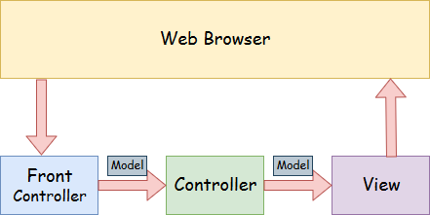

* **Model**-Amodelcontainsthedata oftheapplication.Adata canbea singleobject or a collection of objects.
* **Controller**-Acontroller containsthebusinesslogic of anapplication.Here,the@Controller annotation is used to mark the class as the controller.
* **View**- Aviewrepresentstheprovidedinformationina particularformat. Generally, JSP+JSTL is used to create a view page. Although spring also supports other view technologies such as Apache Velocity, Thymeleaf and FreeMarker.
* **FrontController**-InSpringWebMVC, theDispatcherServletclassworksasthefront controller. It is responsible to manage the flow of the Spring MVC application.

### UnderstandingtheflowofSpringWebMVC

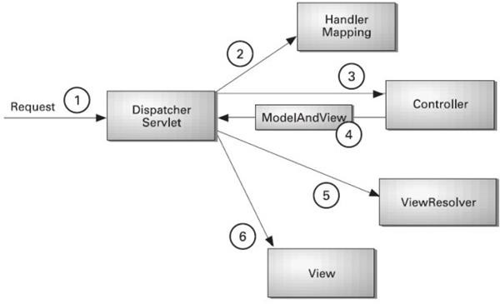

* Asdisplayedinthefigure, alltheincomingrequest isinterceptedbytheDispatcherServlet that works as the front controller.
* TheDispatcherServlet getsanentryof handler mappingfromtheXMLfileandforwardsthe request to the controller.
* ThecontrollerreturnsanobjectofModelAndView.
* TheDispatcherServlet checkstheentryofviewresolver intheXMLfileandinvokesthe specified view component.

### AdvantagesofSpringMVCFramework

Let'ssee some oftheadvantagesofSpringMVCFramework:-

* **Separateroles**-TheSpringMVCseparateseachrole, wherethemodelobject, controller, command object, view resolver, DispatcherServlet, validator, etc. can be fulfilled by a specialized object.
* **Light-weight**-Ituseslight-weightservletcontainertodevelopanddeployyourapplication.
* **PowerfulConfiguration**-Itprovidesarobustconfigurationfor bothframeworkand application classes that includes easy referencing across contexts, such as from web controllers to business objects and validators.
* **Rapiddevelopment**-TheSpringMVCfacilitatesfastandparalleldevelopment.
* **Reusablebusiness code**-Insteadofcreatingnewobjects, itallowsustousetheexisting business objects.
* **Easytotest**-InSpring, generallywecreateJavaBeans classesthat enableyoutoinject test data using the setter methods.
* **FlexibleMapping**-Itprovidesthespecificannotationsthateasilyredirectthepage.

### SpringWebMVCFrameworkExample

Let'sseethesimpleexampleofaSpringWebMVCframework.Thestepsareasfollows:

* LoadthespringjarfilesoradddependenciesinthecaseofMaven
* Createthecontrollerclass
* Providetheentryofcontrollerintheweb.xmlfile
* DefinethebeanintheseparateXMLfile
* DisplaythemessageintheJSPpage
* Starttheserveranddeploytheproject

**DirectoryStructureofSpringMVC**

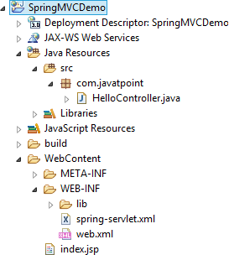

**DirectoryStructureofSpringMVCusing Maven**

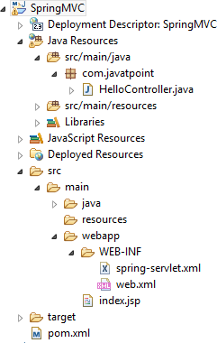

**RequiredJarfilesorMavenDependency**

Torunthisexample,youneedtoload:

* SpringCorejarfiles
* SpringWebjarfiles
* JSP+JSTLjarfiles(If youareusinganyanother viewtechnologythenloadthe corresponding jar files).

**DownloadLink:**[Downloadallthejarfilesforspring includingJSPandJSTL](https://static.javatpoint.com/src/sp/springjars.zip).

IfyouareusingMaven, youdon't needto addjar files.Now,youneedtoaddmaven dependency to the pom.xml file.

1. Provideprojectinformationandconfigurationinthepom.xml file.

##### pom.xml

* 1. <projectxmlns="[http://maven.apache.org/POM/4.0.0"](http://maven.apache.org/POM/4.0.0)xmlns:xsi="[http://www.w3.org](http://www.w3.org/)

/2001/XMLSchema-instance"

* 1. xsi:schemaLocation="<http://maven.apache.org/POM/4.0.0><http://maven.apache.org/maven->v4_0_0.xsd">
  2. <modelVersion>4.0.0</modelVersion>
  3. <groupId>com.javatpoint</groupId>
  4. <artifactId>SpringMVC</artifactId>
  5. <packaging>war</packaging>
  6. <version>0.0.1-SNAPSHOT</version>
  7. <name>SpringMVCMavenWebapp</name>
  8. <url>[http://maven.apache.org](http://maven.apache.org/)</url>
  9. <dependencies>
  10. <dependency>
  11. <groupId>junit</groupId>
  12. <artifactId>junit</artifactId>
  13. <version>3.8.1</version>
  14. <scope>test</scope>
  15. </dependency>
  16. ​
  17. <!--https://mvnrepository.com/artifact/org.springframework/spring-webmvc-->
  18. <dependency>
  19. <groupId>org.springframework</groupId>
  20. <artifactId>spring-webmvc</artifactId>
  21. <version>5.1.1.RELEASE</version>
  22. </dependency>
  23. ​
  24. <!--https://mvnrepository.com/artifact/javax.servlet/javax.servlet-api-->
  25. <dependency>
  26. <groupId>javax.servlet</groupId>
  27. <artifactId>servlet-api</artifactId>
  28. <version>3.0-alpha-1</version>
  29. </dependency>
  30. ​
  31. </dependencies>
  32. <build>
  33. <finalName>SpringMVC</finalName>
  34. </build>
  35. </project>

1. Createthecontrollerclass

Tocreatethecontrollerclass,weareusingtwoannotations@Controllerand @RequestMapping.

The@ControllerannotationmarksthisclassasController.

The@RequestmappingannotationisusedtomaptheclasswiththespecifiedURL name.

##### HelloController.java

* 1. package com.javatpoint;
  2. importorg.springframework.stereotype.Controller;
  3. importorg.springframework.web.bind.annotation.RequestMapping;
  4. @Controller
  5. publicclassHelloController{
  6. @RequestMapping("/")
  7. publicStringdisplay()
  8. {
  9. return"index";

10. }

11. }

1. Providetheentryofcontrollerintheweb.xmlfile

In this xml file, we are specifying the servlet class DispatcherServlet that acts as the front controller inSpringWebMVC.Allthe incomingrequest forthehtmlfilewillbe forwarded to the DispatcherServlet.

##### web.xml

* 1. <?xmlversion="1.0"encoding="UTF-8"?>
  2. <web-appxmlns:xsi="<http://www.w3.org/2001/XMLSchema->

instance"xmlns="<http://java.sun.com/xml/ns/javaee>"xsi:schemaLocation="[http://java.sun.co](http://java.sun.co/) m/xml/ns/javaee <http://java.sun.com/xml/ns/javaee/web->

app_3_0.xsd"id="WebApp_ID"version="3.0">

* 1. <display-name>SpringMVC</display-name>
  2. <servlet>
  3. <servlet-name>spring</servlet-name>
  4. <servlet-class>org.springframework.web.servlet.DispatcherServlet</servlet-class>
  5. <load-on-startup>1</load-on-startup>
  6. </servlet>
  7. <servlet-mapping>
  8. <servlet-name>spring</servlet-name>
  9. <url-pattern>/</url-pattern>
  10. </servlet-mapping>
  11. </web-app>

1. Definethebeaninthexmlfile

ThisistheimportantconfigurationfilewhereweneedtospecifytheView components.

Thecontext:component-scanelement definesthebase-packagewhereDispatcherServlet will search the controller class.

ThisxmlfileshouldbelocatedinsidetheWEB-INFdirectory.

##### spring-servlet.xml

* 1. <?xmlversion="1.0"encoding="UTF-8"?>
  2. <beansxmlns="<http://www.springframework.org/schema/beans>"
  3. xmlns:xsi="<http://www.w3.org/2001/XMLSchema-instance>"
  4. xmlns:context="<http://www.springframework.org/schema/context>"
  5. xmlns:mvc="<http://www.springframework.org/schema/mvc>"
  6. xsi:schemaLocation="
  7. <http://www.springframework.org/schema/beans>
  8. <http://www.springframework.org/schema/beans/spring-beans.xsd>
  9. <http://www.springframework.org/schema/context>
  10. <http://www.springframework.org/schema/context/spring-context.xsd>
  11. <http://www.springframework.org/schema/mvc>
  12. [http://www.springframework.org/schema/mvc/spring-mvc.xsd"](http://www.springframework.org/schema/mvc/spring-mvc.xsd)>
  13. ​
  14. <!--Providesupportforcomponentscanning-->
  15. <context:component-scanbase-package="com.javatpoint"/>
  16. ​
  17. <!--Providesupport forconversion,formattingandvalidation-->
  18. <mvc:annotation-driven/>
  19. ​
  20. </beans>

1. DisplaythemessageintheJSPpage

ThisisthesimpleJSPpage, displayingthemessagereturnedbythe Controller.

##### index.jsp

* 1. <html>
  2. <body>
  3. <p>WelcometoSpringMVCTutorial</p>
  4. </body>
  5. </html>

**Output:**

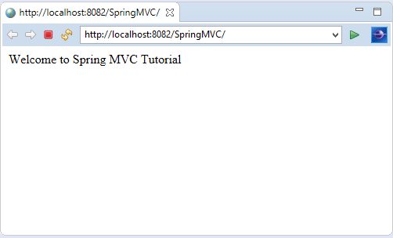

**RESTfulAPIusingSpringFramework**

# BuildingRESTserviceswithSpring

REST hasquicklybecomethede-factostandard forbuildingwebservicesontheweb because they’re easy to build and easy to consume.

There’s a much larger discussion to be had about how REST fits in the world of microservices,but —forthistutorial— let’sjust lookatbuildingRESTfulservices.

WhyREST?REST embracesthepreceptsoftheweb, including itsarchitecture, benefits, and everythingelse.Thisisno surprisegivenitsauthor,RoyFielding,wasinvolved inprobablya dozen specs which govern how the web operates.

Whatbenefits?Thewebanditscoreprotocol,HTTP,provideastackoffeatures:

* Suitableactions(GET,POST,PUT,DELETE,…)
* Caching
* Redirectionandforwarding
* Security(encryptionandauthentication)

These are allcriticalfactorsonbuilding resilient services. Butthat is not all. The web is built outoflotsoftinyspecs, hence it’sbeenabletoevolveeasily, withoutgetting boggeddownin "standards wars".

Developersareabletodrawupon3rdpartytoolkitsthatimplementthesediversespecsand

instantly have both client and server technology at their fingertips. BybuildingontopofHTTP,RESTAPIsprovidethe meanstobuild:

* BackwardscompatibleAPIs
* EvolvableAPIs
* Scaleableservices
* Securableservices
* Aspectrumofstatelesstostatefulservices

What’simportanttorealize isthat REST,howeverubiquitous,isnot astandard, *perse*,but an approach, a style, a set of *constraints* on your architecturethat can help you build web- scale systems. In this tutorial we will use the Spring portfolio to build a RESTful service while leveraging the stackless features of REST.

### GettingStarted

Asweworkthroughthistutorial, we’lluse [SpringBoot](https://spring.io/projects/spring-boot).Goto [SpringInitializr](https://start.spring.io/)andaddthe following dependencies to a project:

* Web
* JPA
* H2

ChangetheNameto"Payroll"andthenchoose"GenerateProject". A .zip willdownload. Unzip it. Inside you’ll find a simple, Maven-based project including a pom.xml build file (NOTE: You *can* use Gradle. The examples in this tutorial will be Maven-based.)

SpringBoot canworkwithanyIDE. YoucanuseEclipse, IntelliJIDEA, Netbeans, etc. [TheSpring ToolSuite](https://spring.io/tools/)isanopen-source,Eclipse-based IDEdistributionthat providesasuperset of the Java EE distribution of Eclipse. It includes features that make working with Spring applications even easier. It is, by no means, required. But consider it if you want that extra **oomph** for your keystrokes. Here’s a video demonstrating how to get started with STS and Spring Boot. This is a general introduction to familiarize you with the tools.

### TheStorysoFar…

Let’sstartoffwiththesimplest thingwecanconstruct.Infact,tomake it assimpleas possible, we can even leave out the concepts of REST. (Later on, we’ll add REST to understand the difference.)

Big picture: We’regoing to createasimplepayroll servicethat managestheemployeesofa company. We’llstoreemployeeobjects ina(H2in-memory)database, andaccessthem(via something called JPA). Thenwe’llwrap that withsomething that willallow accessoverthe internet (called the Spring MVC layer).

ThefollowingcodedefinesanEmployeeinour system.

nonrest/src/main/java/payroll/Employee.java

package payroll;

importjava.util.Objects;

importjavax.persistence.Entity; importjavax.persistence.GeneratedValue; importjavax.persistence.Id;

@Entity classEmployee{

private@Id@GeneratedValueLongid; privateStringname;

privateStringrole; Employee(){}

Employee(Stringname,Stringrole){

this.name=name; this.role=role;

}

publicLonggetId(){ returnthis.id;

}

publicStringgetName(){ returnthis.name;

}

publicStringgetRole(){ returnthis.role;

}

publicvoidsetId(Longid){ this.id = id;

}

publicvoidsetName(Stringname){ this.name = name;

}

publicvoidsetRole(Stringrole){ this.role=role;

}

@Override publicbooleanequals(Objecto){

if(this==o) returntrue;

if(!(o instanceofEmployee)) returnfalse; Employeeemployee=(Employee)o;

returnObjects.equals(this.id,employee.id)&&Objects.equals(this.name,employee.name) &&Objects.equals(this.role,employee.role);

}

@Override publicinthashCode(){

returnObjects.hash(this.id,this.name,this.role);

}

@Override publicStringtoString(){

return"Employee{"+"id="+this.id+",name='"+this.name+'\''+",role='"+this.role+'\''+'}';

}

}

Despitebeingsmall,thisJavaclasscontains much:

* @Entity isaJPAannotationto makethisobject readyfor storageinaJPA-baseddata store.
* id,name, androle areattributesofourEmployee [domainobject](https://www.google.com/search?q=what%2Bis%2Ba%2Bdomain%2Bobject%2Bin%2Bjava).id is markedwithmore JPA annotations to indicate it’s the primary key and automatically populated by the JPA provider.
* acustomconstructoriscreatedwhenweneedtocreateanewinstance,but don’t yet have an id.

Withthisdomainobject definition,wecannowturnto [SpringDataJPA](https://spring.io/guides/gs/accessing-data-jpa/)to handlethetedious database interactions.

Spring Data JPA repositories are interfaces with methods supporting creating, reading, updating, and deleting recordsagainst a back end data store. Some repositoriesalso support datapaging,andsorting,whereappropriate.SpringDatasynthesizesimplementationsbased on conventions found in the naming of the methods in the interface.

TherearemultiplerepositoryimplementationsbesidesJPA. YoucanuseSpringData MongoDB, Spring Data GemFire, Spring Data Cassandra, etc. For this tutorial, we’ll stick with JPA.

Spring makesaccessingdataeasy.BysimplydeclaringthefollowingEmployeeRepository

interfaceweautomaticallywillbeableto

* CreatenewEmployees
* Updateexisting ones
* Delete Employees
* FindEmployees(one,all,orsearchbysimpleorcomplexproperties)

nonrest/src/main/java/payroll/EmployeeRepository.java

package payroll; importorg.springframework.data.jpa.repository.JpaRepository; interfaceEmployeeRepositoryextendsJpaRepository<Employee,Long>{

}

Togetallthis freefunctionality, allwehadtodowasdeclareaninterfacewhichextends

SpringDataJPA’sJpaRepository,specifyingthedomaintypeasEmployeeandtheidtypeas

Long.

SpringData’s[repositorysolution](https://docs.spring.io/spring-data/jpa/docs/current/reference/html/#repositories)makesit possibleto sidestepdatastorespecificsand instead solve a majority of problems using domain-specific terminology.

Believe itornot,this isenoughtolaunchanapplication!ASpringBootapplicationis, at a minimum, a publicstaticvoid main entry-point andthe @SpringBootApplication annotation. This tells Spring Boot to help out, wherever possible.

nonrest/src/main/java/payroll/PayrollApplication.java

package payroll;

importorg.springframework.boot.SpringApplication; importorg.springframework.boot.autoconfigure.SpringBootApplication;

@SpringBootApplication publicclassPayrollApplication{

publicstaticvoidmain(String...args){ SpringApplication.run(PayrollApplication.class,args);

}

}

@SpringBootApplication is a meta-annotation that pulls in **component scanning**, **autoconfiguration**,and**propertysupport**.Wewon’t dive intothedetailsofSpringBootin this tutorial, but in essence, it will fire up a servlet container and serve up our service.

Nevertheless,anapplicationwithno dataisn’t veryinteresting,solet’spreloadit.The following class will get loaded automatically by Spring:

nonrest/src/main/java/payroll/LoadDatabase.java

package payroll;

importorg.slf4j.Logger; importorg.slf4j.LoggerFactory;

importorg.springframework.boot.CommandLineRunner; importorg.springframework.context.annotation.Bean; importorg.springframework.context.annotation.Configuration;

@Configuration classLoadDatabase{

privatestaticfinalLoggerlog=LoggerFactory.getLogger(LoadDatabase.class); @Bean

CommandLineRunnerinitDatabase(EmployeeRepositoryrepository){

returnargs->{

log.info("Preloading"+repository.save(newEmployee("BilboBaggins","burglar"))); log.info("Preloading "+repository.save(newEmployee("Frodo Baggins","thief")));

};

}

}

Whathappenswhenitgetsloaded?

* SpringBoot willrunALLCommandLineRunner beansoncetheapplicationcontext is loaded.
* ThisrunnerwillrequestacopyoftheEmployeeRepositoryyoujustcreated.
* Usingit,itwillcreatetwoentitiesandstorethem.

Right-clickand**Run**PayRollApplication,andthisiswhatyou get:

Fragmentofconsoleoutputshowingpreloadingofdata

...

2018-08-0911:36:26.169INFO74611 ---[main]payroll.LoadDatabase:PreloadingEmployee(id=1, name=Bilbo Baggins, role=burglar)

2018-08-0911:36:26.174INFO74611 ---[main]payroll.LoadDatabase:PreloadingEmployee(id=2, name=Frodo Baggins, role=thief)

...

Thisisn’t the**whole** log,butjust thekeybitsofpreloadingdata.(Indeed,checkoutthewhole console. It’s glorious.)

### HTTPisthe Platform

Towrapyourrepositorywithaweblayer, you mustturntoSpringMVC.ThankstoSpring Boot, there is little in infrastructure to code. Instead, we can focus on actions:

nonrest/src/main/java/payroll/EmployeeController.java

package payroll; importjava.util.List;

importorg.springframework.web.bind.annotation.DeleteMapping; importorg.springframework.web.bind.annotation.GetMapping; importorg.springframework.web.bind.annotation.PathVariable; importorg.springframework.web.bind.annotation.PostMapping; importorg.springframework.web.bind.annotation.PutMapping; importorg.springframework.web.bind.annotation.RequestBody; importorg.springframework.web.bind.annotation.RestController;

@RestController classEmployeeController{

privatefinalEmployeeRepositoryrepository;

EmployeeController(EmployeeRepositoryrepository){ this.repository= repository;

}

//Aggregateroot

// tag::get-aggregate-root[] @GetMapping("/employees") List<Employee>all(){ returnrepository.findAll();

}

//end::get-aggregate-root[]

@PostMapping("/employees") EmployeenewEmployee(@RequestBodyEmployeenewEmployee){ returnrepository.save(newEmployee);

}

//Singleitem

@GetMapping("/employees/{id}") Employeeone(@PathVariableLongid){

returnrepository.findById(id)

.orElseThrow(()->newEmployeeNotFoundException(id));

}

@PutMapping("/employees/{id}") EmployeereplaceEmployee(@RequestBodyEmployeenewEmployee,@PathVariableLongid){

returnrepository.findById(id)

.map(employee ->{ employee.setName(newEmployee.getName()); employee.setRole(newEmployee.getRole()); returnrepository.save(employee);

})

.orElseGet(()->{ newEmployee.setId(id); returnrepository.save(newEmployee);

});

}

@DeleteMapping("/employees/{id}") voiddeleteEmployee(@PathVariableLongid){ repository.deleteById(id);

}

}

* @RestController indicatesthatthedatareturnedbyeachmethodwillbewrittenstraight into the response body instead of rendering a template.
* AnEmployeeRepositoryis injectedbyconstructorintothe controller.
* We have routes for each operation (@GetMapping, @PostMapping, @PutMapping and @DeleteMapping,correspondingtoHTTP GET,POST,PUT,andDELETE calls).(NOTE: It’s useful to read each method and understand what they do.)
* EmployeeNotFoundException isanexceptionusedtoindicatewhenanemployee is looked up but not found.

nonrest/src/main/java/payroll/EmployeeNotFoundException.java

package payroll;

classEmployeeNotFoundExceptionextendsRuntimeException{ EmployeeNotFoundException(Long id){

super("Couldnotfindemployee"+id);

}

}

WhenanEmployeeNotFoundExceptionisthrown,thisextratidbit ofSpringMVCconfigurationis used to render an **HTTP 404**:

nonrest/src/main/java/payroll/EmployeeNotFoundAdvice.java

package payroll;

importorg.springframework.http.HttpStatus; importorg.springframework.web.bind.annotation.ControllerAdvice; importorg.springframework.web.bind.annotation.ExceptionHandler; importorg.springframework.web.bind.annotation.ResponseBody; importorg.springframework.web.bind.annotation.ResponseStatus;

@ControllerAdvice classEmployeeNotFoundAdvice{

@ResponseBody @ExceptionHandler(EmployeeNotFoundException.class) @ResponseStatus(HttpStatus.NOT_FOUND) StringemployeeNotFoundHandler(EmployeeNotFoundExceptionex){ returnex.getMessage();

}

}

* @ResponseBodysignalsthatthisadviceisrenderedstraightintotheresponsebody.
* @ExceptionHandlerconfigurestheadvicetoonlyrespondifanEmployeeNotFoundException

isthrown.

* @ResponseStatus saystoissueanHttpStatus.NOT_FOUND,i.e.an**HTTP404**.
* Thebodyoftheadvicegeneratesthecontent.Inthiscase, it givesthe messageofthe exception.

Tolaunchtheapplication,eitherright-clickthepublicstaticvoidmain inPayRollApplication and select **Run** from your IDE, or:

SpringInitializrusesmavenwrappersotypethis:

$./mvnwcleanspring-boot:run

Alternativelyusing yourinstalled mavenversiontypethis:

$mvncleanspring-boot:run

Whentheapp starts,wecan immediately interrogateit.

$ curl-vlocalhost:8080/employees

Thiswillyield:

* Trying::1...
* TCP_NODELAYset
* Connectedtolocalhost(::1)port8080(#0)
* GET/employeesHTTP/1.1
* Host:localhost:8080
* User-Agent:curl/7.54.0
* Accept:*/*
* ​

<HTTP/1.1200

<Content-Type:application/json;charset=UTF-8

<Transfer-Encoding:chunked

<Date:Thu,09Aug201817:58:00GMT

<

* Connection#0tohostlocalhostleftintact

[{"id":1,"name":"BilboBaggins","role":"burglar"},{"id":2,"name":"FrodoBaggins","role":"thief"}]

Here youcanseethepre-loadeddata,inacompactedformat. If you try and query a user that doesn’t exist…

$ curl-vlocalhost:8080/employees/99

Youget…

* Trying::1...
* TCP_NODELAYset
* Connectedtolocalhost(::1)port8080(#0)
* GET/employees/99HTTP/1.1
* Host:localhost:8080
* User-Agent:curl/7.54.0
* Accept:*/*
* ​

<HTTP/1.1404

<Content-Type:text/plain;charset=UTF-8

<Content-Length: 26

<Date:Thu,09Aug201818:00:56GMT

<

* Connection#0tohostlocalhostleftintact Could not find employee 99

This messagenicelyshowsan**HTTP404**error withthecustommessage **Couldnot find employee 99**.

It’snothardto showthecurrentlycodedinteractions…

If you are using Windows Command Prompt to issue cURL commands, chances are the belowcommandwon’t workproperly.Youmust eitherpickaterminalthat supportsingle quoted arguments, or use double quotes and then escape the ones inside the JSON.

Tocreateanew Employee recordweusethefollowingcommand inaterminal—the$ atthe beginning signifies that what follows it is a terminal command:

$curl-XPOSTlocalhost:8080/employees -H'Content-type:application/json'-d'{"name": "SamwiseGamgee", "role": "gardener"}'

Thenitstoresnewlycreatedemployeeandsends itbacktous:

{"id":3,"name":"SamwiseGamgee","role":"gardener"}

You canupdatethe user.Let’schangehisrole.

$curl-XPUTlocalhost:8080/employees/3 -H'Content-type:application/json'-d'{"name": "SamwiseGamgee", "role": "ring bearer"}'

Andwecanseethechangereflected intheoutput.

{"id":3,"name":"SamwiseGamgee","role":"ringbearer"}

The way you construct your service can have significant impacts. In this situation, we said **update**, but**replace**isabetterdescription.Forexample,ifthenamewasNOTprovided,itwouldinsteadget nulled out.

Finally,youcandeleteuserslike this:

$curl-XDELETElocalhost:8080/employees/3 # Now if we look again, it's gone

$curllocalhost:8080/employees/3 Could not find employee 3

This isallwellandgood, butdo wehaveaRESTfulservice yet?(Ifyoudidn’t catchthehint, the answer is no.)

What’s missing?

### WhatmakessomethingRESTful?

Sofar, youhaveaweb-basedservicethat handlesthecoreoperationsinvolvingemployee data. But that’s not enough to make things "RESTful".

* + PrettyURLslike/employees/3aren’tREST.
  + MerelyusingGET,POST,etc.isn’tREST.
  + HavingalltheCRUDoperations laidoutisn’tREST.

In fact, what we have built so far is better described as **RPC** (**Remote Procedure Call**). That’sbecausethere isno wayto knowhowtointeract withthisservice. Ifyoupublishedthis today, you’d also have to write a document or host a developer’s portalsomewhere with all the details.

ThisstatementofRoyFielding’smayfurtherlendacluetothedifferencebetween**REST**

and**RPC**:

I am getting frustrated by the number of people calling any HTTP-based interface a REST API.Today’sexample istheSocialSiteRESTAPI.ThatisRPC.ItscreamsRPC.There isso much coupling on display that it should be given an X rating.

What needstobedonetomaketheREST architecturalstyleclearonthenotionthat hypertext is a constraint? In other words, if the engine of application state (and hence the API) is not being driven by hypertext, then it cannot be RESTfuland cannot be a REST API. Period. Is

theresomebrokenmanualsomewherethatneedstobefixed?

—RoyFielding

*https://roy.gbiv.com/untangled/2008/rest-apis-must-be-hypertext-driven*

ThesideeffectofNOT includinghypermedia inour representations isthat clientsMUST hardcodeURIsto navigatetheAPI.Thisleadstothesame brittle naturethat predatedthe rise of e-commerce on the web. It’s a signalthat our JSON output needs a little help.

Introducing[SpringHATEOAS,](https://spring.io/projects/spring-hateoas)aSpringproject aimedat helpingyouwritehypermedia- driven outputs. To upgrade your service to being RESTful, add this to your build:

AddingSpringHATEOAStodependencies sectionofpom.xml

<dependency>

<groupId>org.springframework.boot</groupId>

<artifactId>spring-boot-starter-hateoas</artifactId>

</dependency>

ThistinylibrarywillgiveustheconstructstodefineaRESTfulserviceandthenrender it in an acceptable format for client consumption.

AcriticalingredienttoanyRESTfulservice isadding [links](https://tools.ietf.org/html/rfc8288)torelevantoperations.Tomake your controller more RESTful, add links like this:

Gettingasingleitemresource

@GetMapping("/employees/{id}") EntityModel<Employee>one(@PathVariableLongid){

Employeeemployee=repository.findById(id)//

.orElseThrow(()->newEmployeeNotFoundException(id));

returnEntityModel.of(employee,// linkTo(methodOn(EmployeeController.class).one(id)).withSelfRel(), linkTo(methodOn(EmployeeController.class).all()).withRel("employees"));

}

This tutorial is based on Spring MVC and uses the static helper methods from WebMvcLinkBuilder to buildthese links.IfyouareusingSpring WebFluxinyourproject,you must instead use WebFluxLinkBuilder.

Thisisverysimilar towhatwehadbefore,butafewthingshave changed:

* The returntype ofthe method has changed from Employee to EntityModel<Employee>. EntityModel<T>isagenericcontainer fromSpring HATEOASthat includesnotonly the data but a collection of links.
* linkTo(methodOn(EmployeeController.class).one(id)).withSelfRel() asksthatSpringHATEOAS build a link to the EmployeeController 's one() method, and flag it as a [self](https://www.iana.org/assignments/link-relations/link-relations.xhtml)link.
* linkTo(methodOn(EmployeeController.class).all()).withRel("employees")asksSpringHATEOAS to build a link to the aggregate root, all(), and call it "employees".

What do we mean by "build a link"? One of Spring HATEOAS’s core types is Link. It includesa**URI**anda**rel**(relation).Linksarewhat empowertheweb.BeforetheWorldWide

Web,otherdocument systemswouldrender informationorlinks,but it wasthe linkingof documents WITH this kind of relationship metadata that stitched the web together.

RoyFieldingencouragesbuilding APIswiththesametechniquesthat madetheweb successful, and links are one of them.

Ifyou restart theapplicationand querytheemployeerecordof *Bilbo*,you’llget aslightly different response than earlier:

Curlingprettier

Whenyourcurloutputgetsmorecomplexit canbecome hardtoread. Usethisor [othertips](https://stackoverflow.com/q/27238411/5432315)to prettify the json returned by curl:

# Theindicatedpart pipestheoutputtojson_ppandasksittomakeyour JSONpretty. (Or usewhatever tool you like!)

# v v

curl-vlocalhost:8080/employees/1|json_pp

RESTfulrepresentationofa singleemployee

{"id":1,

"name":"BilboBaggins", "role":"burglar", "_links":{

"self":{ "href":"http://localhost:8080/employees/1"

},

"employees":{ "href":"http://localhost:8080/employees"

}

}

}

Thisdecompressedoutputshowsnotonlythedataelements yousawearlier (id,name and role),but also a_links entrycontainingtwoURIs.Thisentiredocument isformattedusing [HAL.](http://stateless.co/hal_specification.html)

HAL is a lightweight [mediatype](https://tools.ietf.org/html/draft-kelly-json-hal-08)that allows encoding not just data but also hypermedia controls, alerting consumersto other partsoftheAPItheycannavigatetoward.Inthiscase, there is a "self" link (kind of like a this statement in code) along with a link back to the [**aggregate root**.](https://www.google.com/search?q=What%2Bis%2Ban%2Baggregate%2Broot)

TomaketheaggregaterootALSO moreRESTful,youwantto includetoplevellinkswhile ALSO including any RESTful components within.

Soweturnthis

Gettinganaggregateroot

@GetMapping("/employees") List<Employee>all(){ returnrepository.findAll();

}

intothis

Gettinganaggregateroot**resource**

@GetMapping("/employees") CollectionModel<EntityModel<Employee>>all(){

List<EntityModel<Employee>>employees=repository.findAll().stream()

.map(employee ->EntityModel.of(employee, linkTo(methodOn(EmployeeController.class).one(employee.getId())).withSelfRel(), linkTo(methodOn(EmployeeController.class).all()).withRel("employees")))

.collect(Collectors.toList());

returnCollectionModel.of(employees,linkTo(methodOn(EmployeeController.class).all()).withSelfRel());

}

Wow!That method,whichusedto just be repository.findAll(),isallgrownup!Nottoworry. Let’s unpack it.

CollectionModel<>isanotherSpringHATEOAScontainer;it’saimedaten

BuildinganapplicationusingMaven

[Maven](https://maven.apache.org/what-is-maven.html)isoneoftheopen-source[Java buildtools](https://devopscube.com/list-of-popular-open-source-java-build-tools/)developed byApacheSoftwareFoundation. It can compile, test, and package a java program into .jar or .war format.

Mavenmakesuseofthepom.xmlfiletobuildjavaprojects.

**ProjectObjectModel(POM)**isanXMLfilethat containsthejavaproject details, configurations, and settings required for maven to build the project.

The**pom.xml** file ispresent intherootofthejavaproject directory.Primarilyit containsthe project dependencies.

For example, when a developer wants to implement a [PostgreSQL](https://devopscube.com/install-postgresql-on-ubuntu/)database connectivity functionality, hewillmakeuseofthe [PostgreSQLJDBCDriver](https://mvnrepository.com/artifact/org.postgresql/postgresql)dependencyfromthe maven repository by adding it to the pom.xml file.

So when you build the code with maven, it reads the pom.xml file and downloads all the dependenciesfromthe mavenrepository.Dependenciescould bethird-partylibrariesfrom the public Maven Repositoryor common libraries hosted within an organization’s private maven repository. You can compare it with Python pip, Nodejs npm, or Rubygems

CommonlyorganizationsuseSonatyopenexusasa[privatehostedmavenrepository.](https://help.sonatype.com/repomanager3/nexus-repository-administration/formats/maven-repositories)

Bydefault, maven uses the public repositorybut if you have in-house private maven repositories, youconfigurecustommavenrepositoryURLsin settings.xmlmavenconfiguration present in the maven installation directory. for example, /opt/apache-maven-3.8.6/conf/settings.xml

### MavenPrerequisites

Formaventoworkyouneedthefollowinginstalledonyour system

1. JavaJDK
2. Maven

ToinstallandconfigureJDKandmaven, followthe[**maveninstallationguide.**](https://devopscube.com/install-maven-guide/)

### BuildJavaApplicationUsing Maven

Forthisexample, wewillbeusingtheopen-source**javaspringbootapplication** namedpet- clinic.

First,clonetheapplicationtoyourdevelopmentmachineor server.

gitclonehttps://github.com/spring-projects/spring-petclinic.git

Thecodebasehasthe following important foldersand files.It iscommoninreal-timeproject code as well.

1. /**srcfolder:**Thisfoldercontainsthesourcecodebasedonthejavaspringframework.
2. **/src/testsfolder:**Thisfolder containstheunittests&integrationtestsofthecodeunderthe

tests folder.

1. **pom.xmlfile:**Itcontainsallthedependenciesrequiredfor thepet-clinicapplications. Asitis an open-source application, all the dependencies are from the public maven repository.

Tobuildtheproject,cdintotheproject root directory.Inmycase its spring-petclinic.Itshould contain the pom.xml file

cdspring-petclinic

FromaCIperspective, wejust haveto **build,test,andpackage**theprojectto createa deployable artifact(jar file)

So commonly in the CI process, we build and package the java projects using the following mavencommand.It compilesthecode,testsit,package it asajar file inthetarget folder,and will also install(copy) the jar package in the local .m2 repository.

mvncleaninstall

Afterexecutingtheabovecommand, youwillseeafolder named **target** intherootdirectory. Inside the target directory, you will see the packaged jar file as shownbelow. We call it a deployable artifact.

[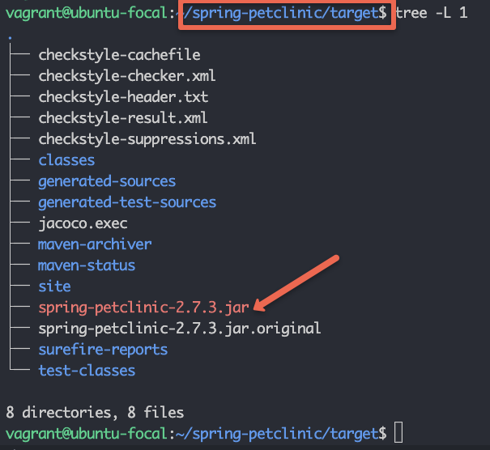](https://devopscube.com/wp-content/uploads/2022/11/image-9.png)

Eventimeyourun**mvncleaninstall**,itdeletestarget directoryandpackagesfromthelocal**.m2**

repositoryandreplacesitwiththelatestbuildfilesandpackages.

Ifyouwanttoskipthetest during build, youcanaddthe **-Dmaven.test.skip=true** parameteras shown below.

mvncleaninstall-Dmaven.test.skip=true

Now that you have understood how to build a java project using maven, let’s look into the maven lifecycle. Few commands we don’t have to use in the CI pipelines. However, it is goodto knowaboutthemavenlifecycle commandsand youcanusethemdependingonyour CI pipeline requirement.

### MavenLifecycleExplained

Let’stakealookat eachmavenlifecyclephase inorder.Eachphaseexecutesallthephases before it. For example, if you execute the third phase, one, two, and three get executed.

1. MavenValidate(mvnvalidate)

**mvnvalidate**validatesthemavenproject. Itdownloadsalltherequireddependenciestothe

local**.m2**repository.

1. MavenCompile(mvncompile)

**mvncompile**compilesthejavaproject.Itrunsvalidatefirstandthencompilesthecode.

1. MavenTest (mvntest)

**mvntest** commandrunstheunit testthat ispartofthecode.Youcantestclassesindividually, methods individually, or add patterns to run tests on all methods that match the pattern.

1. MavenPackage(mvnpackage)

**mvnpackage** commandscompilethecode,test it andfinallypackage it intherequired format (jar or war)

1. MavenVerify(mvnverify)

mvnverifycommandrunsallthephasesexplained before inorderandrunscheckson integration tests and [checkstyles](https://checkstyle.sourceforge.io/)if they are defined in the project.

1. MavenInstall(mvninstall)

**mvninstall**commandinstallsthepackagedcodeinthelocalmavenrepository.

1. MavenDeploy(mvndeploy)

**mvn deploy** command, deploys the package to the remote maven repository. When you run deploy, itfirstrunsvalidate,compile,test,package,verify, install,andthenfinallydeploys the package to the remote maven repository.

### PossibleMavenBuildErrors

java.lang.IllegalStateException:Unabletoloadcacheitem

Ifmavendoesn’tsupporttheJavaversion,youwillgettheabove error.

Torectifyit,installthelatestmavenversionthatsupportstheinstalledJavaversion.

[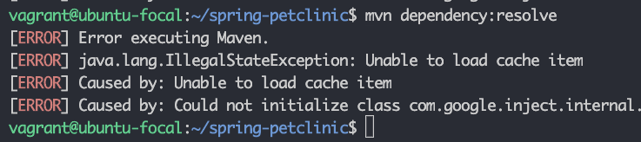](https://devopscube.com/wp-content/uploads/2022/11/image-8.png)

Ifyoutrytoexecutethemavencommandfromthelocationwherethereisno**pom.xml**file,

youwillgetthefollowing error.

Thegoalyouspecifiedrequiresaprojecttoexecutebut thereisnoPOMinthis directory

Torectifythis, executethemavencommandfromthefolder thathasthepom.xmlfile.

### MavenBuild FAQs

Doesmvnpackageruntests?

Yes. Bydefault,the mvnpackage commandrunsthetest. However, youcanaddtheflag - Dmaven.test.skip to skip the tests.

WhatdoesMaventest do?

**mvntest**runsalltheunittestsforthejava project.

### Conclusion

Asa[Devopsengineer,](https://devopscube.com/become-devops-engineer/)it isveryimportantto understandthejavabuildprocess ifyouare working on deploying java projects.

**UNIT–V**

Databases&Deployment

Functionaldependencydefinestherelationshipoftwoormoreattributes, typicallybetween the primarykeyand non-keyattributes ofanother table. It is also defined bythe relation of oneattribute to another attribute in DBMS.

empId→{empName,skill,dependent,contract,project},→Here,empIdcandetermineor defines the values of fields empName, dependent, contract and employee project

UsernameTables:

userName→dateCreatehereifwecanknowtheuserName likewehaveemailaccount if weknow the email Id ofuser then there is possibilityto find the date when account was created.

##### MultivaluedDependency:

MultivalencyDependencyoccurs insuchaconditionortimewhentwoormoreattributes in table are independent to each other but, both of them depend upon the third attributes.

EmployeeTable:

Theattributes likeempName, skill, dependent, contract, project allare independent ofeach other means not depends on one another but depends upon empId example empName can determineskill, oranyotheremployeeattributebecausetherecanbeorevenmorethanone employee with same name or constraints.

empId->skillempId->contractempId->projectempId->dependent These all of the columns is the multivalued dependency on the empId Username Table:

Weonlyhavetwo attributeshere,buttherearenomultipleattributesthatare independentof each other but rely solely on the third variable.

userName→dateCreateheredateCreateisanattributethat dependsorrelateupon the userName onlydateCreate when there is not sufficient to find anything.b)

Minimalkeyistheminimumno ofattributeswhichcan find out otherattributesofa table

i.e.,aprimarykeyorthecandidatekey.**IntheContextofEmployeeTable:**

empId→{empName, skill,dependent,contract,project}

##### IntheContextofUsernameTable:

userName→ dateCreate

##### IntheContextofSubjectTable:

ConsiderSubjecttablewhichhassub_Code,subNamesub_Code->subName

##### IntheContextofEnrollmentTable:

Consideringtheenrollmenttablewhichhastheattributeslike:enrollment Id,Nameof employee, field in which employee enrolled and date

c)

Wehavethe followingEmployeeandUsernameTables:

InContext ofEmployee Table:

Employee table is not in normalize or the normal forms. Because the Attributes in it like: Skill,project, contract and dependent attributes might have one or more values. According tothe1NFprincipleeveryfield must containtheatomicvalues iftheydon’t havetheatomic value.There is need to decompose the table since the table should have the 1 value in each field.

IntheContextofUsername Table:

ItisnormalizingoneSince it hastwofields[UserNameanddateCreate]inwhichbothhave atomic values or data , is fully functional dependent, no transition dependency etc.

d)

Normalization,Decompositionprocesswillbedone.

Normalizationisaprocessortechniqueoforganizingorcollectingthedataindatabase. Itis mainly done for two purposes: Eliminating the redundancy or even the useless data

In1stNF:

Everyfield must containthesingleatomicvalueandtheattributelike:skill,project,contract anddependent attributehasoneor morethanthedecomposetablesothattheeachandevery field has atomic value which will increase the number of tuples in the table name “employee”.

Inthe2ndNF:

Eachtableshouldbeat1stNF.

* Thereshould notbeanyfunctionaldependency. So, inthiscase, afterit is in1stNF tableis in 2ndNF Since the empId can find out all the attributes ofthe employees.

In3rdNF:

* Tableshouldbeat2ndNFForm.
* Thereshould notbeanytransitivedependencyinthetable inwhichthenon-primitive attribute can find another non-primitive attribute i.e., empName, skill, dependent, project is the non-primitive attribute and theycannot find the eachother but the main prime attribute can or able to find all of them.

In BCNF:

* Tableshouldbeat3rdNF.
* TheLHSSideofattributeshould havethecandidatekeyorthesuper key. •So,Inthis case empId → { empName, skill, dependent, contract, project}, The attributeempId is a primary key and can find out all other attributes.

Inthe 4thNF:

TableshouldbeatBCNFForm.

Thereshould notbeanymultivaluedDependency.

So,incurrent EmployeeTablecontext,Employeemight containthemultivalueddependency I.e.: skills, projects [0 or more], dependency[0 or more] and contract [1or more]. So, thereislotsof multivalued attributes or dependencyon the empId which might increase the no of entries in the table which might increase the no of entries in the table after makingit to 1stNF.

InthecaseofmakingtheEmployeetable in4thNF, it willdecomposetheemployeetable intofollowing tables:empId → { empName, skill, dependent, contract, project}

**EmployeeSkils** empId,empName, skill

**EmployeeDependency**empId,empName,dependent**EmployeeContract**empId, empName,

contract

**EmployeeProject**empId,empName, project

Thereis noneedtochangetheUsernameTablesinceitisalreadyon4thNF.

StructuredQueryLanguage

# SQLTutorial

SQLtutorialprovidesbasic andadvancedconceptsofSQL. OurSQLtutorialisdesigned for both beginners and professionals.

SQL(StructuredQueryLanguage) isusedtoperformoperationsontherecordsstoredinthe database, such as updating records, inserting records, deleting records, creating and modifying database tables, views, etc.

SQLisnotadatabasesystem,butitisaquerylanguage.

SupposeyouwanttoperformthequeriesofSQL languageonthestoreddatainthedatabase. You are required to installany database management system in your systems, for example, [Oracle,](https://www.javatpoint.com/oracle-tutorial)[MySQL,](https://www.javatpoint.com/mysql-tutorial)[MongoDB](https://www.javatpoint.com/mongodb-tutorial), [PostgreSQL](https://www.javatpoint.com/postgresql-tutorial), [SQL Server,](https://www.javatpoint.com/sql-server-tutorial)[DB2](https://www.javatpoint.com/db2-tutorial), etc.

### WhatisSQL?

SQL isashort-formofthestructuredquerylanguage, and it ispronouncedasS-Q-Lor sometimes as See-Quell.

This database language is mainly designed for maintaining the data in relational database management systems. It isa specialtoolused bydata professionals for handling structured data(datawhichisstoredinthe formoftables). Itisalso designed forstreamprocessing in RDSMS.

You can easily create and manipulate the database, access and modifythe table rows and columns, etc.ThisquerylanguagebecamethestandardofANSI inthe year of1986andISO in the year of 1987.

If you want to get a job in the field ofdata science, then it is the most important query languagetolearn.BigenterpriseslikeFacebook,Instagram,andLinkedIn,useSQLfor storing the data in the back-end.

### WhySQL?

Nowadays,SQLiswidelyused indatascienceand analytics.Followingarethereasons which explain why it is widely used:

* ThebasicuseofSQLfor dataprofessionalsandSQLusersistoinsert, update, anddeletethe data from the relational database.
* SQLallowsthedataprofessionalsanduserstoretrievethedatafromtherelational database

managementsystems.

* Italsohelpsthemtodescribethestructured data.
* ItallowsSQLuserstocreate,drop, andmanipulatethedatabaseandits tables.
* Italsohelpsincreatingtheview,storedprocedure, andfunctionsintherelationaldatabase.
* Itallowsyoutodefinethedataandmodifythat storeddataintherelational database.
* ItalsoallowsSQLuserstosetthepermissionsor constraintsontablecolumns, views, and stored procedures.

### HistoryofSQL

"ARelationalModelofDatafor LargeSharedDataBanks"wasapaper whichwaspublished by the great computer scientist "E.F. Codd" in 1970.

The IBM researchers Raymond Boyce and Donald Chamberlin originally developed the SEQUEL (Structured English Query Language) after learning from the paper given by E.F. Codd.Theybothdeveloped theSQLat theSanJoseResearch laboratoryofIBMCorporation in 1970.

At the end of the 1970s, relational software Inc. developed their own first SQL using the concepts of E.F. Codd, Raymond Boyce, and Donald Chamberlin. This SQL was totally based on RDBMS. Relational Software Inc., which is now known as Oracle Corporation, introducedtheOracleV2 inJune1979,whichisthe first implementationofSQLlanguage. This Oracle V2 version operates on VAX computers.

### ProcessofSQL

When we are executing the command of SQL on any Relational database management system, thenthesystemautomaticallyfindsthebestroutinetocarryout ourrequest,andthe SQL engine determines how to interpret that particular command.

StructuredQueryLanguagecontainsthefollowingfourcomponentsinitsprocess:

* QueryDispatcher
* OptimizationEngines
* ClassicQueryEngine
* SQLQueryEngine,etc.

Aclassicqueryengineallowsdataprofessionalsanduserstomaintain non-SQLqueries. The architecture of SQL is shown in the following diagram:

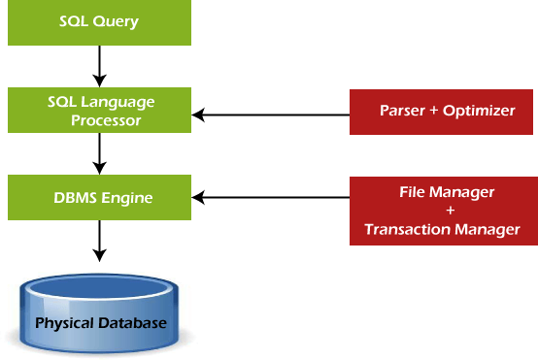

### SomeSQLCommands

TheSQLcommandshelp increatingand managingthedatabase.The most commonSQL commands which are highly used are mentioned below:

1. CREATEcommand
2. UPDATEcommand
3. DELETE command
4. SELECTcommand
5. DROPcommand
6. INSERTcommand

CREATECommand

Thiscommandhelpsincreatingthenewdatabase,newtable,table view,andotherobjectsof the database.

UPDATECommand

Thiscommandhelpsinupdatingorchangingthestoreddatainthedatabase. DELETE Command

Thiscommandhelpsinremovingorerasingthesavedrecordsfromthedatabasetables.It erases single or multiple tuples from the tables of the database.

SELECTCommand

Thiscommandhelps inaccessingthesingleormultiplerowsfromoneormultipletablesof the database. We can also use this command with the WHERE clause.

DROPCommand

Thiscommandhelps indeletingtheentiretable, table view,andotherobjectsfromthe database.

INSERT Command

Thiscommandhelps ininsertingthedataorrecords intothedatabasetables. Wecaneasily insert the records in single as well as multiple rows of the table.

### SQLvsNo-SQL



The followingtabledescribesthe [differencesbetweentheSQLandNoSQL](https://www.javatpoint.com/sql-vs-nosql), whichare necessary to understand:

|  |  |
| --- | --- |
| **SQL** | **No-SQL** |
| 1.SQLisarelationaldatabasemanagement system. | 1.WhileNo-SQLisanon-relationalordistributed database management system. |
| 2.Thequerylanguageusedinthisdatabase system is a structured query language. | 2.ThequerylanguageusedintheNo-SQLdatabase systems is a non-declarative query language. |
| 3.TheschemaofSQLdatabasesispredefined, fixed, and static. | 3.TheschemaofNo-SQLdatabasesisadynamic schema for unstructured data. |
| 4.Thesedatabasesareverticallyscalable. | 4.Thesedatabasesarehorizontallyscalable. |
| 5.ThedatabasetypeofSQLisintheformof tables, i.e., inthe formof rows and columns. | 5.ThedatabasetypeofNo-SQLis intheformof documents, key-value, and graphs. |
| 6.ItfollowstheACIDmodel. | 6. ItfollowstheBASEmodel. |

|  |  |
| --- | --- |
| 7.Complexqueriesareeasilymanagedinthe SQL database. | 7.NoSQLdatabasescannothandlecomplex queries. |
| 8.Thisdatabaseisnotthebestchoicefor storing hierarchical data. | 8.WhileNo-SQLdatabaseisaperfectoptionfor storing hierarchical data. |
| 9.AllSQLdatabasesrequireobject-relational mapping. | 9.ManyNo-SQLdatabasesdonotrequireobject- relational mapping. |
| 10.Gauges,CircleCI,Hootsuite,etc.,arethe top enterprises that are using this query language. | 10. Airbnb, Uber, and Kickstarter are the top enterprisesthatareusingthisquerylanguage. |
| 11.SQLite,Ms-SQL,Oracle,PostgreSQL,and  MySQLareexamplesofSQLdatabase systems. | 11.Redis,MongoDB,Hbase,BigTable,CouchDB,  andCassandraareexamplesofNoSQLdatabase systems. |

### AdvantagesofSQL

SQLprovidesvariousadvantageswhichmake it morepopular inthe fieldofdata science.It is a perfect query language which allows data professionals and users to communicate with the database. Following are the best advantages or benefits of Structured Query Language:

##### Noprogrammingneeded

SQLdoesnotrequirea large numberofcoding linesformanagingthedatabasesystems.We can easily access and maintain the database by using simple SQL syntactical rules. These simple rules make the SQL user-friendly.

##### High-SpeedQueryProcessing

A large amount ofdata is accessed quicklyand efficiently fromthe database by using SQL queries.Insertion,deletion,andupdationoperationsondataarealso performed inlesstime.

##### StandardizedLanguage

SQLfollowsthe long-establishedstandardsofISOandANSI,whichofferauniform platform across the globe to all its users.

##### Portability

Thestructuredquerylanguagecanbeeasilyused indesktopcomputers,laptops,tablets,and even smartphones. It can also be used with other applications according to the user's requirements.

##### Interactivelanguage

We can easily learn and understand the SQL language. We can also use this language for communicatingwiththedatabasebecause it isasimplequerylanguage.Thislanguage isalso

usedforreceivingtheanswerstocomplexqueriesinafewseconds.

##### More thanoneDataView

TheSQLlanguagealso helpsinmakingthe multiple viewsofthedatabasestructureforthe different database users.

### DisadvantagesofSQL

WiththeadvantagesofSQL,italsohassomedisadvantages, whichareasfollows:

##### Cost

TheoperationcostofsomeSQLversionsishigh.That'swhysomeprogrammerscannot use the Structured Query Language.

##### InterfaceisComplex

Anotherbigdisadvantage isthatthe interfaceofStructuredquerylanguage isdifficult,which makes it difficult for SQL users to use and manage it.

##### PartialDatabasecontrol

Thebusinessrulesarehidden. So,thedataprofessionalsanduserswho areusingthisquery language cannot have full database control.

**DatapersistenceusingSpring**

I'mused to using Spring Roo to generate my entities and having it handle injecting the entityManageraswellasthepersist andothermethodsvia AspectJclasses. NowI'mtryingto use Spring Boot to do something simple that will write things to the database ...

@Entity

@Table(name="account") publicclassAccount {

transientEntityManagerentityManager; @Id

@GeneratedValue

privateLongid;

@Column(name="username",nullable=false,unique=true) private String username;

@Column(name="password",nullable=false) private String password;

...gettersand setters

@Transactional publicvoidpersist(){

if(this.entityManager==null)this.entityManager=entityManager(); this.entityManager.persist(this);

}

@Transactional

publicAccountmerge(){

if(this.entityManager==null)this.entityManager=entityManager(); Accountmerged=this.entityManager.merge(this); this.entityManager.flush();

returnmerged;

}

WhenI'mcallingpersistormerge,entityManagerisobviously null.

I've also tried adding implements CrudRepository<Account, Long>to the Accountclass to see it'll give methat functionalityviaaDefault Implementation,but what I'mgetting issimplyempty classes that needs to be filled in.

I'vehada lookattheSpringBoot docs,theycoverit verybrieflyomitting just enoughdetail to so that it's not obvious what I'm missing.

IhaveanApplicationclassthatbootstrapstheapplication:

@Configuration @ComponentScan @EnableAutoConfiguration publicclassApplication {

publicstaticvoidmain(String[]args)throwsException{ SpringApplication.run(Application.class, args);

}

}

Myproperties filelookslikethis:

spring.application.name:TestApplication

spring.datasource.url: jdbc:mysql://localhost/test spring.datasource.username=root spring.datasource.password= spring.datasource.driverClassName=com.mysql.jdbc.Driver spring.jpa.hibernate.ddl-auto=update

Thisdatabaseisautomaticallybeingcreatedthankstotheddl-auto=updateproperty

What isthecorrectwayto persist entitiesinSpring Boot+JPAand ifwhat I'vedone is correct so far, how do I "autowire" or auto-create the entityManager?

**JDBCAgiledevelopmentprinciples**

### WhataretheAgile Principles?

There are 12 [agile](https://www.productplan.com/agile-product-management/)principles outlined in [The Agile Manifesto](https://www.productplan.com/resources-pp/what-is-the-agile-manifesto/)in addition to the 4 agile values. These 12 principles for agile software development help establishthe tenetsofthe agile mindset.Theyare notasetofrules forpracticingagile, but ahandfulofprinciplesto help instill agile thinking.

Belowwewillrevieweachofthe12agileprinciplesanddescribe howtheymaybe practiced.

### AgilePrinciple1

“Our highest priorityistosatisfythecustomer throughearlyandcontinuousdeliveryof valuable software.”

Thebest waysto ensureyoumakecustomershappywhilecontinuouslydeliveringvaluable software are to ship early, iterate frequently, and listen to your market continually.

Unlike traditional approaches to product development, which have notoriously long development cycles, agileprinciplesencourage minimizing thetimebetween ideationand launch. The idea istogetaworkingproductin thehandsofcustomersassoonaspossible. Doingthissuccessfullymeansproductmanagersareabletoquicklyget a [minimumviableproduct(MVP)](https://www.productplan.com/minimum-viable-product/)out andintotheworldanduse ittoget feedback fromrealcustomers.This feedback is then fed back into the product development process and used to informfuture releases.

[](https://cta-redirect.hubspot.com/cta/redirect/3434168/9e6140b2-e382-45fd-ace0-16435228cf7b)

##### Howitlooksinpractice:

* Productteamsuseminimumviableproductsandrapidexperimentationtotesthypothesisand validate ideas.
* Frequentreleaseshelpfuelacontinuousfeedbackcyclebetweencustomerandproduct.
* Shippedanddonearenot thesamething. Insteadofreleasinga “finished”product, iterations continue to make incremental improvements to product based on customer and market feedback.

### AgilePrinciple2

“Welcomechangingrequirements,evenlateindevelopment.Agileprocessesharnesschange for the customer’s competitive advantage.”

In the world around us, change is the only constant. Agile principles and values support responding to these changes rather than moving forward in spite of them. Previous approachesto product development wereoftenchangeadverse;detailed,well-documented

planswere madebeforedevelopment beganandwereset instoneregardless ofnew findings. Agile principles support observing changing markets, customer needs, and competitive threats and changing course when necessary.

##### Howitlooksinpractice:

* Product teams areguidedbyhigh-levelstrategicgoals andperhaps even [themes](https://www.productplan.com/organize-your-roadmap-by-themes/)belowthose goals. Theproduct department’ssuccess is measuredagainst progress towardthosestrategic goals rather than by delivery of a predefined feature set.
* Product constantly has its ear to the ground monitoring the market, customer feedback, and other factorswhichcouldinfluenceproductdirection.Whenactionableinsightisuncovered, plans are adjusted to better serve customer and business needs.
* Product strategyandtacticalplansarereviewed, adjusted, andsharedonaregular cadenceto reflect changes and new findings. As such, product needs to manage the expectations of executive stakeholders appropriately and ensure they understand the *why* behind changes.

### AgilePrinciple3

“Deliverworkingsoftwarefrequently, fromacoupleofweeksto acoupleofmonths, witha preference to the shorter timescale.”

Agile philosophy favors breaking a product’s development into smaller components and “shipping”thosecomponentsfrequently.Usinganagileapproach,therefore—andbuilding in more frequent mini-releases of your product—can speed the product’s overall development.

Thisagileapproach, withshort-termdevelopmentcyclesofsmaller portionsoftheproduct, results in less time spent drafting and poring over the large amounts ofdocumentation that characterizes Waterfall product development. More importantly, this frequent-release approach creates moreopportunities for you and yourteams to validate your product ideas and strategies from the qualified constituencies who see each new release.

##### Howitlooksinpractice:

* Agile development cycles, often called “sprints” or “iterations” break down product initiativesintosmaller chunksthatcanbecompletedina settimeframe. Oftenthistimeframe is between 2 and 4 weeks which truly is a sprint if you consider the marathon-like development cycles waterfall teams often follow.
* Another popular alternative to agile sprints is continuous deployment. This method of shippingsoftwarefrequentlyworks less interms ofpredeterminedtimeboxes and morein terms of simply deciding what to do and doing it.

### AgilePrinciple4

“Businesspeopleanddevelopers mustworktogetherdailythroughoutthe project.”

Communicationisacriticalcomponentofanyprojectorteam’ssuccess, andagileprinciples essentially mandatethat it’sa dailyevent.It takesa village to raise a child theysay, and that applies to product as well.

Asuccessfulproductrequires insight fromthebusinessandtechnicalsidesofanorganization which can only happen if these two teams work together consistently. Regular communication between business people and developers helps improve alignment across the organization by building trust and transparency.

##### How itlooksinpractice:

* Cross-functionalagileproductdevelopmentteamsincludeproductpeople.This meansthat product is representedonthedevelopment teamandbridges thegap betweentechnicaland business aspects of the product.
* Dailyupdatemeetings, or standups, areonetechniquemanyagileshopsusetoput this principle in practice and keep everyone connected.

### AgilePrinciple5

“Buildprojectsaround motivatedindividuals.Givethemtheenvironment andsupportthey need, and trust them to get the job done.”

A key part of the agile philosophy is empowering individuals and teams through trust and autonomy.Theagileteamneedstobecarefullybuilt to includetheright peopleandskillsets to get the job done, and responsibilities need to be clearlydefined before the beginning ofa project. Once the work has begun, however, there’s no place in agile for micromanagement or hand holding.

##### Howitlooksinpractice:

* Product must clearly ensure engineering understands strategy and requirements before development starts.Thismeansnot onlysharinguser stories withthecross-functionalteam but also the bigger picture outlined in the product roadmap.
* Product isnot responsiblefor explaining“how”somethingshouldbebuilt.Theyneedto sharewhat andwhy, but it’s the deliveryteam’s job to determinethe how. Furthermore, during sprints product does not micromanage outcome, instead they make themselves available to answer questions and provide support as needed.

[](https://cta-redirect.hubspot.com/cta/redirect/3434168/bfb5032e-5746-4c05-9f2a-54b36ba0e871)

### AgilePrinciple6

“Themost efficient andeffectivemethodofconveyinginformationtoandwithina development team is face-to-face conversation.”

Withso manydistributedor [remotedevelopmentteams](https://www.productplan.com/remote-product-teams/)thesedays, thisprinciplegetsabit of critique. But at the root of it, effective communication with developers means getting these conversations out of Slack and email and favoring more human interaction (even if done by video conference calls). The overallobjective behind this principle is to encourage product peopleanddeveloperstotrulycommunicateinrealtimeabouttheproduct,requirements, and the high-level strategy driving those things.

##### Howitlooksinpractice:

* Dailystandupmeetings
* Collaborative[backloggroomingsessions](https://www.productplan.com/resources-pp/what-is-backlog-grooming/)
* Sprintplanningmeetings
* Frequentdemos
* Pair-programming

### AgilePrinciple7

“Workingsoftwareistheprimarymeasureofprogress.”

Proponents of the agile philosophy are quick to remind us that we’re in the business of building software, and that’swhereourtimeshould bespent. Perfect, detailed documentation issecondarytoworkingsoftware.Thismentalitypushesto get productsto themarket quickly rather than let documentation or an “it’s not done until it’s perfect” mentality become a bottleneck. The ultimate measure for success is a working product that customers love.

##### Howitlooksinpractice:

* Designingandreleasing“MinimumViableFeatures”rather thanfully-developedfeaturesets means thinking first and foremost about the smallest things we can ship to start getting customer feedback and validate as we continue to build software.
* Afailfast mentalitymeans movingforwardevenintimes ofuncertaintyandtestingideas rapidly.
* Shipsoftwareoften:a usefulproductnowisbetter thanaperfectonelater.

### AgilePrinciple8

“Agileprocessespromotesustainabledevelopment.Thesponsors,developers,andusers should be able to maintain a constant pace indefinitely.”

Keeping up with a demanding, rapid release schedule can be taxing on a team. Especially if expectations are set too high. Agile principles encourage us to be mindful of this and set realistic,clearexpectations.The idea isto keepmoralehighand improvework-life balanceto prevent burnout and turnover among members of cross functional teams.

##### Howitlooksinpractice:

* Beforeeverysprint, carefulconsiderationoftheamount ofworkthat canbecommittedtois made. Development teams don’t over promise on what they can and cannot deliver. Effort estimations are a common practice in setting output expectations for development teams.
* Everyoneagreesonwhat willget doneduringa sprint.Oncea sprint hasbegun, noadditional tasks are to be added except in rare cases.
* Product managersshouldactasgatekeeperstoreducethenoisefromother stakeholdersand to avoid squeezing in additional unplanned work during an ongoing sprint.
* Product peopleshoulddotheir part inpromotinga senseofpsychologicalsafetyacross the cross-functional team that encourages open communication and freely flowing feedback.

### AgilePrinciple9

“Continuousattentiontotechnicalexcellence and gooddesignenhances agility.”

While the agile philosophy encourages shorter cycles and frequent releases, it also puts emphasisonthe importanceofkeepingthingsneat andtidysotheydon’t causeproblemsin the future. Product managers often forget about this aspect of development because they mostlydon’t spendtheir dayswadingthroughtheir products’codebases, but it isstillofthe utmost importance to them.

##### Howitlooksinpractice:

* Theteamneedstobecognizant of [technical debt](https://www.productplan.com/glossary/technical-debt/)andthetechnical debt implicationsofany new features or initiatives added to the backlog. Developers and product need to work together to understand if and when technical debt is acceptable.
* Ona regular basis,product willneedtoallocatedevelopmentresourcestorefactoringefforts. Refactoring cannot be an afterthought, it needs to be an ongoing consideration.

### AgilePrinciple10

“Simplicity—theartofmaximizingtheamountofworknotdone—isessential.”

You’ve probably heard ofthe 80/20 rule—the concept that you canusuallyget 80%of your intended results with just 20% of the work. Agile principles encourage thinking this way; doingthethingsthat canhavethe most impact.Inaproduct management contextthismeans having a laser sharp focus on organizational objectives and making some cutthroat [prioritizationdecisions.](https://www.productplan.com/product-management-frameworks/) Agileprinciplesdiscouragebuilding merelyfor thesakeofbuilding by emphasizing the importance of being strategic and building with purpose.

##### Howitlooksinpractice:

* Product managers need to make very focused product decisions and closely align product strategy with organizational goals while being extremely picky about what user stories and featuresactuallymakethecut. Usingprioritizationtechniquestoprioritizeinitiativesbyeffort and predicted impact is one way product teams can apply this agile principle to product development.
* The short sprints that agile is characterized by present many opportunities for rapid testing andexperimentationwhichcanhelpreduceuncertaintyaroundwhether initiativeswilltruly have the predicted impact. Using experiments to validate ideas before building them up to spec is a great way to weed out bad ideas and identify good ones.

### AgilePrinciple11

“Thebestarchitectures,requirements,anddesignsemerge fromself-organizingteams.”

In traditional software development methodologies, you’ll often see pyramid shaped teams where management makes keydecisions for contributors. Agile principles suggest the useof self-organizing teams which work with a more “flat” management style where decisions are made as a group rather than by a singular manager or management team. The concept tiesinto agile’svalueofteamsand interactionsoverprocessesandtools,andtheintent behindthe concept is to empower teams to work together as they need to.

##### Howitlooksinpractice:

* Self-organizing teams are autonomous groups within the organization who take control and responsibility over their respective projects and have ownership of those areas. Different organizationspracticethisprincipledifferently.Spotify,for exampleuses“productsquads”to practice this.

Learnmoreaboutmanagingcomplexrequirementsinanagileworldinthewebinar below.

## deployingapplicationinCloud

### AboutDeployingOracleAgilePLMonCloud

If your organization wants to develop, deploy, and/or update parts of an Agile Product LifecycleManagement (PLM)applicationinafaster,moreagileway, insteadofinvestingin building on-premise implementations, then deploy Agile PLM on Oracle Cloud Infrastructure.

By using Agile PLM on Oracle Cloud, replication from on-premise to cloud and cloud-to-cloud platforms can easily be established and managed. You can also gain the benefits of faster infrastructureupdates, easier scalingup(anddown),lower capitalexpenditure,andfewer personnel dedicated to basic infrastructure maintenance.

KeyWorkloadRequirements

ThearchitecturesthatOracleprovideshelp youaddresstheserequirements:

* Designingforhighavailabilityanddisaster recovery
* Deployinga securearchitecture.
* Matchingyourhigh-performanceandhighlyisolatednetworkmodel.
* Deployingyourapplicationanddatabaseenvironmentsintothecloud.
* Maintainingvisibilityovercostsandusage.
* Monitoringinfrastructurehealthandperformance.

ArchitectureforDeployingAgilePLMonCloud

You can deployAgile PLM in a single availability domain while ensuring high availability. Usethisarchitecturewhenyouwantto ensurethatyourapplicationisavailableevenwhenan application instance goes down. The other available application instances in the availability domain continue to process the requests.

Oracle AgilePLMcanbedeployedoncloud inamulti-tieredarchitecture.Thearchitecture consists of a virtual cloud network (VCN) with the bastion host, load balancer tier, application tier, and database tier. The tiers are placed in separate subnets ofthe VCN in a single availability domain.

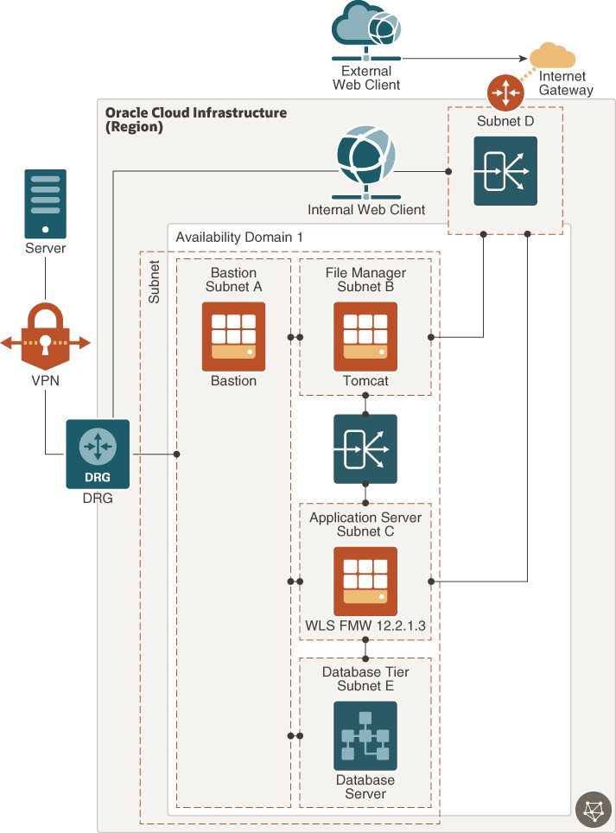

[Descriptionoftheillustrationagile_plm_reference_architecture_high_availability.png](https://docs.oracle.com/en/solutions/learn-deploy-agileplm-to-oci/img_text/agile_plm_reference_architecture_high_availability.html)

TheAgilePLMapplicationservercanbeset upinastandaloneorclusteredconfiguration.In the image shown, a standalone server is considered, which has only one Oracle WebLogic Server instance. All client servers and users connect to the application server either directly

or indirectly. To permit traffic to the web server fromthe internet, you can create load balancers in the public subnet. You can access Oracle Cloud instances in the private subnet fromyour datacentersbyconnectingthroughthedynamicroutinggateway(DRG). TheDRG is the gatewaythat connects your on premise networkto your cloud network and you can enablecommunicationbetweenthetwo usingVPN. You’llalso havetoupdatetheroutetable to enable traffic to and from the DRG.

The load balancer receives requests from users, and then routes these requests to the application tier. You can allow for redundancy (and scalability) by configuring multiple instances of the WebLogic server for the core application, Tomcat for File Manager, and RACfordatabase.Youcanaugment redundancythroughtheuseoffault domainsso thatyou cancontinueaccessing theapplicationeven ifan instancegoesdown. Allinstancesareactive and receive traffic from the load balancer.

There's a private Load Balancer between File Manager and ApplicationServer to distribute traffic to your application instances within a VCN. This service provides a primaryand a standby instance of the load balancer to ensure that if the primary load balancer becomes unavailable, thestandbyload balancer forwardstherequests.The loadbalancer ensuresthat requests are routed to the healthy application instances. If there’s a problem with an applicationinstance,thenthe loadbalancerremovesthat instanceandstartsroutingrequests to the remaining healthy application instances.

The database server stores allproduct content and systemsettings and is placed inthe private subnet. This database is accessed only by the application server. For performance and high availabilityrequirements, Oraclerecommendsthat youusetwo-nodeOracleRealApplication Clusters (Oracle RAC) database systems in Oracle Cloud Infrastructure.

ArchitectureofAgilePLMDisasterRecovery

Oracle Cloud provides Agile PLM implementations that ensure you can build disaster recovery(DR)intoyourdeployment inunforeseeneventsthatwouldrequireyouto failover and still keep Agile PLM up and running.

ThefollowingimageillustratesthereferencearchitecturefordeployingAgilePLMin multiple regions with high availability and disaster recovery.

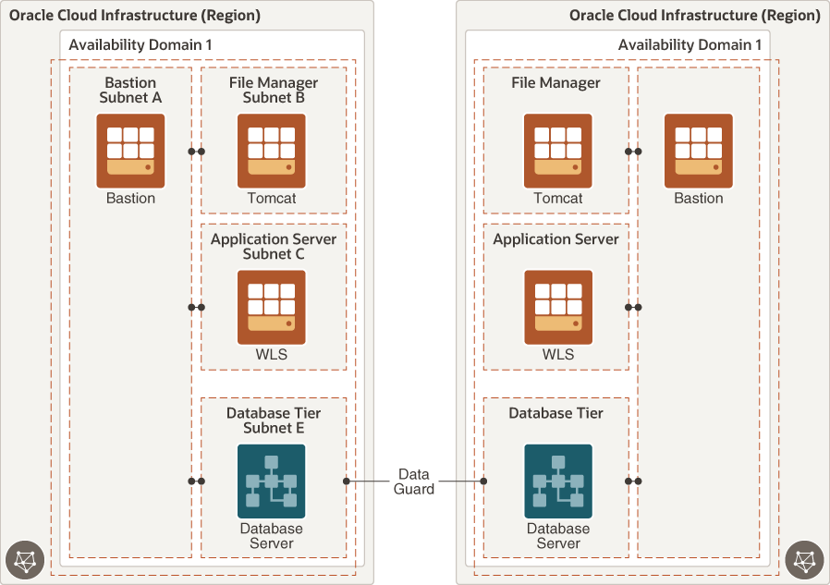

[Description of the illustrationagile_plm_reference_architecture_high_availability_and_dr.png](https://docs.oracle.com/en/solutions/learn-deploy-agileplm-to-oci/img_text/agile_plm_reference_architecture_high_availability_and_dr.html)

OracleDataGuardprotectsyour databasetierbyreplicatingdataacrossavailabilitydomains.